Tab 1

NAME: MUHAMMAD FIRDAUS BIN MD SHAHRUNNAHAR

ID: A24CS5031

**InfinityFree Dashboard:**

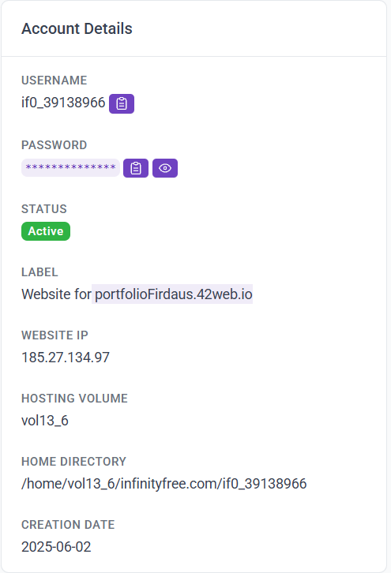

**Website Homepage:**

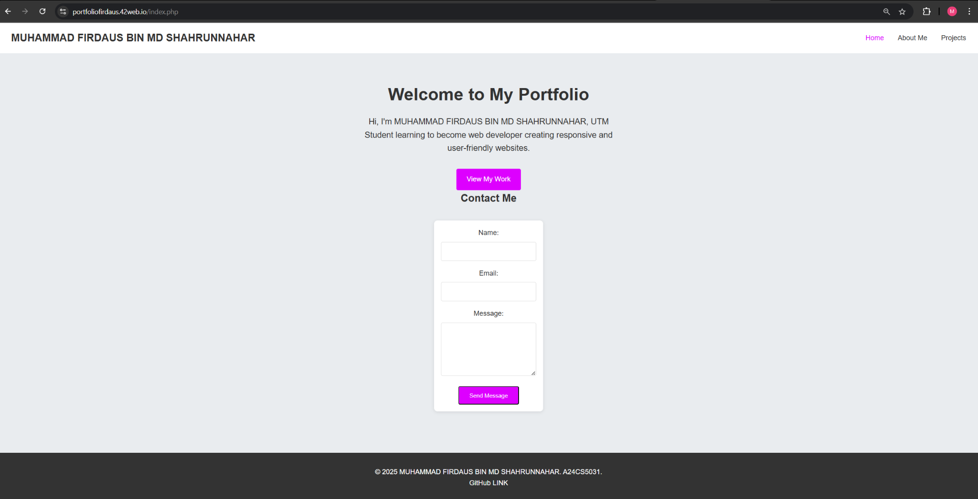

**Dynamic Features:**

