Lab 4 Analysis — WalkMates
Course: Principles & Practices in Software Testing (DV033G)
Pair: Lena Edlind, Jakob Cederblad & Gemini CLI

SUsAF Map
Link:

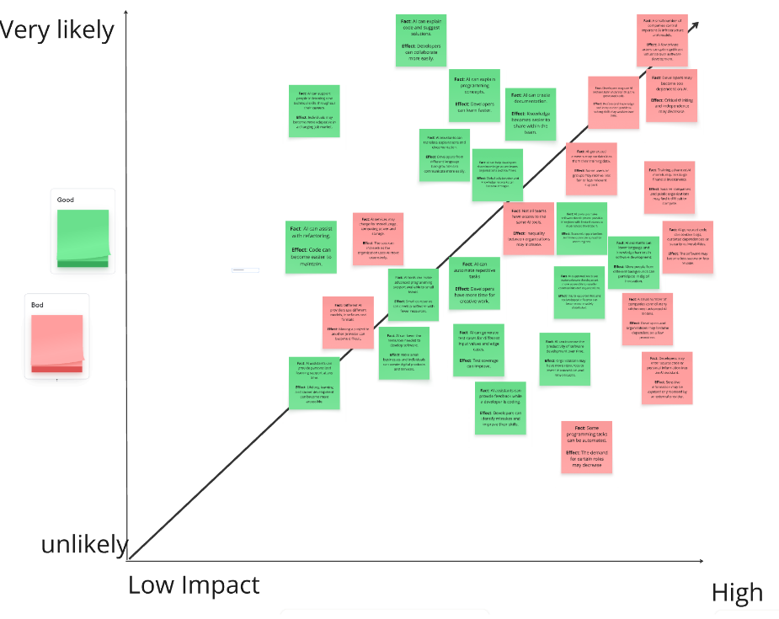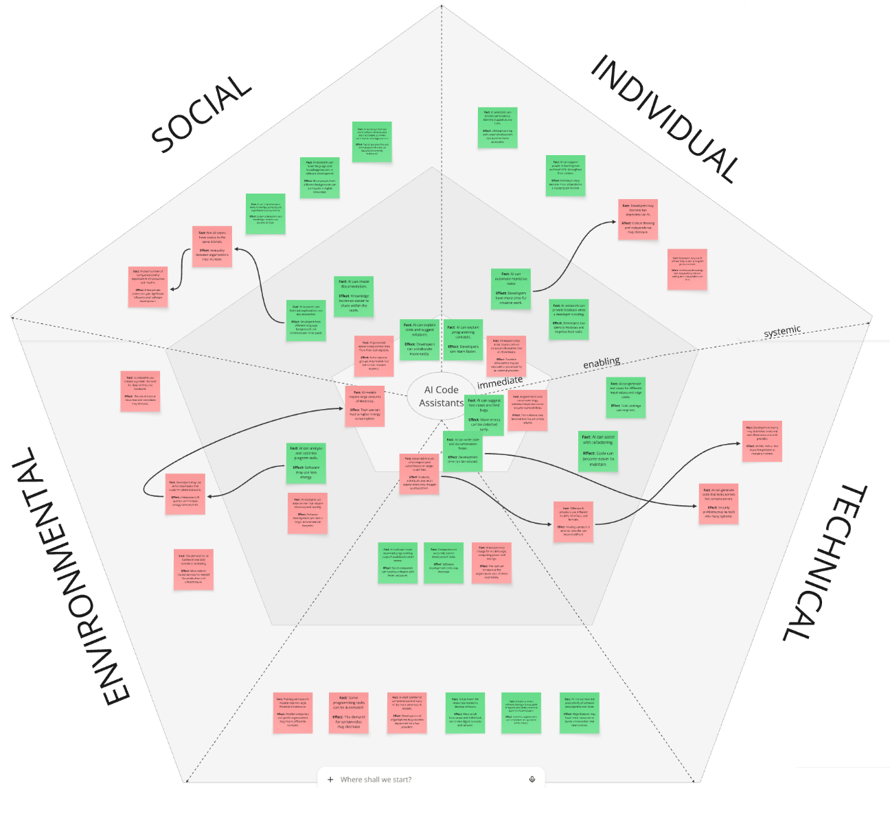

Discussion

Chain of effects
- AI can automate repetitive tasks Developers may become too dependent on AI.
Short-term benefit
AI can automate repetitive and time-consuming tasks, allowing developers to spend less time on repetitive work and more time on complex or creative activities. This can improve individual productivity and reduce development costs, (Individual/Economic).
Long-term risk
If developers become overly reliant on AI to perform routine tasks, they may gradually lose their understanding of the underlying processes and the purpose of those tasks. Over time, this dependency may weaken their critical-thinking, problem-solving, and independent working skills, (Individual/Technical).

- AI can write code and documentation faster AI can generate code that looks correct but contains error.
Short-term benefit
AI can generate code and documentation significantly faster than a developer working without AI assistance. This allows AI-augmented developers to complete tasks more quickly, faster development, and potentially improve short-term productivity, (Individual/Economic).
Long-term risk
AI-generated code may appear correct and well-structured, while still containing errors and flawed assumptions. They may become embedded in the software as it grows and becomes complex. Correcting them later can require substantial rework, increase costs, and slow long-term development, (Technical/Economic).

Ethics of AI-augmented
The increasing adoption and availability of AI are accompanied by substantial investments in computing infrastructure, energy, and water resources. Although investors currently finance much of this expansion, the long-term economic sustainability of many AI services remains uncertain. This raises the question of whether the benefits of AI-augmented testing justify its financial, environmental, and security-related costs.
One argument in favor of AI-augmented testing is that it can help developers identify defects that conventional testing might overlook. If left undetected, these defects could cause serious harm to users or other components of the system. Therefore, using AI to improve test coverage and software reliability may be ethically justified, particularly when software failures could have serious consequences.
However, AI-augmented testing can also introduce security risks. When developers provide an external AI service with source code, test cases, or architectural information, they may expose sensitive details about the product. If this information is retained in databases, accessed by unauthorized parties, or leaked, it could reveal potential vulnerabilities. Furthermore, internally deployed AI systems with web access may unintentionally disclose sensitive information if they are not properly configured and secured.
Our position is that AI-augmented testing is ethically justified when its expected improvements in software quality outweigh its financial, environmental, and security costs. However, organizations should not adopt AI testing simply because it is available or promises faster development. Instead, they should evaluate whether it provides meaningful improvements over conventional testing methods.

