Create Custom Action Plugin

# Introduction

Often in any database system you have the need to do some update on the database or other data. In OpenStore there is an interface that allows a simple plugin to make updates, without having to create a UI for the plugin.

You need to have Visual Studio and the VS template for the OpenStore Plugin template (“OS_CustomAction”).

<https://github.com/openstore-ecommerce/OS_CustomAction/releases>

# Create Project

Create a new project in VS using the “OS_CustomAction” VS project template. In the DesktopModules strucuture. Best to create this in you company name folder, this was the paths for the compile will be correct.

Change assembly name.

Change CustomAction.cs code to run your changes.

Compiling will copy the dll to the DNN bin folder, the assembly needs to be there so it can run.

**[NOTE: If using DNN9.3+ you will need to move the Asp.Net framework to v4.7.2+]**

# Run the Plugin

Move the plugin assembly to the DNN bin folder.

Then go into AdminPanel>Admin>Tools and enter the namespace, class and assembly in the Custom Action provider.

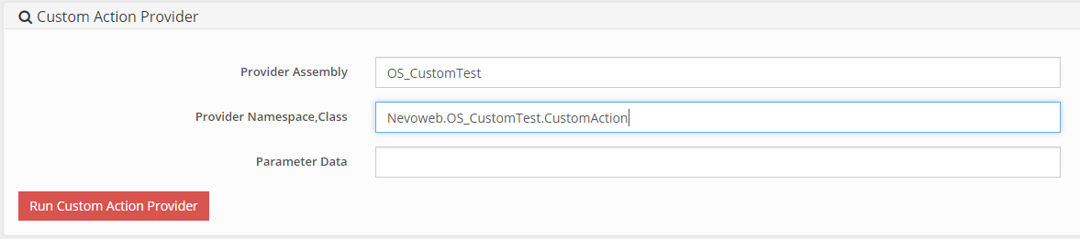

Parameter data can also be passed to the function.

The “Run()” function will always be called by the interface.