Create Plugin (List & Detail)

Introduction

This document explains how to create a List & Detail plugin for Open Store.

You need to have Visual Studio and the VS template for the OpenStore Plugin template (“OS_PluginTemplate”).

<https://github.com/openstore-ecommerce/OS_PluginTemplate/releases>

# Create Project

Create a new project in VS using the “OS_PluginTemplate” VS project template.

**USE case match on next replace operation:**  
Rename ALL instances of “os_plugintemplate_” with “new project name_” (IMPORTANT: for this replace make sure you use LOWERCASE) **NOTICE: “_” on the end of this replacement.  
**If you forget the case sensitive replacement, it’s easier to start again.**

Rename ALL instances of “OS_PluginTemplate” with “new project name” (Turn off match case).

Ensure the xml ctrl field in the “plugin*.xml” file is the lowercase “new gateway name”.   
<ctrl update="save">lowercase</ctrl> This should match the replacement above (without “_”).

Rename files and project to match new project.

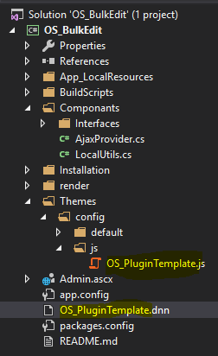

You should be able to compile now.

# Add to OpenStore Menu

The plugins are added to the OpenStore admin menu via the plugin interface. The easiest way to add a plugin is to copy the “pluginconfig.xml” of the project into the “\DesktopModules\NBright\NBrightBuy\Plugins” folder, then go into the OpenStore BO>Admin>Plugins and the plugin will be automatically added to the menu. You can also create the plugin manually through the plugin page if you want to.

NOTE: If you create the plugin manually you can use the XML field to get a copy of the XML required to create a pluginconfig.xml file.