**MARS**

***A Cold Year on Mars***

**Unleash the Power of Data: Discover Mars News and Weather**

Dive into the world of web scraping and data analysis as we explore the Red Planet, Mars.

Identifying HTML elements, extracting valuable data, and presenting insights.

Scrape Titles and Preview Text from Mars News.

Using Splinter to access the Mars News website and delve into its source code to uncover valuable data. With the formidable BeautifulSoup.

Automated browsing was employed to visit the Mars Temperature Data Site.

Beautiful Soup was used to scrape the HTML table containing Mars weather data.

The data was then organized into a Pandas DataFrame with appropriate data types. Subsequent data analysis answered several questions:

The number of months on Mars was determined, with varying data for each month.

The dataset contained 1867 Martian days' worth of data.

The coldest and warmest months on Mars were identified based on average minimum temperatures. March was the coldest, while August was the warmest.

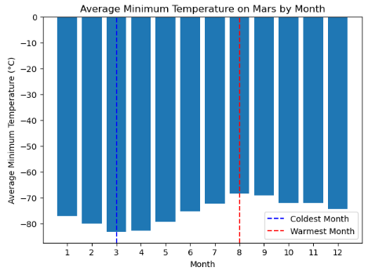

The months with the lowest and highest atmospheric pressure were found, with June having the lowest and September the highest.

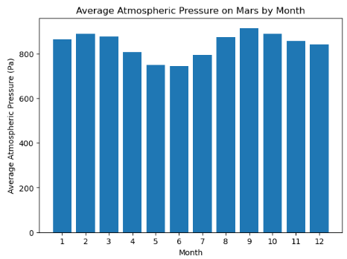

An estimate of about 685 Earth days in a Martian year was made by visually analysing the daily minimum temperature data.



