## Pymaceuticals Inc.

Pymaceuticals, Inc. Recently began screening for potential treatments for squamous cell carcinoma (SCC), a commonly occurring form of skin cancer. In this study, 249 mice who were identified with SCC tumors received treatment with a range of drug regimens. Over the course of 45 days, tumor development was observed and measured. The purpose of this study was to compare the performance of Pymaceuticals’ drug of interest, Capomulin, against the other treatment regimens.

### Data Cleaning and Overview

The initial dataset contained information on 249 mice that received treatment for squamous cell carcinoma (SCC) using various drug regimens.

After removing duplicate timepoints for a mouse ID, a cleaned dataset was obtained.

## Summary Statistics

The summary statistics provides insights into the performance of different drug regimens in terms of tumor volume.

The Capomulin regimen exhibited the lowest mean and median tumor volumes, indicating its potential effectiveness in reducing tumor size.

Ramicane also showed promising results with lower mean and median tumor volumes.

## Bar and Pie Charts

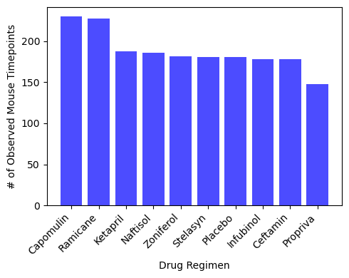

## Quartiles, Outliers and Boxplots

Box plots were created to visualize the distribution of tumor volumes for the four most promising treatment regimens: Capomulin, Ramicane, Infubinol, and Ceftamin.

Outliers were identified in the Infubinol regimen, suggesting potential variations in response to this treatment.

**Box Plot and Outliers:**

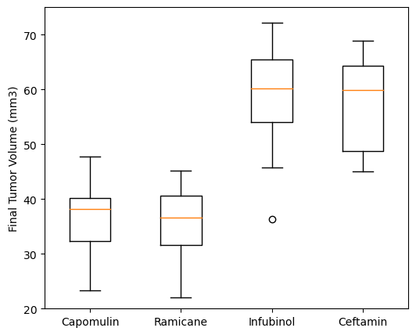

## Line Plot

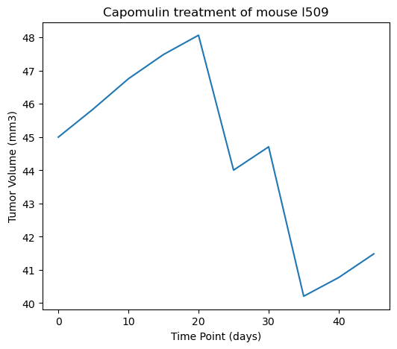

## Correlation and Regression

A strong positive correlation (0.84) was observed between mouse weight and average observed tumor volume for the Capomulin regimen.

The linear regression model indicated that as mouse weight increases, average tumor volume tends to increase as well.

The correlation between mouse weight and the average tumor volume is 0.84

**Observations and Inferences:**

Capomulin and Ramicane appear to be the most effective treatments in reducing tumor volume, as evidenced by their lower mean and median tumor volumes compared to other regimens.

Infubinol demonstrated higher variability in tumor volume, as indicated by the larger variance and standard deviation. Additionally, potential outliers were detected in this regimen.

There is a strong positive correlation between mouse weight and average tumor volume in the Capomulin regimen, implying that heavier mice tend to have larger tumor volumes.

Overall, the analysis suggests that Capomulin and Ramicane are the most promising treatment options, with lower tumor volumes and potential positive effects on heavier mice. However, further investigations are needed to understand the effects of different variables on treatment outcomes and to validate the observed trends.