QMRA DEVS model

Design summary
The model is a tool to estimate the levels of exposure via the three known routes of transmission and how these are affected by
- background infection prevalence in the larger population
- patterns of usage of indoor spaces, e.g., occupancy levels
- behaviours, such as frequent face touching
- mitigations to minimise the risk of infection, such as mask wearing, vaccination, increased ventilation, hand washing and sanitary intervention
The aim of this work is to provide an adaptable simulation framework, making it easier to assess the impacts of mitigations and behavioural changes upon the risk of infection without requiring significant re-writing of code.
Design principle: air zones, surfaces, hands, respiratory systems of susceptible people and infectors and mucous membranes are treated as abstract reservoirs. Calculating transmission and exposure, as well as deposition onto surface and mixing between air zones, amounts to tracking the transfer of pathogens between these reservoirs, both continuously using differential equations and discretely, using discrete event simulation. This way we unify the modelling of pathogen sources, sinks (e.g., ventilation and pathogen decay – mono and bi-phasic), mixing between air zones, deposition onto surfaces and re-aerosolisation into a single framework. The design goal is to separate out pathogen transfers, factors such as spatial configuration, occupancy levels and rules (e.g., max occupancy in small spaces) and behavioural assumptions from the simulation engine itself to rapid development of simulation models describing a wide range of scenarios.

Preliminary model outputs
The following is based on Scenario F from Noakes & Sleigh 2009.
There are nine interconnected zones consisting of 6 inpatient wards connected by a corridor, which is itself made up of three sub-zones. Alongside global mixing between adjacent zones, there are net flows of air due to imbalances of ventilation rates between the different areas. An infector spends 10 mins in Zone 1A then 10 mins in Zone 1B, moves along the corridor (through C1, C2 & C3, spending half a minute in each) before spending 10 mins in Zone 3B and 10 mins in Zone 3A. Zonal concentrations take into account rates of air mixing between adjoining zones due both to global mixing and differential ventilation rates in each zone. The left hand panel below shows the zonal concentrations, while the right hand panel shows the potential airborne exposures in the each zone.
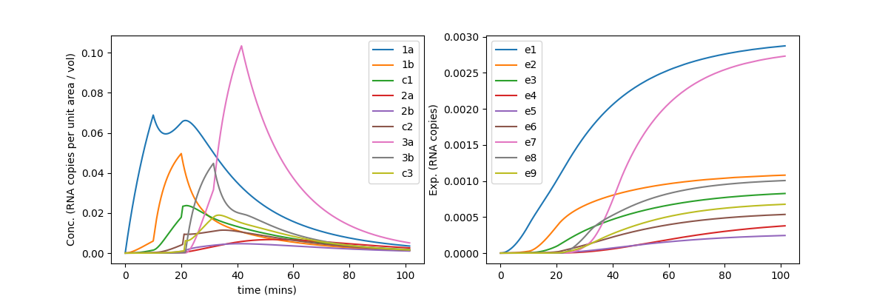
Changing the scenario, now there is a single infector in Zone 2B and susceptible people in Zones 1A, 1B and 2A. Below is an estimate of their airborne exposures over the course of an hour.
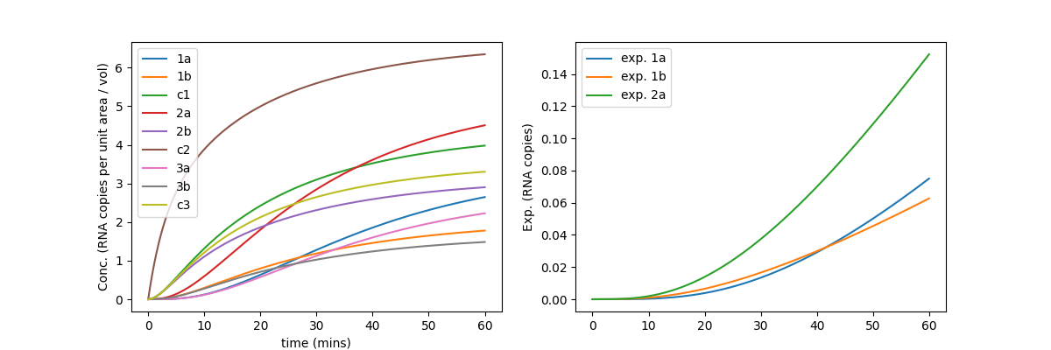

Plan
- Develop individual behavioural and respiratory simulations based on the DEVS framework
- For certain key scenarios, such as inpatient care settings, small shared spaces in occupational environments, public transport, develop R Shiny apps allowing users to assess impact of factors such as occupancy levels, individual behaviours and mitigation strategies upon transmission risk
- In partnership with Research Computing, develop and make publicly available a code library with which users can develop different scenarios, with different behavioural assumptions.

