**Mat345 Project 4**

* Your Name: Uijin Lee
* The programming language you used for the project: Python

1)

* printout of a resulting clustering for each k

Original K = 3 K = 4

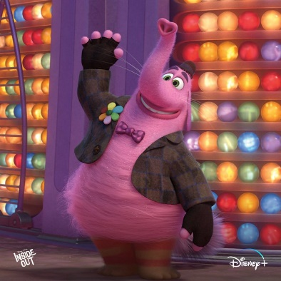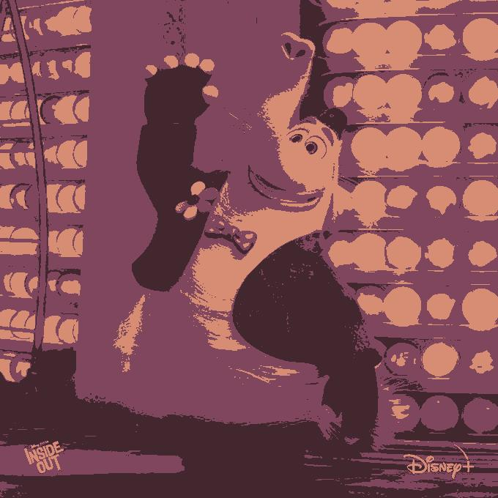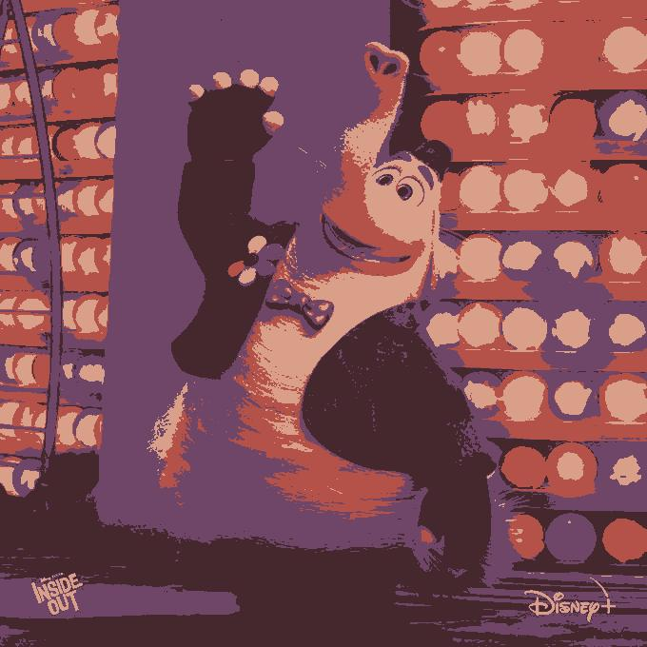

K = 5 K = 6 K = 7

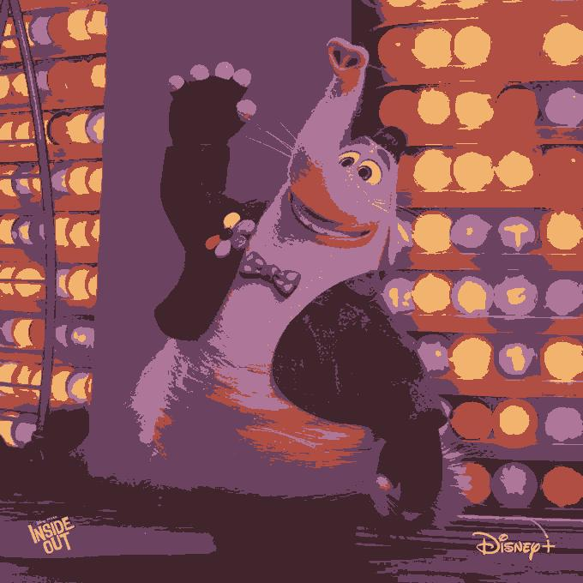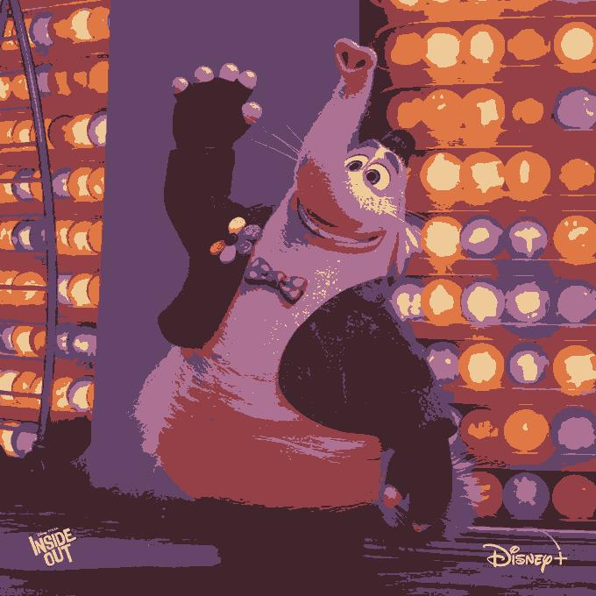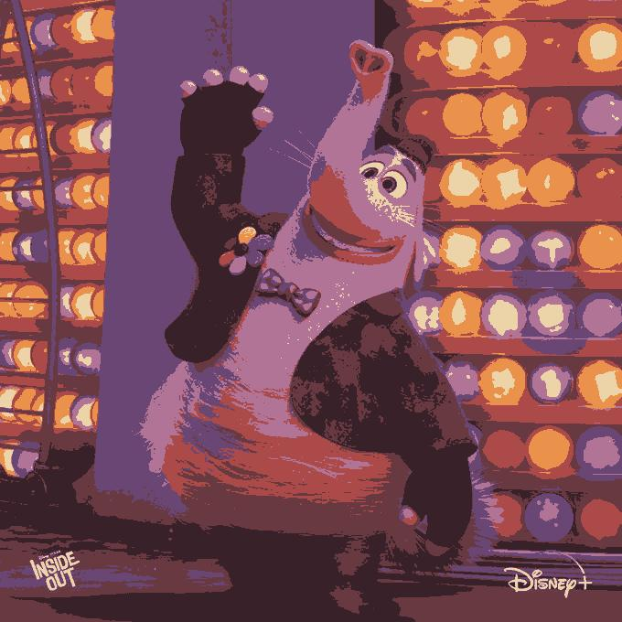

K = 8 K = 9 K = 10

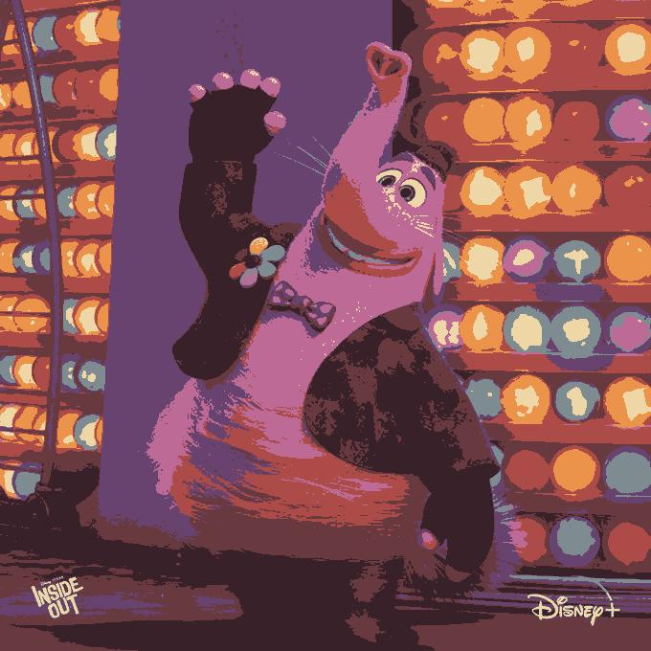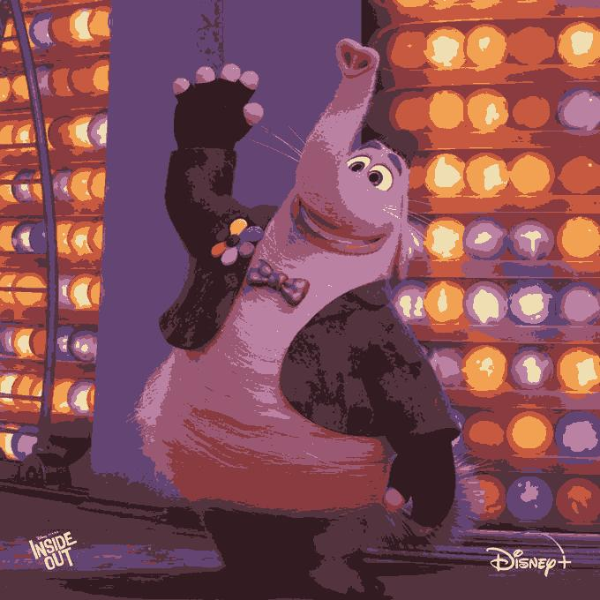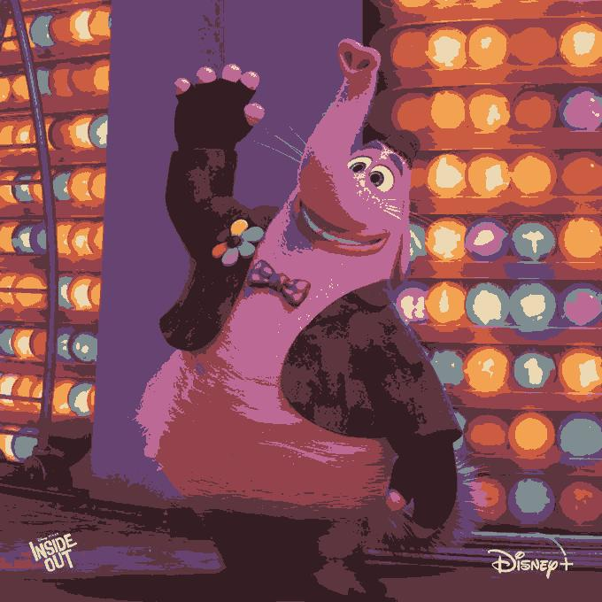

* best choice of k and explanation why

Comparing all the printed images with each k, I think k = 8 is the best. Of course, when k = 10, it has a more 3D effect, expresses light better, and produces more colors, but I think that even when K = 8, it also outputs images that show sufficient color and appropriate 3D effect.

* any relevant discussion of changes in output for specific choices of k, and when k varies

As K increases, more colors are output.

2)

* printout of a resulting clustering for each k

Original K = 3 K = 4

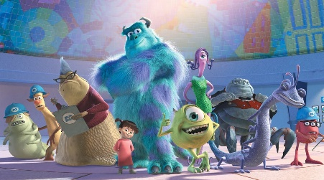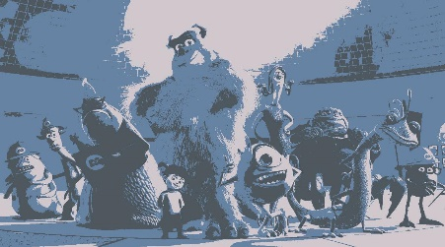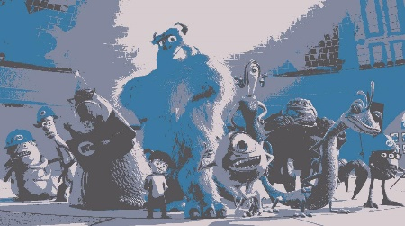

K = 5 K = 6 K = 7

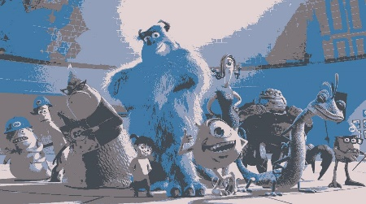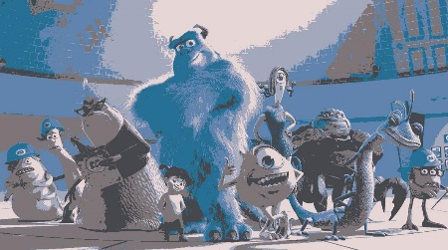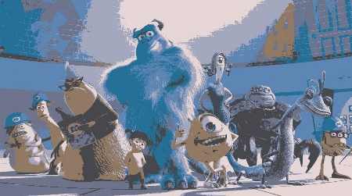

K = 8 K = 9 K = 10

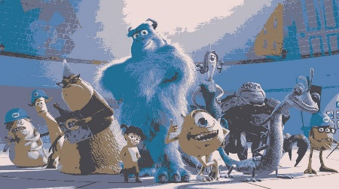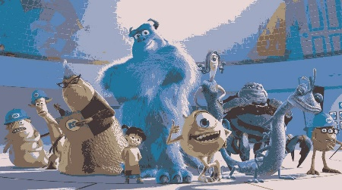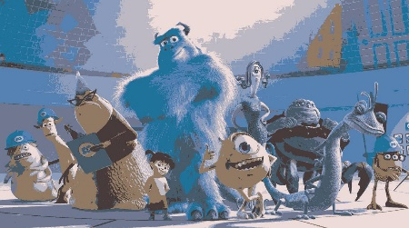

* best choice of k and explanation why

To be honest, I couldn’t output colors similar to the original image until k reached 10. So If I have to choose best choice of from k = 3 to k = 10, k = 10 seems to be the best choice. It didn’t output enough color, but compared to other ks, it seems to have better shading.

* any relevant discussion of changes in output for specific choices of k, and when k varies

The more color-contained image, the more k is required. When I printed this image(Monster Inc.), unlike the first(InsideOut) and third(Looney Tunes) images, even though I run the program with this image up to K = 10, it was still different from the original and printed out an extremely insufficient color. It could be concluded that the more color in the image, the more k is needed.

3) printout of a resulting clustering for each k

Original K = 3 K = 4

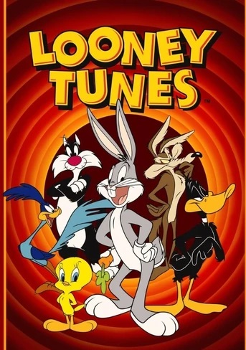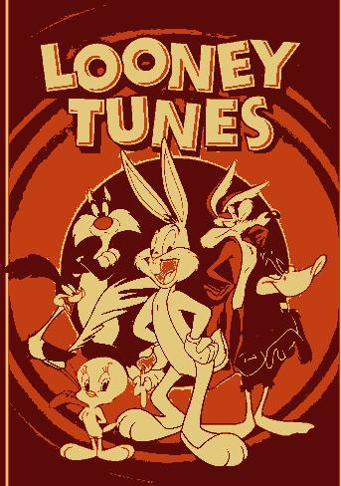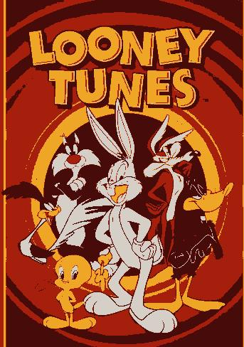

K = 5 K = 6 K = 7

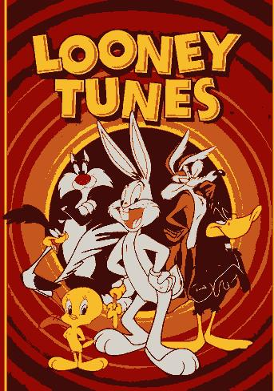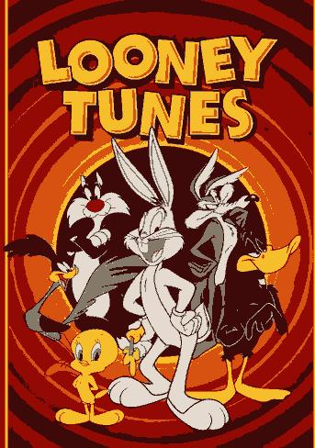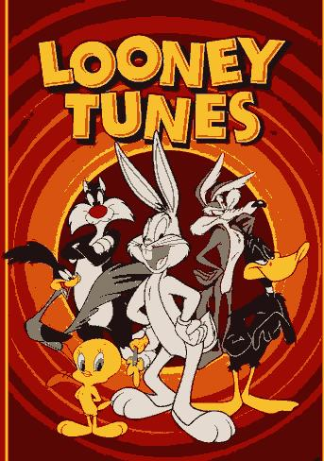

K = 8 K = 9 K = 10

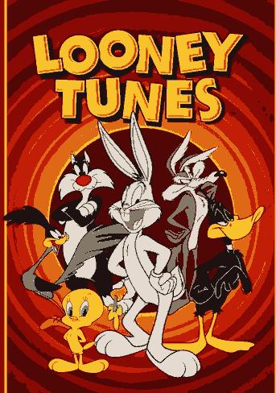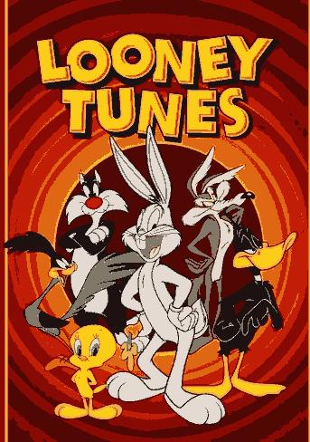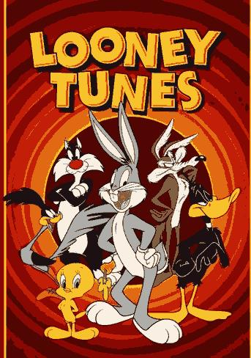

* best choice of k and explanation why

K = 10 is the best choice of k. Except for Bugs Bunny located in the middle, other characters have their own color clearly from k = 2, but Bugs Bunny does not have its own color gray until k = 10.

* any relevant discussion of changes in output for specific choices of k, and when k varies

Unlike the first(Inside Out) and second(Monster Inc.) images, this third(Looney Tunes) image is the only one that is not 3D and consists of flat characters. So, unlike other images that use shading to show a 3D effect even in areas that need one color, this Image doesn’t need shading, so even a small k can get a color similar to the original.