2022-2 Web service Development

22100579 LeeJinju

Test02- 0916

It is a program that plays an animation and shows a specific effect when the mouse is raised.

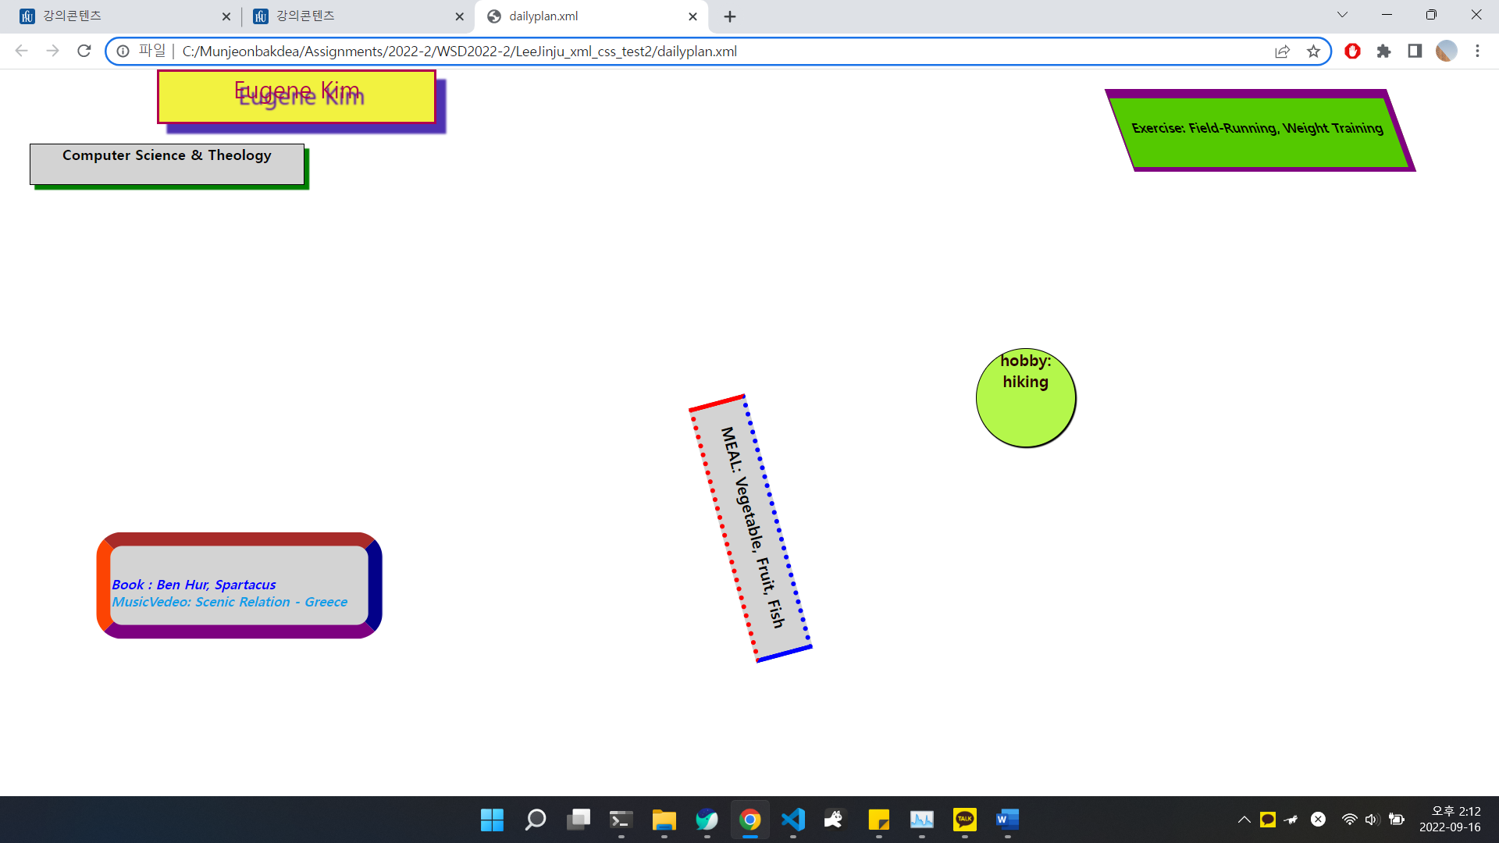

Default state

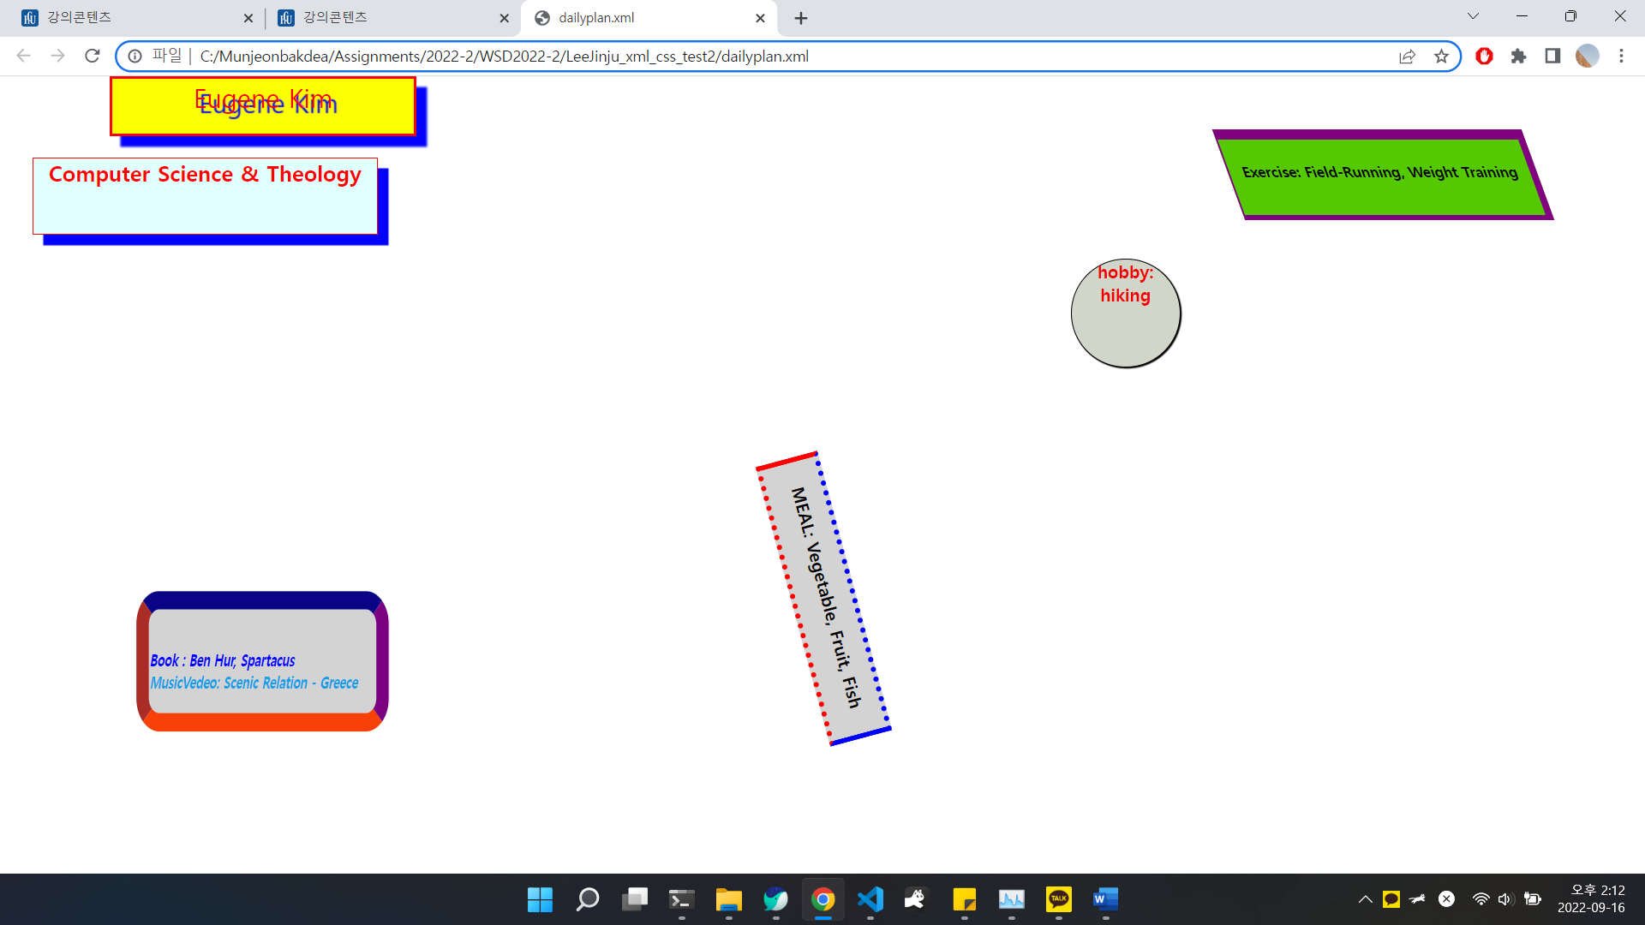

Image when you mouse over ‘myjor’

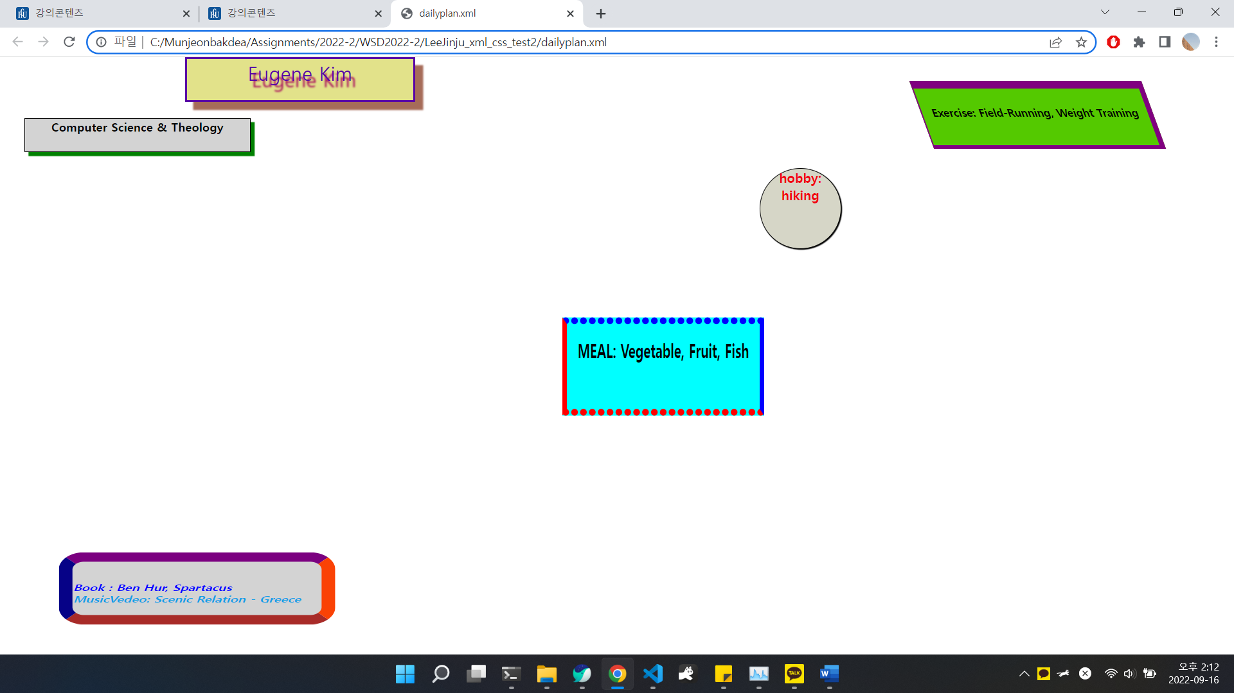

Image when you mouse over ‘meal’

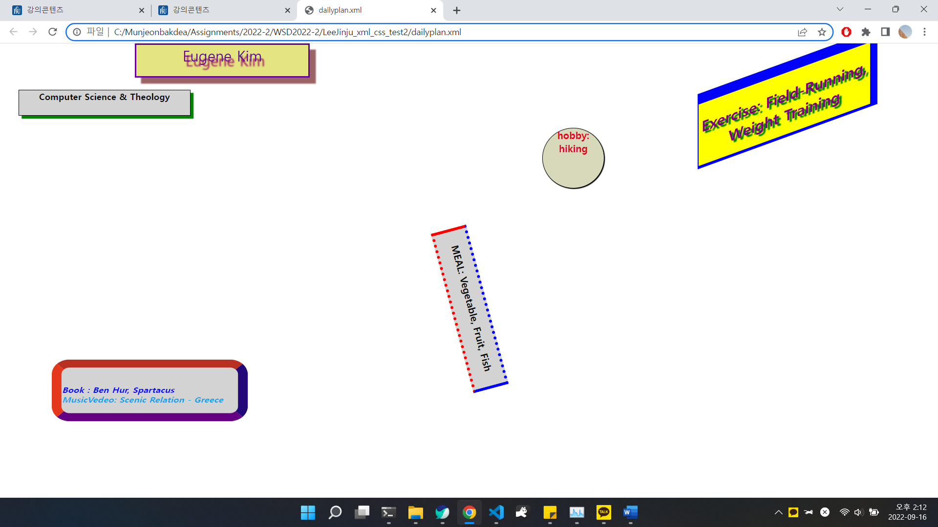

Image when you mouse over ‘Exercise’

I struggled with the layout of the images. It was solved using ‘relative’ position.

It was fun to practice various animations.