# **23-1 Database System Team Project1**

**21900156 김예준 / 22000796 함상훈 / 22100579 이진주**

**How to attack this problem?**

Our first step is to analyze the website, <https://kubic.handong.edu/>.

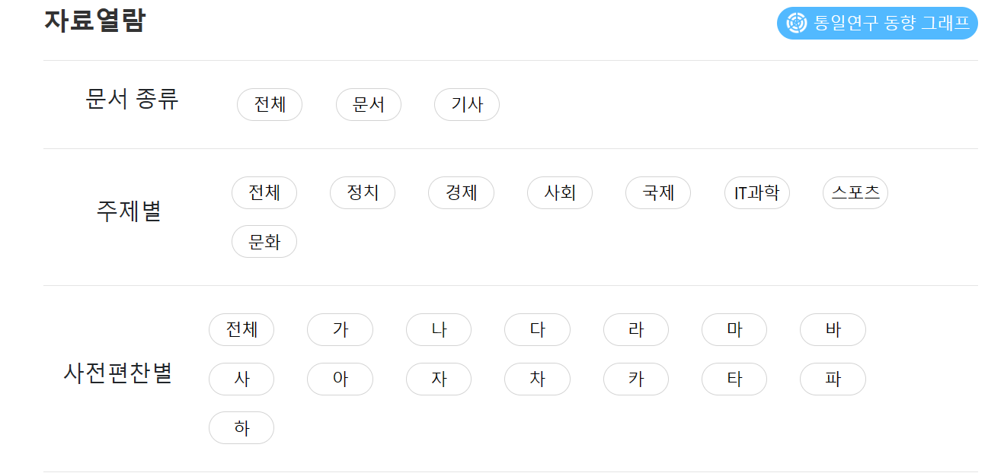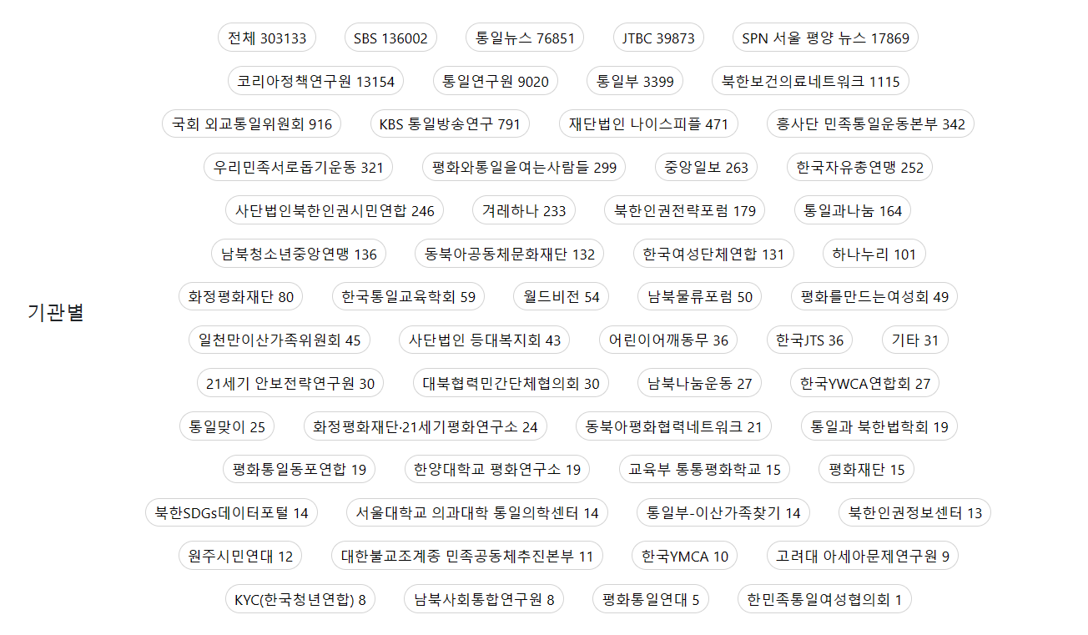

We are able to find attributes that allow us to find the document, such as doc_type, title, post,title,first_char, published_institution.

We do a search through the search bar, and we get results like the one in the following image.

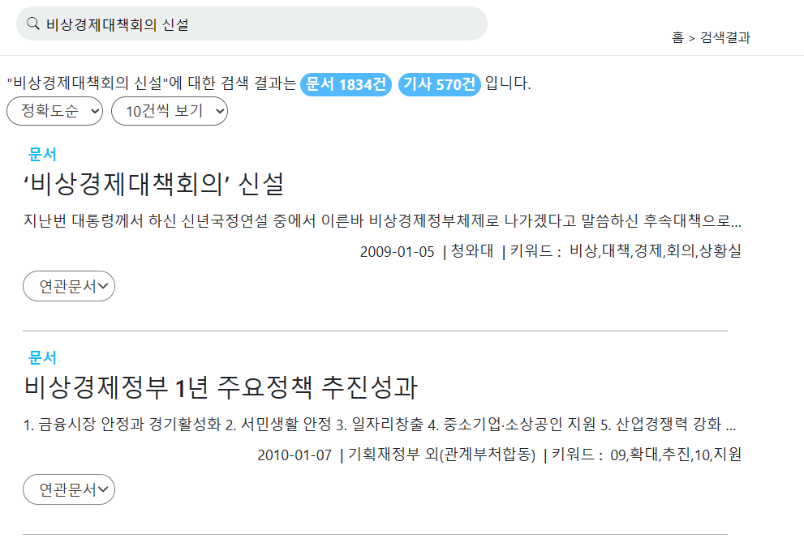

We were able to find attributes like post_title, post_date, post_writer, and abstract that make up the documents.

And if we click on the documentation and look closely, we can find attributes like published_institution, published_institutuion_url, original_url, post_body.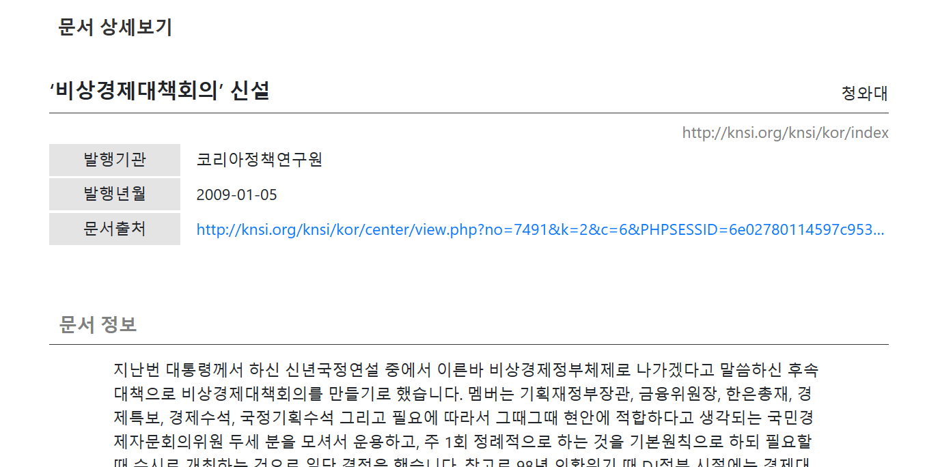When we sign up, it asks for the information such as occupation, institute, and email. The email also contains information about the name.

|  |  |
| --- | --- |
|  | |

When we look at the Announcements, FAQs, and Q&As in the Community tab, we find the following properties: docId, category, title, content, userName, regDate and content.

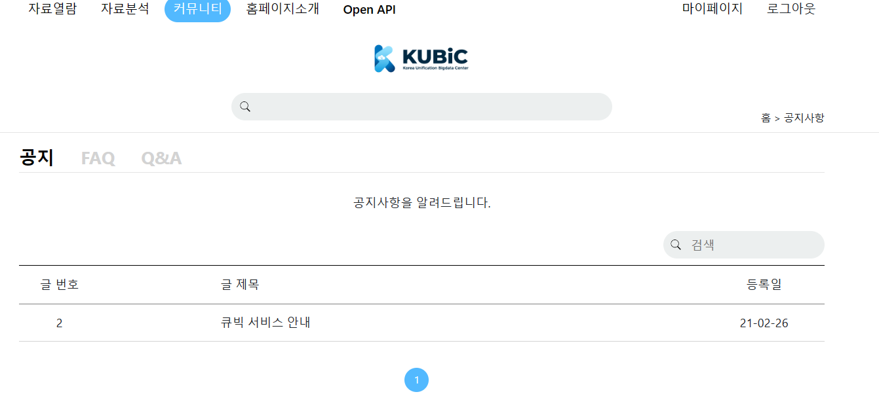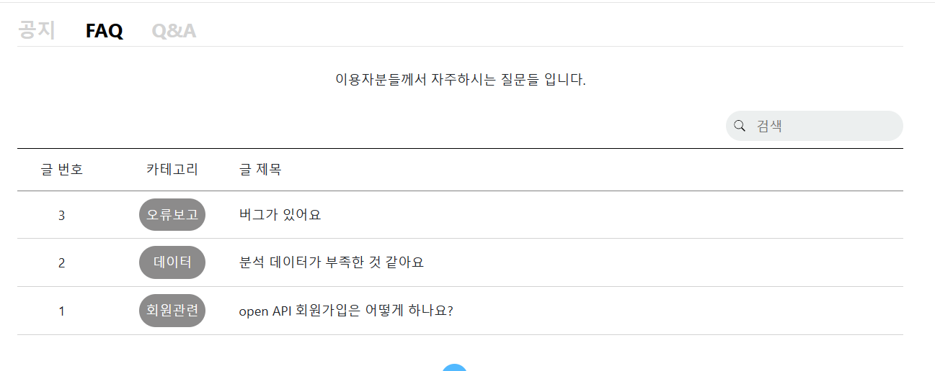

ff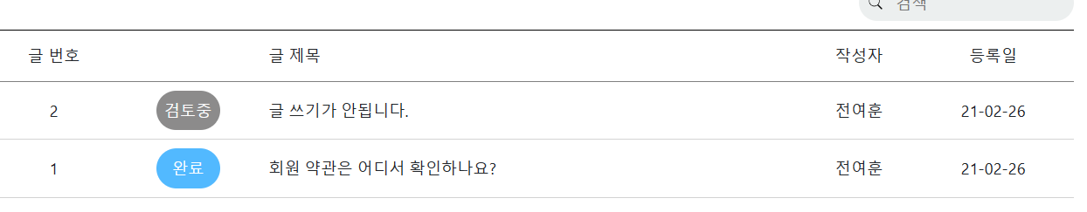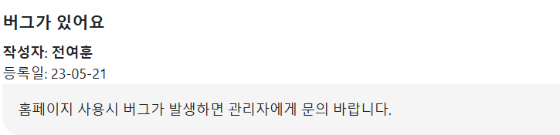

When we log in and search a document, we find the ability to save the document.



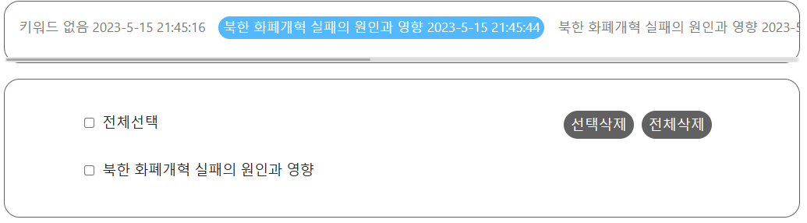

This shows us that to save the document use keyword, savedUser, and savedDocDate.

The second step is to find out if the attribute we haven't identified is associated with other attributes.After running the query and comparing the properties not found on the homepage.

Also, normalization principles were consulted to discover and reflect dependencies between columns.

According to the above steps, we are able to create the following table.

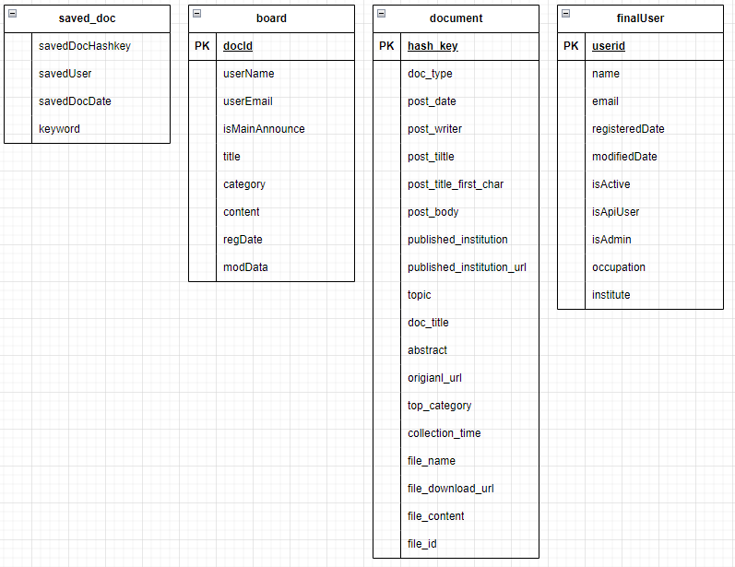

The next step is to find unnecessary duplicates.

We used various queries with ‘distinct’ to find duplicates like this.

| SELECT COUNT(DISTINCT [column name]) FROM [origin table]; |
| --- |

If the result of this kind of query is significantly less than the whole count, we made a new table for that column called ‘[column name]Mapping’.

The mapping tables consist of the de-duplicated target columns from the original table and the primary keys of smaller capacity (e.g., small int) assigned to each unique data of the columns . And the columns separated by the mapping from the origin table are replaced by the columns of the primary key of the mapping table. then, part of the size becomes like this example.

| origin table |  | origin table + mapping table |
| --- | --- | --- |
| 35000 * varchar(255) | > | 35000 * smallint + 100 * (smallint + varchar(255)) |

We expect the mapping table to minimize the size of the overlapping parts, making the overall data smaller.

Finally, we adjust whole data types and sizes. in the row data, there were many columns defined with non-efficient domain type.

We changed the domain to the most appropriate data type, taking into account the maximum length of the data and the diversity of each data length in each column.

For example, for strings with large length variation within 255 characters, we chose the 'VARCHAR' type. But for strings where all the data is 22 characters long, we chose 'CHAR'. For strings longer than 255 characters, we chose the 'MEDIUM TEXT' type.

| hello  haha! i am JJ  wanna go home……  welcome to HGU!  null  .  . | VARCHAR(255) |
| --- | --- |
| 21800156  22000796  22100579  .  . | CHAR(8) |

And for numeric data types, we chose 'TINY INT', 'SMALLINT', etc. as appropriate, considering the maximum value. We were pleasantly surprised at how much space this process could save.

| 0~255 | TINY INT |
| --- | --- |
| 255~65535 | SMALL INT |
| 65535~4294967295 | INT |

This is the final result of our effort.

**DDL Query**

| ***document*** |
| --- |
| create table document as  select doc_type, post_date, post_title, post_body, hash_key, doc_title, abstract, original_url, collection_time, file_name, file_download_url, file_content, file_id, post_title_first_char, topic, top_category, published_institution, post_writer from kubicdb  group by doc_type, post_date, post_title, post_body, hash_key, doc_title, abstract, original_url, collection_time, file_name, file_download_url, file_content, file_id, post_title_first_char, topic, top_category, published_institution, post_writer;  alter table document add docType_id tinyint;  alter table document add firstChar_id tinyint unsigned;  alter table document add topic_id tinyint;  alter table document add topCategory_id tinyint unsigned;  alter table document add pubInst_id tinyint;  alter table document add postWriter_id smallint;  alter table document modify post_data varchar(255);  alter table document modify post_title varchar(255);  alter table document modify post_body text;  alter table document modify doc_title varchar(255);  alter table document modify original_url text;  alter table document modify collection_time char(22);  alter table document modify file_name varchar(255);  alter table document modify file_download_url text;  alter table document modify file_content text;  alter table document modify file_id varchar(255);  #create a mapping table with them  alter table document drop doc_type;  alter table document drop post_title_first_char;  alter table document drop topic;  alter table document drop top_category;  alter table document drop published_institution;  alter table document drop post_writer;  alter table document add PRIMARY KEY document (hash_key);  alter table savedDoc add CONSTRAINT document_PostfirstCharMapping_firstChar_id_fk FOREIGN KEYS (firstChar_id) REFERENCES PostfirstCharMapping(firstChar_id);  alter table savedDoc add CONSTRAINT document_topicMapping_topic_id_fk FOREIGN KEYS (topic_id) REFERENCES topicMapping(topic_id);  alter table savedDoc add CONSTRAINT document_topCategoryMapping_topCategory_id_fk FOREIGN KEYS (topCategory_id) REFERENCES topCategoryMapping(topCategory_id);  alter table savedDoc add CONSTRAINT  document_pubInstitutionMapping_pubInst_id_fk FOREIGN KEYS (pubInst_id) REFERENCES pubInstitutionMapping(pubInst_id);  alter table savedDoc add CONSTRAINT  document_postWriterMapping_postWriter_id_fk FOREIGN KEYS (postWriter_id) REFERENCES postWriterMapping(postWriter_id); |

| ***savedDoc*** |
| --- |
| create table savedDoc as  select keyword, savedUser, savedDocDate, savedDocHashKey from kubicdb  group by keyword, savedUser, savedDocDate, savedDocHashKey;  alter table savedDoc add key_id tinyint;  alter table savedDoc add eid tinyint;  alter table savedDoc add savedDocs_id tinyint;  alter table savedDoc add PRIMARY KEY savedDoc (eid, key_id, savedDocs_id);  alter table savedDoc add CONSTRAINT savedDoc_keyword_mapping_key_id_fk FOREIGN KEYS (key_id) REFERENCES keyword_mapping(key_id);  alter table savedDoc add CONSTRAINT savedDoc_finalUser_eid_fk FOREIGN KEYS (eid) REFERENCES finalUser(eid);  alter table savedDoc add CONSTRAINT savedDoc_savedDocsMapping_savedDocs_id_fk FOREIGN KEYS (savedDocs_id) REFERENCES savedDocsMapping(savedDocs_id);  #create a mapping table with them  alter table savedDoc drop keyword;  alter table savedDoc drop savedUser;  alter table savedDoc drop savedDocDate;  alter table savedDoc drop savedDocHashKey; |

| ***finalUser*** |
| --- |
| create table finalUser as  select distinct userId, name, email, institute, occupation, registeredDate, modifiedDate, isActive, isApiUser, isAdmin  from kubicdb  where userId is not null  group by userId, name, email, institute, occupation, registeredDate, modifiedDate, isActive, isApiUser, isAdmin;  alter table finalUser add eid tinyint;  alter table finalUser add occu_id tinyint;  alter table finalUser add inst_id tinyint;  alter table finalUser add PRIMARY KEY finalUser(eid);  alter table finalUser add CONSTRAINT finalUser_occupationMapping_occu_id_fk FOREIGN KEYS (occu_id) REFERENCES occupationMapping(occu_id);  alter table finalUser add CONSTRAINT finalUser_instituteMapping_inst_id_fk FOREIGN KEYS (inst_id) REFERENCES instituteMapping(inst_id);  #create a mapping table with them  alter table finalUser drop email;  alter table finalUser drop occupation;  alter table finalUser drop institute;  alter table finalUser modify userId char(24);  alter table finalUser modify name varchar(23);  alter table finalUser modify registeredDate bigint;  alter table finalUser modify modifiedDate bigint;  alter table finalUser modify isActive tinyint;  alter table finalUser modify isApiUser tinyint;  alter table finalUser modify isAdmin tinyint; |

| ***board*** |
| --- |
| create table board as  select title, content, userName, userEmail, isMainAnnounce, regDate, modDate, docId, category  from kubicdb  where docId is not null  group by title, content, userName, userEmail, userEmail, isMainAnnounce, regDate, modDate, docId, category;  alter table board add eid tinyint;  #create a mapping table with them  alter table board drop userName;  alter table board drop userEmail;  alter table board modify title varchar(255);  alter table board modify content varchar(255);  alter table board modify isMainAnnounce tinyint;  alter table board modify regDate bigint;  alter table board modify modDate bigint;  alter table board modify docId tinyint;  alter table board modify category varchar(255);  alter table board add PRIMARY KEY board(docId);  alter table board add CONSTRAINT board_emailMapping_eid_fk FOREIGN KEYS (eid) REFERENCES emailMapping(eid); |

| ***doc_type_mapping*** |
| --- |
| create table doc_type_mapping(  docType_id tinyint primary key auto_increment,  doc_type char(5)  ); |

| ***emailMapping*** |
| --- |
| create table emailMapping(  eid tinyint primary key auto_increment,  email varchar(255)  ); |

| ***instituteMapping*** |
| --- |
| create table instituteMapping(  inst_id tinyint primary key auto_increment,  institute varchar(100)  ); |

| ***keyword_mapping*** |
| --- |
| create table keyword_mapping(  key_id tinyint primary key auto_increment,  keyword varchar(5)  ); |

| ***occupationMapping*** |
| --- |
| create table occupationMapping(  occu_id tinyint primary key auto_increment,  occupation varchar(255)  ); |

| ***PostfirstCharMapping*** |
| --- |
| create table PostfirstCharMapping(  firstChar_id tinyint unsigned primary key auto_increment,  post_title_first_char(1)  ); |

| ***postWriterMapping*** |
| --- |
| create table postWriterMapping(  postWrite_id smallint primary key auto_increment,  post_writer varchar(255)  ); |

| ***pubInstitutionMapping*** |
| --- |
| create table pubInstitutionMapping(  pubIinst_id tinyintprimary key auto_increment,  published_institution varchar(255),  published_institution_url varchar(255)  ); |

| ***savedDocsMapping*** |
| --- |
| create table savedDocsMapping(  savedDocs_id tinyint primary key auto_increment,  savedDocDate date,  savedDocHashKey char(20)  ); |

| ***topCategoryMapping*** |
| --- |
| create table topCategoryMapping(  topCategoty_id tinyint unsigned primary key auto_increment,  top_category varchar(255)  ); |

| ***topicMapping*** |
| --- |
| create table topicMapping(  topic_id tinyint primary key auto_increment,  topic varchar(255)  ); |

**Result for View instruction**

. ***#1. total_volume***

| create view total_volume as  SELECT table_schema AS 'DB16',  ROUND(SUM(data_length+index_length)/1024, 1) AS 'Size(KB)'  FROM information_schema.tables  WHERE table_schema = 'DB16'  AND TABLE_NAME <> 'kubicdb'; |
| --- |
|  |

***#2. userCount***

| create view userCount as  select COUNT(*) from finalUser; |
| --- |
|  |

***#3. boardCount***

| create view boardCount as  select COUNT(*) from board; |
| --- |
|  |

***#4. docCount***

| create view docCount as  select COUNT(*) from document; |
| --- |
|  |

***#5. instInfo***

| create view instInfo as  select published_institution, count(published_institution) as CNT from document d join pubInstitutionMapping p on d.pubInst_id = p.pubInst_id  group by published_institution  order by count(published_institution) asc; |
| --- |
|  |

***#6. my_docs_2019_keyword_count***

| create view my_docs_2019_keyword_count as  select keyword, count(keyword) as keyword_count from savedDoc d  join keyword_mapping k on d.key_id = k.key_id  join DB16.savedDocsMapping sDM on d.savedDocs_id = sDM.savedDocs_id  where savedDocDate like '2019%'  group by keyword  order by count(keyword) desc; |
| --- |
|  |

***#7. policy_writer_count***

| create view policy_writer_count as  select post_writer, count(post_writer) as data_count from document d  left join postWriterMapping pWM on d.postWriter_id = pWM.postWriter_id  left join savedDocsMapping sDM on d.hash_key = sDM.savedDocHashKey  left join savedDoc sD on sD.savedDocs_id = sDM.savedDocs_id  left join keyword_mapping k on sD.key_id = k.key_id  where keyword = '토론'  group by post_writer  order by count(post_writer) desc; |
| --- |
|  |

***#8. inst_data_max_status***

| create view inst_data_max_status as  with users(eid, institute, occupation) as (  select f.eid, institute, occupation from finalUser f  join instituteMapping iM on f.inst_id = iM.inst_id  join occupationMapping oM on f.occu_id = oM.occu_id  )  select institute,  (select occupation from users  where institute = u.institute  group by occupation  order by count(occupation) desc  limit 1) as max_status,  (select count(sD.savedDocs_id)  from savedDoc sD  left join users us on sD.eid = us.eid  left join occupationMapping o on us.occupation = o.occupation  where sD.eid = us.eid and us.institute = u.institute and us.occupation = (  select occupation from users  where institute = u.institute  group by occupation  order by count(occupation) desc  limit 1)) as max_status_count,  (select count(sD.savedDocs_id)  from savedDoc sD left join users us on sD.eid = us.eid  where sD.eid = us.eid and us.institute = u.institute) as data_count  from users u  left join savedDoc sD on u.eid = sD.eid  group by institute  order by count(institute) desc; |
| --- |
|  |

***#9. checkDoc***

| create view checkDoc as  select post_title, post_writer, published_institution, post_date, top_category from document d  left join postWriterMapping pWM on d.postWriter_id = pWM.postWriter_id  left join pubInstitutionMapping pIM on d.pubInst_id = pIM.pubInst_id  left join topCategoryMapping tCM on d.topCategory_id = tCM.topCategory_id  order by post_date desc  limit 5; |
| --- |
|  |

***#10. category_Count***

| create view category_Count as  select top_category, count(top_category) as category_count, rank() over (order by count(top_category) desc) as category_rank  from document d  left join topCategoryMapping tCM on d.topCategory_id = tCM.topCategory_id  group by top_category  order by count(top_category) desc; |
| --- |
|  |

**ER-diagram**

|  |
| --- |

This is the ER-Diagram we draw.

**Summary of the database size and table sizes**

* database size is 216160.0 KB
* table sizes are below image
* 