# RMI Distributed Agenda Service

We build a distributed shared agenda service using Java RMI.There are 1 server and 3 clients. The RMI server ip is 59.77.236.15 and port number is 6060. Various clients should be able to connect to the shared agenda to query, add, and delete meetings. The server should also have management functionality that allows registration and clearing meetings.

Next, we will achieve the following functions, including 5 operations.

**1、Start RMI Server.**

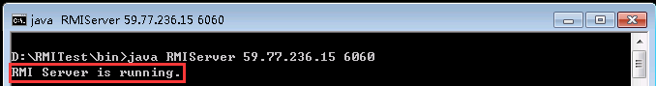

**2、Start RMI Client**

**(1)Register Meetings**

We register 3 users in 3 different clients.

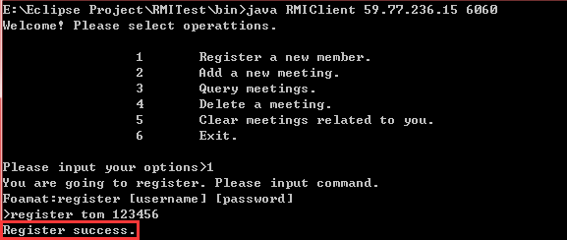

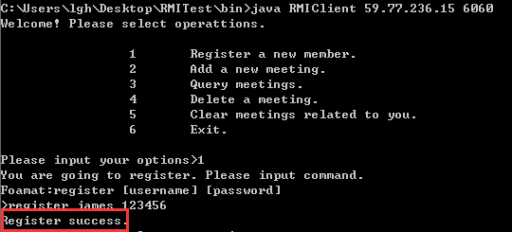

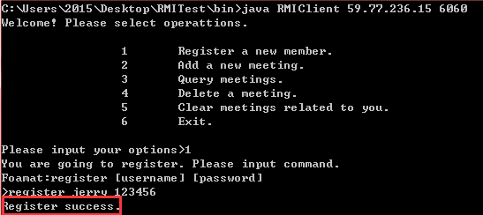

We can see there are 3 clients register success.

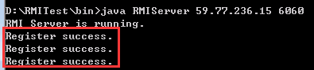

**(2)Add Meetings**

We add 2 meetings, one meeting is called between jerry and james.and the start time is 2017-01-01-08-30,end time is 2017-01-01-12-00,and titile is RMI.And the other meeting is called between tom and james,and the start time is 2016-12-30-09-00,end time is 2016-12-30-15-00,and titile is RMI.

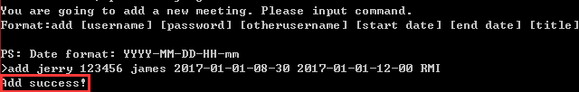

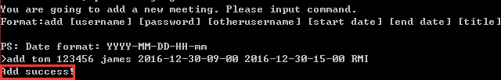

**(3)Query Meetings**

We query meeting from 2017-01-01-08-30 to 2017-01-02-08-30,we can see the results as follow.

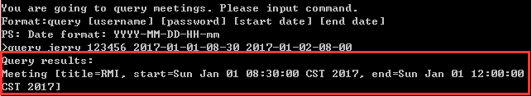

**(4)Deleting Meetings**

We delete a meeting which is created by jerry and the meeting id is 1.

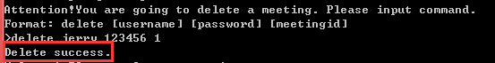

**(5)Clearing Meetings**

