

UNIVERSITI TUNKU ABDUL RAHMAN
FACULTY OF INFORMATION & COMMUNICATION TECHNOLOGY (KAMPAR CAMPUS)

FINAL YEAR PROJECT II (FYP II)

INFORMATION BOOKLET

Prepared by FYP Committee

*Version 26 October 2025
*Note: Please always refer to the most updated version

Table of Contents

1 INTRODUCTION……………………………………………………………………………………………………… 4
1.1 Selection of Project Area and Project Proposal………………................................. 4
1.2 General Classification of Final Year Project…………………………………………………... 5
1.3 Research-Based Projects …………………………………………………………………………. 5
1.4 Developed-Based Projects……………………………………………………………………………. 6
1.5 Combining Project Categories………………………………………………………………………. 6

2 PITFALLS AND PROBLEMS………………………………………………………………..…………………….. 6

3 PROJECT REPORT CONTENTS AND ARRANGEMENT……………………..………………………… 7
3.1 Report Contents and Arrangement Guidelines for Project II………..………………... 7
3.2 Poster Content and Arrangement Guidelines for Project II …………………………... 11
3.3 FYP2 Submission Form for Project II………………………………………………………………. 11

4 PROJECT REPORT FORMAT…………………………………………………………………………..……….. 12
4.1 Report Format for Project II……………………………………………………..………………….. 12
4.2 Other Points to Note on Writing Report……………………………………..……………….. 13

5 VIVA: ORAL PRESENTATION AND PRODUCT DEMONSTRATION…………………..………... 14

6 FYP GUIDELINES FOR SUPERVISOR AND MODERATORS…………………………………………. 15

APPENDICES……………………………………………………………………………………………..………………….. 16
Appendix A: Report Front Cover………………………………………………………………………….. A-1
Appendix B: Sample of Report Arrangement………………………………..…………………….. B-1
Appendix C: IEEE Style Referencing………………………………………..…………………………… C-1
Appendix D: FYP2 Submission Form ……………………………………………………………………. D-1
Important Notice to All Students

Plagiarism is a serious offence. Copy and paste for the report content is prohibited.

You must sign the report submission declaration to confirm that your FYP report has been done by your own efforts without any plagiarism.

Please report any error found in this document to FICT DD of R&D directly or through your supervisor

1 Introduction

Every UTAR student undertaking a degree program in FICT is required to complete a project under the supervision of a FICT (Kampar) academic staff or an external supervisor from the industry. In the case whereby an external supervisor is appointed, a FICT (Kampar) staff shall be appointed as a co-supervisor for the student. The project should provide student with the opportunity to bring together the academic knowledge and skills acquired from the range of modules already studied. In general, the whole project can be divided into three parts, namely Introduction to Inventive Problem Solving and Proposal Writing (IIPSPW), Project I and Project II, which are to be completed by Year 3.

Although students are required to take the modules starting from Year 2 semester 2 or 3, they are encouraged to explore the areas of interest, identify the project supervisors and define a project topic if possible, as early as the first semester of Year 2. The detailed planning of the project is described in the following sections.

The objectives of Project II:
[1] To encourage students to demonstrate their technical skills and put in practice their experiences and knowledge.
[2] To provide an opportunity for students to highlight and realize in projects, their grasp of interdisciplinary knowledge, including business domain knowledge.
[3] To provide an opportunity for students to further their research, in their discipline and that of the industry, and report their findings appropriately.
[4] To provide an avenue for students to document and showcase their project, e.g. to potential employers.

The learning outcomes of Project II:
After completing this unit, students will be able to:
[1] Review and re-evaluate the project scope, objectives, and project plan proposed in Project I.
[2] Compile and perform literature and technical review for the project.
[3] Formulate project requirements into specifications or models.
[4] Analyze the specifications or models and select suitable tools or methods for project development.
[5] Develop a system or theorem based on the stated specifications or models.
[6] Evaluate the system or prove the theorem.
[7] Write a formal report for project outcomes.
[8] Present or demonstrate the project results.

Generally, all projects will involve elements of preliminary investigation, project design, realization of design and evaluation.

1.1 Selection of Project Area and Project Proposal

Students who have taken FYP1 and wish to change supervisors when enrolling in FYP II may do so subjected to the agreements of the FYP1 supervisor, the new supervisor for supervising FYP II projects and the FYP committee. (Please contact the Deputy Dean of R&D who chairs the FYP committee)
Students who have completed their FYP I should not change their project completely, for example, from an Android application development to a Webpage development. However, students can change their project title; for instance, the original project is about developing a retail POS system, and need to add or reduce the objectives or scope of the project due to additional modules can enhance the system or to reduce the size of the project. The change of project title at this stage is mainly to better describe the project objectives.

1.2 General Classification of Final Year Project

The following is a guide and framework for setting up and running your project. There are two broad categories:

- Research-Based projects.
- Development-based projects.

These categories are merely a guide to help students design their projects. While most projects will fit neatly into one of these two categories; some projects may have characteristics of both of these categories. It is important for students to recognise what project category that their project might fit into so as to enable them to address the relevant learning outcomes and requirements in which will help defining clear and concise project objectives.

1.3 Research- Based Projects

Research-based projects are undertaken to investigate a research question. A research-based project must contain a research contribution from the student, for example, the development of a model or the design of an algorithm towards analysing/solving a problem. A research project might include data gathering; however, the gathering of data in itself does not constitute an acceptable level of research effort by the student. Rather some rigorous analysis of the data and/or the development of some deliverable based on the data are required.

The deliverable should have the potential for further research used by a third party, for example the supervisor, an external body or other stakeholders in the project. Furthermore, research-based project must be designed so that it is clear of what factors affect the validity and generalization of the results.

In developing Research-based projects, your proposal should state:

- The research question to be addressed.
- Any research initiative or project that your project is a part of.
- The research methods and tools to be used.
- How you will judge the validity and generality of your results.
- In what ways the project may contribute to related research activities.

For research-based project, please refer to Research-based survey FYP(Guidelines for students).pdf in Guidelines folder in FYP portal.

1.4 Development-based Projects

These types of projects involve design and construction of a prototype for an application that can be in the form of hardware or software or a mixed hardware/software. The design and construction must be non-trivial. The development should follow an established hardware/software engineering method. In exceptional cases, students are permitted to do projects that involve analysis and design without a construction. The outcome of such project should provide sufficient information for implementation by a third party in the future. Alternatively, a formal theory may be built, and its soundness and application are demonstrated. The following should be stated for Development-based projects:

- The purpose of the hardware/software.
- In what way the project is novel.
- What theory (if any) underpins the project.
- Applicable hardware/software engineering methods.
- What tools will be used, so far as decided.
- Methods envisaged for testing and evaluating the hardware/software.
- How the complexity of the work merits it being a final year project.

1.5 Combining Project Categories

For projects that do not fit neatly into one of the two project categories, the union of the respective lists of details must be clearly stated in the proposal.

2 Pitfalls and Problems

The final year project will be a demanding but exciting learning experience. However, it is not without problems, if not identified and addressed, could seriously affect the final result and ultimately reduce your grade. This section addresses some of these problems and provides tips on how to avoid them.

a. The “Overachiever” Problem. A common problem is selecting a topic that is far too ambitious for the allotted time. Remember that you have only 12-13 weeks to finish the coding, debugging, and testing. Be careful not to select a topic that is unrealistically large. This can lead to frustration as well as errors caused by “cutting corners” and hurrying through the implementation. Discuss with your supervisor the scale of what you are planning. If he or she thinks it may be too large, consider implementing the project in stages, and complete the project stage by stage. When one stage is working, then move on to the next stage. If you cannot complete the project, you will still have a functioning system.

b. The “Do It Tomorrow” Problem. Thirteen weeks sounds like a long time, but it goes by quickly. You need an implementation schedule that allocates reasonable amounts of work throughout the entire semester. Then you must stick to that schedule. Don’t be tempted to postpone work on the project because week 13 seems so far off. All that happens is that during the final few weeks you rush madly to get something working, and software implemented in a rush rarely works correctly!
REMEMBER: Four marks will be deducted for all late submission.

c. The “Sleeping Member” Problem. In the ideal world, all team members have equal ability, equal interest in the problem, and work equally hard. This may not happen in the real world. You may have one or more team members who do not carry their share of the workload, not because of a lack of ability, but rather lack of interest or motivation. This is a serious problem because, although part of your grade is based on each individual’s effort, another part is based on successfully finishing the project. A non-contributing team member can slow down or prevent completion of the work. If you have a teammate who is not doing his or her share of the work, talk to them and stress the importance of everyone’s role. If this does not solve the problem then talk to your supervisor. Do not let the failure of others prevent you from completing the work and receiving a good grade.

d. The “Poop Out At The End” Problem. You have worked hard for 13 weeks to complete this project. You have spent many late nights and caught hundreds of bugs, and the program is working, so are you done? Absolutely not! The project grade is not based only on the programs you developed but also on your written reports and oral presentations. Remember that even though you may be ‘burned out” from implementation, there is still work to be done. Do not produce a poorly written document or give a poorly organized presentation. That will negate much of your good work. Put in the time needed to prepare both a well written, high-quality final report and a well organized, polished presentation. In fact, you should write your project document starting on the first day. The project document is the blueprint of your project, so you should write the document before implementing your project. A good job on these last steps will insure that you receive a grade that fairly represents the work you have done.

3 Project Report Contents and Arrangement

Students should not copy large sections of books and/or reports. By copying, the change in writing style and the way information is presented can be easily detected. Students will be penalised for copying. Whenever values of short passages have been quoted, the full reference should be given. Students will be penalised for not referencing previous work.

Report Contents and Arrangement Guidelines for Project II

The essential components of the content of the final year project report should include the items listed below. They should also be arranged in the top-down order as listed. The report should comprise between 8,000 – 20,000 words. Please follow/copy the report writing example in Appendix C. Report with incorrect format can get 5 mark (1 grade) reduction.

Item No. | Arrangement of the Report | Content
 | Front Cover | Please refer to Appendix A for the report format.  The format (font type, size, capitalization and the sentences arrangement) must be strictly adhered to. No changes to the report format are allowed.
 | Title Page | 1 page. Refer to Appendix B.
 | Copyright Statement | 1 page. Refer to Appendix B.
 | Acknowledgements | 1 page. Refer to Appendix B.
 | Abstract | Maximum 1 page. Usually it is limited to between 150 and 300 words. Refer to Appendix B. It should states the field of study, problem definition, methodology and techniques adopted, research process, results obtained and conclusion of the project work. Highlight the novelties if there is any. State the area of study (Minimum 1, Maximum 2) and the keywords( Minimum 5 , Maximum 10)
 | Table of Contents | Refer to Appendix B. It should list all the chapters and their corresponding sections and subsections found in the report.
 | List of Figures | Refer to Appendix B. It should list all the figures and their corresponding page numbers found in the report.
 | List of Tables | Refer to Appendix B. It should list all the tables and their corresponding page numbers found in the report.
 | List of Symbols | Refer to Appendix B. It should list all the symbols found in the report and their corresponding meanings.
 | List of Abbreviations | Refer to Appendix B. It should list all the abbreviations found in the report and their corresponding meanings.
 | Chapters | Each chapter should begin on a new page. Within a chapter, separate the information pertaining to the chapter into sections and subsections. Subsection is limited to 3 levels only. The following is a general guideline on the arrangement of chapters and what to be included as part of each chapter, i.e. different supervisors might change the requirements and format as they see fit.  Chapter 1: Introduction (5 to 10 pages)  1.1 Problem Statement and Motivation  1.2 Objectives  1.3 Project Scope  1.4 Contributions  1.5 Report Organization  - Pls refer to the FYP2 Report Template in the UTAR FYP portal  Chapter 2: Literature Review (5 to 30 pages)  2.1 Review of the Technologies  2.1.1 Hardware Platform  2.1.2 Firmware/OS  2.1.3 Database  2.1.4 Programming Language  2.1.5 Algorithm  2.1.6 Summary of the Technologies Review  2.2 Review of the Existing Systems/Applications  2.2.1 Existing System A  2.2.2 Existing System B  2.2.3 Existing System C  2.2.4 Existing System D  2.2.5 Summary of the Existing Systems  - Pls refer to the FYP2 Report Template in the UTAR FYP portal  Chapter 3 :System Methodology/Approach  (For Development- Based Project)  System Model (For Research-Based Project)  3.1 System Design Diagram/Equation  3.1.1 System Architecture Diagram  3.1.2 Use Case Diagram and Description  3.1.3 Activity Diagram  - Pls refer to the FYP2 Report Template in the UTAR FYP portal  Chapter 4: System Design (5 to 30 pages)  4.1 System Block Diagram  4.2 System Components Specifications  4.3 Circuits and Components Design  4.4 System Components Interaction Operations  All development projects should have this chapter. This chapter describes in detail how the project is developed. One thing to keep in mind when writing this chapter is to provide all the necessary information for someone who reads this chapter could rebuild your system.  Give top-down system design diagrams (i.e. system flowchart, design block diagram, etc.). Explain what is the functionality (and any other detail) of each block in diagrams.  For example, if your project is about writing an Android application for time management, then you should mention about the system flow diagram, how your program is written, such as the classes and methods used in the program, the database for keeping information, such as the SQL for creating the database, how to compile the program, and how to upload the program to a phone.  Another example is if you are building a moving robot, then you should mention how the physical robot is built, the parts or components required, mention about the design of your program that controls the robot, how to program the microcontroller, such as the steps to compile and upload the program to the microcontroller, how the sensors, servos, wires are connected, provide a schematic diagram that illustrates the connection of all the components, and how to operate the robot.  - Pls refer to your supervisor regarding your sub-topics, above is just a guideline.  Chapter 5 System Implementation (For Development- Based Project)  Experiment/Simulation (For Research- Based Project)  5.1 Hardware Setup  5.2 Software Setup  5.3 Setting and Configuration  5.4 System Operation (with Screenshot)  5.5 Implementation Issues and Challenges  5.6 Concluding Remark  - Pls refer to your supervisor regarding your sub-topics, above is just a guideline.  Chapter 6 :System Evaluation And Discussion  6.1 System Testing and Performance Metrics  6.2 Testing Setup and Result  6.3 Project Challenges  6.4 Objectives Evaluation  6.5 Concluding Remark  - Pls refer to your supervisor regarding your sub-topics, above is just a guideline  Chapter 7: Conclusion and Recommendation (2 to 5 pages)  7.1 Conclusion  7.2 Recommendation  - Pls refer to your supervisor regarding your sub-topics, above is just a guideline
 | References | Refer to Appendix C. It should list all the reference materials used for the project. (10 to 60 references)
 | Appendices | The appendices are supplementary materials that are too lengthy to be included or may not suite well in the main part of your document.  The following is a guideline on the arrangement of appendices and what may be included as part of the appendices.  - Specifications, data sheets and drawings of equipment or components used.  - Data used for analysis.  - Survey sheets.  - Charts and data tables.  - Lengthy mathematical derivations.  - etc.
 | Poster | See description in section 3.2.
Remark:
* Please ensure that all highlighted text in your report, particularly in the Copyright Statement form and Abstract, is properly edited to reflect your own information. After making the necessary changes, you must remove all yellow highlighting before submitting your report. Highlighted text is only provided as a guide and should not appear in the final version of your submission.

3.2 Poster Content and Arrangement Guidelines for Project II

The essential components of the content of the poster report should include the items listed as follow:

Item No. | Poster Presentation | Content
1 | Size | A4 paper
2 | Font | Use contrasting fonts for the title, text and figure legends. (Ensure the font size used are large enough)
3 | Required Elements | - You may use photos, figures, and table  - Determine a logical sequence for the material you will be presenting.  - Organize that material into sections, e.g.,  - FYP2: Introduction, Methods (may use flowchart or block diagram), Results, Discussion, and Conclusions.  - Arrange the material into columns.
4 | File Type | Softcopy, save the softcopy in any of the following format: JPEG / TIFF / BMP / EPS.
5 | See poster examples at FICT FYP web site, https://fypfict.utar.edu.my/

3.3 FYP2 Submission Form for Project II

Students should complete the FYP1 Submission Form (https://fypfict.utar.edu.my/documents/FYP2_Submission_Form.docx) (see Appendix D) and submit it separately along with the Project II proposal report.
The FYP2 Submission Form includes:
- UTAR Institutional Repository (UTAR-IR) Permission Form
- Final Year Project Bi-Weekly (Long Trimester) / Weekly (Short Trimester) Report Form (at least six bi-weekly/weekly report forms)
- Plagiarism Check Result
- Supervisor’s Comments on Originality Report Generated by Turnitin for Submission of Final Year Project Report (for Undergraduate Programmes): FM-IAD-005 Form
- Checklist for FYP2 Report Submission Form
Remark:
# When submitting your report to Turnitin, please ensure that you upload only the main report content and the reference list. To obtain an accurate similarity score and prevent unnecessary matches, you are required to REMOVE sections such as the declaration, acknowledgments, table of contents, list of figures or tables or symbols or abbreviations, headers, footers, and appendices that contain forms, code, poster, or reused materials. The purpose of this submission is solely for similarity checking; therefore, ONLY the title page, abstract, main chapters or sections, and references should be INCLUDED. Please remember to keep your complete report file intact for final submission after the Turnitin check.

4 Project Report Format

4.1 Report Format for Project II

The report should be written using the third person and in the past tense. For example, do not use "I" or "you" in the report.

- Font
- Times New Roman, 12 points, 1.5 line spacing.
- Applies to ALL, including figure caption, table caption, chapter headings, subheadings, and citations.
- Exceptions:
Header, Footer, Footnote, Words in Figure/Table, font size should be within 10 to 11 points.
- Colour: black.
- Citing references in text: refer to the citation style “IEEE Style Referencing” in Appendix D.

- Language
- British English

- Header
- Align left: chapter number and title.

- Footer
- Align right: page number.
- The following is to be aligned left:
Bachelor of Information Systems (Honours) Information Systems Engineering
Faculty of Information and Communication Technology (Kampar Campus), UTAR

- Page Number
- Align right at the Footer.
- Title, Copyright Statement, Acknowledgements, Abstract, Table of Contents and Listing – pages are numbered using small Roman numeric (i, ii, iii, etc). Note even though the Title Page is numbered i, the number is not to be printed on the page.
- Chapters and Bibliography – pages are numbered 1, 2, 3, etc.
- Appendices – pages are numbered A-1, A-2, etc. for Appendix A, B-1, B-2, etc. for Appendix B and etc.

- Margins
- Left (1 inches) except the Front Cover (1.2 inches)
- Right (1 inch)
- Header/Footer (0.5/0.4 inch)
- Top/Bottom (1 inch)

- Front Cover (refer to Appendix B)
- Content same as the Title Page.
- Do not include UTAR logo.
- The font used is Times New Roman 12.
- Note the format (font type, size, capitalization and the sentences arrangement) must be strictly adhered to. No changes are allowed.

- Table of Contents (refer to Appendix B)

- Tables/Figures (refer to Appendix B)
- Should include table (figure) caption immediately below the table (figure).
- Number the tables and figures sequentially, with respect to the chapter or section of a chapter. To be consistent, use either one format, not both.
- For example, Table 2-2 is the second table of chapter 2.
- For example, Table 4-2-6 is the sixth table of section 2 of chapter 4

- Citation
- Use IEEE standard citation (please refer to Appendix B and C).

- References
- Use IEEE standard citation (please refer to Appendix B and C).

4.2 Other Points to Note on Writing Report

- A thesis should be written according to the intended group of reader. It should be in a logic form with strong explanation to convince the reader on the conclusion of the thesis. It should be written in good language and easy to understand. Any technical language or daily language should be avoided. As far as possible, all statements must be supported by facts, numbers, and data.

- The writer should be able to defend all statements by referring to a reliable research or research findings.

- Symbols or nomenclature used should be defined. Standard symbols or acronym normally accepted in engineering field can be used. International System Unit (S.I) should be used. If you use other units, SI equivalent unit should be in bracket.

- Equations and formulae should be typed and in Italic. Avoid ambiguous equation that has alternative interpretations; for example:

(y/x) = ax + b is preferred compared to:

y/x = ax + b

- Diagram can include graphs and figures. Diagrams should be easy to understand.

- Every diagram should have relevant title and should be numbered using the Arabic number at the bottom (if possible different for each chapter).
- Coordinate units (abscissa) should be written clearly in the graph.
- All the data points and lines should be clear - generally it should not be more than 2 or 3 curves in every diagram.
- Types of different data points must be shown in a legend.
- Every diagram should be referred and elaborated in the text.
- The gridlines should be in appropriate intervals.

5 Viva: Oral Presentation and Project Demonstration

This exercise is intended to assess the students’ ability to deliver a technical presentation as a result of their project investigation. The Oral Presentation is attended and assessed by the Supervisor and Moderator.

The presentation should describe the aim of the project, an outline of the presentation, the results obtained and the extent to which the goals of the project are met. The time allocated for the presentation session is 15 to 20 minutes and an additional 10 minutes for the ‘Question and Answer’ session.

The project demonstration session can be arranged to be the subsequent session to the oral presentation session for effective assessment. Otherwise, the demonstration may be arranged separately. The time allocated for the demonstration session is not more than 30 minutes.

Marking for FYP2
Technical Achievement : 50%
Evaluation and Analysis (15%)
Prototyping (10%)
General (15%)
Contribution/Innovation (10%)
Report format and Writing: 30%
Presentation of Report (3%)
Abstract, Problem Statement, Objectives and Project Scope (3%)
Literature Review (3%)
Problem Analysis and Hypothesis (3%)
Modelling (3%)
Implementation/Prototyping of System (5%)
Experimental/Survey Results (5%)
Conclusion (5%)
Presentation : 10%
General Effort : 10%
Total : 100%

6 FYP Guidelines for Supervisor and Moderators

Guidelines for Supervisor

The Project Student conducts his/her work under the direction of the Project Supervisor. The Supervisor can be a qualified internal academic faculty staff or someone qualified external to the faculty. In the case of external supervisor, an internal supervisor will be attached to the project to act as the moderator.

The Supervisor’s role is to stimulate discussion and indicate the various avenues of approach and resources available. Although the Supervisor may serve as a guide and mentor for the project, it is emphasized that the ultimate responsibility for the project lies with the students.

Purchase of special components or equipment requires prior consent from the Supervisor, who acts as the ‘budget controller’ due to the limited funds available.

The Supervisor will evaluate the biweekly report, the project proposal, the full report, the oral presentation and product demonstration.

If the student could not manage to meet the supervisor in 4 consecutive weeks, the lecturer will have to contact the student to find out the current status of the student and report the situation to the Final Year Project committee.

Guidelines for Moderators

Moderator is member of staff whose function is to ensure a uniform standard of assessment is applied to each project.

Moderation will take place at two stages:
- An assigned Moderator will evaluate the oral presentation and product demonstration. The moderation forms are available in the faculty’s shared drive.

Appendices

Appendix A: Report Front Cover

CUSTOMISABLE CLOUD-BASED IOT MONITORING SYSTEM
WITH SMARTPHONE INTERFACE
BY
ANG CHENG KEE

A REPORT
SUBMITTED TO
Universiti Tunku Abdul Rahman
in partial fulfillment of the requirements
for the degree of
BACHELOR OF COMPUTER SCIENCE (HONOURS)
Faculty of Information and Communication Technology
(Kampar Campus)

JAN 2020

Difference of the front cover page (page 20) and title page (page 23) is shown below using one example from a book. You need to have both in your thesis.

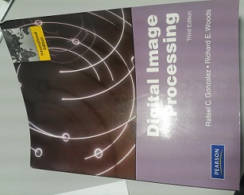
Front cover page


Title page shown on right (e.g. page 26 in this document)

Appendix B: Sample of Report Arrangement After the Front Cover Page

CUSTOMISABLE CLOUD-BASED IOT MONITORING SYSTEM
WITH SMARTPHONE INTERFACE
BY
ANG CHENG KEE

A REPORT
SUBMITTED TO
Universiti Tunku Abdul Rahman
in partial fulfillment of the requirements
for the degree of
BACHELOR OF INFORMATION SYSTEMS (HONOURS) INFORMATION SYSTEMS ENGINEERING
Faculty of Information and Communication Technology
(Kampar Campus)

OCTOBER 2024

COPYRIGHT STATEMENT
Example

© 2024 Ang Cheng Kee. All rights reserved.

This Final Year Project report is submitted in partial fulfillment of the requirements for the degree of Bachelor of Information Systems (Honours) Information Systems Engineering at Universiti Tunku Abdul Rahman (UTAR). This Final Year Project report represents the work of the author, except where due acknowledgment has been made in the text. No part of this Final Year Project report may be reproduced, stored, or transmitted in any form or by any means, whether electronic, mechanical, photocopying, recording, or otherwise, without the prior written permission of the author or UTAR, in accordance with UTAR's Intellectual Property Policy.

ACKNOWLEDGEMENTS

I would like to express thanks and appreciation to my supervisor, Dr. Cheng Wai Khuen and my moderator, Dr. Alex Ooi Boon Yaik who have given me a golden opportunity to involve in the Internet of Things field study. Besides that, they have given me a lot of guidance in order to complete this project. When I was facing problems in this project, the advice from them always assists me in overcoming the problems. Again, a million thanks to my supervisor and moderator.

Other than that, I would like to thank my project teammate, Chia Shun Cheng who has provided a lot of assistance to me when completing this project. Although both of us are having different project and task scope, he is still willing to support me when I faced difficulties in developing this project.

ABSTRACT

This project is regarding a growing trend – Internet of Things (IoT). IoT is a collection of multiple things that connected to the Internet and performing data collection, sharing, and processing. As the IoT trend is growing at an incredible speed, people begin to concern about the challenges raised from IoT. For example, security, user-friendliness, privacy, and customizable issues. There are two major problems will be the focus on this project – customisation and user-friendliness. As most of the existing IoT applications are unable to fulfil a user-friendly and customisable IoT monitoring system, there is still a huge learning gap for IoT users in terms of understanding and customising their IoT solution. Some researches and literature reviews are carried out to look deeper into IoT customisation and user-friendliness issues. The reviews of the products including IoT in a Box, EzBlock Studio, RaspController, IoTool, Lego Mindstorm EV3, SimpleLink SensorTag, Xiaomi Home and Skydrop Smart Sprinkler are written in the literature review section of the report. After reviewing the strengths and weaknesses of existing products, a clearer vision regarding the IoT challenges will be presented in the report. The solution of this project is to develop a customisable cloud-based IoT monitoring system with smartphone interface in order to assist users in learning IoT and customising preferable IoT solutions easily. The final product of the project is the combination of IoT hardware, Google Cloud Platform, Firebase and an Android mobile application with the ability to connect, control, monitor and customise users’ IoT solutions.

Area of Study (Minimum 1 and Maximum 2): Internet of Things, Computer Vision

Keywords (Minimum 5 and Maximum 10): Data Collection in IoT, Monitoring Applications, User-friendly Application, IoT Security, Mobile Application, Cloud Solution
TABLE OF CONTENTS
TITLE PAGE | i
COPYRIGHT STATEMENT | ii
ACKNOWLEDGEMENTS | iii
ABSTRACT | iv
TABLE OF CONTENTS | v
LIST OF FIGURES | viii
LIST OF TABLES | ix
LIST OF SYMBOLS | x
LIST OF ABBREVIATIONS | xi
CHAPTER 1 INTRODUCTION | 1
1.1 Problem Statement and Motivation | 1
1.2 Objectives | 1
1.3 Project Scope and Direction | 2
1.4 Contributions | 2
1.5 Report Organization | 2
CHAPTER 2 LITERATURE REVIEW | 4
2.1 EzBlock Studio | 4
2.2 IoT in a Box | 10
2.3 Skydrop Smart Sprinkler Controller | 12
2.4 IoTool | 14
2.5 RaspController | 16
CHAPTER 3 SYSTEM METHODOLOGY/APPROACH (FOR DEVELOPMENT-BASED PROJECT) | 17
CHAPTER 3 SYSTEM MODEL (FOR RESEARCH-BASED PROJECT) | 17
3.1 System Design Diagram/Equation | 17
3.1.1 System Architecture Diagram | 17
3.1.2 Use Case Diagram and Description | 17
3.1.3 Activity Diagram | 18
CHAPTER 4 SYSTEM DESIGN | 19
4.1 System Block Diagram | 19
4.2 System Components Specifications | 20
4.3 Circuits and Components Design | 21
4.4 System Components Interaction Operations | 22
CHAPTER 5 SYSTEM IMPLEMENTATION (FOR DEVELOPMENT- BASED PROJECT) | 25
CHAPTER 5 EXPERIMENT/SIMULATION (FOR RESEARCH- BASED PROJECT) | 25
5.1 Hardware Setup | 25
5.2 Software Setup | 30
5.3 Setting and Configuration | 41
5.4 System Operation (with Screenshot) | 52
5.5 Implementation Issues and Challenges | 62
5.6 Concluding Remark | 66
CHAPTER 6 SYSTEM EVALUATION AND DISCUSSION | 70
6.1 System Testing and Performance Metrics | 70
6.2 Testing Setup and Result | 75
6.3 Project Challenges | 82
6.4 Objectives Evaluation | 89
6.5 Concluding Remark | 91
CHAPTER 7 CONCLUSION AND RECOMMENDATION | 101
7.1 Conclusion | 101
7.2 Recommendation | 103
REFERENCES | 120
APPENDIX 130
POSTER 150
LIST OF FIGURES

Figure Number | Title | Page
Figure 1.1 | Infographic from Bosch Blog | 1
Figure 2.1 | Ezblock Studio | 10
Figure 2.2 | IoT in a Box | 13
Figure 2.3 | Skydrop Smart Sprinkler Controller | 14
Figure 3.1 | System Architecture Diagram | 19
Figure 3.2 | Use Case Diagram | 20

LIST OF TABLES

Table Number | Title | Page
Table 2.1 | Specifications of laptop | 4
Table 2.2 | Comparison between the existing applications and proposed application | 16
Table 3.1 | Use Case Description of Register Account | 18

LIST OF SYMBOLS

β | beta
Ω | Ohm (resistance)
LIST OF ABBREVIATIONS

5G | Fifth Generation
API | Application Programming Interface
CPU | Central Processing Unit
GPIO | General Purpose Input Output
IOT | Internet of Things
IP | Internet Protocol
RAM | Random Access Memory

Chapter 1
Introduction

In this chapter, we present the background and motivation of our research, our contributions to the field, and the outline of the thesis. ……….

1.1 Problem Statement and Motivation
According to recent research from Business Insider, IoT Analytics, Gartner and Intel, there will be 64 billion IoT devices connected in the world by 2025 and investment is gearing up in IoT solution with 5G technology on the horizon [1]. The increasing number of IoT devices in recent years indicates that there will be a huge number of users using IoT solutions as well. However, there are some existing problems of IoT solutions in the market which are customisable and user-friendliness issues that cause a gap between end-user and IoT solutions….

Figure 1.1 Infographic from Bosch Blog

1.2 Objectives
In this project, Google Cloud platform is acting as a middleware to connect multiple IoT hardware and software application. Cloud computing and IoT technology have become two closely affiliated technologies as one provides another a platform to success [2]. The role of a cloud platform in IoT ecosystem becomes extremely important because the greater generation of IoT data collected. With the cloud computing features provided by the platform, users no need to bother about the storage, data processing, and other data monitoring issue anymore. It is also a cost-effective approach for IoT development because the cloud computing platform allow virtualisation of resources with pay for use model. By combining Google Cloud platform, Firebase services and a mobile application, a customisable cloud-based IoT platform is developed to enable multiple things connection, control, and monitoring. In short, users just need to interact with the extremely user-friendly interfaces provided to have their own solutions easily. Furthermore, communication between the things can be achieved by the simple if-then interface provided in the application……

1.3 Project Scope and Direction
…………

1.4 Contributions
People are always aimed for a perfect IoT solution to fulfil their current needs or even future requirement development. Normally, there are few ways to do but it is not effective in terms of cost, time, and effort. For instance, users can develop an IoT solution from scratch but it requires technical knowledge in terms of hardware design, software design, selected Cloud IoT platform and other issues. Other than that, users can find a reliable IoT solution providers to develop a solution to meet their current needs. However, when there is a change required in the solution, it becomes a tedious task again for the users and providers. It is normally time and cost consuming to change a pre-packaged IoT solution in the future. Hence, after the completion of this project, there will be some contributions to the customisation and user-friendliness problems mentioned above in the current IoT ecosystem……

1.5 Report Organization
This report is organised into 6 chapters: Chapter 1 Introduction, Chapter 2 Literature Review, Chapter 3 System Design, Chapter 4 System Implementation and Testing, Chapter 5 System Outcome and Discussion, Chapter 6 Conclusion. The first chapter is the introduction of this project which includes problem statement, project background and motivation, project scope, project objectives, project contribution, highlights of project achievements, and report organisation. The second chapter is the literature review carried out on several existing IoT applications in the market to evaluate the strengths and weaknesses of each product. The third chapter is discussing the overall system design of this project. The fourth chapter is regarding the details on how to implement the design of the system. Furthermore, the fifth chapter reports the ……

Chapter 2
Literature Review

2.1 EzBlock Studio
Ezblock Studio is a mobile application that works with its hardware products – Ezblock Pi. Ezblock Pi is a controller that can be attached to a Raspberry Pi as an extension to build a connection between Raspberry Pi and Ezblock Studio app. In this IoT product, Ezblock Pi acts as a platform to connect sensors and actuators to Raspberry Pi, whereas the Ezblock Studio acts as the software application interface to monitor the Ezblock Pi………

Table 2.1 Specifications of laptop
Description | Specifications
Model | Asus A456U series
Processor | Intel Core i5-7200U
Operating System | Windows 10
Graphic | NVIDIA GeForce GT 930MX 2GB DDR3
Memory | 4GB DDR4 RAM
Storage | 1TB SATA HDD

Chapter 3
System Methodology/Approach OR System Model

3.1 System Design Diagram/Equation
Here is the format for scientific equation for Fourier Series:

$f\left(x\right)=a_{0}+\sum_{n=1}^{∞}{\left(a_{n}\cos{\frac{nπx}{L}}+b_{n}\sin{\frac{nπx}{L}}\right)}$ (1)

where

$a_{0}$, $a_{n}$ and $b_{n}$ are constants
$n$ is integer
$x$ is variable
$L$ is periodic length

REFERENCES

Examples of Reference Format (IEEE style)
Article:
Journal article
[1] T. John, “Ultrawideband and WiMedia,” Embedded Systems Programming, vol. 16, no. 4,
pp. 29-36, Apr. 2003.

Conference article
[2] T. Ali, “BLANKSOFT : A Computer Aided Manufacturing System for Metal Blanking Processes Design,” presented at the IEEE International Conference on Systems, Man, and Cybernetics, Yasmine Hammamet, Tunisia, Oct. 2002.

Book:
One author
[3] P. McBreen, Questioning Extreme Programming. Boston: Addison-Wesley, 2003.

More than one author
[4] T. James and B. Scholz, Advanced Symbolic Analysis for Compilers: New Techniques and
Algorithms for Symbolic Program Analysis and Optimisation. Berlin: Springer, 2002.

[5] D. Louis, A. Prasad, and S. Bandyopadhyay, Networking Infrastructure for Pervasive Computing: Enabling Technologies & Systems. Dordrecht: Kluwer Academic, 2004.

More than six authors
[6] P. Norton et al., Beginning Python. Indianapolis, IN: Wiley, 2005.

Chapter or part of a book
[7] L. Rosenfeld and P. Morville, “Designing Navigation Systems,” in Information Architecture for the World Wide Web, 2nd ed., Sebastopol, CA: O'Reilly, 1998, pp. 47-71.

Standard:
[8] IEEE Standard Signalling Method for a Bidirectional Parallel Peripheral Interface for Personal Computers, IEEE Standard 1284, 2000.

Thesis:
[9] R. John, “Contextual and data refinement for the refinement calculus for logic programs,” PhD thesis, Universiti Malaya, Malaysia, 2004.

Website:
Article:
[10] J. Case, D. S. Rajan, and A. M. Shende. (2001, Jan.) “Lattice Computers for Approximating Euclidean Space”, Journal of the ACM [Online]. 48(1), 110-144.
Available: http://portal.acm.org/citation.cfm?id=363688&coll=portal&dl=ACM&CFID=1141529&CFTOKEN=57117280

Internet site:
[11] Engineers Without Borders, “Annual Report 2001-2003,” Engineers Without Borders. [Online]. Available:
http://www.jt.org.my/resource/file/299_Annual_Report_0607-low_resi_final.pdf

How to use it?
The method used for paper 1 is neural network training model [2].
Instead of using Harvard style, i.e. (Ali, 2002), the IEEE style is used the [2] as citation. The references are listed based on which reference is being cited accordingly.

POSTER

Appendix C: IEEE Style Referencing

Refer to UTAR library IEEE style referencing source
https://opac.utar.edu.my/gw_2013_2_8/html/default/en/Guides/IEEE-Reference-Guide-Online-v.04-20-2021.pdf

Or see the attachment pdf file “IEEE Referencing Style” at FICT FYP Portal

Appendix D: FYP2 Submission Form

 | FORM | REF NO. | : | FM-LIB-501
 |  | REVISION NO. | : | 0
 | UTAR Institutional Repository | EFFECTIVE DATE | : | 24/06/2024
 |  | PAGE | : | 1
 | (UTAR-IR):
 | Permission Form
Universiti Tunku Abdul Rahman

Title of Final Work :

Degree Awarded :

Faculty :

By signing below, I acknowledge that I have fully read and understood the Open Access (OA) Policy for Scholarly Output, and agree to abide by the terms and conditions outlined in the Policy.
I certify that the version of the document(s) that I deposited in UTAR-IR is the same as that approved by the examination committee, and hereby declare that I own the copyright to this work and it does not contain any unauthorised third party copyrighted materials.
I hereby grant to Universiti Tunku Abdul Rahman (UTAR) permission to make available my thesis / project work open access in UTAR-IR, and to exercise the copyright in those materials. More specifically, I grant to UTAR a non-exclusive, irrevocable, worldwide licence to exercise any and all rights under copyright relating to my thesis / project work, in any medium, and to authorise others to do the same. I shall retain copyright in my thesis / project work.
Alternative Access Option (if applicable):
Restricted Access. Reason(s):

Embargo for up to 24 months. Reason(s):

Start Date: End Date: Total Duration: months

Signature: Signature:

Name: Supervisor’s Name:
ID:
Date: Date:

FINAL YEAR PROJECT BI-WEEKLY (LONG TRIMESTER) / WEEKLY (SHORT TRIMESTER) REPORT
(Project II)

Trimester, Year: | Study week no.:
Student Name & ID:
Supervisor:
Project Title:

1. WORK DONE
[Please write the details of the work done in the last fortnight.]

2. WORK TO BE DONE

3. PROBLEMS ENCOUNTERED

4. SELF EVALUATION OF THE PROGRESS

_________________________ _________________________
Student’s signature Supervisor’s signature

PLAGIARISM CHECK RESULT

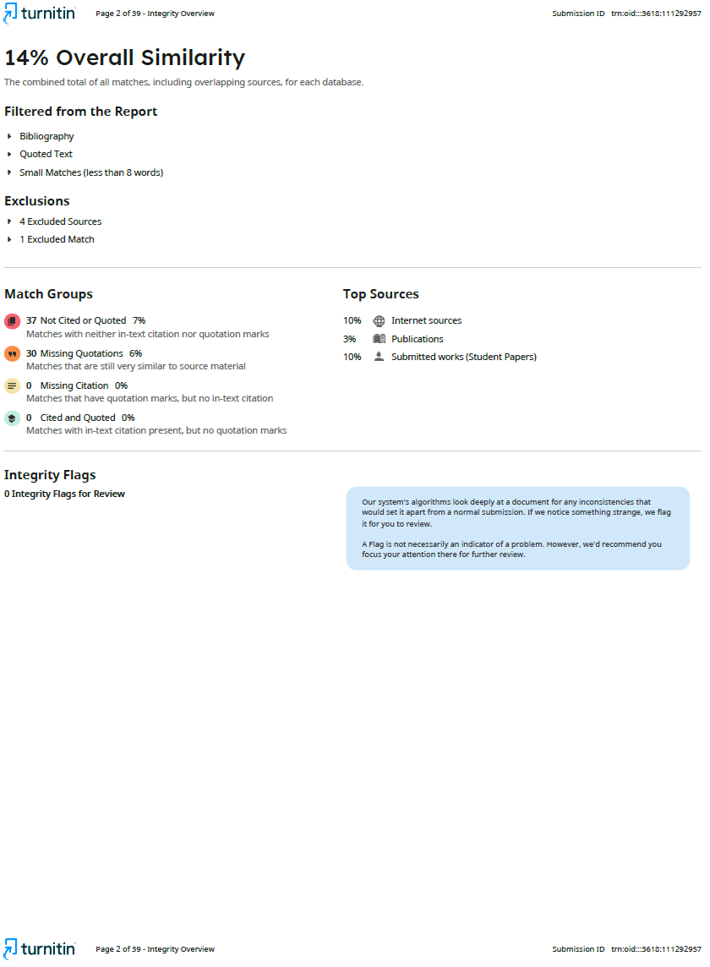

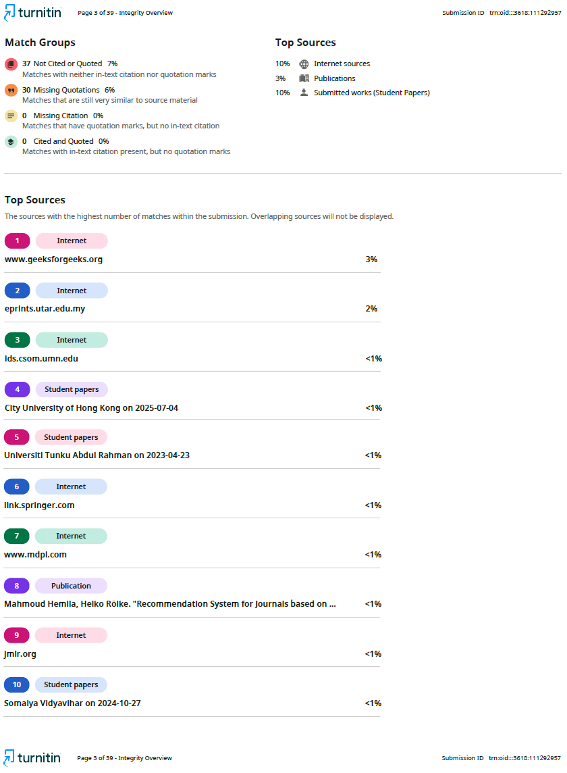

Universiti Tunku Abdul Rahman
Form Title : Supervisor’s Comments on Originality Report Generated by Turnitin
for Submission of Final Year Project Report (for Undergraduate Programmes)
Form Number: FM-IAD-005 | Rev No.: 0 | Effective Date: 01/10/2013 | Page No.: 1of 1

FACULTY OF INFORMATION AND COMMUNICATION TECHNOLOGY

Full Name(s) of
Candidate(s)
ID Number(s)

Programme / Course
Title of Final Year Project

Similarity | Supervisor’s Comments  (Compulsory if parameters of originality exceed the limits approved by UTAR)
Overall similarity index: ___ % Similarity by source
Internet Sources: __________ %
Publications: __________ %
Student Papers: __________ %

Number of individual sources listed of more than 3% similarity:
Parameters of originality required and limits approved by UTAR are as Follows:
(i) Overall similarity index is 20% and below, and
(ii) Matching of individual sources listed must be less than 3% each, and
(iii) Matching texts in continuous block must not exceed 8 words
Note: Parameters (i) – (ii) shall exclude quotes, bibliography and text matches which are less than 8 words.
Note Supervisor/Candidate(s) is/are required to provide softcopy of full set of the originality report to Faculty/Institute

Based on the above results, I hereby declare that I am satisfied with the originality of the Final Year Project Report submitted by my student(s) as named above.

______________________________ ______________________________
Signature of Supervisor |  | Signature of Co-Supervisor
Name: __________________________ |  | Name: __________________________
Date: ___________________________ |  | Date: ___________________________



UNIVERSITI TUNKU ABDUL RAHMAN
FACULTY OF INFORMATION & COMMUNICATION TECHNOLOGY (KAMPAR CAMPUS)

CHECKLIST FOR FYP2 REPORT SUBMISSION
Student ID
Student Name
Supervisor Name

TICK (√) | DOCUMENT ITEMS  Your report must include all the items below. Put a tick on the left column after you have checked your report with respect to the corresponding item.
 | Title Page
 | Copyright Statement
 | Acknowledgement
 | Abstract (with Area of Study and Keywords)
 | Table of Contents
 | List of Figures (if applicable)
 | List of Tables (if applicable)
 | List of Symbols (if applicable)
 | List of Abbreviations (if applicable)
 | Chapters / Content
 | References
 | All references are cited in the report, especially in the chapter of literature review
 | Appendices (if applicable)
 | Poster
 | I agree 5 marks will be deducted due to incorrect format, declare wrongly the ticked of these items, and/or any dispute happening for these items in this report.

I, the author, have checked and confirmed all the items listed in the above table are included in my report.

______________________
(Signature of Student)

Date:

-End -

