CHANGES ONLY — paste-ready sections
This document contains ONLY the sections that changed in the latest round, in order. For each blue banner, open the matching section of your own report, delete the old text/table, and copy the heading, paragraphs and table from here. Tables are already real tables — they paste as tables. Yellow boxes mark where a picture goes. Anything not shown here is unchanged. Do not include the blue banner or yellow boxes in your final report.
REPLACE IN YOUR REPORT (1 of 22)
FRONT MATTER - List of Figures (added Figures 1.2 and 1.3)
Go to this section in your own report, delete its old contents, then copy everything under this banner (tables copy as tables).

LIST OF FIGURES
- Figure 1.1 Spam as a share of worldwide email traffic in 2024 (Kaspersky Securelist). - Figure 1.2 Phishing attacks recorded per quarter in 2024 (Anti-Phishing Working Group). - Figure 1.3 Key email-security threat statistics summary. - Figure 2.1 Taxonomy of spam-detection approaches and the position of this project. - Figure 2.2 Rule- / keyword-based filtering. - Figure 2.3 Content-based statistical (machine-learning) classification. - Figure 2.4 Metadata / reputation-based filtering. - Figure 2.5 Hybrid content–metadata fusion classification. - Figure 3.1 System architecture of the adaptive fusion spam-detection framework. - Figure 3.2 Use-case diagram for the reviewer/administrator actor. - Figure 3.3 Activity diagram for scoring, review and adaptive retraining. - Figure 4.1 System block diagram (ingestion, features, fusion, action, adaptation). - Figure 5.1 Software and virtual-environment setup. - Figure 5.2 Browser check-and-review console showing a phishing verdict and signal chips. - Figure 5.3 Example service prediction response (label, probability and signals). - Figure 5.4 Mailbox watch run quarantining a flagged message. - Figure 5.5 Live IMAP run scoring four messages retrieved from a commercial mailbox. - Figure 5.6 Review inbox with confirm, correct and retrain controls. - Figure 6.1 Confusion matrix of the fused model on the held-out test split (n = 20,288). - Figure 6.2 ROC curve and threshold sweep for the fused model. - Figure 6.3 Catch rate versus decision threshold on the LLM-phishing set. - Figure 6.4 ROC curves before and after one adaptive retraining cycle. - Appendix A Poster.

REPLACE IN YOUR REPORT (2 of 22)
FRONT MATTER - List of Tables (renumbered 5.1/5.2/5.3)
Go to this section in your own report, delete its old contents, then copy everything under this banner (tables copy as tables).

LIST OF TABLES
- Table 2.1 Comparison of detection paradigms. - Table 2.2 Review of existing methods and their limitations. - Table 3.1 Use-case descriptions. - Table 3.2 Integrated public corpus and class distribution. - Table 4.1 Component modules and responsibilities. - Table 4.2 The thirteen structural metadata signals. - Table 5.1 Specifications of the development machine. - Table 5.2 Software and libraries used in the project. - Table 5.3 Model and feature hyper-parameters. - Table 5.4 Mailbox connection and filtering configuration. - Table 5.5 Command-line operations used to run the system. - Table 6.1 Held-out performance of the deployed fused model. - Table 6.2 Classifier and feature-group comparison (Objective 3). - Table 6.3 Detection of genuine LLM-generated phishing (n = 4,986). - Table 6.4 Before/after adaptive retraining on held-out modern-threat email. - Table 6.5 Commercial-filter comparison: vendor-reported and independently measured AI-phishing detection. - Table 6.6 Comparison with published classical models on comparable public corpora. - Table 6.7 Objectives evaluation summary.

REPLACE IN YOUR REPORT (3 of 22)
CHAPTER 1 - opener (new Figures 1.2/1.3 + BEC/phishing/Verizon stats)
Go to this section in your own report, delete its old contents, then copy everything under this banner (tables copy as tables).

CHAPTER 1: INTRODUCTION
Electronic mail remained one of the most widely used communication channels in organisations and, at the same time, one of the most exploited. Cybersecurity had become a pressing global concern as internet adoption, cloud services, e-commerce and remote work expanded the exposure of individuals and organisations to cyber risk; industry estimates projected annual cybercrime damages reaching into the trillions of United States dollars, with ransomware, phishing, data breaches and identity theft among the principal causes [1]. Among the available attack vectors, email continued to be favoured because it was ubiquitous, trusted and inexpensive to abuse. Unsolicited or fraudulent messages, broadly termed spam, had for many years accounted for a large share of global email traffic — Kaspersky measured spam at roughly 47 per cent of all email sent worldwide in 2024 [18] — and ranged from nuisance advertisements to sophisticated phishing campaigns designed to steal credentials or financial data or to distribute malware [2]. The scale of the problem is illustrated in Figure 1.1.
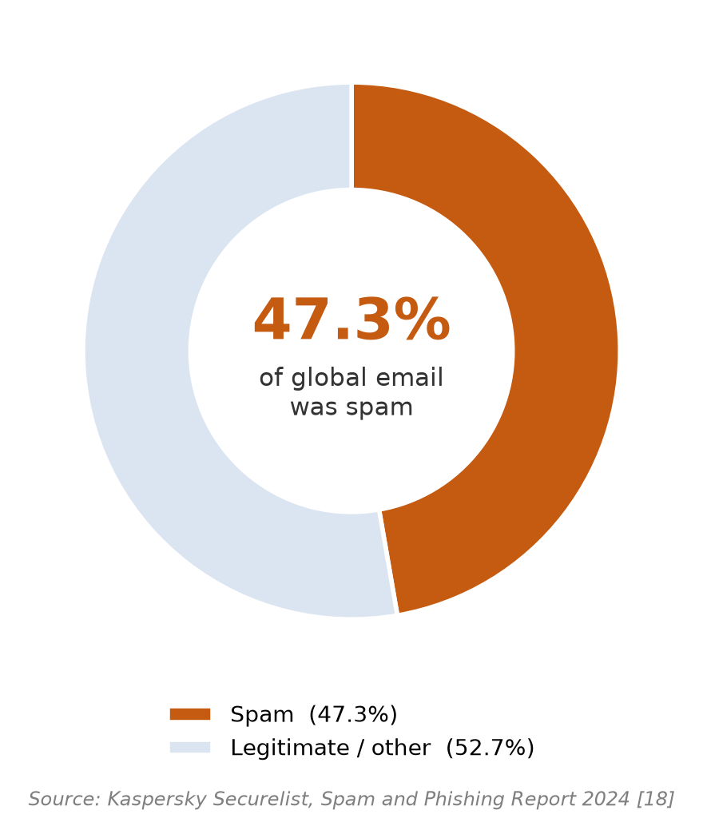
Figure 1.1: Spam as a share of worldwide email traffic in 2024 (Kaspersky Securelist [18
Early spam messages were comparatively simple and could be blocked by keyword filters or blacklists, but attackers evolved their techniques continuously. Modern campaigns used obfuscation such as inserted characters, misleading links and disguised headers, while phishing — the subset of spam that deceived recipients into revealing sensitive information — grew particularly dangerous and featured prominently in reported data breaches [2]. Two trends made the problem materially harder. First, business-email-compromise attacks used calm, professional, grammatically correct language and frequently contained no malicious link or attachment, so they evaded signatures designed for obvious, keyword-laden spam. These link-less impersonation attacks were also among the costliest of cybercrimes: the Federal Bureau of Investigation recorded business-email-compromise losses of USD 2.77 billion across 21,442 complaints in 2024 [19], and the Anti-Phishing Working Group recorded close to 3.8 million phishing attacks over the same year [20], as shown in Figure 1.2. Second, large language models allowed attackers to generate fluent, personalised, typo-free fraudulent messages at scale. Compounding these trends was concept drift: the characteristics of spam evolved over time, so a model trained once on older data gradually failed to recognise new tactics unless it was updated.
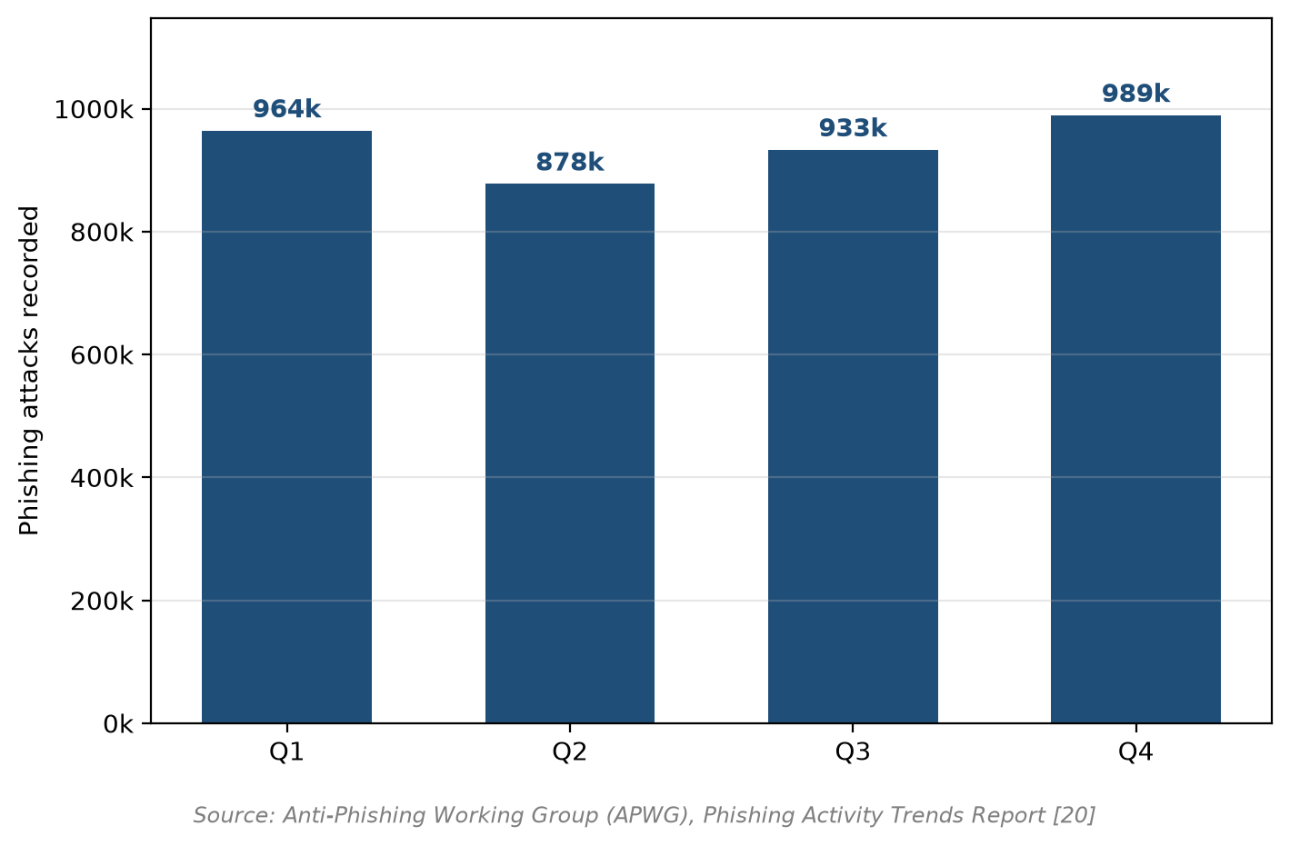
Figure 1.2: Phishing attacks recorded per quarter in 2024 (Anti-Phishing Working Group [20
Such threats also acted faster than manual review could: the 2024 Verizon study found that the median time for a user to click a phishing link was 21 seconds and that a non-malicious human element was involved in 68% of breaches [2], reinforcing the case for automatic detection. The key threat statistics are summarised in Figure 1.3.
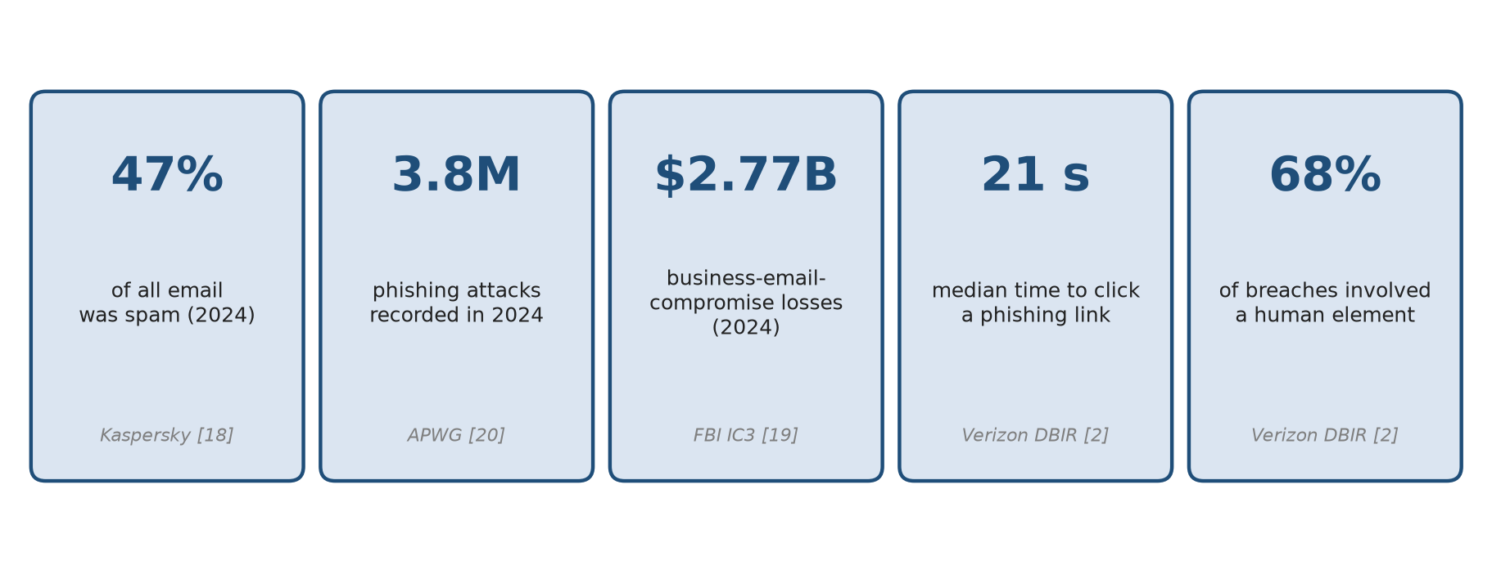
Figure 1.3: Summary of key email-security threat statistics from recent official reports
Machine learning offered a more robust basis than static rules, because a learned model generalised from labelled examples rather than matching hand-maintained patterns and could be retrained as new campaigns appeared. Even so, no single view of a message was sufficient: content-based models examined what a message said but ignored how it was constructed, whereas structural and reputation-based signals caught routing and authentication anomalies but were bypassed by well-written text. This project therefore developed an adaptive detector that fused the textual content of a message with its structural metadata within a classical machine-learning pipeline and improved over time through a reviewed-feedback retraining loop. The system was designed to run locally on commodity hardware without a graphics processor, to remain interpretable through its metadata signals, and to detect malicious intent rather than artificial-intelligence authorship.
The remainder of this chapter states the problem and motivation (Section 1.1), lists the objectives (Section 1.2), defines the project scope (Section 1.3), states the contributions (Section 1.4) and outlines the organisation of the report (Section 1.5).

REPLACE IN YOUR REPORT (4 of 22)
SECTION 1.1 - added citations [4][5][19]
Go to this section in your own report, delete its old contents, then copy everything under this banner (tables copy as tables).

1.1 Problem Statement and Motivation
Despite the widespread deployment of anti-spam filters, email spam remained a persistent and evolving problem. Static rule lists and keyword filters were brittle: they required constant manual maintenance and were easily evaded by rewording or obfuscation [4], [5]. Learned content models were more effective but examined only what a message said and ignored its structure, while metadata and reputation systems used structural indicators that were themselves bypassed by well-formed, link-less business-email-compromise mail sent from plausibly configured accounts [19]. Models that were never updated could not follow evolving campaigns, so their accuracy degraded as concept drift accumulated [4], [5].
These weaknesses produced the two errors that mattered most in practice. False negatives allowed malicious mail to reach the user, while false positives — legitimate email wrongly marked as spam — interrupted business communication and damaged trust in the filter, and were often judged the costlier error in an organisational setting. A detector therefore needed to combine complementary views of a message, to keep false positives low, and to be updated as threats changed, without depending on the proprietary, non-reproducible models used by large commercial providers.
The motivation for this project was therefore to build a detector that (a) fused content and metadata so that fluent wording and structural anomalies were judged together, (b) remained fast and interpretable enough to run locally on ordinary hardware without dependence on external cloud services, and (c) adapted to new threats through a reviewed retraining loop rather than through manual editing of rules. The project therefore designed, implemented and evaluated a complete, deployable adaptive content–metadata fusion spam-detection system: the pipeline was built at scale on a varied public corpus, hardened against malformed real-world input, wrapped in a service and quarantine layer, equipped with a reviewed retraining loop, and tested for generalisation against genuinely AI-generated phishing. The remainder of this report describes that system and measures the extent to which each stated objective was met.

REPLACE IN YOUR REPORT (5 of 22)
REFERENCES - new entries [18] Kaspersky, [19] FBI IC3, [20] APWG
Go to this section in your own report, delete its old contents, then copy everything under this banner (tables copy as tables).
[18] Kaspersky, "Spam and phishing in 2024," Securelist, Kaspersky Lab, Feb. 2025. [Online]. Available: https://securelist.com/spam-and-phishing-report-2024/115536/
[19] Federal Bureau of Investigation, "2024 Internet Crime Report," Internet Crime Complaint Center (IC3), 2025. [Online]. Available: https://www.ic3.gov/AnnualReport/Reports
[20] Anti-Phishing Working Group, "Phishing Activity Trends Report, 2024," APWG, 2024-2025. [Online]. Available: https://apwg.org/resources/phishingactivitytrends/ [21] N. A. Alam, "Phishing email dataset," Kaggle, 2024. [Online]. Available: https://www.kaggle.com/datasets/naserabdullahalam/phishing-email-dataset (accessed Sep. 3, 2026). [22] A. Al-Subaiey, M. Al-Thani, N. A. Alam, K. F. Antora, A. Khandakar, and S. A. U. Zaman, "Novel interpretable and robust web-based AI platform for phishing email detection," Computers and Electrical Engineering, vol. 120, art. 109625, Dec. 2024, doi: 10.1016/j.compeleceng.2024.109625.

REPLACE IN YOUR REPORT (6 of 22)
SECTION 2.1.2 - removed 'also tested on Linux' claim (Windows 11 only)
Go to this section in your own report, delete its old contents, then copy everything under this banner (tables copy as tables).

2.1.2 Firmware / Operating System
All core components were written in Python and were developed and tested on Windows 11. No special firmware was required, and no hardware programming was involved. The operating system served only as the host for the Python runtime, the virtual environment and the local file storage used for email and model artefacts.

REPLACE IN YOUR REPORT (7 of 22)
SECTION 2.4 - 'Python virtual environment' wording
Go to this section in your own report, delete its old contents, then copy everything under this banner (tables copy as tables).

2.4 Summary
This chapter reviewed the technologies used in the project — commodity central-processing-unit hardware, a Python virtual environment, comma-separated-value storage, and the scikit-learn machine-learning stack — and surveyed existing spam-detection systems, from rule-based and content-statistical methods through metadata and hybrid/fusion approaches to proprietary commercial filters. The review established that no single source of evidence was sufficient on its own, that fusion of content and metadata was among the most robust approaches, and that adaptation to evolving and AI-assisted threats remained under-served by locally deployable, explainable systems. These findings motivated the proposed solution.

REPLACE IN YOUR REPORT (8 of 22)
SECTION 3.1 (use-case table) - generic service wording
Go to this section in your own report, delete its old contents, then copy everything under this banner (tables copy as tables).

3.1.2 Use Case Diagram and Description
The system had a single human actor: an administrator who also acted as the reviewer, confirming or correcting verdicts. In normal operation the system did not require a person to handle each message: the mailbox watcher monitored a mail folder and automatically scored and quarantined incoming mail (in the same way a conventional mail filter sits on the mail server), the detection service scored messages submitted to it, and the administrator used the browser console only for testing and occasional review. Corrections were therefore made only for the rare misclassified message and were used in a periodic batch retraining rather than for every email. Figure 3.2 presents the use-case diagram from the administrator's point of view, and Table 3.1 describes each use case.
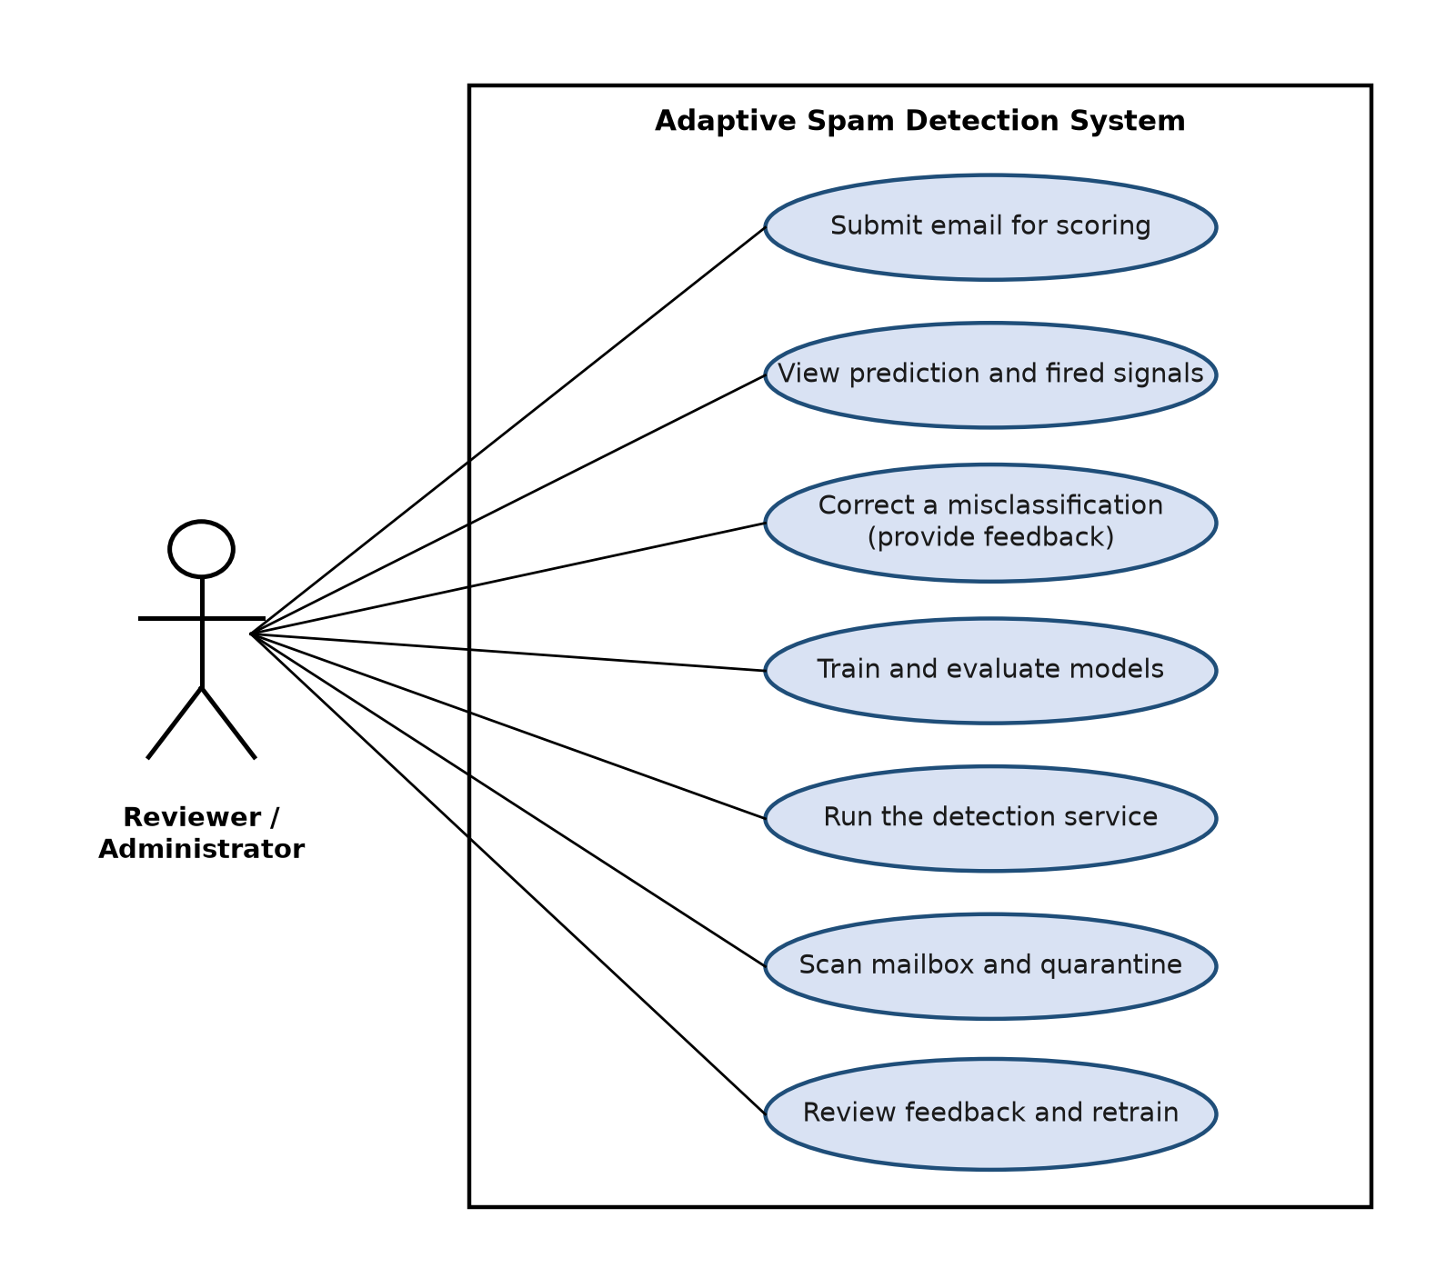
Figure 3.2: Use-case diagram for the reviewer/administrator actor
Table 3.1 — Use-case descriptions.
Use case | Actor | Description
Submit email for scoring | Reviewer / Administrator | Each incoming message is processed automatically — the mailbox watcher scores mail in the monitored folder, or the detection service scores a message submitted to it; the console also allows a message to be pasted for testing. The system parses the message and prepares it for classification.
View prediction and fired signals | Reviewer / Administrator | The system displays the predicted label (spam or legitimate), the spam probability, and the structural signals that contributed to the decision, so the administrator can understand and check a verdict.
Correct a misclassification (provide feedback) | Reviewer / Administrator | When the occasional verdict is wrong, the administrator marks the message as spam or legitimate. The correction is saved to the labelled feedback store for the next periodic retraining; this is done only for rare errors, not for every message.
Train and evaluate models | Reviewer / Administrator | The administrator trains the fusion classifier on the labelled corpus and the system reports its accuracy, precision, recall, F1 score and ROC-AUC on a held-out test split.
Run the detection service | Reviewer / Administrator | The administrator starts the detection service so that incoming messages can be submitted and scored automatically through the service interface or the web console.
Scan mailbox and quarantine | Reviewer / Administrator | Running unattended in watch-and-quarantine mode, the system automatically scores every message that arrives in the monitored folder, moves spam to a quarantine folder, and logs every decision to the review queue — no manual action per message.
Review feedback and retrain | Reviewer / Administrator | Run periodically: the accumulated reviewed feedback is merged with the training data and a new model is fitted, which is then evaluated on the held-out split before further use.

REPLACE IN YOUR REPORT (9 of 22)
SECTION 3.3 - added plain-English TF-IDF explanation
Go to this section in your own report, delete its old contents, then copy everything under this banner (tables copy as tables).

3.3 Feature Extraction and Classification Approach
Content features. Subject and body text were concatenated and converted into numerical features using term frequency–inverse document frequency (TF-IDF). In plain terms, TF-IDF gave each word a high score when it appeared often in a particular email but rarely across all emails, so distinctive spam vocabulary stood out while common words such as "the" or "and" were down-weighted. The text was vectorised with TF-IDF over word unigrams/bigrams (up to 40,000 terms) and over character n-grams of length three to five (up to 30,000 features), using sub-linear term-frequency scaling. The word stream captured phrasing while the character stream tolerated obfuscation. The weight assigned to a term t in an email d was computed as in Equations (3.1) and (3.2):
w(t, d) = ( 1 + ln tf(t, d) ) · idf(t) (3.1)
idf(t) = ln ( (1 + N) / (1 + df(t)) ) + 1 (3.2)
where tf(t, d) is the frequency of term t in email d, df(t) is the number of emails in the training set that contain t, and N is the total number of emails. Equation (3.1) uses the sub-linear term-frequency scaling configured in the vectoriser, and Equation (3.2) is the smoothed inverse-document-frequency form used by the library; the resulting vectors were L2-normalised. A term that is frequent in one email but rare across all emails therefore receives a high weight, while common words receive a low weight.
Metadata features. Thirteen structural signals were extracted from the parsed message and encoded with a dictionary vectoriser: subject length, body length, URL count, number of unique link domains, attachment count, a sender-has-domain flag, a sender-domain/link-domain mismatch flag, reply-to presence, sender-policy-framework pass indicator, DomainKeys-Identified-Mail presence indicator, subject all-capitals ratio, exclamation count and a suspicious/urgency-term count. These metadata values were standardised (with a sparse-safe standard scaler) so that raw lengths could not dominate the normalised text features. Each metadata value x was standardised to z as in Equation (3.3):
z = ( x − μ ) / σ (3.3)
where μ is the mean and σ the standard deviation of that signal over the training set.
Preprocessing. Raw messages were parsed with the Python standard-library email package so that multipart bodies and headers were handled uniformly. Available text/plain MIME parts were extracted and the subject was prefixed to the body; when no plain-text part was available, a fallback representation of the raw message was used as the body text. Structural values were derived without reading attachment content, and no message body left the local machine. Malformed or plain-text inputs were handled by a fallback path that treated the entire input as body text and zeroed the header-derived metadata.
Fusion and classification. A scikit-learn feature union concatenated the three streams into a single sparse vector. Three classifiers were evaluated — multinomial Naïve Bayes, class-balanced logistic regression and a linear support-vector classifier — all on identical features for a fair comparison. Logistic regression was selected for deployment because it produced a probability, supported balanced class weighting and exposed interpretable signal contributions. The pipeline was fitted on training data only and serialised as a single artefact, eliminating train/test leakage and making the deployed model exactly the model that was evaluated. The deployed logistic-regression classifier combined the fused feature vector x into a linear score, which the logistic function converted to a spam probability, as in Equations (3.4) and (3.5):
z = w₀ + w₁x₁ + w₂x₂ + … + wₘxₘ (3.4)
P(spam | x) = 1 / ( 1 + e^(−z) ) (3.5)
The probability was compared with a configurable decision threshold θ (0.55 by default) to produce the label, as in Equation (3.6):
label = { spam if P(spam | x) ≥ θ; legitimate otherwise } (3.6)
where w₀ is the bias term and w₁ … wₘ are the weights learned for the fused features.

REPLACE IN YOUR REPORT (10 of 22)
SECTION 3.4 - added plain definitions of TP/FP/FN/TN and the metrics
Go to this section in your own report, delete its old contents, then copy everything under this banner (tables copy as tables).

3.4 Evaluation Design and Performance Definitions
Performance was measured using accuracy, precision, recall, the F1 score and the receiver-operating-characteristic area under the curve, together with the confusion matrix and false-positive rate, because a legitimate message wrongly quarantined was the most costly error. These terms were defined as follows. A true positive (TP) was a spam message correctly caught; a false negative (FN) was spam that reached the user; a false positive (FP) was a legitimate message wrongly marked as spam; and a true negative (TN) was legitimate mail correctly allowed through. Accuracy was the overall fraction of messages classified correctly; precision was the fraction of flagged messages that were truly spam (so a high precision meant few legitimate emails were blocked); recall was the fraction of real spam that was caught (so a high recall meant little spam slipped through); and the F1 score was the harmonic mean of precision and recall, summarising the balance between them. The metrics were computed as in Equations (3.7) to (3.11):
Accuracy = ( TP + TN ) / ( TP + TN + FP + FN ) (3.7)
Precision = TP / ( TP + FP ) (3.8)
Recall = TP / ( TP + FN ) (3.9)
F1 = 2 · ( Precision · Recall ) / ( Precision + Recall ) (3.10)
False-positive rate = FP / ( FP + TN ) (3.11)
A threshold sweep reported phishing recall at a low (≤5%) false-positive operating point. The receiver-operating-characteristic area under the curve (ROC-AUC) summarised the true-positive/false-positive trade-off across all thresholds, with a value of 1.0 indicating perfect ranking. Per-message latency (50th and 95th percentiles) was measured on the central processing unit. External tests assessed generalisation to large-language-model-generated phishing, and a before/after experiment measured the improvement attributable to reviewed retraining. Validity controls were strict train/test separation, no training on any test email, and the use of inert placeholder domains in synthetic data.

REPLACE IN YOUR REPORT (11 of 22)
SECTION 4.1 - fixed broken sentence / removed code names
Go to this section in your own report, delete its old contents, then copy everything under this banner (tables copy as tables).

4.1 System Block Diagram
The system comprised five top-level blocks, shown in Figure 4.1:
1. Ingestion — a request to the detection service, a mailbox folder watcher, or a local file. 2. Parsing and feature extraction — robust RFC-5322 parsing producing content text and the thirteen metadata signals, with crash-safe handling of malformed mail. 3. Fusion classifier — the word/character/metadata feature union, standardisation and the logistic-regression classifier. 4. Action and decision — threshold comparison, labelling, quarantine and signal explanation. 5. Adaptation — the review queue, feedback store and scheduled retraining path.
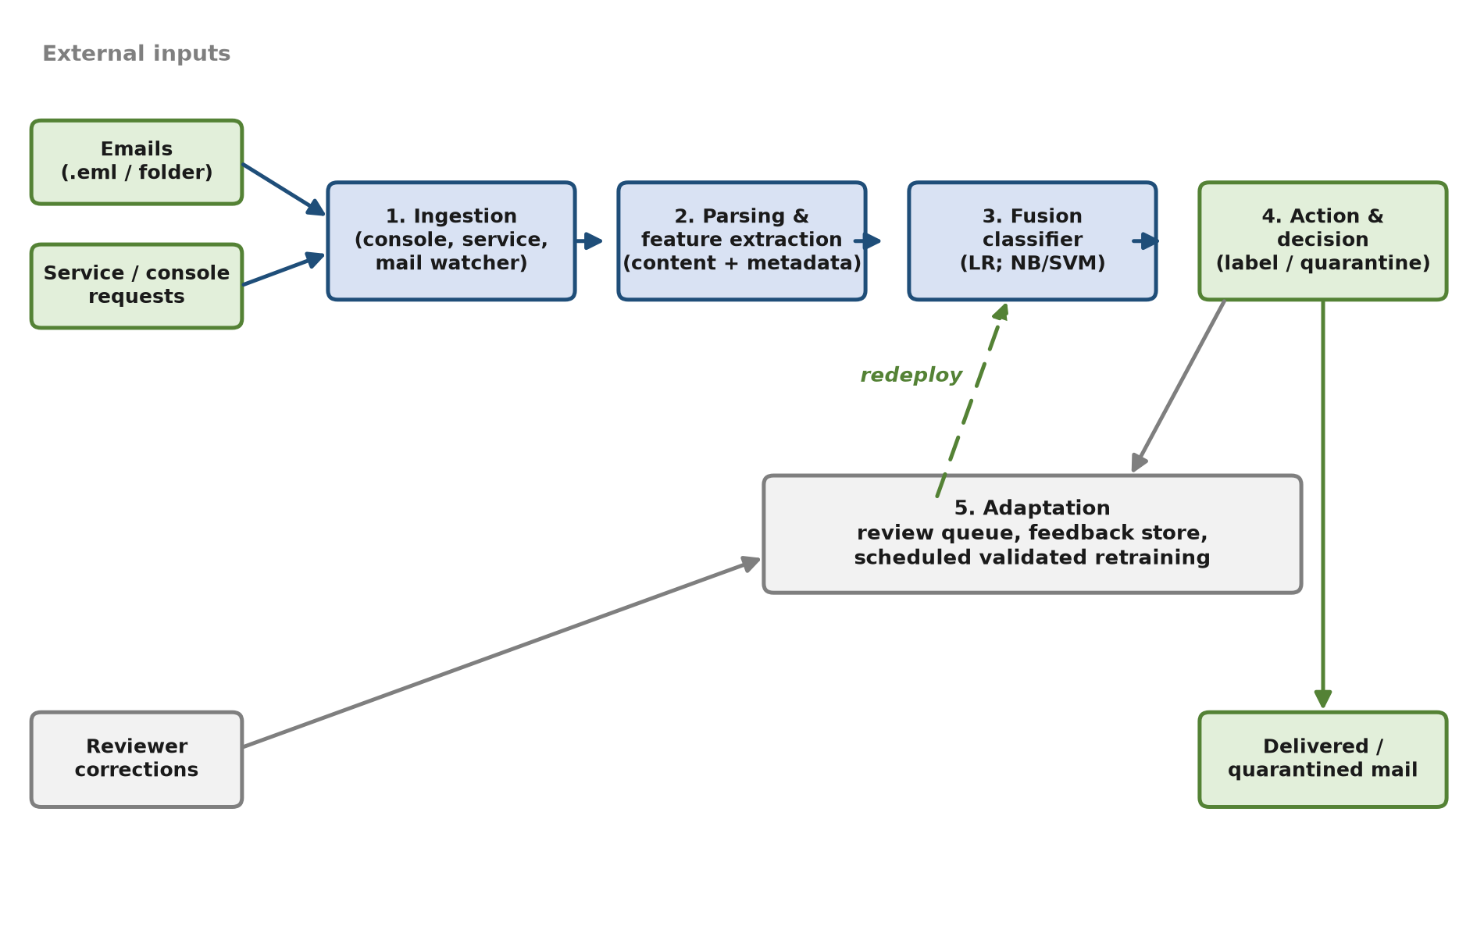
Figure 4.1: System block diagram of the five main blocks
Each block was implemented as an independent, testable module within the detector package, which allowed individual stages to be updated and retrained without rebuilding the whole pipeline. The following section specifies each block in turn.

REPLACE IN YOUR REPORT (12 of 22)
SECTION 4.2 - RESTRUCTURED: overview Table 4.1 + new subsections 4.2.1-4.2.5
Go to this section in your own report, delete its old contents, then copy everything under this banner (tables copy as tables).

4.2 System Components Specifications
The five blocks of Figure 4.1 were realised as eight functional components, summarised in Table 4.1 and then described in detail in Sections 4.2.1 to 4.2.5. Each component was kept independent so that it could be modified or replaced without affecting the others.
Table 4.1 — System components and their responsibilities.
Component | Block (Figure 4.1) | Responsibility
Email parsing and feature extraction | Parsing and feature extraction | Parsed each message and produced the content text together with the thirteen structural metadata signals.
Data preparation | Ingestion | Merged and de-duplicated the public corpora into one reviewed dataset.
Fusion classification engine | Fusion classifier | Combined content and metadata features and produced the label, probability and fired signals.
Detection service | Action and decision | Exposed the trained engine through a web interface with a review console.
Mailbox scanner | Action and decision | Monitored a mail folder and quarantined flagged messages.
Review and feedback store | Adaptation | Recorded reviewer corrections as labelled examples for retraining.
Training and evaluation | Fusion classifier | Fitted, validated and saved the model, and reported the metrics.
External (AI-mail) evaluation | Fusion classifier | Scored external and AI-generated sets and reported catch rate.

4.2.1 Data Ingestion and Preparation
The input to the system was an electronic-mail message, which could arrive in three ways: pasted into the review console, submitted to the detection service, or present as a file in a monitored mailbox folder. Before training, a data-preparation stage combined the several public source corpora into a single reviewed dataset. Because the same message sometimes appeared in more than one source corpus, the preparation stage de-duplicated the records on the normalised message content so that no email could appear in both the training and the held-out split; such leakage would otherwise have inflated the reported metrics. The stage also tolerated the practical inconsistencies of public data by handling several text encodings, raising the limit on very long email bodies, and accepting the different label conventions used by each source.

4.2.2 Email Parsing and Feature Extraction
Each message was parsed according to the standard Internet message format (RFC 5322) to separate the headers, the subject, the body and any attachments. Parsing was deliberately defensive: malformed links were handled without aborting, and a message that was plain text with no headers (as in the body-only AI-generated test sets) was still accepted, with the header-derived signals set to neutral values so that the feature structure was preserved. From the parsed message the extractor produced two outputs: the textual content (subject and body concatenated) for the content features, and a set of thirteen structural metadata signals described in Section 4.3.

4.2.3 Fusion Classification Engine
The classification engine was the core of the system and is specified in full in Table 5.3. It joined three feature branches into one sparse vector. Two branches described the text using term frequency–inverse document frequency: a word branch over one- and two-word terms (capped at 40,000 features) that captured phrasing, and a character branch over three- to five-character sequences (capped at 30,000 features) that tolerated obfuscation such as inserted symbols. The third branch encoded the thirteen metadata signals and scaled them so that their magnitudes did not overwhelm the text features. The scaled, combined vector was passed to a class-balanced logistic-regression classifier (regularisation strength C = 1.5), which output a spam probability; multinomial Naïve Bayes and a linear support-vector machine were also implemented and evaluated for comparison. A configurable decision threshold (0.55 by default) converted the probability into a spam-or-legitimate label, and the metadata signals that contributed most to a positive decision were returned as an explanation.

4.2.4 Detection Service and Mailbox Scanner
The trained engine was exposed in two ways. The detection service provided a web interface with a health check, a prediction endpoint and a feedback endpoint, together with a browser console in which a reviewer could paste an email, immediately see its label, probability and fired signals, and confirm or correct the decision. The mailbox scanner instead monitored a folder on disk and operated in one of three modes: report only (log decisions), quarantine (move flagged messages to a quarantine folder), or continuous watch (act on new mail as it arrived). Every decision, whether from the service or the scanner, was written to a review queue with a blank correction field awaiting human review.

4.2.5 Review, Feedback and Adaptive Retraining
The adaptation block closed the learning loop. When a reviewer corrected a decision in the console, the correction was saved as a labelled example in the feedback store. A scheduled retraining stage merged these reviewed labels with the original training data and fitted a new model, which was then evaluated on the held-out split before further use so that its effect on both the main corpus and the target threat could be measured. Retraining in scheduled batches rather than continuously prevented a small batch of feedback from silently degrading the detector, and it distinguished the system from both a static model and an uncontrolled online-learning loop.

REPLACE IN YOUR REPORT (13 of 22)
SECTION 4.3 - Table 4.2 signals in plain English; code snippets removed
Go to this section in your own report, delete its old contents, then copy everything under this banner (tables copy as tables).

4.3 Data and Feature Design
The thirteen structural metadata signals are defined in Table 4.2.
Table 4.2 — The thirteen structural metadata signals.
Signal | Meaning / rationale
Subject length | Phishing often uses unusually short or long subjects.
Body length | Length of the body in characters.
Number of links | Count of URLs in the body.
Distinct link domains | Number of different domains linked; many distinct domains suggest bulk campaigns.
Number of attachments | Count of attached files.
Sender has a domain | Whether the sender address contained a usable domain.
Sender–link domain mismatch | The sender's domain was absent from the body's link domains — a classic phishing signal.
Reply-To present | Whether a Reply-To header was present (a possible redirect of replies).
SPF authentication result | Whether a sender-policy-framework pass was indicated in the authentication headers.
DKIM signature present | Whether a DomainKeys-Identified-Mail signature header was present.
Capitals ratio in subject | Fraction of upper-case letters in the subject line.
Exclamation count | Number of exclamation marks in the subject and body.
Urgency term count | Number of urgent or verification-related terms (eleven-term list) found in the subject and body.
The subject and body were concatenated into a single content string so that both parts were represented in the text features. For plain-text inputs without headers (such as the body-only external sets), the parser treated the whole input as the body and set the header-derived signals to neutral values, preserving the feature-vector structure. Once trained, the model was saved to a single file so that the service and the mailbox watcher loaded an identical predictor. Keeping the metadata to thirteen signals deliberately avoided a large, fragile handcrafted rule set: unlike a keyword blocklist, each signal contributed a numeric feature whose weight was learned by the classifier rather than maintained by hand, satisfying the objective of an adaptive, learning-based system rather than a static rule engine.

REPLACE IN YOUR REPORT (14 of 22)
SECTION 4.4 - removed 'one-line commands' phrase
Go to this section in your own report, delete its old contents, then copy everything under this banner (tables copy as tables).

4.4 System Components Interaction Operations
Ingestion passed raw email text to the feature block, which returned a content string and a metadata dictionary. The fusion pipeline transformed these into a single vector and the classifier returned a probability. The action block compared the probability to the threshold, emitted a label and the fired signals, and — in quarantine mode — moved the file to a quarantine directory. Every decision was appended to a review queue with a blank correction field. The reviewer's corrections were written to the labelled feedback store; the retraining path merged those reviewed labels with the training data, fitted a new model, validated it on the held-out split, and replaced the deployed model only if performance was maintained. All randomness used fixed seeds for reproducibility, and the data-preparation, training and evaluation stages were each implemented as a single repeatable procedure, so that the entire system could be rebuilt from the public corpus by following Sections 4.2 and 4.3.

REPLACE IN YOUR REPORT (15 of 22)
CHAPTER 5 - opener + 5.1 Hardware + 5.2 Software + 5.3 Config + 5.4 Operation
Go to this section in your own report, delete its old contents, then copy everything under this banner (tables copy as tables).

CHAPTER 5: SYSTEM IMPLEMENTATION
This chapter explains how the design presented in Chapter 4 was implemented and operated. It describes the hardware used, the software environment and the role of each library, the configuration settings of the deployed model, and the commands used to train, evaluate and run the system, before discussing the implementation issues encountered and how they were resolved.

5.1 Hardware Setup
This section outlines the hardware used to develop, train and evaluate the spam-detection system. Because the detector used classical machine-learning models rather than deep neural networks, it trained and ran entirely on the central processing unit and needed no graphics processing unit, so it could be reproduced on an ordinary consumer laptop. The specifications of the development machine are summarised in Table 5.1.
Table 5.1 — Specifications of the development machine.
Description | Specifications
Model | [FILL IN: laptop brand and model, e.g. Acer Aspire 5 A514]
Processor | Intel Core i5-13420H (central processing unit only)
Operating system | Windows 11
Graphic | Intel UHD Graphics (integrated; no discrete GPU)
Memory | 24 GB
Storage | 475 GB SSD
Based on Table 5.1, the development and evaluation machine was a consumer laptop powered by an Intel Core i5-13420H processor with 24 GB of memory and 475 GB solid-state storage, running Windows 11. The machine used integrated Intel UHD graphics and had no discrete graphics processing unit, which was fully sufficient because the classical models trained and served predictions entirely on the central processing unit: training on the full corpus completed within minutes, and the median inference latency was approximately 13 milliseconds per email, as reported in Chapter 6.

5.2 Software Setup
The system was implemented entirely in Python using a dedicated virtual environment. The libraries used by the project, together with their version numbers, were recorded in a requirements text file (requirements.txt) so that the same software environment could be recreated on another machine, and these dependencies were installed into the virtual environment. Only mature, widely used open-source libraries were chosen so that the project could be understood and reproduced without proprietary software. The software stack and the role of each component are summarised in Table 5.2.
Table 5.2 — Software and libraries used in the project.
Software / package | Version | Purpose
Python | 3.13 | Main programming language for the detector, the service and the evaluation scripts
pip | 26.2.1 | Package manager used to install the required libraries from the requirements file
scikit-learn | 1.9.0 | Core machine-learning library: TF-IDF vectorisation, Naïve Bayes, logistic regression, support-vector machine and feature scaling
NumPy | 2.5.2 | Numerical array and matrix operations used alongside scikit-learn
SciPy | 1.18.1 | Sparse-matrix and scientific routines relied on by scikit-learn
Joblib | 1.5.3 | Serialising (saving) the trained model and loading it for prediction
FastAPI | 0.141.1 | Web framework that exposes the detector as a representational-state-transfer (REST) service
Uvicorn | 0.52.4 | Server that runs the FastAPI service and accepts prediction requests
Pydantic | 2.13.4 | Validates the data received in each request to the service
Matplotlib | 3.11.1 | Plots the evaluation and benchmarking results (classifier-comparison charts, ROC curves and the confusion matrix) used in the performance analysis
Python standard library (email, csv, re, urllib, pathlib, argparse, shutil, imaplib and others) | built-in | RFC-5322 email parsing, dataset and review-queue file handling, regular expressions, URL parsing, folder and command-line operations, quarantine moves and the secure live-mailbox connection
Table 5.2 lists the primary libraries the detection, evaluation and benchmarking work was built on. The performance measures themselves (accuracy, precision, recall, F1 score and latency) were computed with scikit-learn, while Matplotlib was used to visualise those results. The additional packages shown by the package manager (such as Starlette, AnyIO, Click, h11, httptools, watchfiles, websockets, pydantic-core, lxml, contourpy, kiwisolver and pillow) are supporting dependencies installed automatically alongside FastAPI, Uvicorn, scikit-learn and Matplotlib, rather than components used directly. A separate document-generation library was used only to assemble this report document and formed no part of the detection system. The virtual environment and the successful installation of the libraries are shown in Figure 5.1.
INSERT YOUR OWN PICTURE HERE — Figure 5.1: Software and virtual-environment setup
Based on Table 5.2, scikit-learn provided every machine-learning component, so no separate deep-learning framework was needed, which kept the installation light and the training fast on the central processing unit. The public corpus was prepared with a dataset-preparation script that merged the source comma-separated-value files, raised the field-size limit for long email bodies, handled multiple encodings and label formats, and de-duplicated the records. De-duplication was performed on normalised message content so that identical emails repeated across the merged corpora were counted once; this prevented the same message from appearing in both the training and the held-out split, which would otherwise have inflated the reported metrics. Training on the full corpus completed within minutes, and the resulting model file was small enough to be loaded instantly by the service.

5.3 Setting and Configuration
This section outlines the configuration steps required to prepare the environment, train the detector and connect it to a mailbox so that incoming messages are scored automatically. No paid service, cloud classification API or third-party scanning key was required: all classification is performed locally by the trained model, and the only credential involved is the mail-account application password used to read the mailbox. Each step below was performed once and is reproducible on any machine with Python installed.

5.3.1 Python Environment Configuration
1. Install Python 3.13 for Windows from python.org, selecting "Add python.exe to PATH". 2. Create the project virtual environment in the project folder so that the libraries are isolated from the system installation: python -m venv .venv 3. Activate the environment: .venv\Scripts\activate (the prompt is then prefixed with (.venv)). 4. Install the required libraries: pip install -r requirements.txt, which installs scikit-learn, FastAPI, Uvicorn, pandas, Matplotlib and Joblib together with their dependencies. 5. Verify the installation with pip list, as shown in Figure 5.1.
No configuration file, environment variable or administrator privilege is required for this stage.

5.3.2 Detector Configuration
The classifier settings were fixed at training time and are stored inside the saved model file, so the mailbox connector and the service load an identical predictor. The deployed decision threshold defaulted to 0.55 and was re-tuned per deployment using the threshold sweep; lowering the threshold increased recall at the cost of more false positives, which was useful when prioritising catch rate for AI-style mail. Table 5.3 lists the model and feature hyper-parameters.
Table 5.3 — Model and feature hyper-parameters.
Component | Setting
Word TF-IDF | n-grams 1–2; max 40,000 features; sub-linear TF
Character TF-IDF | char_wb; n-grams 3–5; max 30,000 features; sub-linear TF
Metadata vectoriser | DictVectorizer (sparse)
Metadata scaling | StandardScaler(with_mean=False)
Classifier | LogisticRegression(class_weight="balanced", C=1.5, max_iter=1000)
Decision threshold | 0.55 default; sweep-tunable
Random state | Fixed seed for reproducibility
In plain terms, the word and character TF-IDF rows controlled how the email text was turned into numbers: single words and two-word pairs (and three-to-five-character fragments) were counted, up to a fixed vocabulary size, with very frequent words dampened. The dictionary vectoriser turned the thirteen metadata signals into numerical features, and the standard scaler rescaled those signals so that a raw value such as body length could not outweigh the word features. The classifier used class-balanced weighting so that the spam and legitimate classes were treated fairly even if one was more common, with a regularisation strength of C = 1.5. The decision threshold of 0.55 meant an email was flagged as spam only when the model's spam probability exceeded 0.55; lowering it caught more spam but produced more false positives, and the threshold sweep used in evaluation chose a suitable operating point. A fixed random seed ensured that the same training run could be reproduced exactly.

5.3.3 Mail-Account Configuration for Live Filtering
To filter real incoming mail rather than pasted samples, the detector connects to a mail account over the Internet Message Access Protocol (IMAP), the same protocol ordinary mail clients use to read mail. A dedicated test account was used throughout, so that no third party's private correspondence was processed. The account was prepared as follows:
1. Create a dedicated test mail account used only for this project, so that no personal or third-party mail is read by the system. 2. Enable two-step verification on that account, which is a prerequisite for issuing an application password. 3. Generate an application password: in the account security settings, create a sixteen- character application password for the connector. The ordinary login password is never used and is never stored by the system. 4. Enable IMAP access in the mail account settings so that external clients may read the mailbox. 5. Supply the credentials as environment variables rather than editing any source file, so that no password is written into the code or the report:
$env:IMAP_USER = "the test address"
$env:IMAP_PASS = "the sixteen-character application password"
6. Run a read-only check first. The connector defaults to report mode, in which messages are scored and logged but nothing is moved or deleted: python -m spam_detection.imap_watch --action report 7. Enable automatic filtering once the read-only check succeeds: python -m spam_detection.imap_watch --action quarantine --watch

5.3.4 Filtering and Review Configuration
The connector's operational settings are summarised in Table 5.4. The server host and port are inferred automatically from the address domain for common providers, so in normal use only the account credentials must be supplied.
Table 5.4 — Mailbox connection and filtering configuration.
Setting | Value | Purpose
Protocol | IMAP over SSL/TLS (port 993) | Encrypted retrieval of new mail
Server host | Inferred from the address domain | Avoids manual server entry for common providers
Authentication | Sixteen-character application password, supplied as an environment variable | Avoids storing a password in code or configuration files
Action mode | report (read-only) or quarantine | Read-only scoring for testing; quarantine for live filtering
Quarantine folder | Spam_Quarantine | Flagged mail is copied there, never deleted
Poll interval | 10 seconds | Frequency at which the inbox is checked for new mail
Processed-message state file | imap_seen.txt | Prevents a message from being scored twice
Review queue | review_queue.csv | Records every decision so a reviewer can correct mistakes
Decision threshold | 0.55 | Probability above which a message is treated as spam
As shown in Table 5.4, the configuration was deliberately conservative: flagged mail is copied into a quarantine folder rather than deleted, the read-only mode allows the filter to be validated before it is allowed to move anything, and every decision is logged so that reviewer corrections can be fed back into the next retraining cycle described in Section 3.4.

5.4 System Operation (with Screenshots)
The system was operated through four stages. First, the public corpus was merged and de-duplicated into a single reviewed dataset, as described in Section 5.2. Second, the fusion model was trained on the training split and evaluated on the held-out split, after which the trained model was saved for deployment. Third, the external and AI-generated message sets were scored to measure generalisation to modern threats. Fourth, the detection service and the mailbox watcher loaded the saved model and served predictions, while reviewer corrections accumulated in the feedback store to be incorporated in the next retraining cycle. These stages could be triggered through short command-line instructions, which are listed in Table 5.5; the following figures illustrate the system in operation.
Table 5.5 — Command-line operations used to run the system.
Operation | Command
Create the virtual environment and install the libraries | python -m venv .venv ; .venv\Scripts\activate ; pip install -r requirements.txt
Train on the reviewed corpus, evaluate on the held-out split and save the model | python -m spam_detection.evaluate data/reviewed_mail.csv --save models/email_spam_detector.joblib
Score an external or AI-generated message set | python -m spam_detection.evaluate_external models/email_spam_detector.joblib data/llm_test.csv
Start the detection service and open it in a web browser | python -m uvicorn spam_detection.api:app --host 0.0.0.0 --port 8000
Monitor a mail folder and quarantine flagged messages | python -m spam_detection.scan_mailbox mail_inbox --action quarantine --watch
Filter a live mailbox automatically over IMAP | python -m spam_detection.imap_watch --action quarantine --watch
Retrain from reviewer corrections | python -m spam_detection.feedback review_queue.csv
As shown in Table 5.5, every stage of the workflow was reproducible from a single command, which kept the environment easy to recreate on any machine with Python installed and required no graphics-processing hardware. The complete source code is provided in the accompanying submission archive, organised into the modules described in Section 4.2.

5.4.1 Checking an Email in the Review Console
The review console was the manual entry point to the detector. A reviewer pasted the complete source of an email into the console and submitted it for scoring. The console returned the predicted label, the spam probability, a confidence value and the list of structural signals that fired for that message, so that the verdict could be interpreted rather than merely accepted. Figure 5.2 shows the console after a phishing message was submitted.
INSERT YOUR OWN PICTURE HERE — Figure 5.2: Browser check-and-review console showing a phishing verdict and fired signals
Figure 5.2 shows the console classifying a credential-harvesting message as spam. The probability bar reports the score assigned by the model, and the signal chips beneath it name the structural evidence that contributed to the decision, including the mismatch between the sender domain and the domain of the embedded link and the presence of a reply-to address different from the sender.

5.4.2 Service Prediction Response
The same detector was exposed as a local service so that other software could obtain a verdict programmatically rather than through the browser. A client submitted the raw email to the prediction endpoint and received a structured response. Figure 5.3 shows a response returned by the service.
INSERT YOUR OWN PICTURE HERE — Figure 5.3: Example service prediction response (label, probability and signals)
Figure 5.3 shows the response for a single message, containing the predicted label, the spam probability, the confidence value and the named structural signals. Returning the signals alongside the verdict allowed a calling system to log why a message was flagged, which was a requirement for the review and appeal process described in Section 4.4.

5.4.3 Mailbox Watch and Quarantine
The mailbox watcher applied the detector to a folder of stored messages rather than to a single pasted email. Each message file was parsed, scored and recorded in the review queue; in quarantine mode a flagged message was moved into a separate quarantine folder while legitimate mail was left untouched. Figure 5.4 shows a watch run in progress.
INSERT YOUR OWN PICTURE HERE — Figure 5.4: Mailbox watch run quarantining a flagged message
Figure 5.4 shows the watcher processing a folder containing both legitimate and phishing messages. Each line reports the verdict and the probability for one message, and the flagged messages are reported as moved to the quarantine folder. Nothing was deleted at any point: the quarantine folder retained every flagged message so that a false positive could be recovered.

5.4.4 Live Mailbox Filtering over IMAP
To confirm that the connector operated outside a controlled local folder, it was run against a live mailbox hosted by a commercial provider. A disposable account was created for the purpose, application-specific credentials were issued for it, and four test messages were sent to it: one ordinary message and three phishing messages of the credential-harvesting, fraudulent invoice and account-suspension types. The connector authenticated over an encrypted IMAP connection on port 993, retrieved each message in its complete RFC 5322 form and scored it with the same saved model used throughout Chapter 6, with no change to the classifier, its features or its decision threshold.
An unanticipated but instructive observation arose during this run. The provider applied its own filter before delivery and placed all four test messages, including the legitimate one, in its spam folder, so that none of them reached the inbox. The connector was therefore directed at that folder instead, which had the useful effect of turning the exercise into an independent second opinion on messages the provider had already judged. Figure 5.5 records the result.
INSERT YOUR OWN PICTURE HERE — Figure 5.5: Live IMAP run scoring four messages retrieved from a commercial mailbox, showing three phishing messages flagged and one legitimate message released
Figure 5.5 shows that the three phishing messages were assigned spam probabilities of 97.6%, 98.7% and 99.8% and were flagged, whereas the legitimate message received 27.4% and was correctly released. The proposed detector therefore agreed with the provider on the three phishing messages and disagreed on the one legitimate message, which the provider had filtered and the detector had not. This single observation is a demonstration of deployment, not a measurement of comparative accuracy, and no general claim about the relative performance of the two systems is drawn from it; the quantitative results in Chapter 6 rest entirely on the held-out corpus and the external test sets. It does, however, confirm that the detector operates correctly on live network mail.

5.4.5 Reviewer Feedback and Retraining
Every message scored by either watcher was written to the review queue, and the console presented those messages to a reviewer for confirmation or correction. For each message the reviewer either confirmed the verdict or recorded the correct label; a verdict entered by mistake could be changed simply by selecting a different one, and only the most recent verdict for a message was retained. Corrections accumulated in the feedback store and did not alter the deployed model until retraining was explicitly requested. Figure 5.6 shows the review inbox.
INSERT YOUR OWN PICTURE HERE — Figure 5.6: Review inbox showing scored messages with confirm and correct controls, and the retraining control
Figure 5.6 shows the queued messages with their verdicts and probabilities, the controls used to confirm or correct each one, and the control that starts a retraining cycle. When retraining was requested, a candidate model was trained on the historical corpus together with the accumulated corrections and was compared with the deployed model on the held-out split; the candidate replaced the deployed model only if it did not reduce ranking quality. This validation gate is discussed further in Section 7.2.

REPLACE IN YOUR REPORT (16 of 22)
CHAPTER 6 - new opener paragraph
Go to this section in your own report, delete its old contents, then copy everything under this banner (tables copy as tables).

CHAPTER 6: SYSTEM EVALUATION AND DISCUSSION
This chapter reports and discusses the experimental results. It describes the testing setup and the metrics used, presents the performance of the three classifiers in both content-only and fused configurations, examines precision, recall, the false-positive rate, latency and the effect of the decision threshold, evaluates the adaptive-retraining mechanism, and assesses each objective against the measured evidence.

REPLACE IN YOUR REPORT (17 of 22)
SECTION 6.2.2 - classifier comparison rewritten as prose (no commands)
Go to this section in your own report, delete its old contents, then copy everything under this banner (tables copy as tables).

6.2.2 Classifier and Feature-Group Comparison (Objective 3)
The three classifiers — multinomial Naïve Bayes, class-balanced logistic regression and a linear support-vector machine — were each trained and evaluated under two feature configurations: content features only, and the full content–metadata fusion. All five resulting configurations used the same training and held-out split, the same preprocessing and the same decision threshold, so that the comparison reflected only the choice of classifier and feature set. For each configuration the accuracy, precision, recall, F1 score and ROC-AUC were recorded on the held-out split; the commands used are listed in Table 5.5. The results on the full 81,152-email corpus are summarised in Table 6.2. The support-vector machine's iteration limit was raised from the default 1,000 to 10,000 because the default value produced a convergence warning on the large fused feature set; with this setting the metrics were stable and effectively unchanged beyond that point.
Table 6.2 — Classifier and feature-group comparison (held-out split, default 0.5 threshold).
Configuration | Accuracy | Precision | Recall | F1 | ROC-AUC
Naïve Bayes (content only) | 0.968 | 0.988 | 0.950 | 0.969 | 0.997
Logistic regression (content only) | 0.988 | 0.987 | 0.990 | 0.989 | 0.999
Linear SVM (content only) | 0.992 | 0.990 | 0.993 | 0.992 | 1.000
Logistic regression (content + metadata fusion — deployed) | 0.992 | 0.990 | 0.994 | 0.992 | 1.000
Linear SVM (content + metadata fusion) | 0.993 | 0.992 | 0.995 | 0.993 | 1.000
All configurations were trained and evaluated on the same 75/25 stratified split, using the classifier's default 0.5 decision threshold so that the five configurations were compared under identical conditions. The deployed mailbox tool instead operates at a tuned threshold of 0.55 (Table 5.3), which is why the deployed-fusion precision/recall pair reported for the production operating point in Table 6.1 (precision 0.991, recall 0.992) differs slightly from the default-threshold figures here; accuracy and F1 are identical at 0.992.
The five configurations were compared metric by metric on the same held-out split.
In terms of accuracy, the Naïve Bayes baseline was the weakest at 0.968, while all learned classifiers reached the high nineties: content-only logistic regression improved to 0.988, the content-only support vector machine reached 0.992, and fusing the structural metadata raised the two linear classifiers further, with the fusion support vector machine at 0.993 and the deployed fusion logistic regression at 0.992. The differences above 0.99 were small, indicating that the word/character TF-IDF representation already separated the classes very well on the public corpus, but fusion consistently removed a few additional errors.
For precision, Naïve Bayes actually recorded the highest standalone value (0.988) because it predicted spam conservatively; however, this conservatism came at the cost of the lowest recall (0.950), meaning it missed roughly five percent of phishing. Among the learned classifiers the fusion support vector machine had the highest precision (0.992) and the fusion logistic regression 0.990, so almost every message flagged as spam was genuinely malicious.
Recall was the operationally important metric for a filter, because it measured how much phishing was actually caught. Here the fusion models were best, with the fusion support vector machine at 0.995 and the deployed fusion logistic regression at 0.994, both above their content-only forms (0.993 and 0.990). Adding the thirteen metadata signals therefore bought additional phishing recall, as intended in the fusion design. The F1 score, which balances precision and recall, followed the same ordering, with the two fusion classifiers highest (0.993 and 0.992). Finally, the ROC-AUC measured how reliably each model ranked spam above legitimate mail regardless of threshold; every learned configuration reached 0.999 or 1.000, indicating near-perfect ranking on the held-out corpus.
The fusion support vector machine had the marginally highest raw numbers, but the fusion logistic-regression model was selected for deployment for two operational reasons. First, logistic regression outputs a spam-probability estimate that can be compared with a configurable threshold (the deployed 0.55) and allows a confidence value and signal explanation to be shown, whereas the support vector machine's decision scores are not directly interpretable as probabilities. Second, the two fusion models were effectively tied in performance (accuracy 0.992 versus 0.993), so the model that provided a tunable threshold, explainable outputs and equally strong results was preferred. The results therefore supported the fusion design and the choice of a probability-based, explainable classifier over the marginally higher-scoring alternative.
The support-vector-machine fusion model edged logistic regression by one to two thousandths in the reported metrics, but logistic regression was selected for deployment for operational rather than raw-accuracy reasons: it produced a genuine probability that could be compared against the configurable decision threshold (a margin-mapped support-vector score is not a probability), it supported balanced class weighting and it exposed interpretable per-signal coefficients. Because both fusion models sat at ROC-AUC 1.000 on this corpus, the choice reflected these practical properties rather than a meaningful performance difference.

REPLACE IN YOUR REPORT (18 of 22)
SECTION 6.2.4 - adaptive demonstration sentence fixed
Go to this section in your own report, delete its old contents, then copy everything under this banner (tables copy as tables).

6.2.4 Adaptive Improvement (Objective 4)
After retraining on a disjoint, reviewed batch of modern AI-style and business-email-compromise emails, detection ranking on a held-out modern-threat set improved from ROC-AUC 0.81 to 0.945, and phishing recall at a near-zero false-positive point rose from 0.810 to 0.945 — a 16.7% relative improvement in ranking quality — while main-corpus accuracy was maintained (0.991). Table 6.4 summarises the change; in a controlled before/after demonstration on a held-out new campaign, the number of campaign messages caught rose from 0 out of 6 before retraining to 5 out of 6 after a single reviewed retraining cycle.
Table 6.4 — Before/after one adaptive retraining cycle on held-out modern-threat email.
Measure | Before retraining | After retraining
ROC-AUC (modern set) | 0.81 | 0.945
Phishing recall at threshold 0.55 | 95% | 95%
Main-corpus accuracy | 0.991 | 0.991 (maintained)
Demo campaign caught (held-out set) | 0 / 6 | 5 / 6
The improvement was greatest for threat types actually represented in the reviewed feedback; this scope was reported honestly rather than claiming universal adaptation. The same before/after comparison was also applied to a second, independent held-out set, on which the baseline detector was already close to its ceiling at ROC-AUC 0.965 and 100% recall. After the same retraining cycle, recall on that set remained at 100% while ROC-AUC moved slightly to 0.951. Adaptation therefore did not improve a set on which there was effectively no headroom to gain, and the small change in ranking quality is within the variation expected from refitting on a marginally different training sample. This outcome is reported because it delimits the claim: reviewed feedback improves detection for threat families the baseline handles poorly, and neither improves nor materially harms performance where the baseline is already near-perfect. The retraining cycle was run as a scheduled batch step, and the retrained model was evaluated on the held-out data before further use, confirming that main-corpus accuracy was maintained while the target threat ranking improved. Retraining in controlled batches rather than continuously distinguished the system from both a static model and an uncontrolled online-learning loop. The improvement in ranking is visualised by the two ROC curves, before and after retraining, in Figure 6.4.
INSERT YOUR OWN PICTURE HERE — Figure 6.4: ROC curves before and after one adaptive retraining cycle

6.2.5 Comparison with Existing Systems and Commercial Filters
Two comparisons were made to position the proposed model relative to the systems reviewed in the literature. The first (Table 6.5) concerned commercial mail providers. Google reported blocking more than 99.9% of spam, phishing and malware in Gmail with machine-learning models, including a large-language-model component that alone blocked about 20% more spam than the previous system [10], and Microsoft reported very high efficacy for its Defender for Office 365 e-mail protection [11]. These figures were aggregate production statistics reported by the vendors rather than per-class accuracy, precision, recall or F1 measured on a fixed labelled test set; the commercial providers did not publish such metrics, and Yahoo Mail published no comparable vendor figure at all.
Independent, peer-reviewed measurement did exist, however. Opara, Modesti and Golightly created controlled accounts on Gmail, Outlook and Yahoo and sent the same set of 63 GPT-4o-generated phishing emails to each provider, recording how many each filter flagged [17]. On that test Yahoo was the most aggressive, flagging roughly 90% of the AI-phishing messages, Gmail flagged about 14% and Outlook only about 4%; the same study found that Yahoo's aggressive setting produced a high false-positive rate, flagging roughly 60–67% of legitimate AI-written mail, whereas Gmail and Outlook rarely over-blocked [17]. These were independent measured values rather than vendor claims, but they came from a small, one-shot sample of 63 messages on a different corpus from the 4,986 used here, so they were indicative rather than strictly identical in protocol; the authors themselves noted the limited scale. Table 6.5 lists both the vendor-reported and the independently measured figures. No claim of strict superiority was made because the test sets differed; the proposed model's 92% catch on a much larger, unseen AI-phishing set with an approximately 0.9% main-corpus false-positive rate nonetheless compared favourably, particularly against Gmail and Outlook, and without Yahoo's high false-positive cost. Replicating this controlled black-box protocol on one shared labelled corpus was retained as Recommendation 2 (Section 7.2).
Table 6.5 — Commercial-filter comparison: vendor-reported block rates and independently measured detection of AI-generated phishing (independent study by Opara et al. [17]).
System | Vendor-reported overall block rate | AI-phishing flagged (independent, n = 63) [17] | Legit AI-mail wrongly flagged (false positive) [17]
Gmail (Google) | > 99.9% block rate (vendor aggregate) [10] | ≈ 14% flagged (≈ 86% bypassed) | Low (≈ 1.6%)
Outlook / Microsoft 365 | High efficacy reported; no numeric metric public [11] | ≈ 4% flagged (≈ 97% bypassed) | ≈ 0%
Yahoo Mail | No vendor figure published | ≈ 90% flagged (≈ 10% bypassed) | High (≈ 59–67%)
Proposed fusion model (this project) | — | 92% catch on 4,986 unseen AI-phishing (Table 6.3) | ≈ 0.9% FPR on held-out main corpus (Table 6.1)
Unlike the proprietary commercial filters, the proposed system is open-source and runs entirely locally, so its results are reproducible and can be benchmarked offline, whereas the providers' models cannot be independently re-tested.
The second comparison (Table 6.6) concerned published classical models evaluated on the same family of public corpora used in this project (Enron, SpamAssassin, Ling-Spam, CEAS-2008, Nazario and Nigerian-Fraud). The figures were taken from recent comparative studies [6], [7], restricted to the classical machine-learning classifiers comparable to the deployed system. Because the studies used different splits, preprocessing and corpora combinations, the numbers were indicative rather than strictly identical in protocol; the dataset/setting is shown for each row. The proposed fusion model reached 99.2% accuracy on a merged 81,152-email corpus drawn from exactly these sources, running on a commodity central processing unit at about 16 milliseconds per email with no graphics processor and while exposing interpretable metadata signals.
Table 6.6 — Comparison with published classical models on comparable public corpora.
Method | Type | Corpus / setting | Reported accuracy
Multinomial Naïve Bayes | Classical ML | Spambase / phishing corpora [7] | ~79–88%
Support vector machine | Classical ML | Enron1; merged corpora [6], [7] | ~98–99%
Random forest | Classical ML | Spam/Spambase; phishing corpora [7] | ~97–99.9%
Proposed fusion LR (word+char TF-IDF + 13 metadata) | Classical ML (fusion) | Merged Enron/Ling/SpamAssassin/CEAS/Nazario/Nigerian, 81,152 emails | 99.2% (CPU, ~13 ms/email)
The interpretation was twofold. First, on the standard public-corpus task the proposed classical fusion model sat at the level of the strongest reported classical results, consistent with the observation that stylistically distinct public-corpus classes were relatively easy to separate and that most published systems saturated the high-nineties there. Second, the real differentiator was not the saturated benchmark number but the system's properties: local and fully reproducible, fast on a central processing unit, explainable through its metadata signals, and — through the reviewed retraining loop — able to adapt, with demonstrated improvement on unseen modern and AI-generated phishing (Sections 6.2.3 and 6.2.4).

REPLACE IN YOUR REPORT (19 of 22)
SECTION 6.4 - objectives table cells genericised
Go to this section in your own report, delete its old contents, then copy everything under this banner (tables copy as tables).

6.4 Objectives Evaluation
Table 6.7 maps each objective to its outcome and evidence.
Table 6.7 — Objectives evaluation summary.
Objective | Status | Evidence
1. Extract content + metadata features | Achieved | Content and metadata extraction component; thirteen metadata signals (Table 4.2)
2. Content–metadata fusion framework | Achieved | FeatureUnion pipeline with standardised metadata (Sections 3.3 and 4.2)
3. Train/evaluate NB, LR, SVM | Achieved | Classifier comparison experiment; Table 6.2
4. Adaptive retraining maintains accuracy | Achieved | ROC-AUC 0.810 → 0.945; recall maintained at 95% (Table 6.4)
Objective 1, extracting content and metadata features, was achieved. The system extracted both word- and character-level content features using term-frequency inverse-document-frequency weighting, together with thirteen structural metadata signals (Section 4.2, Table 4.2) such as link counts, the mismatch between the sender domain and linked domains, and authentication indicators; a message was therefore judged on both what it said and how it was structured, rather than on either source alone.
Objective 2, a content–metadata fusion framework, was achieved. The content and metadata streams were combined in a single sparse pipeline in which the metadata signals were standardised before being fused with the text features (Sections 3.3 and 4.2), allowing one classifier to reason over content and metadata jointly rather than as separate decisions.
Objective 3, training and evaluating Naïve Bayes, logistic regression and the support-vector machine, was achieved. All three classifiers were trained and evaluated on the same stratified 75/25 split under identical settings (Table 6.2); the fused logistic-regression model was selected for deployment because it matched the best reported accuracy while also providing probability estimates and a tunable decision threshold.
Objective 4, adaptive retraining that maintained accuracy, was achieved. After one reviewed retraining cycle on modern threat email, ranking performance on a held-out modern-threat set rose from ROC-AUC 0.81 to 0.945 and recall at a near-zero false-positive point rose from 0.810 to 0.945, while recall was maintained at 95% and accuracy on the main corpus was maintained at 0.991 (Table 6.4), demonstrating measurable adaptation to new threat styles without degrading normal performance.

REPLACE IN YOUR REPORT (20 of 22)
CHAPTER 7 - new opener paragraph
Go to this section in your own report, delete its old contents, then copy everything under this banner (tables copy as tables).

CHAPTER 7: CONCLUSION AND RECOMMENDATION
This final chapter concludes the project. It first summarises what was achieved and how the results satisfied each of the four objectives stated in Chapter 1, then reflects on the limitations of the present system and recommends directions for future work, including a direct comparison with commercial filters on the same emails and deployment in a live mail environment.

REPLACE IN YOUR REPORT (21 of 22)
APPENDIX B - placeholder wording genericised
Go to this section in your own report, delete its old contents, then copy everything under this banner (tables copy as tables).

Appendix B — Full Classifier Output and Confusion Matrices
[FILL IN: paste the complete classifier-comparison output table and the per-configuration confusion matrices produced during the evaluation described in Section 6.2.]

REPLACE IN YOUR REPORT (22 of 22)
APPENDIX D - NOW contains the full command reference
Go to this section in your own report, delete its old contents, then copy everything under this banner (tables copy as tables).

Appendix D — Weekly / Bi-weekly Log
[FILL IN: insert at least six bi-weekly/weekly progress report forms signed by the supervisor.]

