**Q1:** Using the BNF grammar below show a **parse tree** and a **leftmost derivation** for each of the following 4 statements:

1. A = ( A + B ) * C

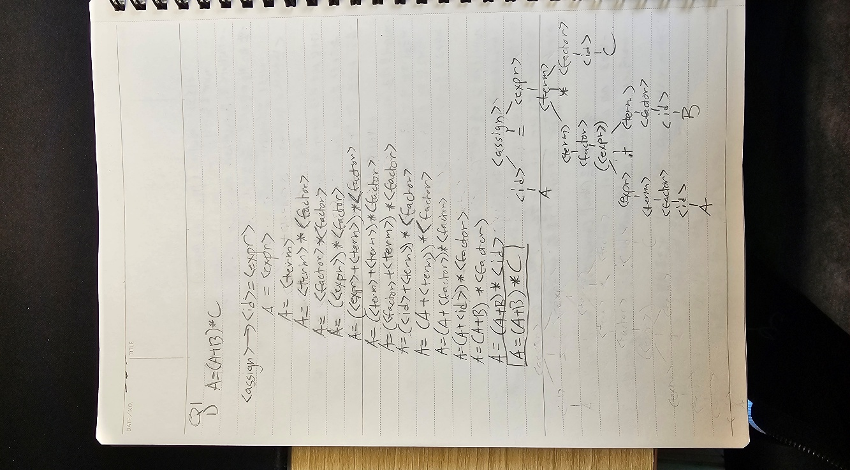

1. A = B + C + A

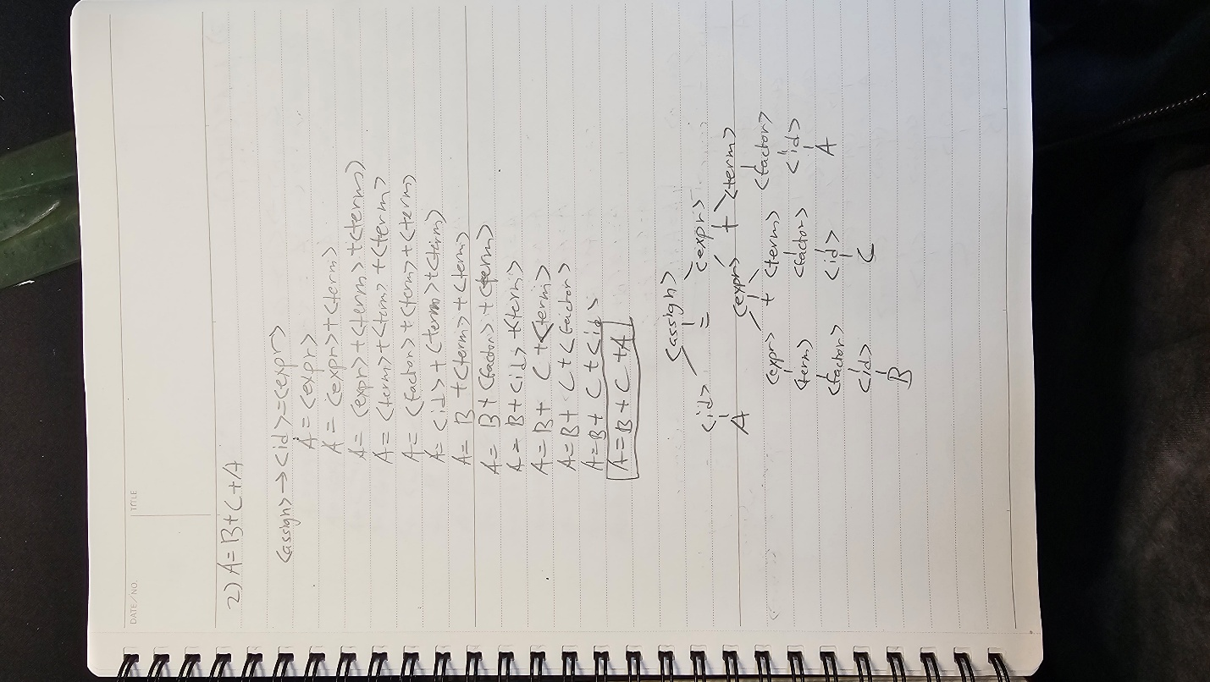

1. A = A * (B + C)

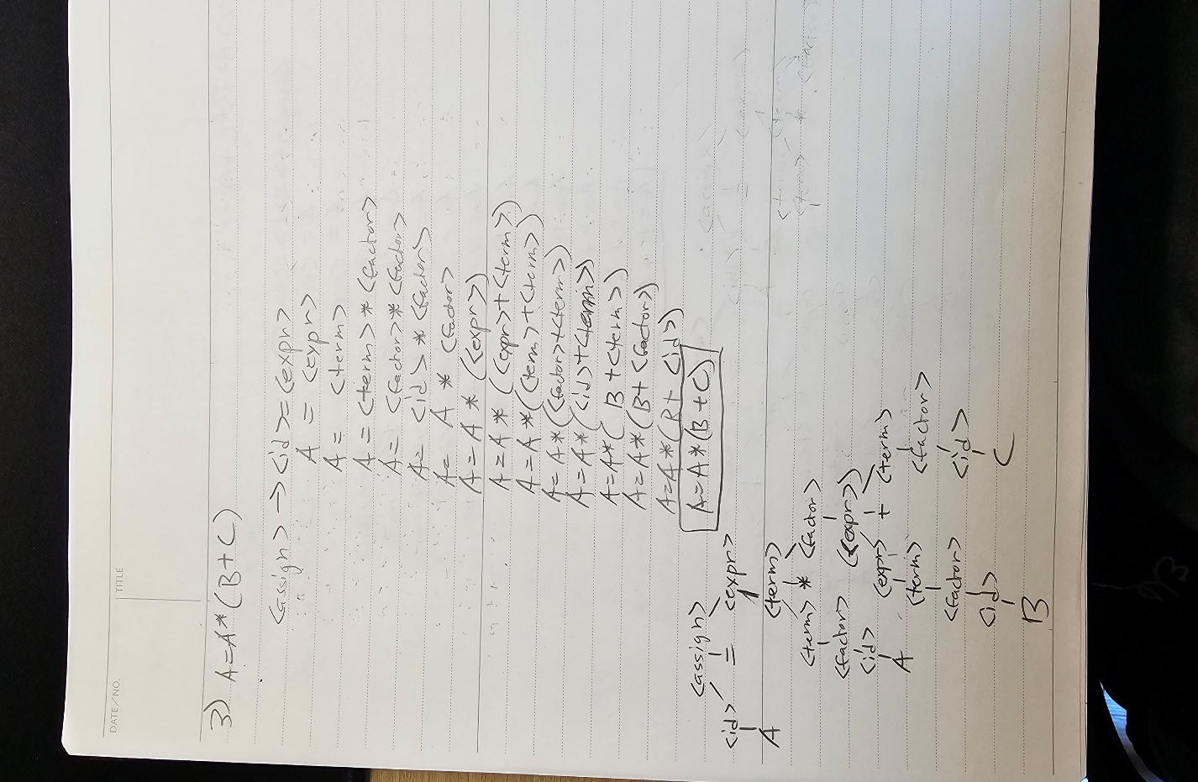

1. A = B + (C * (A * B))

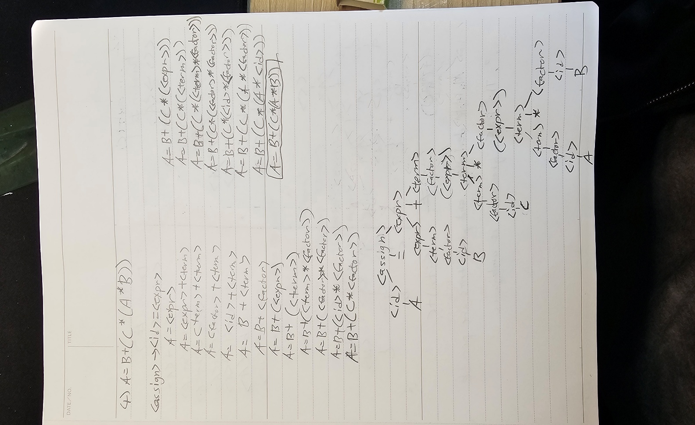

|  |
| --- |
| BNF grammar |
| <assign> →  <id> = <expr>  <id>  A | B | C  <expr> →  <expr> + <term> | <term>  <term> → <term> * <factor> | <factor>  <factor> → ( <expr> ) | <id> |

**Q2:** Prove that the following grammar is ambiguous:

|  |
| --- |
| BNF grammar |
| <S> → <A>  <A> → <A> + <A> | <id>  <id> → a | b | c |

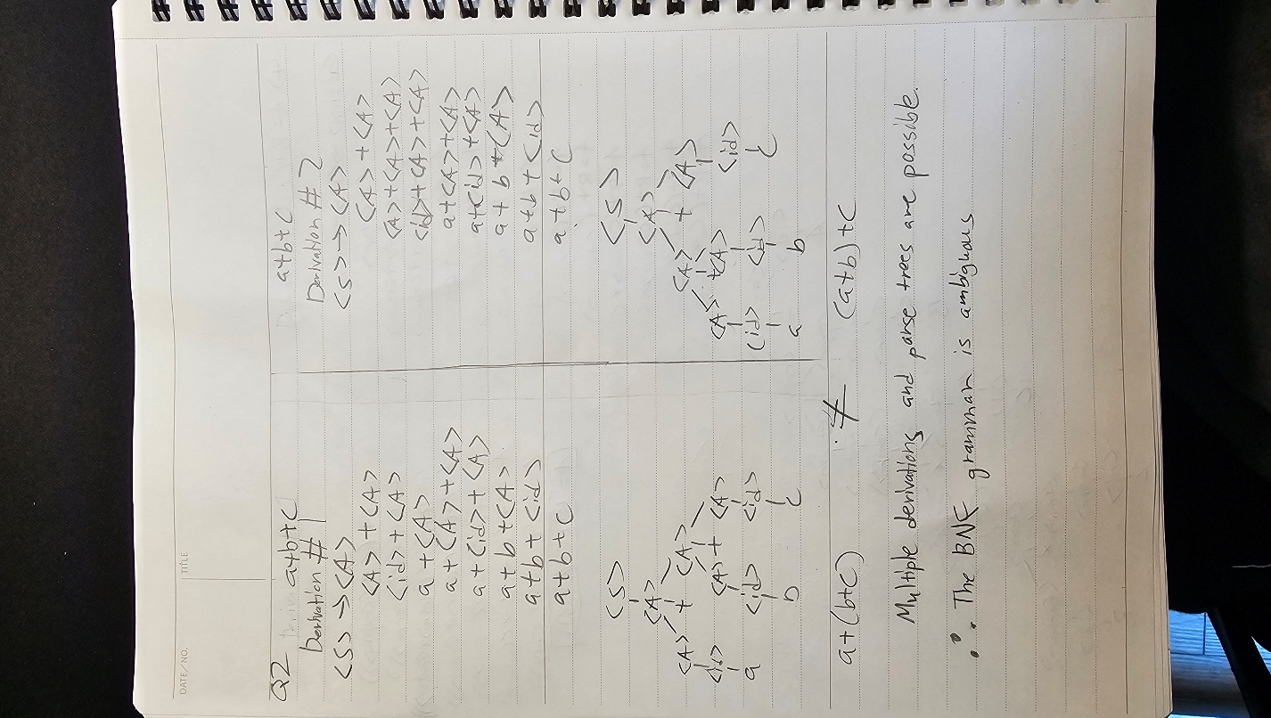

**Q3:** Modify the grammar below to add a unary minus ─ operator and ^ power operator that have higher precedence than either + or *.

Thus, the precedence of the operators in the final BNF should be ranked from the **highest** to the **lowest** as follows: ( ) , ─ , ^ , * , +

Also, all the operators have left associativity except the power operator ^ and unary minus ─ , which have right associativity.

|  |
| --- |
| BNF grammar |
| <assign> →  <id> = <expr>  <id>  A | B | C  <expr> →  <expr> + <term> | <term>  <term> → <term> * <factor> | <factor>  <factor> → ( <expr> ) | <id> |

