In this assignment, you are going to implement in Python a simple selling software for a store chain (for example: Home Store). We assume that the chain has several stores. In addition, these stores will sell their products to customers through the store’s staff.

Create the following Classes:

Store class with the following private instance data (ID, Name, Address, Tel)

- Properties, setter, and object __str__ functions must be implemented.

Staff class with the following private instance data (ID, SSN, Name, Address, JobTitle, salary)

- Properties, setter, and object __str__ functions must be implemented.

Customer class with the following private instance data (SSN, Name, Address, Purchasing_Points, Tel, Memberships[])

- Properties, setter, and object __str__ functions must be implemented.
- Purchasing_Points is an integer number that represents the points the customer receives when he buys products.
- Membership is a list of string that represents the memberships the customer has. These memberships could be good to get some discounts on the purchased products
Product class with the following private instance data (ProductCode, Name, Description, Price, Points)

- Properties, setter, and object __str__ functions must be implemented.
- Point type is an integer that represents the number of points that a customer will receive if they buy that product. When a customer receives a specific number of points, they will receive a gift from the store chain.

Order class (it is a composite class) represents each customer order that will be handled by a staff member at a specific store of the chain. Therefore, each order will have private objects that hold all the information of the order. (Store_object, Customer_Object, Staff_Object, Product_Objects [] , Quantity)
- Product_Objects [] is a list of products the customer wants to buy from the store.
- Quantity is either the total quantity of the order or the list of quantities of all products in the order.
- Implement the addProduct method that will add a product object to the Product_Objects list.
- Implement printReceipt method that will print a receipt including store information, staff member name, customer Store ID and name, list of all products he wants to buy with their price, quantity of each product, and the total money and points of the order.
Order
- Store_object
- Customer_Object
- Staff_Object
- Product_Objects []
- Quantity

Staff
- JobID
- JobTitle
- Salary
+

Customer
- ID
- Purchasing_Points
- Tel
- Memberships[]
+

Store
- ID
- Tel
+

Store Chain
- Name
- Address
+
Citizen
- SSN
- Name
- Address
+
Product
- ProductCode
- Name
- Description
- Price
- Points

Some functions or classes are not used and are only used to evaluate your coding. You can also add more instance data and functions to the classes as you want.

Console application
- Create one Store object
  - Print the store information on the screen
- Create at least two Customers and two staff members of the store.
  - Print the object's information on the screen [nice format].
- Create one order that includes several products for a customer
  - During the order, prompt the user to enter the product's information and quantity
  - Print the Receipt on the screen (Python console), similar to (minor changes are acceptable) the following image. ST is the store ID.

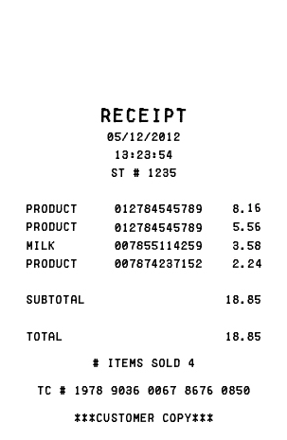
Product Name ProductCode Price Q
Total Points: 336456
Welcome to HomeStore
Staff: Kim YoungJae
Custmer ID: 102155222554

1
1
1
1

