2021315385
이건 Gun Daniel Lee

- To enable random number generation, the random module was imported. Two lists were made, the “numbers” list that will store the 200 random values, and a “counter” list that will store the counter for the 5 categories using 5 indices, respectively. Using a for loop, 200 integer values between 1 and 100 will be generated. These values will increment the respective counter index using the if and elif conditional blocks, then the value will be appended to the “numbers” list. After the for loop, the sort() function will be used to sort the values of the “numbers”. Once sorted, another for loop will be used to print out the sorted values in the requested format. Since the format had 10 rows, the for loop will have a step of 20 to print 20 values per row. This can be done using a string formatting method and an “inline” for loop to print 20 values. After the formatted printing, one last for loop will be used to print the star graph. For this for loop, the formatting will contain each category’s range values, the right amount of stars (by multiplying the stars by each counter index), and the counter values.
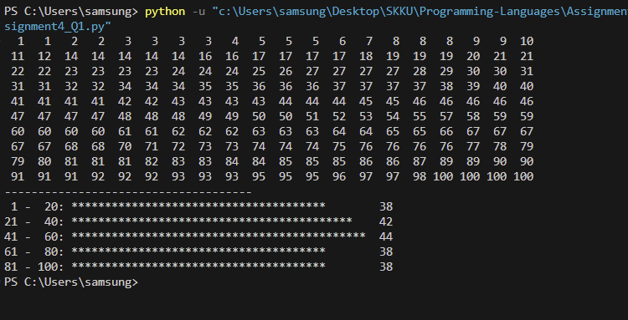

- First, the recursive function recursiveAddition(n) was constructed. When receiving a parameter of ‘n’, this function will return the sum of all positive integers from 1 up to ‘n’. To enable this recursive sum, each recursiveAddition() function will return the sum of its argument and the result of recursiveAddition() with the parameter ‘n – 1’. If the received argument is 0, then the returned value is 0. The return value of 0 was still considered since the function should still work if 1 was the argument. Now in the main function, we will use a while loop that is always True, to continuously receive an input until “Exit” is received. When an input is received, the string will first be compared with the “Exit” string. If the input string is “Exit”, the program will break out from the while loop, ending the program. If not, the program will check and make sure the input string is a digit. If not, the program will print an error message and go to the next loop. If an integer value is received, since the requested program is the recursive sum of all numbers before the received number, the main function will call the recursiveAddition() function and use the received number minus 1 as the argument.

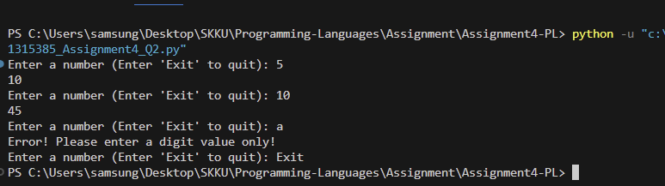

- This function makes use of two functions, isPrime() and primeChecker(). The isPrime() function’s main purpose is to check if the received parameter is a prime number or not. Three “outlier” conditions were defined using if statements before the main prime number checking code. First, if a value is below 2, it is not a prime number, so the function returns false. Second, if the value is 2, it is a prime number, so the function returns true. Lastly, all even numbers are not prime, so using mod, if a number divided by 2 does not have a remainder, it should return false. Now to check if a number is prime, it should not have an odd numbered factor less than its square root. So using a while loop, the function will check for any factors of the number while the odd number is still smaller or equal to the square root of the number. If a factor was found, the function will return false. Else, it means that it is prime, so the program will return True.

The primeChecker() function finds the prime number at rank n, where n is its argument. We will make use of a counter to check for the prime number’s rank. Now using a while loop, the function will increment a “num” variable by 1 and call the isPrime() function to check if the value is prime. The “num” variable will continually increment until a prime number is detected. When detected, the “counter” will be increased, and the counter will be compared with the requested rank n. If the counter finally reaches the requested rank n, the function will return the “num”, which will then store the prime number at the rank n.

For the main function, the program will be in an infinite loop to receive an input. Since the question did not specify an exit condition, the program will run infinitely until an interrupt (keyboardInterrupt, etc.) occurs. Once an input is received, the main function will make sure to check if it is a digit. An error message will be printed if the input is not a digit, as well as if a 0 or smaller value is detected. Now, the program will print the formatted text, and use the primeChecker() function to find the requested prime number at rank n.

