Week 3 - Le Dinh Hieu

Link project githup: https://github.com/leehie1209/Project_2_20241.git

Completed result

* Complete circuit design

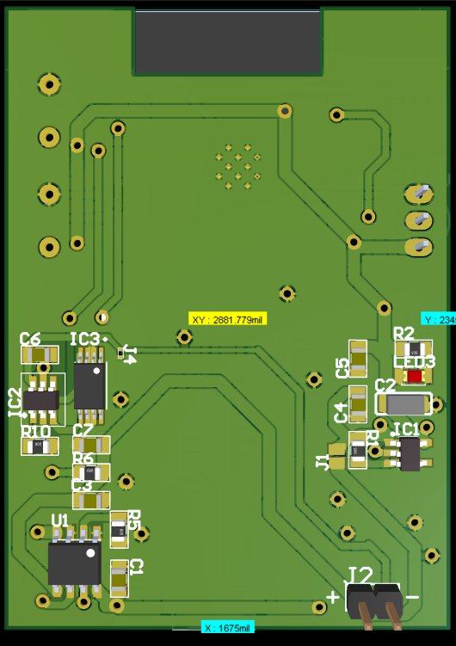3D

2D

* Fomula for caculating voltage output of lm1117

* More precise orientation of ble mesh algorithm diagram

ToDo:

* Made circuit for 1 – 2 week
* Complete algorithm diagram
* Sorting directory path
* Buy component to solder circiut