I. System design
1. Modules
There are 5 modules in the system: Panel, Lift Manager, Lift Control, Lift Body and Lift Sensor
a) Panel
- Lift operation panel of the first floor, accept the button-down of the delivery destination button, and control the first floor arrival and an error indicator lamp.
- Lift operation panel of the x floor, accept the button-down of call button and control the arrival indicator lamp of the x floor.
b) Lift Manager:
- Manage the request of lift movement from the lift operation panel of each floor, inform of the state of lift movement and request of the lift movement.
c) Lift Control:
- Manage the request of lift movement from the lift operation panel of each floor, inform of the state of lift movement and request of the lift movement.
d) Lift Body:
- Manage the request of lift movement from the lift operation panel of each floor, inform of the state of lift movement and request of the lift movement.
e) Lift Sensor:
- Manage the request of lift movement from the lift operation panel of each floor, inform of the state of lift movement and request of the lift movement.
2. Module detail:
a) Panel:
Input: User’s input from terminal
Output: Send messages containing floor number to lift Manager
Workflow:
1) The panel creates its own UDP socket
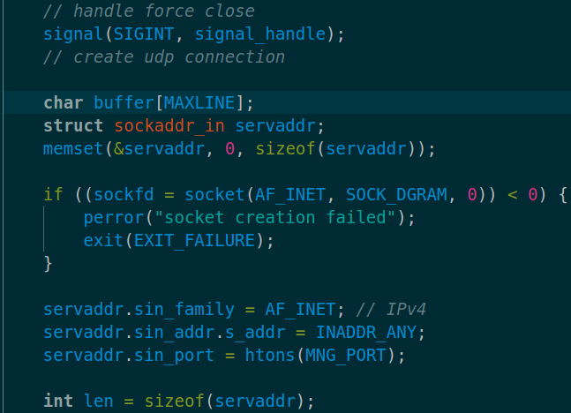

2) The panel goes into a loop, where it will scan floor number from user, validate it, then send it to Lift Manager’s socket

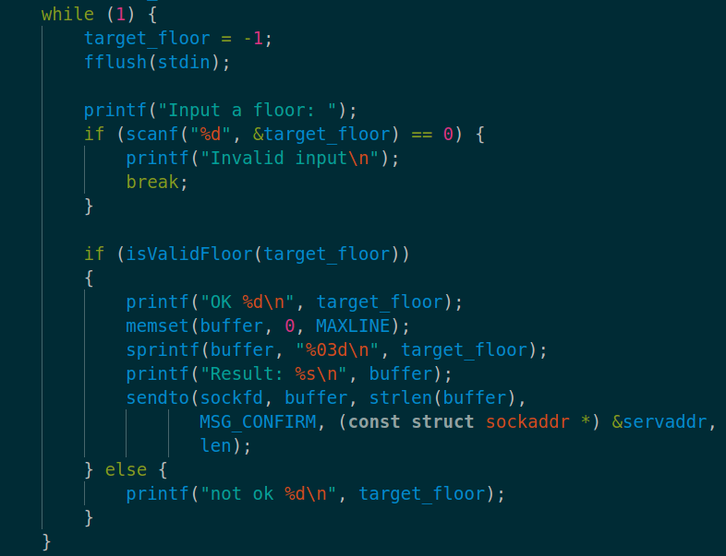
b) Lift Manager
Input: Floor number from
Output: Floor request message (to be sent to Lift Control)
Workflow:
1) The Lift Manager creates its socket to listen to Panel’s messages, then goes into listening loop

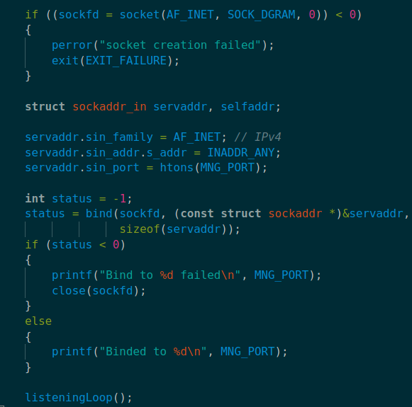

2) The Lift Manager goes into a listening loop, where it’ll listen to floor number from Lift Control, validate it, then send to Lift Control using a message queue
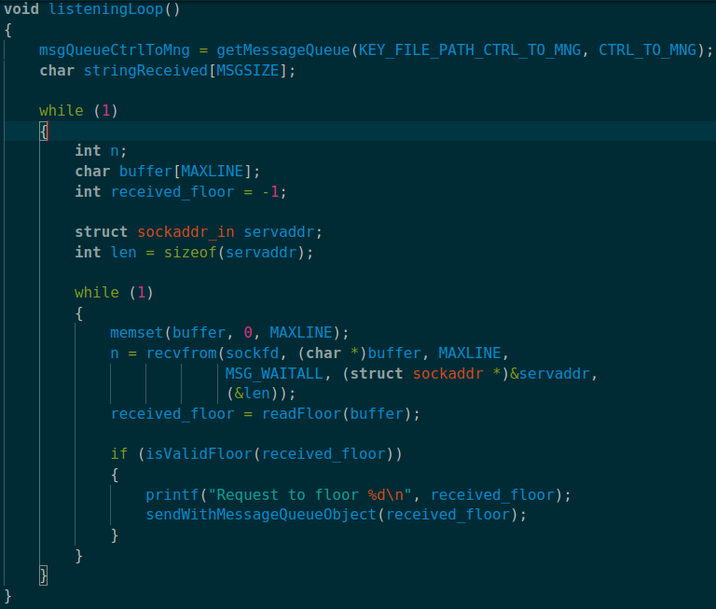
Function sendWithMessageQueueObject() create a message using floor number, then send it to Lift Control
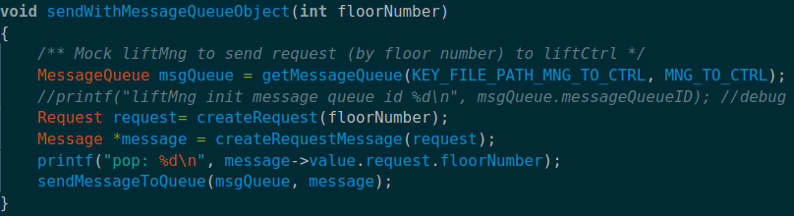
c) Lift Control
Input: Lift Sensor’s message, Lift Manager’s message, Lift Body’s message
Output: Command messages to Lift Body
Workflow: The Lift Control goes into a listening loop which consist off
1) Try to get a sensor message from the message queue, and issue command if the sensor detects that the lift is at floor 1 or requested floor
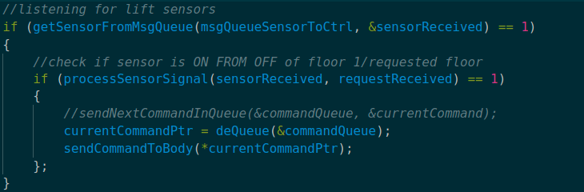

The function processSensorSignal() returns 1 when the sensor’s state is on and not at floor 0, and returns 0 otherwise.
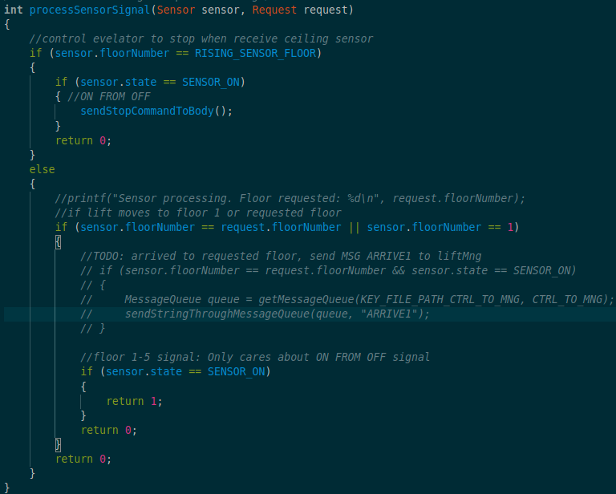
2) Lift Control then make sure there’s no ongoing request before taking a new request.
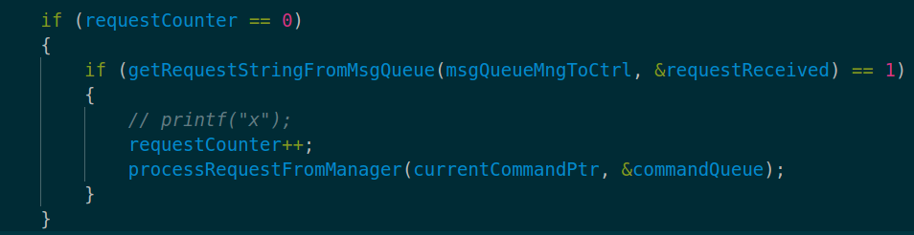

The function processRequestFromManager will make sure that the commandQueue is empty before adding new commands to it. Each request corresponds to a set of 4 commands: UP, DOWN, STANDBY1(when the lift reaches requested floor) and STANDBY2 (when the lift have gone back to floor 1)
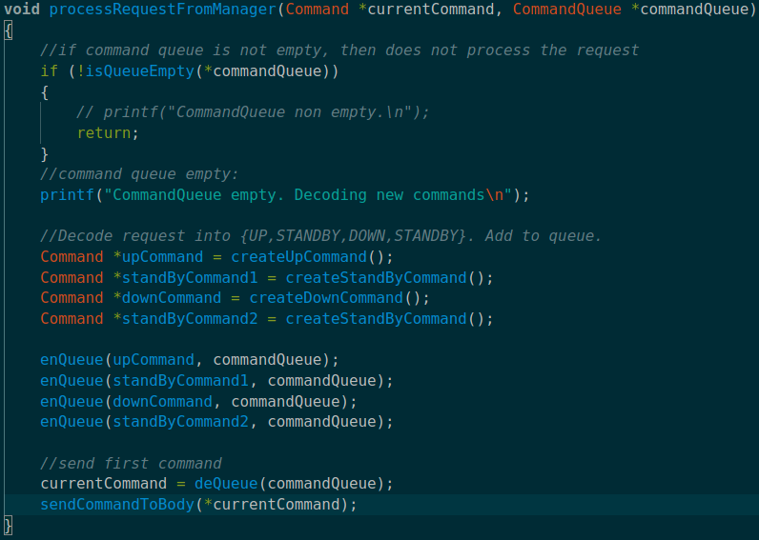

3) Lift Control will try to get completed command message from Lift Body using a message queue. If the previous command is completed, a new command will be sent to body, if the command queue is not empty. If the command queue is empty, the request is completed and Lift Control is ready for new requests.

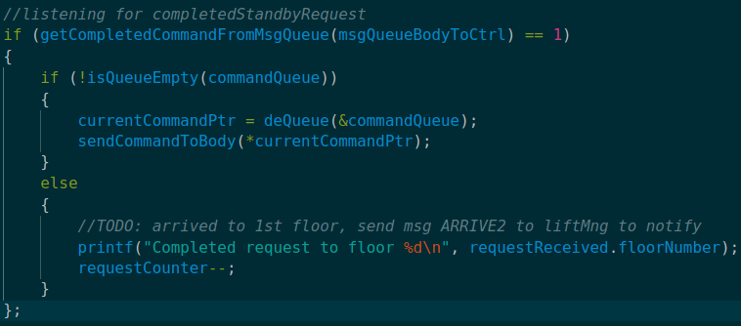
d) Lift Body
Input: Commands from Lift Control
Output: Heights to sensor
Workflow:
1) Lift Body initialize variables and bind SIGINT and SIGALRM to terminateHandler and sigAlarmHandler

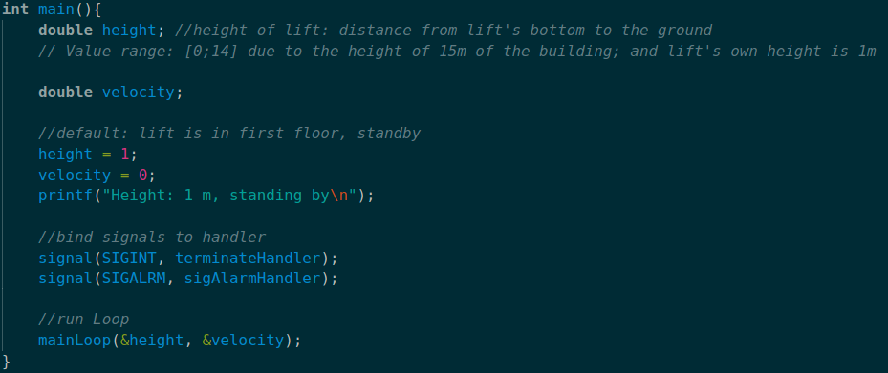

The function terminateHandler will set isKeyboardInterrupted, which will be used in the loop to terminate this module
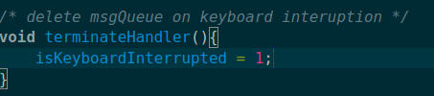

The function sigAlarmHandler will turn lift’s state from WAITING_TO_STOP to STANDING_BY, and from STANDING_BY to WORKING. A COMPLETED_COMMAND_MSG will also be sent to the body if the state is switched to WORKING.
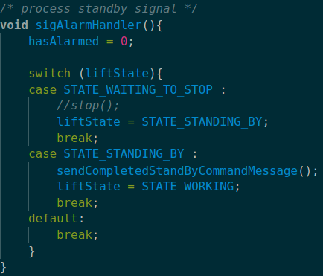
2) Lift Body enters infinite loop where each loop will happens FPS times per second
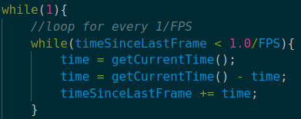
3) Lift Body then stimulates lift’s height and movement
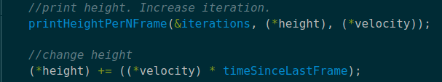

4) Lift Body will schedule an alarm if it’s standing by, then reset time frame and send lift’s height to Lift Body
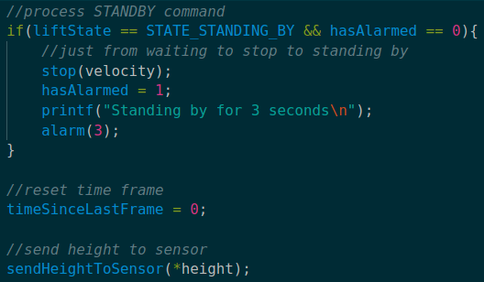

5) Lift Body will check if isKeyboardInterrupted is set, in which case it will delete its message queue to Lift Control and terminate itself. If not, it will try to receive a command message from Lift Control and process it.
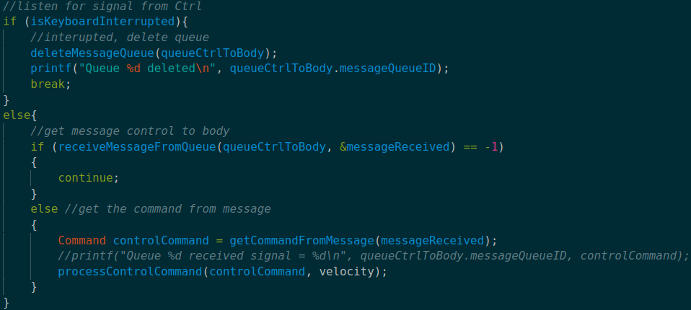

The function processControlCommand() will decode the command to control the lift. Up, DOWN, STOP command will be decoded into corresponding movement functions. STANDBY command will schedule an alarm in 1 second and turn lift’s state into WAITING_TO_STOP
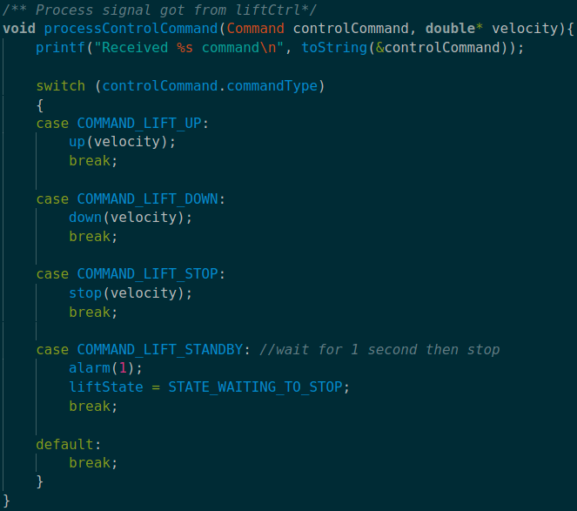
The movement functions will set the lift’s velocity to to positive or negative the preset amount of velocity, depending on the direction.
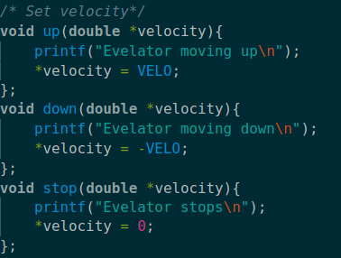

e) Lift Sensor
Input: lift’s height from Lift Body
Output: Sensor’s state change message to Lift Control
Workflow:
1) Lift Sensor will first initialize its variables, bind interrupt signal with sigIntHandler (which will set isKeyboardInterrupted to 1 and allow the Sensor to terminate itself). It then goes into a listening loop to listen for
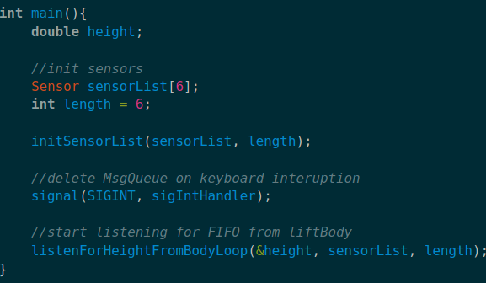

2) Inside the loop, Lift Sensor will try to receive message from Lift Body, then operate the sensor based on the lift’s height

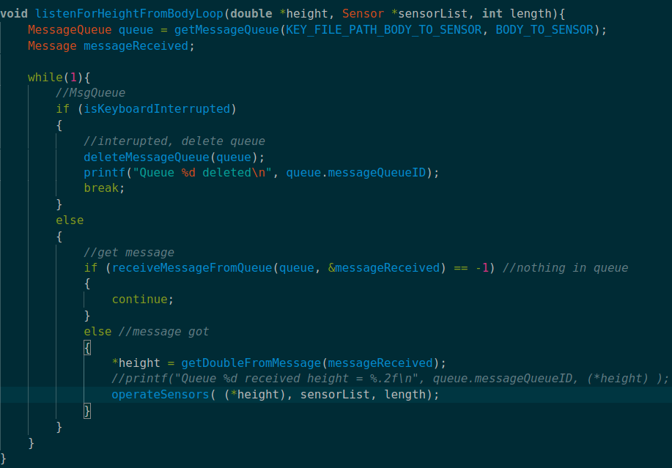
The function operateSensors() will call operateSensor() on all sensors. OperateSensor() will check if the lift is in the sensor’s detection range using checkHeightSensor(), store the sensor’s previous state, then check if the sensor’s state is switched. In either way, the sensor’s information will be printed and be sent to Lift Control
