Hain-Lee Hsueh

EDUC 328X

Final Assignment Option 2

A Conceptual Understanding of How the Internet Works

# Introduction

The Internet is widely used in everyday routine and has become an integral part of many consumers’ lives. For many of these people, however, the Internet remains a black box. Their idea of the Internet is strongly associated with the data they consume such as websites, email, or streaming media. What is hidden behind the presentation of data is the amazing network that supports the flow of information. My instruction aims to leverage **analogy**, **just-in-time telling**, **elaboration**, and a bit of **contrasting cases** to help learners crack open this black box that is the Internet and obtain a conceptual understanding of how it functions.

# Lesson Plan

The target learners for this lesson are primarily non-technical consumers of the Internet who regard the Internet as a black box, but who have a general understanding of what a network is in any particular context (e.g. social network). The short curriculum has two main objectives for the learners:

1. Understand how information travels on the Internet
2. Understand what is going on when one goes to a website

The first objective is meant to give a lower-level understanding of how data moves from one point to another and have learners conclude that the Internet is a network of computer networks. The second objective is a slightly higher-level understanding of basic Internet protocol with a client-server relationship.

## Information Flow

The US Postal System (USPS) is used as an **analogy** for the Internet. The deep structure relating the two is a “**network of networks**.” The USPS is introduced with simple concrete scenarios that the learners talk through with the facilitation of the instructor.

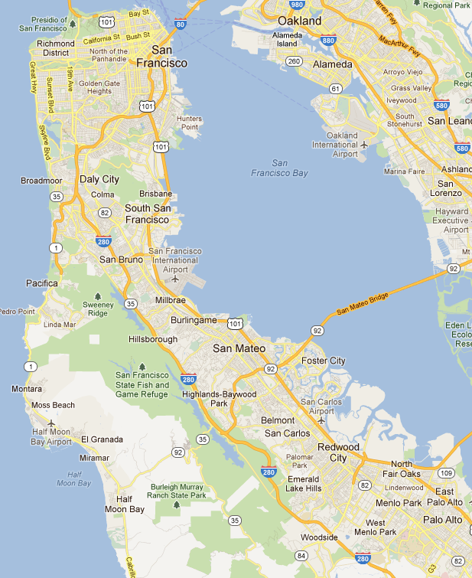

Stanford

Figure 1: Sending a letter within the Stanford community. The blue square is the Stanford post office, the red circle represents the area served by the post office, and the purple dot is a place from which a letter originates.



Stanford

South SF

Figure 2: Sending a letter from Stanford to South San Francisco. Intermediate post offices are the red squares.

Figure 1 displays a map with the Stanford post office indicated by a blue square. The first scenario asks the learners to share what happens if a person within Stanford wants to send a letter to another person also within Stanford. The key idea here is that the letter never leaves the circled region. The local post office manages its own local network of places.

In the second scenario, illustrated in Figure 2, a letter is being sent from Stanford to South San Francisco. The learners also talk through what happens in this situation, with facilitation from the instructor. The key idea here is that the letter goes through several different post offices before reaching the destination’s local post office and ultimately the destination address. Building upon the key idea in the first scenario, the USPS is essentially a network of “place networks.”

By having the learners talk through how a letter travels from one place to another in the USPS, the instructor sets them up for a **just-in-time** explanation of how data travels from one point to another on the Internet.

Figure 3 displays the same network of post offices as in Figure 2, but without the map backdrop. The instructor makes the connection between the USPS and the Internet by explicitly telling some of the mappings, namely that a place (purple dot) is like a computer, and a post office (red or blue square) is like a router. A router manages the flow of information for all the computers in its local network. If it receives data addressed to a computer outside of its network, it forwards it to another router to handle (the router makes a best guess as to which router to forward to – how this best guess is calculated is outside the scope of the lesson). With this explanation, the deep relational structure enables the learners to realize that just as the USPS is a network of “place networks,” the Internet is a network of computer networks.

Figure : A conceptual network diagram (same as Figure 2 but with the map background removed.

The first part of the lesson concludes with an **elaboration** of the term “Internet.” One example elaboration is that the Internet is simply made up of INTER-connected NET-works.

## Going to a Website

The second part of the lesson also leverages **analogy** to explain what happens when a browser loads a website. The analogy is a large lecture room with assigned seats, and Bob, sitting on one side of the room, wants to get Alice’s phone number. Alice, however, is sitting on the other side of the room. The main deep relational structure here is the **client-server relationship**, but there are also bits of Internet protocol. In the website scenario, the browser acts as a client requesting a website, and the provider for the website is the server.

Bob

Alice

Creeper with the seating chart

Digits please

My #

Seat H12

Seat A3

Figure 4: Lecture hall analogy. Bob wants to get Alice's phone number.

The lecture hall analogy is presented first. The scenario between Bob and Alice is illustrated in Figure 4. Learners talk through what Bob needs to do in order to obtain Alice’s number, assuming that this is during class so talking and moving around is not allowed. Bob needs to write a note asking for her number, and needs to get it passed by other people until it reaches Alice. But in order for people to know where to pass it to, Bob needs to know what seat Alice is sitting in. He obtains this information from the creeper with the seating chart near him. Armed with Alice’s seat number, he sends off the note until it reaches Alice. When Alice receives it, she writes her number down, and sends it back to Bob by passing it to other people.

Following the lecture hall scenario is an explanation of what happens when a person wants to open Facebook. The diagram is shown in Figure 5.

f

Browser

Client

Server

DNS

facebook.com

69.171.229.11

request

response

Domain Name

IP address

Figure 5: Browser requesting the Facebook home page.

The instructor uses this example to introduce the terminology (server, client, domain name, DNS, etc). The sequence of events is told to the learners with progressive reveal and animations in PowerPoint (the browser sends the domain name “facebook.com” to the DNS, which provides an IP address; then the browser prepares a request to send through the Internet so that it reaches the Facebook servers, which upon receiving the request prepares and sends back a response consisting of HTML content that is rendered on the client’s browser window).

After this explanation, the learners are asked to explicitly create/recall on a piece of paper the mappings between the objects/entities in the lecture hall analogy and the client-server example. This is meant to assess whether they understood the connection from the base to the target analogy. In Figures 4 and 5, the positions of Bob/Alice and Client/Server are flipped intentionally, so that mappings are not correctly made because of spatial position but because of successful transfer of understanding.

The final part of instruction touches upon “breakdowns” that might occur, namely delays and commonly encountered errors. Learners are asked to write down their thoughts on paper addressing the question “Sometimes websites take longer to load; considering the two analogies discussed, what might cause this to happen?” Then learners are shown a list of commonly encountered HTTP errors and asked to hypothesize what could cause these errors. The errors used are as follows:

* 404 – Not Found
* 401 – Forbidden
* 503 – Service Unavailable
* 500 – Internal Server Error
* “Oops! Google Chrome could not find …”

The purpose of this assessment was to see if learners could infer additional information about what might happen in the Internet that causes these issues by drawing on the analogies of the USPS and Bob and Alice in the lecture hall. After a few minutes of thinking/discussion, the instructor provides two pieces of information that serve both as **just-in-time** telling and facilitation of **contrasting cases** (for differentiation and precision of encountered errors):

* Error 4xx means there’s an issue with the client
* Error 5xx means there’s an issue with the server

After learners finish writing and discussing with each other, the lesson concludes with a brief **just-in-time** conceptual explanation of possible causes for the errors.

# Testing and Discussion

Volunteers were solicited from the LDT program. An email was sent to the LDT12 mailing list describing potential candidates as those with a non-technical background or whose idea of the Internet was either a black box or a vague network at best. Three volunteers responded and were taught altogether in a single session (i.e. a three person class). The participants (Learners 1, 2, and 3) included two students in EDUC328X, Jennifer Bundy and Lisa Peterson.

In the first part of instruction (the USPS analogy), the learners had a popcorn-style talk-through with the scenarios with mailing a letter. The direction was largely guided with questions I was asking, but learners were able to draw on their prior knowledge to answer them (e.g. “you address it, drop it in your mailbox…the letter goes to the post office…there it gets sorted…then mail carrier drops it in the destination box.”). When talking through the scenario with a letter going from Stanford to South SF, one of the learners mentioned a key word “forward” (the post office forwards the letter to another post office), which is a term often used when describing how routers send data to other networks. Later when explaining the target analogy in terms of computers and routers (which map to places and post offices), I repeated this term to reinforce the connection.

After explaining the target analogy, I tried to get the learners to generate a description of the Internet by completing the following sentence: “If the USPS is a network of place networks, then the Internet is a ___?” They were unable to immediately respond, but one learner answered “a network of routers.” Thus, it seems like the “higher-level” network of post offices was successfully grasped, but the “lower-level” local network was not captured as strongly. It’s likely that this is a consequence of the visual representation, which predominantly illustrates the higher-level network.

When asked, “Why do you think it’s called the ‘Internet’?” learners were able to elaborate an explanation which included words like “between” and “network.”

For the second part of the instruction, walking through the lecture hall analogy was effective in getting the learners to think at a more detailed level. For example, after one learner said, “[Bob] passes a note!” I asked, “And what does he write on the note?” Another learner answered, “’Can I have your number?’” My follow-up question was, “But if he’s passing the note to other people, how do they know where to pass it to?” This lead to a discussion about the distinction between knowing Alice’s name and knowing precisely where she is sitting, and ultimately helped in the learners thinking more rigorously about the mechanics of how Bob obtains Alice’s number that have meaning in the target domain.

After presenting the description of accessing a website with the terminology (client, server, etc), I passed out pieces of paper and asked the learners to map the objects/entities from the lecture hall to the example scenario of accessing Facebook. Their work is shown below:

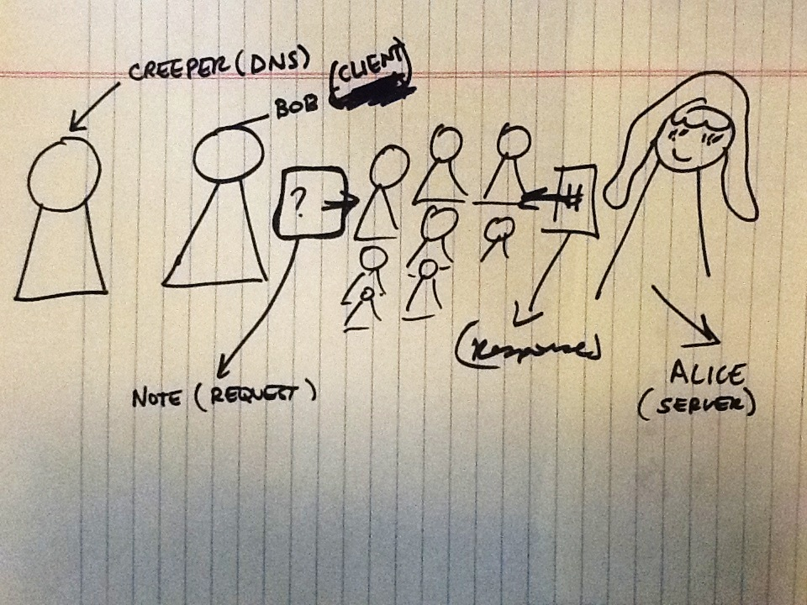

Figure 6: Learner 1's mapping between the lecture hall and the Internet.

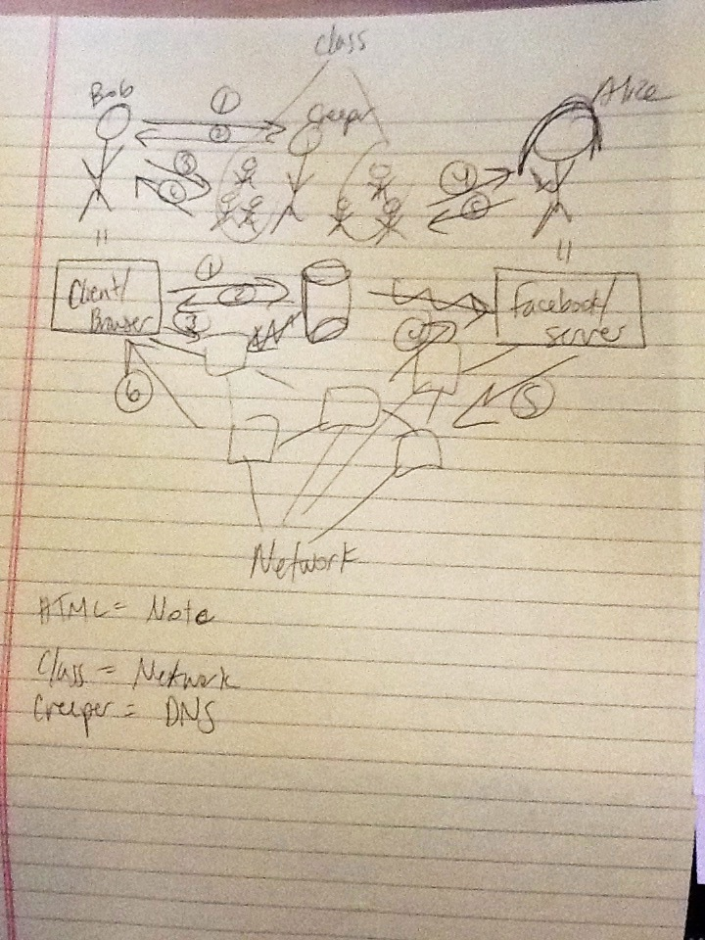

Figure 7: Learner 2's mapping

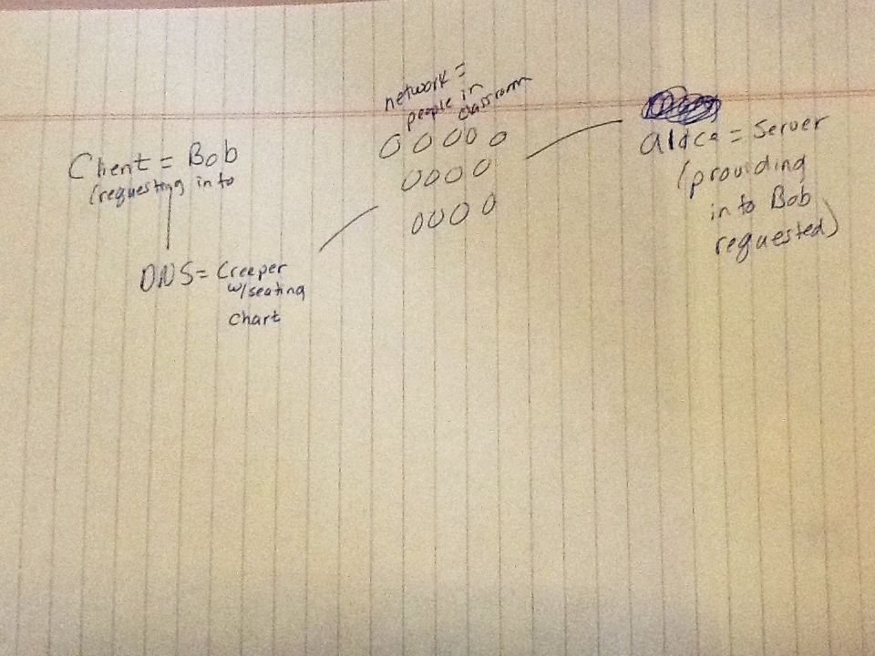

Figure 8: Learner 3's mapping

All of the learners drew some form of a diagram and successfully mapped Bob to the client and Alice to the server, despite the spatial flipping of their positions in Figures 4 and 5. Everyone also understood the creeper to be the DNS. Learner 3 also elaborated by indicating that Bob was the client because he was requesting info, and Alice was the server because she was providing info that Bob requested. Learner 1 was the only one who explicitly mapped both the request (Bob’s note) and the response (Alice’s number). Learner 2 was the only one who captured the procedure with a sequence of steps. Thus, the analogy appears to be successful in transferring the client-server relationship as well as other details involved in Internet protocol. It may be noteworthy, however, that no one included the domain name/seat location mapping.

After reviewing the mappings together, learners then had to fill out a sheet with two questions that assessed how much they could infer about the Internet with respect to delays and errors. The main purpose of having learners write things down was for me to have a record, which I could use to analyze their thought processes. The first question was “What might cause delays? (i.e. why would a website take a longer time to load?)” A list of their answers follows:

|  |  |  |
| --- | --- | --- |
| Learner 1 | Learner 2 | Learner 3 |
| * “Network routers are being blocked or simply the request isn’t being sent by the networks.” * “Routers are closed!” * “Too many request being asked may be a problem, too.” | * “Missing address or IP address – like building demolished” * “More networks in the middle – distance = slow” * “Address not accessible – private/locked” * “Address moved – like if someone moves” | * “Signals get dropped – like if the note got dropped between Bob and Alice.” * “Too much traffic – lots of people in the class to pass the note through” * “Errors in signals – got wrong seat number from creeper” * “Server offline – Alice not in class that day” * “Intercepted – professor snags note!” |

In general, learners were able to infer quite a bit of valid possible causes for errors in addition to simple delays. There are a couple interesting points:

* Both analogies were used to make inferences – a strength of using two analogies instead of one becomes apparent
* All learners mentioned the concept of things being “down”
* Learner 1 mentioned data congestion, Learner 2 mentioned network distance, and Learner 3 confounded them (“Too much traffic – lots of people in the class”).
* Learner 3 inferred issues with the DNS (“wrong seat number from creeper”) and even cyber-sniffing (“professor snags note”).

Thus, the analogies were successful in enabling learners to construct new information and reasonably accurate hypotheses about the Internet. The fact that many answers were related to errors also provided a nice segue for the second question on the worksheet, which asked learners to hypothesize what could happen to cause various errors (404, 403, 503, 500 – refer to Lesson Plan). For this question I allowed free discussion among the learners.

In this instance, contrary to the first question, it was apparent that the learners’ experiences with these errors and the previous analogies were not effective in constructing accurate hypotheses for the precise errors. Their responses are compiled in the table below.

|  |  |  |  |
| --- | --- | --- | --- |
|  | Learner 1 | Learner 2 | Learner 3 |
| Error 404 | IP Address not found | Missing or wrong IP address | I can’t locate address or resolve name |
| Error 403 | Can’t ask for a request | Can’t access | Need permission (Alice’s dad) |
| Error 503 | Server is down | Too busy to process, not on | Server down? (Alice dating someone else) |
| Error 500 | My server is down: No internet | Couldn’t read incoming HTML | Coding error (illegible handwriting) |
| “Oops! Could not find…” | Typed wrong address (same as 404), maybe combination of 404, 503, and 500 | Not connected to internet | Address or translation wrong |

Although many of their responses are valid causes for error, they were unable to map them to their corresponding errors. For example, all the learners thought that Error 404 meant that there was an issue with the IP address, but it’s really an issue with the client requesting information that doesn’t exist. Some responses were also vague (e.g. “Can’t access”). What’s interesting is that all learners thought Error 500 was an issue with the client, with Learners 2 and 3 thinking there was a problem specifically with reading/interpreting data.

These responses and discussions combined with learners’ existing experiences with the Internet provided an excellent platform for **just-in-time** telling and **contrasting cases**. I concluded the lesson with the distinction between Error 4xx and 5xx and a brief explanation of possible causes for each error. There was evidence of the “click of comprehension” in some of the learners’ response to the lecture (e.g. “Ohh…I had 4xx and 5xx largely mixed up”). Some of the learners continued to ask questions for clarification (e.g. “What’s the difference between Error 404 and Oops! Google Chrome could not find…?”), which added a small but significant element of **liveliness** that contributed to their learning.

# Conclusion

All in all, my instruction for teaching a conceptual understanding of the Internet was successful and positively received. The primary core mechanics were **analogy** and **just-in-time telling**, supported with bits of **elaboration** and **contrasting cases**. Judging from their responses to the worksheets, the analogies were helpful in not only transferring presented concepts, but also in inferring new information and hypothesizing in the target domain. Having students infer and hypothesize on their own also provided an opportune set up for just-in-time telling to consolidate their thoughts and existing experiences related to errors and delays with the Internet.

If compared to equivalent instruction without these core mechanics, I would expect a difference in a posttest of learning, assuming that the equivalent instruction consisted of a tell-first one-sided talk and description of the Internet being a network and the HTTP protocol. My thought is this kind of instruction places more of an onus on the learners to memorize information and make connections to existing knowledge themselves, if they do make those connections. I think the greatest difference would be in assessing breakdowns. A student could still obtain a conceptual understanding of the Internet as a network of networks without the analogies, but might be less prepared for brainstorming possible errors and issues that happen. The strength of analogy in my instruction was to leverage learners’ existing understanding of a familiar network (the USPS) and a hypothetical but conceivable scenario (Bob getting Alice’s number). This enabled them to be more creative about potential problems that could happen in the network. An assessment on specific HTTP error codes would also show a difference. Just-in-time telling (having students reflect on their own experiences, discuss hypotheses with each other, and then listening to the explanation) also helps in assessing breakdowns, vs. those who are simply told a static subset of causes of error. Those who knew that 4xx errors were client-related could score higher because they would be in a better position to make educated guesses on unfamiliar codes than those who memorize a subset of common codes. Thus, I believe the core mechanics enabled learners to think more creatively and adaptively in the target domain.