Tan Nguyen

EE 104

YouTube link: <https://youtu.be/RdXaxQtPM1k>

GitHub link: <https://github.com/leehuy21/Lab-2>

Lab 2

In this documentation, I will discuss the overview of changing the background image and go through the process of coding to add features.

Adding three more field to the User database and define a function called ‘focus’.

Figure . Adding 3 more columns

Figure 1 shows a function that formats an Excel sheet and adds column headings for specific information. The function first sets the width of each column and then adds headings for first name, middle name, last name, date of birth, phone number, email, and three additional columns for sex, height, and weight.

Figure .

Figure 2 demonstrates a set of Python functions that can be used with a graphical user interface (GUI) in a Python application, such as a form or dialog box, to set the focus on different input fields.

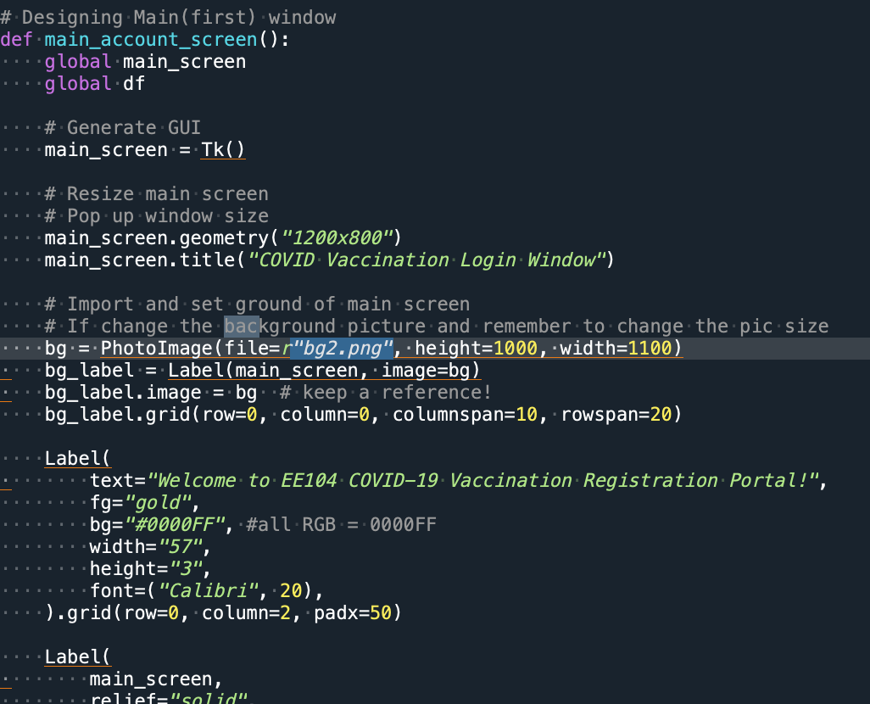

Figure . Changing background picture

Figure 3 displays the main screen of the application. The background picture has been modified, and the geometry of the picture has been resized to fit with the background image. When the application runs, this screen will appear in a pop-up window.