2.2 Functional Requirements Specification
2.2.1 Admin (Manage Items) Use Case

Use Case: View Current Items
Diagram:
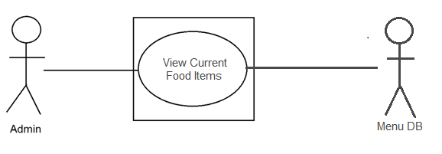
Brief Description
Admin views the list of the current food items in the menu.

Initial Step-By-Step Description
Before this use case can be initiated, the Admin has already accessed the Online Order-taker.

- The Admin chooses to view the current food items.
- The system links to the database.
- The system displays the list of current food items in the menu.

Use Case: Edit/Update Menu.
Diagram:
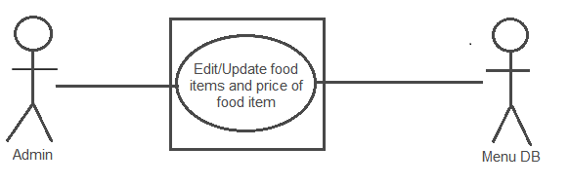
Brief Description
Admin edits/updates the menu and the price of the food items in the menu.

Initial Step-By-Step Description
Before this use case can be initiated, the Admin has already accessed the Online Order-taker.
- The Admin chooses to edit/update the food items.
- The system links to the database and displays the current items in the menu.
- The Admin edits/updates the menu and the prices of the food items.
- The system saves the changes made by the Admin.

Use Case: Add Food Items
Diagram:
Brief Description
Admin adds food items in the menu and its price.

Initial Step-By-Step Description
Before this use case can be initiated, the Admin has already accessed the Online Order-taker.
- The Admin chooses to add food items.
- The system connects to database and displays the items in the menu.
- The Admin adds the food in the menu and the price of the food item.
- The system saves the changes in the menu.

Use Case: Remove /Delete Food Items
Diagram:
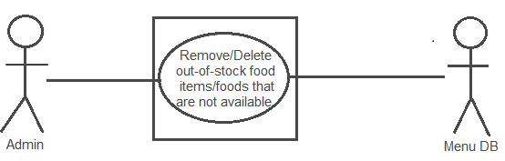
Brief Description
Admin remove/delete food items in the menu that are not available or out-of-stock..

Initial Step-By-Step Description
Before this use case can be initiated, the Admin has already accessed the Online Order-taker.
- The Admin chooses to remove/delete food items.
- The system connects to database and displays the items in the menu.
- The Admin removes the selected food item(s) in the menu.
- The system saves the changes made by the Admin.

3.2 Functional Requirements

3.2.1 View current food items
Use Case Name | View Current Items
XRef | Section 2.2.1, View Current Items
Trigger | Admin wants to view the list of food items.
Precondition | The system is connected to database.
Basic Path | - The Admin chooses what to do. The choices are View current items, Edit/Update menu, Add food item and Remove/Delete food item.  - If Admin chooses View current items, the system displays the food items contained in the menu.
Alternative Paths | In step 1, if the Admin chooses another functionality, the system is redirected to the corresponding page of the functionality.
Postcondition | Admin viewed the food items in the menu.
Exception Paths | Admin may abandon the view functionality anytime.
Other (notes) | The food item is based from the actual menu from Bugong.  (Individual) Jomar Furiscal

3.2.2 Edit/Update menu
Use Case Name | Edit/Update menu
XRef | Section 2.2.1, Edit/Update menu
Trigger | Admin wants to edit/update the list of food items.
Precondition | The system is connected to database.
Basic Path | - The Admin chooses what to do. The choices are View current items, Edit/Update menu, Add food item and Remove/Delete food item.  - If Admin chooses View current items, the system displays the food items contained in the menu.  - The system saves the changes made by the Admin.
Alternative Paths | In step 1, if Admin choose another functionality, the system is redirected to the corresponding page of the functionality.
Postcondition | Admin edited/updated the food items in the menu.
Exception Paths | Admin may abandon the edit/update functionality anytime.
Other (notes) | The food item is based from the actual menu from Bugong.  (Individual) Jomar Furiscal

3.2.3 Add Food item
Use Case Name | Add Food item
XRef | Section 2.2.1, Add Food item
Trigger | Admin wants to add food items in the menu.
Precondition | The system is connected to database.
Basic Path | - The Admin chooses what to do. The choices are View current items, Edit/Update menu, Add food item and Remove/Delete food item.  - If Admin chooses View current items, the system displays the food items contained in the menu.  - The system saves the changes made by the Admin.
Alternative Paths | In step 1, if Admin choose another functionality, the system is redirected to the corresponding page of the functionality.
Postcondition | Admin added food item(s) in the menu.
Exception Paths | Admin may abandon the add functionality anytime.
Other (notes) | The food item is based from the actual menu from Bugong.  (Individual) Jomar Furiscal

3.2.4 Remove/Delete food item(s)
Use Case Name | Remove/Delete food item(s)
XRef | Section 2.2.1, Remove/Delete food item(s)
Trigger | Admin wants to remove/delete food items in the menu.
Precondition | The system is connected to database.
Basic Path | - The Admin chooses what to do. The choices are View current items, Edit/Update menu, Add food item and Remove/Delete food item.  - If Admin chooses View current items, the system displays the food items contained in the menu.  - The system saves the changes made by the Admin.
Alternative Paths | In step 1, if Admin choose another functionality, the system is redirected to the corresponding page of the functionality.
Postcondition | Admin removed/deleted food item(s) in the menu.
Exception Paths | Admin may abandon the remove/delete functionality anytime.
Other (notes) | The food item is based from the actual menu from Bugong.  (Individual) Jomar Furiscal

