Swagger UI :  [http://campcord.us-east-2.elasticbeanstalk.com/swagger-ui.html#/](%20http://campcord.us-east-2.elasticbeanstalk.com/swagger-ui.html#/)

Upload File

Api : <http://campcord.us-east-2.elasticbeanstalk.com/api/file/upload>

In body put parameters

name(this name used in S3) and myfile (orginal file)

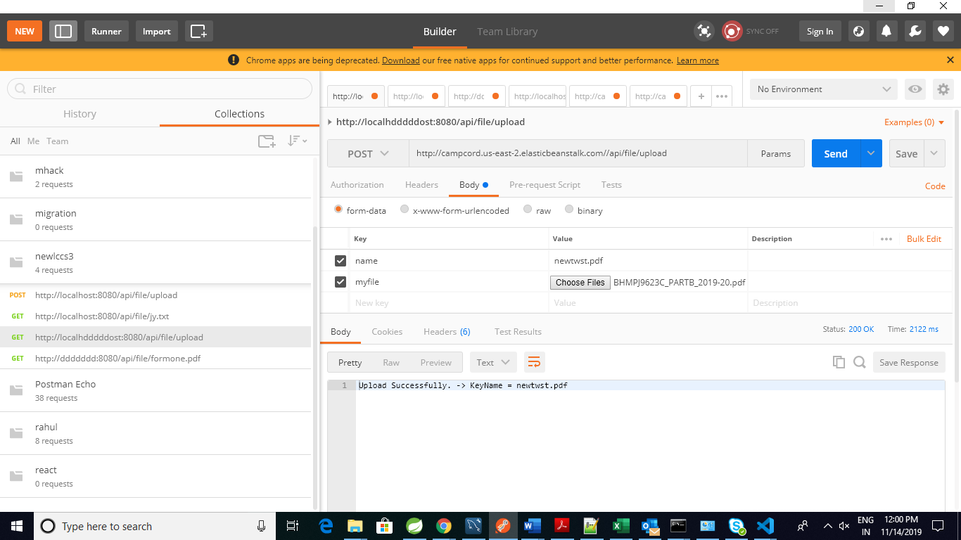

Download file

Api : http:// campcord.us-east-2.elasticbeanstalk.com /api/file/{Specifi file name with extension}

eg: http:// campcord.us-east-2.elasticbeanstalk.com /api/file/myfile.jpg

Login

Api: <http://campcord.us-east-2.elasticbeanstalk.com/user/login>

Type : post

In body give json

{

"email":"admin@gmail.com",

"password":"12ss3"

}

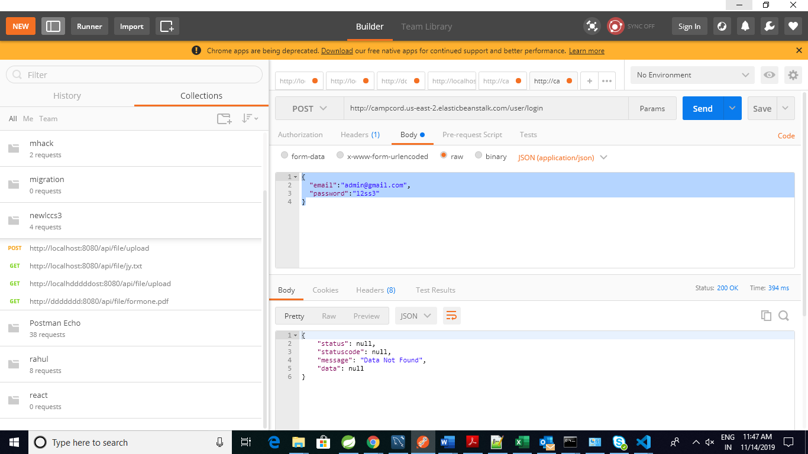

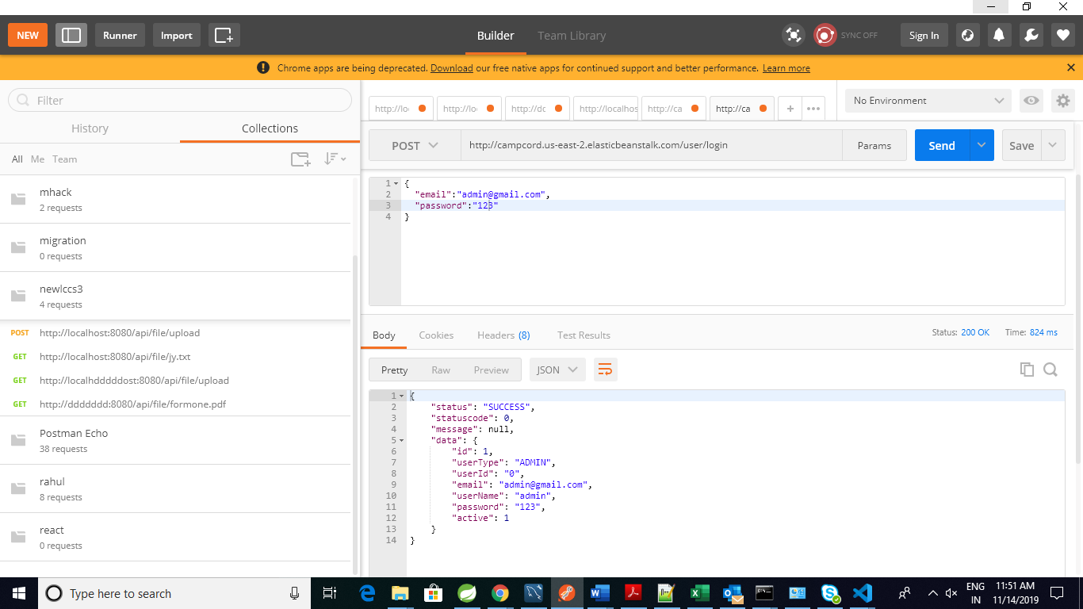

Response like

{

"status": "SUCCESS",

"statuscode": 0,

"message": null,

"data": {

"id": 1,

"userType": "ADMIN",

"userId": "0",

"email": "admin@gmail.com",

"userName": "admin",

"password": "123",

"active": 1

}

}

Get all Student

Api :  [http://campcord.us-east-2.elasticbeanstalk.com/student/getAllStudents](%20http://campcord.us-east-2.elasticbeanstalk.com/student/getAllStudents)

Response

{

"status": "SUCCESS",

"statuscode": 0,

"message": null,

"data": [

{

"studentId": 1,

"studentName": "swsssjjaaa",

"studentContact": "bjjjbbb",

"studentEmail": "jjcccc",

"studentCourse": "jjdddd",

"studentSemester": "112",

"course": {

"courseId": 1,

"courseName": "Bsc IT",

"courseCount": "6"

}

}

]

}

Save student

Api :  [http://campcord.us-east-2.elasticbeanstalk.com/student/saveStudent]( http://campcord.us-east-2.elasticbeanstalk.com/student/saveStudent)

{

"studentName":"swsssjjaaa",

"studentContact":"bjjjbbb",

"studentEmail":"jjcccc",

"studentCourse":"jjdddd",

"studentSemester":"112",

"course":{

"courseId":1

}

}

Response

{

"status": null,

"statuscode": 0,

"message": "SUCCESS",

"data": {

"studentId": 1,

"studentName": "swsssjjaaa",

"studentContact": "bjjjbbb",

"studentEmail": "jjcccc",

"studentCourse": "jjdddd",

"studentSemester": "112",

"course": {

"courseId": 1,

"courseName": null,

"courseCount": null

}

}

}