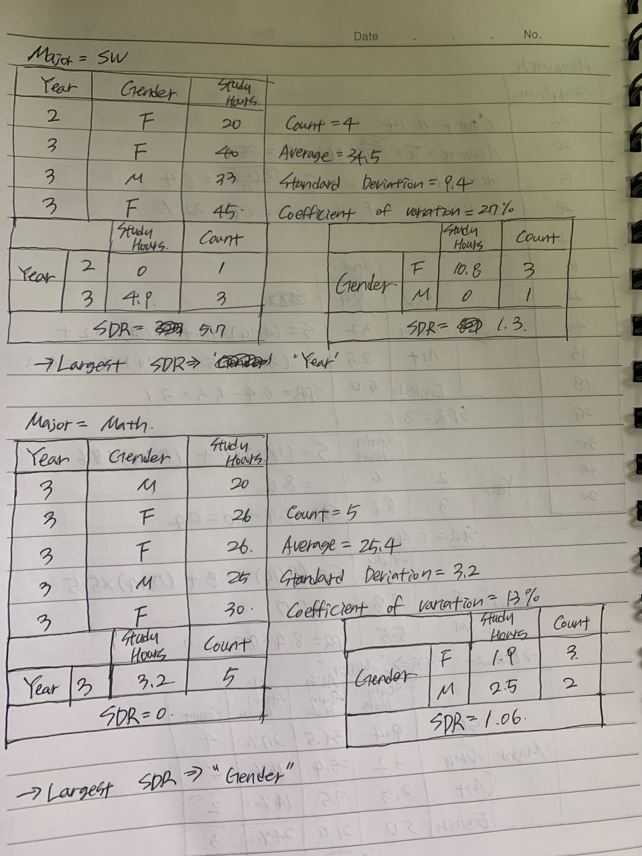

from matplotlib import pyplot as plt  
from sklearn.model_selection import train_test_split  
from sklearn import datasets  
from sklearn.tree import DecisionTreeRegressor  
import pandas as pd  
import numpy as np  
  
dataset = np.array(  
[['SW', 2, 'F', 20],  
['Math', 3, 'M', 20],  
['Art', 3, 'F', 15],  
['English', 3, 'M', 28],  
['Math', 3, 'F', 26],  
['English', 3, 'M', 17],  
['Math', 3, 'F', 26],  
['SW', 3, 'F', 40],  
['SW', 3, 'M', 33],  
['English', 3, 'M', 18],  
['Math', 3, 'M', 25],  
['Math', 3, 'F', 30],  
['SW', 3, 'F', 45],  
['Art', 3, 'M', 20],  
])  
  
print(dataset)  
  
X = dataset[:, 1:2].astype(int)  
  
# print X  
print(X)  
  
y = dataset[:, 3].astype(int)  
  
# print y  
print(y)  
  
# create a regressor object  
regressor = DecisionTreeRegressor(random_state=0)  
  
# fit the regressor with X and Y data  
regressor.fit(X, y)  
  
  
# arange for creating a range of values  
X_grid = np.arange(min(X), max(X), 0.1)  
  
# reshape for reshaping the data  
X_grid = X_grid.reshape((len(X_grid), 1))  
  
# scatter plot for original data  
plt.scatter(X, y, color='red')  
  
# plot predicted data  
plt.plot(X_grid, regressor.predict(X_grid), color='blue')  
  
  
# show the plot  
plt.show()  
  
# import export_graphviz  
from sklearn.tree import export_graphviz  
  
# export the decision tree to a tree.dot file  
# for visualizing the plot easily anywhere  
export_graphviz(regressor, out_file='tree.dot',  
 feature_names=['HW1'])