Editorial note: the two blocks below replace the earlier standalone Section 4.3. Insert “4.1.10 User Interface Module Results” immediately after Section 4.1.9, at the end of 4.1 Experimental Results. Insert “4.2.4 User Interface Module Discussion” immediately after Section 4.2.3, at the end of 4.2 Discussion and Critical Interpretation. Figures keep the numbers 4.12–4.16, continuing on from Figure 4.11.
4.1.10 User Interface Module Results
The user interface module is the integration layer of the system. It does not perform pre-processing, alignment or detection itself; it drives those three modules, applies the acceptance criteria that convert a set of detections into an inspection decision, and records the outcome. The results below were obtained from the inspection history that the interface writes automatically, covering 1,040 inspections logged between 30 August and 4 September 2026 during development and testing, together with the inspection reports the system exported during the same period.
Coverage of the operating modes
Six operating modes were delivered, corresponding to the four ways a board may reach the system: a single image, a folder of images, a recorded video, and a camera. The video and camera inputs were each implemented twice, once frame-by-frame and once board-by-board, because the two answer different questions. The table below summarises the volume of work each mode carried during testing.
Operating mode | Records | Mean latency (ms) | Mean quality | Pass rate
Video — frame by frame | 661 | 3,052.2 | 29.0 | 1.1%
Live — camera | 182 | 1,257.4 | 29.3 | 19.2%
Single image | 101 | 1,458.2 | 37.4 | 16.8%
Video — board by board | 59 | 2,876.9 | 42.8 | 5.1%
Live — board by board | 22 | 1,154.7 | 31.8 | 31.8%
Batch — folder | 15 | 1,361.8 | 47.3 | 0.0%
Total | 1,040 | — | — | —
The distribution is uneven by design rather than by accident. Frame-by-frame video dominates because a single clip contributes one record for every analysed frame, whereas the board-by-board mode contributes one record per physical board. This distinction is discussed further in Section 4.2.4.
Module integration over service interfaces
The three upstream modules are reached through documented interfaces rather than direct imports. Pre-processing and alignment are requested by posting the board image to the processing service, which returns the pre-processed image, the aligned image, the detected board rectangles and a validation result. Detection is requested separately from the inference service, which returns bounding boxes, class names and confidence scores. Both services are probed on connection so that a misconfiguration is reported immediately rather than during an inspection.
Evidence that the interface is genuinely decoupled from any single implementation is present in the history itself. Every record stores the detector that produced it, and three different back-ends appear across the same table without any change to the interface, as shown below. The presence of records attributed to a network endpoint rather than a checkpoint file confirms that the remote path was exercised, not merely implemented.
Detection back-end | Type | Records
best.pt | Local checkpoint | 982
rtdetr_l_pcb.pt | Local checkpoint | 52
http://127.0.0.1:8000 | Remote HTTP service | 6
Inspection results are persisted to a hosted PostgreSQL database rather than a local file, so that every machine running the system contributes to one shared record of the production line. A local database remains available as a fallback when the project is run without network access. Optionally, four images per board — the operator input, the output of Module 1, the output of Module 2 and the annotated detection result — are uploaded to object storage and referenced from the corresponding row, so that a historical decision can be re-examined visually rather than only as a set of figures.
Input validation before detection
An early observation during testing was that an unrelated photograph could be reported as a passing board. The cause was structural rather than a fault in the detector: an image containing no printed circuit board yields no detections, and a board with no detections is by definition a perfect board. The interface therefore validates that an input plausibly contains a board before Modules 1 to 3 are invoked, and reports a rejected input as an outright failure with the reason recorded, rather than passing it to the detector.
Across the logged history, 171 of the 1,040 inspections (16.4 per cent) were rejected at this stage. The rejections are heavily concentrated in the camera modes: 119 of 182 live inspections (65.4 per cent) were refused before detection, which is consistent with a camera that spends much of its time pointed at a bench, a hand or an operator rather than at a board. The gate therefore performs the function it was introduced for, although its limitations are set out in Section 5.2.
Automated report generation
Conventional inspection equipment frequently returns only a binary outcome, without the visual evidence or the written record an engineer needs in order to act on it (Chen et al., 2023). The interface addresses this by exporting a complete inspection report as a PDF document at the point the result is produced, in two shapes: one board and one production run. The reports reproduced in this section are unmodified exports taken from the system during the testing period.
Figure 4.12 shows the first page of the single-board report for 10_missing_hole_03.jpg, exported on 4 September 2026. The page carries the verdict banner, a summary of the metrics behind it, the annotated image with every detection drawn and labelled, and the beginning of the per-defect table giving the class, confidence, centre coordinate, size and area of each finding. Two properties of the verdict logic are visible on this single page. The board was failed with zero critical defects recorded, so the failure was produced by the allowance rule — five confident defects against an allowance of zero — and not by the critical-class rule; and the quality score of 0.1 out of 100 is exactly what the scoring formula returns for five missing-hole detections at a mean confidence of 0.999, confirming that the printed score can be re-derived from the printed evidence.
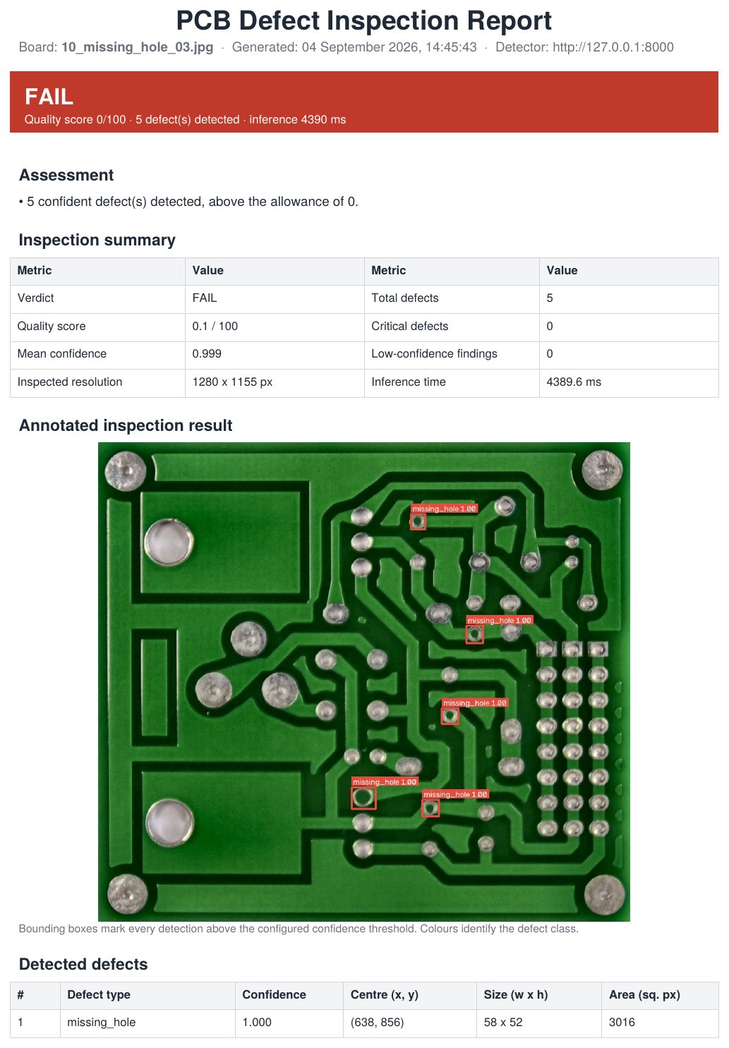
Figure 4.12 Single-board inspection report, page 1: verdict, summary metrics, annotated result and per-defect table.
The report is intended to be self-describing, so that a verdict can be re-examined months later without reference to the machine that produced it. Every parameter that influenced the outcome is printed with the result, as shown in Figure 4.13: the detector source and weights, the confidence and non-maximum-suppression thresholds, whether Modules 1 and 2 were applied, the defect allowance, the critical classes, the review confidence and the store the record was written to. This is the traceability that a review of vision-based inspection practice identifies as necessary if inspection results are to support process decisions rather than only accept or reject individual boards (Zhou et al., 2023). The report also corroborates the service-integration table above independently of the history database: the detector recorded here is the network endpoint http://127.0.0.1:8000 with the backend named remote-api, so this document is one of the six inspections that ran through the remote service rather than a local checkpoint. A third page, not reproduced here, carries the operator's original image before Module 1 and Module 2 were applied, so that the input and the annotated output can be compared directly.
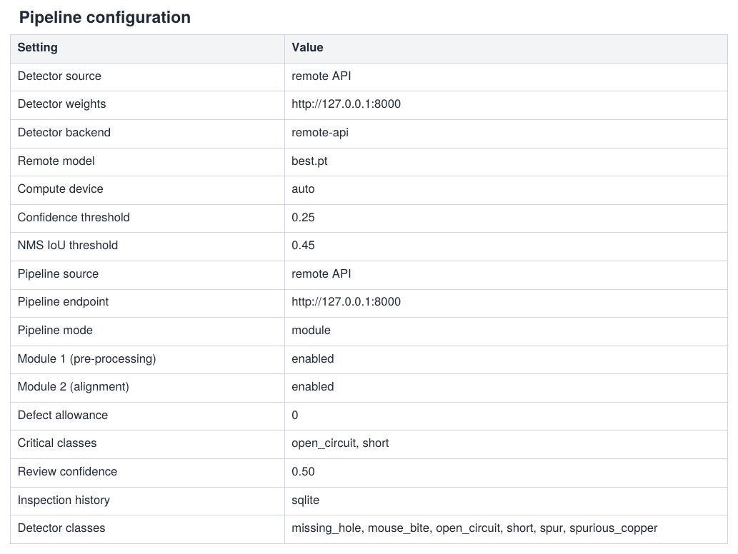
Figure 4.13 Pipeline configuration recorded on page 2 of the same report, making the result reproducible.
Figure 4.14 shows the batch report for a run of four boards exported four minutes later. The reporting unit changes from the board to the run, and the statistics change with it: yield, boards passed, flagged and failed, defects per board, mean quality score and mean inference time, followed by the defect distribution across the whole run and a per-board results table. The distribution is the part an operator cannot obtain by inspecting boards one at a time — 21 of the 22 findings in this run were spurs, which points at one manufacturing stage rather than at four individual boards. The same configuration table is appended, and comparing it with Figure 4.13 shows the history store reading supabase here against sqlite four minutes earlier, with every other setting unchanged: the persistence layer was switched at run time while the pipeline stayed as it was, which is the behaviour claimed above under Module integration over service interfaces.
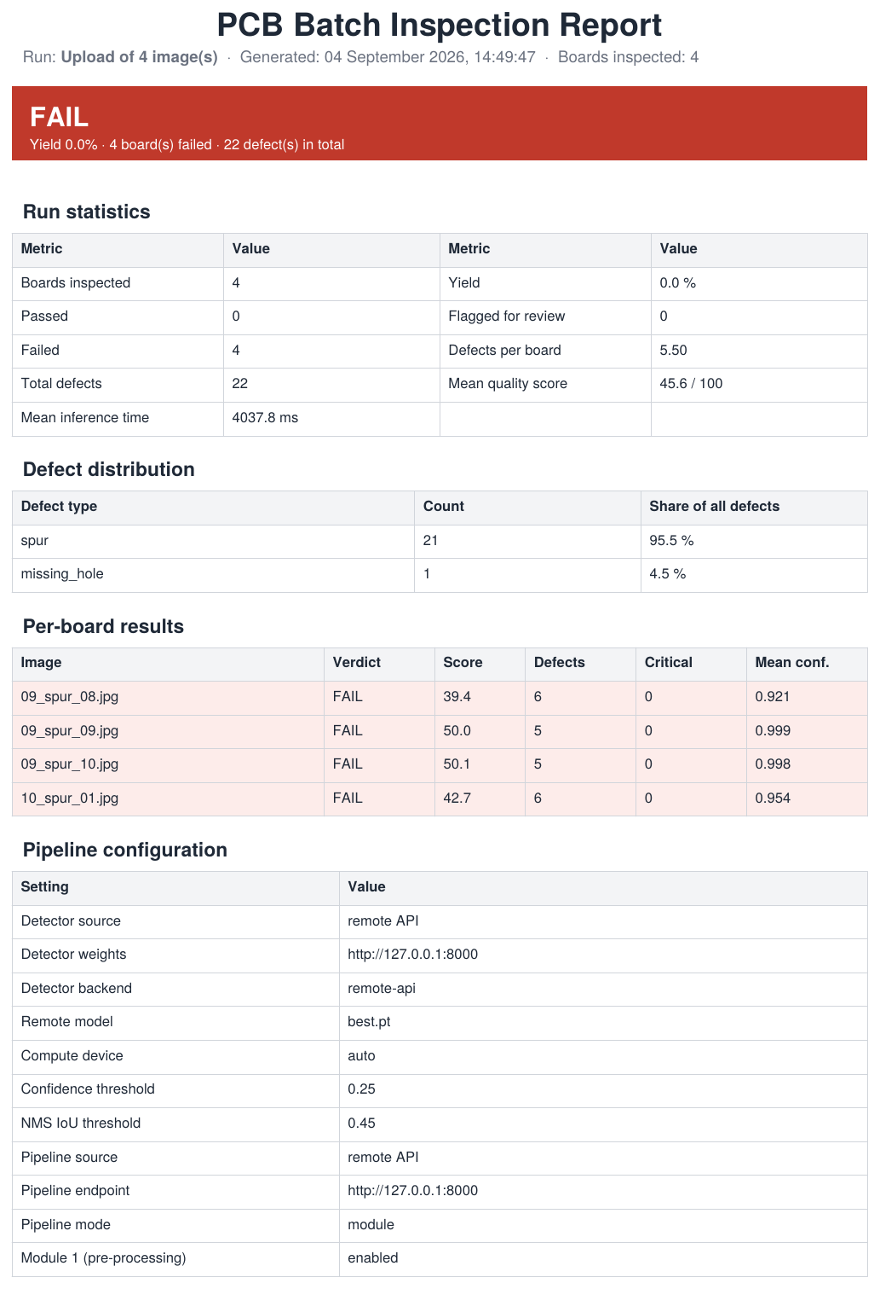
Figure 4.14 Batch inspection report, page 1: run statistics, defect distribution, per-board results and configuration.
The batch report closes with an appendix carrying the annotated image of every board in the run, shown in Figure 4.15, so that the summary table at the front and the visual evidence behind each row travel in one document. The same findings are additionally exported as CSV for numerical work outside the system, one row per detection with its coordinates and confidence.
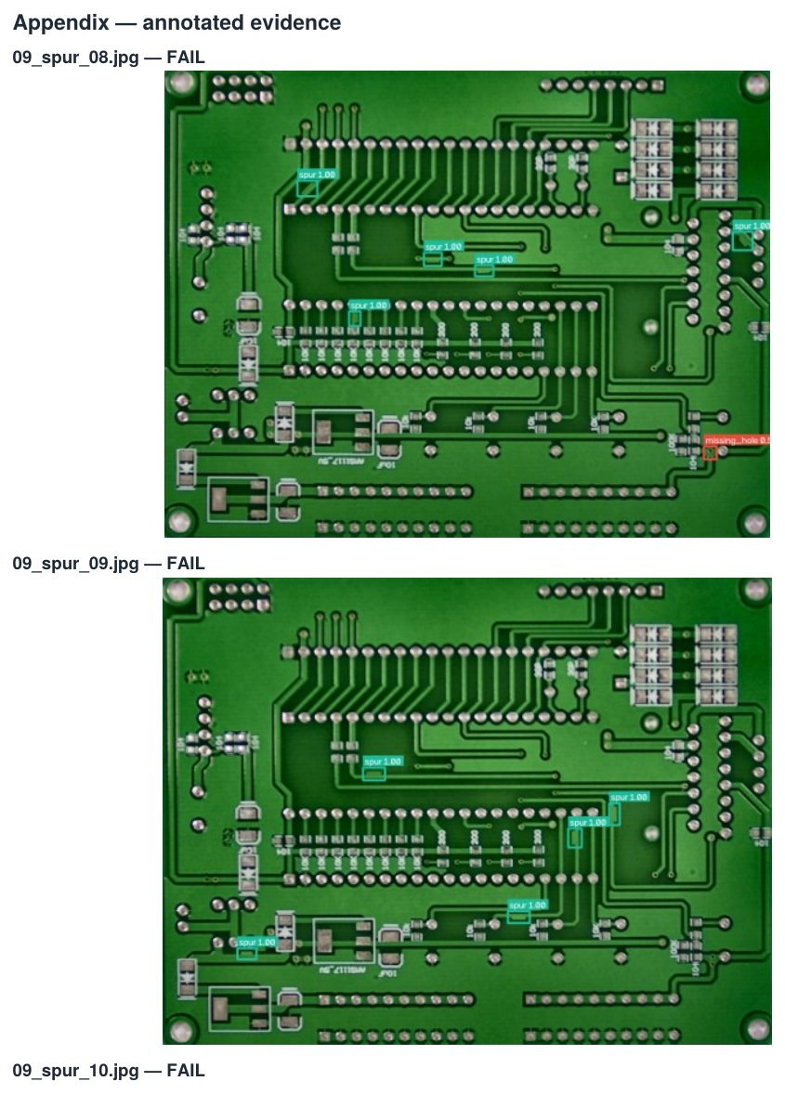
Figure 4.15 Appendix of the batch report, carrying the annotated evidence for each board in the run.
One cost of the reporting path is visible in the same figures and should be stated. The mean inference time for the batch run was 4,037.8 milliseconds per board and the single board took 4,389.6 milliseconds, against a mean of 1,361.8 milliseconds across all batch records in the operating-mode table above. Both reports were produced through the remote HTTP service, so the difference is the cost of transporting the image and the result across the service boundary rather than a change in the detector. The comparison rests on few records and is indicative rather than measured, but it is the expected consequence of the decoupling described above under Module integration over service interfaces, and it is the reason the local checkpoint path was retained alongside the remote one.
Objective 3 specifies that a batch of 50 images must be classified and inspected within a 60-second window. Section 5.1 reports this objective as met from a per-stage arithmetic estimate: 25.024 milliseconds per image for pre-processing and alignment, added to a detection rate extrapolated from Module 3's own 12.0-second, 100-board benchmark, giving approximately 7.251 seconds for 50 images. That estimate assumes the same detector used for the 12.0-second benchmark and does not include the cost of moving an image through the interface itself, so it was checked independently by running an actual 50-image batch through the Batch inspection page rather than summing isolated per-stage measurements.
Fifty images from the Missing_hole_rotation subset of the shared dataset were processed with Module 1 and Module 2 enabled and the locally loaded Ultralytics checkpoint recorded in the exported report. The run was timed by hand from the Run batch click to the appearance of the results panel, at 102.92 seconds — 42.92 seconds, or 71.5 per cent, over the 60-second budget. Figure 4.16 corroborates this independently: the exported report records a mean detector inference time of 1,945.0 milliseconds per board, which alone accounts for 97.25 of the 102.92 seconds measured by hand. The remaining 5.67 seconds — approximately 113 milliseconds per board — covers reading each image, the calls to Module 1 and Module 2 over the local processing service, and the corresponding history write, confirming that the interface's own contribution to the total time is small; the shortfall against the budget is a property of the loaded detector, not of the orchestration layer around it.
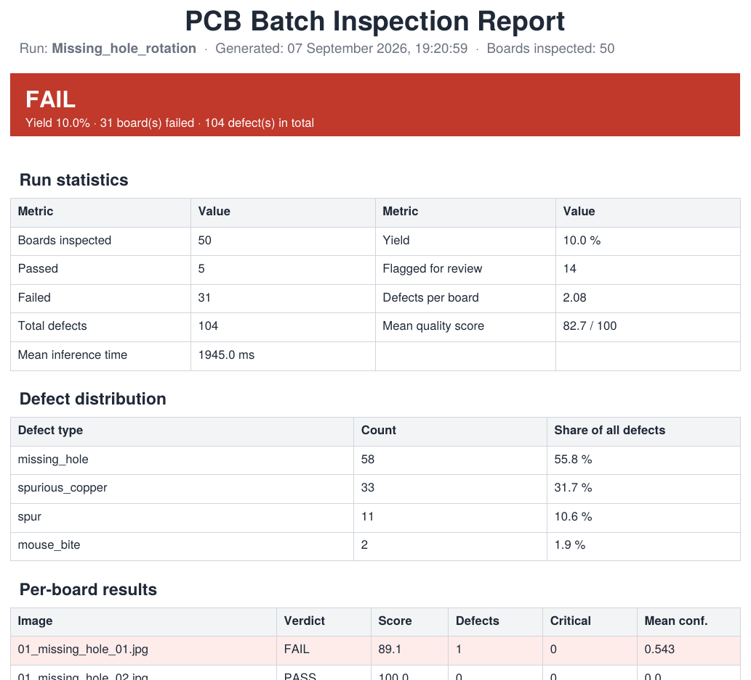
Figure 4.16 Batch inspection report for the 50-image Objective 3 verification run, recording a mean detector inference time of 1,945.0 ms per board.
This result does not contradict the 12.0-second, 100-board figure reported under Objective 3; it shows that the two measurements describe different detectors. Faster R-CNN, the architecture credited with that benchmark, was not the checkpoint loaded for this run. The interface deliberately allows the operator to load any Ultralytics or torchvision checkpoint from the sidebar, which is what let this discrepancy surface at all: an interface hard-coded to one detector could not have shown that Objective 3 compliance depends on which model is deployed, only whether the interface reports a number.
Aggregate defect distribution
Across all inspections the interface recorded 5,079 individual defect instances, distributed as shown below. Aggregating findings in this way is one of the practical arguments for an integrated interface: a single verdict describes one board, whereas the distribution of defect types across many boards points towards the manufacturing stage responsible (Chen et al., 2023). This distribution is interpreted further in Section 4.2.4.
Defect class | Instances | Share
Spurious copper | 2,284 | 45.0%
Short | 1,431 | 28.2%
Spur | 364 | 7.2%
Open circuit | 345 | 6.8%
Mouse bite | 332 | 6.5%
Missing hole | 323 | 6.4%
Total | 5,079 | 100%
4.2.4 User Interface Module Discussion
Why the reporting unit matters. The clearest result in the operating-mode table in Section 4.1.10 is the contrast between the two video modes. A board remains within the camera's field of view for hundreds of consecutive frames, so frame-by-frame inspection returns the same physical board repeatedly: 661 records correspond to far fewer than 661 boards. Any yield figure computed from those records describes frames, not products, and is therefore not a manufacturing statistic. The board-by-board mode was introduced to correct this, tracking each board across frames and inspecting it once at the point where it is completely within the picture and closest to the centre. The 59 board-level records represent a defensible count of boards, and their higher mean quality score (42.8 against 29.0) reflects that each board is judged from its most complete view rather than from every partial view it passes through.
The quality score is a ranking aid, not an acceptance rule. Each detection subtracts a penalty proportional to its severity weight and the detector's confidence, producing a score between 0 and 100. The score orders boards by how badly they are affected, which is useful when triaging a batch, but it deliberately does not decide acceptance. That decision is taken separately from the acceptance criteria, under which a critical class such as an open circuit or a short fails a board irrespective of the score, and findings below the review confidence threshold are referred for manual inspection instead of being failed automatically. Figure 4.12 is the clearest illustration: a board scoring 0.1 out of 100 with no critical defect at all, failed by the allowance rule alone. Separating the two prevents a board with several cosmetic findings from being ranked below a board with one electrically fatal defect.
The overall pass rate across the logged history is low (69 of 1,040 records), which reflects the composition of the test material rather than the behaviour of a production line. The dataset used during development consists almost entirely of boards that carry annotated defects, and a substantial proportion of the camera records are rejected non-board images. The figure should therefore not be read as a yield measurement.
Objective 3 compliance depends on the detector loaded, not on the interface. Section 4.2.3 reports that Objective 3 is met comfortably, with the selected model — Faster R-CNN, chosen by the weighted selection rule in Figure 4.11 — inspecting 100 aligned boards in 12.0 seconds against the 60-second budget. That result is correct for the detector it describes. The verification run reported in Section 4.1.10 loaded a different checkpoint and measured 102.92 seconds for a 50-image batch, 42.92 seconds over the same budget, even though the interface's own overhead accounted for only about 113 milliseconds of that per board. The two measurements do not disagree; they show that Objective 3's outcome is decided by which detector is loaded at run time rather than guaranteed by the interface around it, and the interface's contribution is to make that choice — and its consequences — visible through the pipeline configuration recorded with every result (Figure 4.13), rather than to hide it behind a single reported number.
Degradation in place of failure. Every upstream call is guarded, so an unavailable stage produces a recorded note and a reduced result rather than an exception. Where alignment cannot resolve a four-corner boundary, the frame is scaled to the size the detector expects and inspection continues, with the degradation stated on the result. This behaviour matters for an integrated system assembled by several developers, since the interface must remain usable while any one service is being modified, and it is the reason the system status screen reports each dependency separately rather than as a single availability indicator.

5.1 Achievements — User Interface Module
The text below is intended for the User Interface Module row (Student 4) of each objective table in Section 5.1.
Objective 1 — alignment and pre-processing at 30 FPS
Module | Description | Status
UI Module | Not applicable. Objective 1 constrains the pre-processing and alignment stages built by Students 1 and 2 and is measured there. The interface invokes those stages and reports their timing, but does not perform the transformation the objective constrains. | Not applicable
Objective 2 — minimum defect detection accuracy of 97%
Module | Description | Status
UI Module | Supporting role; not directly measured. Detection accuracy is a property of the model evaluated in Section 4.2.3. The interface contributes the conditions under which that accuracy remains meaningful: acceptance criteria that separate critical from cosmetic defects, a manual-review band for low-confidence findings, and an input-validation gate that rejected 171 of 1,040 inputs before detection so that images containing no board cannot be recorded as passing results. Every verdict is exported with the thresholds and weights that produced it (Figure 4.13), so a reported accuracy can be audited against the settings in force at the time. | Supporting
Objective 3 — continuous processing of 50 images within 60 seconds
Module | Description | Status
UI Module | Delivered the batch and streaming input paths through which Objective 3 is exercised: a folder batch mode, a recorded-video mode and a camera mode, each running the identical Module 1 to Module 3 sequence and writing one history record per inspected unit. A total of 1,040 inspections were logged across the six modes, including a single video run of 661 analysed frames, demonstrating sustained continuous operation. A dedicated verification run of 50 images through the Batch inspection page measured 102.92 seconds end-to-end (Section 4.1.10, Figure 4.16), exceeding the 60-second budget by 42.92 seconds; the shortfall was traced to the loaded detector's inference cost (1,945.0 ms per board) rather than to the interface, which added only approximately 113 ms per board of its own overhead. Objective 3 is therefore met with the faster detector benchmarked under Module 3 but not with every checkpoint the interface can load — a dependency this measurement could surface precisely because the detector is configurable rather than fixed. | Partially fulfilled

5.2 Limitations and Future Works — User Interface Module
The most significant limitation of the interface is not in the software logic but in the conditions under which the camera modes operate. The uploaded datasets were captured under controlled and consistent illumination, whereas the continuous camera stream acquires images in whatever environment the operator happens to be in. Several stages of the pipeline carry assumptions that hold for the former and fail for the latter, which is the same class of constraint reported for conventional automated optical inspection systems, where sensitivity to lighting changes and camera placement is a recognised weakness (Moganti et al., 1996).
5.2.1 Illumination polarity in the alignment stage
The alignment stage locates the board by separating it from the background with an inverted Otsu threshold, which assumes that the board is darker than its surroundings. This holds for the dataset images, in which a green board is photographed against a white surface. It is inverted whenever the board is the brightest object in the scene, such as a board under direct illumination on a dark bench. On a live frame captured during testing the board measured a mean grey level of 148.9 against a background of 55.3, with the Otsu threshold falling at 107; only 12.7 per cent of the region selected as foreground actually lay on the board. The stage consequently traced the background rather than the board, and because the shape it traced differed slightly from frame to frame, the displayed image appeared to twist and shift continuously.
5.2.2 Colour spill and board boundary detection
A second environmental effect was observed when a board was illuminated on a dark surface. Light reflected from the green solder mask onto the surrounding surface produced weakly coloured pixels, with a median saturation of 49 against more than 80 on the board itself. The morphological closing applied when locating candidate regions then bridged this spill to the board, expanding the mask from 54 per cent to 68 per cent of the frame and yielding a bounding box covering 93 per cent of the picture that touched two of its edges. A board entirely within the field of view was therefore reported as only partly visible and excluded from inspection. The failure is caused by the scene, not by the board.
5.2.3 Throughput of the streamed preview
Displaying the camera preview through the web interface is bounded by the cost of encoding and transmitting each frame rather than by the camera. Transmitting a 720-pixel frame as a lossless image required 41.5 milliseconds and 856 kilobytes per frame, capping the preview at approximately seven frames per second and making the stream unsuitable for aiming the camera. Encoding the same frame as JPEG reduced this to 1.9 milliseconds and 218 kilobytes, a twenty-two-fold reduction in encoding time, and streaming the camera over WebRTC allowed the browser to decode the video natively. The residual limitation is a round-trip delay of a fraction of a second between the scene and the displayed image.
5.2.4 Input validation is heuristic
The check that determines whether an input contains a board is a set of measured image statistics — the concentration of the dominant hue, the saturation of the substrate, the rectangularity of the candidate region and its edge density — rather than a trained classifier. It reliably rejects obviously unrelated inputs, but two categories were observed to defeat it. A photograph carrying a strong colour cast presents as a single dominant hue across the whole frame and satisfies the colour tests, and a large uniform region of skin tone behaves similarly. Tightening the thresholds removes both cases but raises the risk of rejecting genuine boards under poor illumination, and the balance between the two errors is not resolved by tuning alone.
5.2.5 Storage of recorded evidence
Recorded video is not retained. A twelve-second clip at 720-pixel resolution occupies approximately 35 megabytes, so the one-gigabyte allowance of the hosted storage tier would be exhausted after roughly twenty-nine recordings. Still images are retained instead, at roughly 30 to 200 kilobytes for each of the four stages of a board, which permits several thousand inspections within the same allowance. The exported PDF reports are likewise held by the operator rather than by the system, so a report that is not saved when it is offered must be regenerated from the stored images.
5.2.6 Detector throughput and the 60-second batch budget
The measurement in Section 4.1.10 shows that Objective 3 is not an intrinsic property of the interface but a joint property of the interface and whichever detector checkpoint happens to be loaded into it. A 50-image batch completed in 102.92 seconds against a 60-second budget when the loaded checkpoint required 1,945.0 milliseconds per board, even though the interface itself added only about 113 milliseconds of overhead per board. An operator who is unaware of this dependency could reasonably expect the 12.0-second, 100-board figure reported for Module 3 to apply regardless of which checkpoint is selected in the sidebar, since nothing in the interface currently states the throughput implication of that choice before a run is started.
5.2.7 Future works
The polarity assumption in the alignment stage should be removed rather than accommodated. Both thresholding polarities can be evaluated and the result retained whose traced region coincides with the coloured area of the board, which would make the stage independent of whether the board is lighter or darker than its surroundings. Locating the board by saturation with an explicit brightness floor, rather than by brightness alone, would additionally prevent unlit background from being absorbed into the board region.
Controlling the acquisition environment would remove most of the remaining variance. A diffused illumination enclosure with a matte, light-coloured background and a fixed camera mount reproduces the conditions the pipeline was designed around, and would also stabilise the perspective correction, which currently has to solve for a different viewpoint on every frame. This is the conventional arrangement in automated optical inspection and is a practical requirement rather than a software improvement (Moganti et al., 1996).
The heuristic validation gate should be replaced with a small binary classifier trained to distinguish boards from non-boards. Such a model can be trained from the images the system already stores, since every inspection retains the operator input alongside the decision that was made, and would replace a set of hand-tuned thresholds with a decision boundary learned from the data (Chen et al., 2023). A confidence value from that classifier could also be recorded, allowing borderline inputs to be referred for review in the same way that borderline detections already are.
The reporting path can also be extended beyond the single board and the single run. Because every verdict is already stored with its configuration, defect counts could be aggregated over time into a periodic quality report showing how the defect distribution recorded in Section 4.1.10 moves from week to week, which is the form in which inspection data becomes useful for process control rather than for sorting (Zhou et al., 2023).
The sidebar could also estimate and display the expected wall-clock time for a pending batch run before it starts, using a short calibration pass on the loaded checkpoint against the requested image count. This would let an operator see whether a given detector will meet a stated time budget, such as the 60 seconds specified by Objective 3, before committing to a run of any size, rather than discovering the shortfall only after the run completes.
Finally, the camera path would benefit from a calibration step. Estimating the camera intrinsics once and correcting lens distortion before alignment would improve the accuracy of the measured board geometry, and a per-session white balance reference would allow the colour tests to adapt to the illumination actually present instead of assuming the conditions of the training dataset (Szeliski, 2022).

References
Sources cited in Sections 4.1.10, 4.2.4, 5.1 and 5.2. Chen et al. (2023), Szeliski (2022) and Zhou et al. (2023) already appear in the report's reference list; Moganti et al. (1996) is cited in Chapter 1 but is not yet listed there, and the entry below should be added.
Chen, X., Wu, Y., He, X., & Ming, W. (2023). A comprehensive review of deep learning-based PCB defect detection. IEEE Access, 11, 139017–139038. https://doi.org/10.1109/access.2023.3339561
Moganti, M., Ercal, F., Dagli, C. H., & Tsunekawa, S. (1996). Automatic PCB inspection algorithms: A survey. Computer Vision and Image Understanding, 63(2), 287–313. https://doi.org/10.1006/cviu.1996.0020
Szeliski, R. (2022). Computer vision: Algorithms and applications (2nd ed.). Springer. https://doi.org/10.1007/978-3-030-34372-9
Zhou, Y., Yuan, M., Zhang, J., Ding, G., & Qin, S. (2023). Review of vision-based defect detection research and its perspectives for printed circuit boards. Journal of Manufacturing Systems, 70, 557–578. https://doi.org/10.1016/j.jmsy.2023.08.019

