[2110030140cse@gmail.com](mailto:2110030140cse@gmail.com)

T.Leekhitha

**Digital Nurture 3.0**

**Week-2 ServiceNow Administration Fundamentals**

1Q) Demonstrate a comprehensive understanding of ServiceNow platform overview and architecture.

**Ans**: Here are five key points summarized from the content:

1**. Course Overview**: The ServiceNow Admin training covers a comprehensive range of topics including platform overview, user interface, task management, notifications, knowledge management, service catalog, and more, designed to prepare users for the ServiceNow Admin certification.

2. **Platform Features**: The course introduces the platform’s architecture, supported browsers, and mobile applications. It also differentiates between out-of-the-box features and custom configurations in ServiceNow.

3. **User Interface and Customization**: Detailed explanations are provided on how to navigate the UI, configure lists, forms, fields, and dashboards. The course also covers how to create custom tables, fields, and layouts.

4. **Security and Access Control**: Access control mechanisms like ACLs (Access Control Lists) and their configuration are discussed, ensuring that administrators can manage who sees and interacts with specific data.

5. **Practical Application and Tools**: The training includes practical demos on data import, workflow creation, notifications, and catalog item management, offering hands-on experience with various ServiceNow tools and functionalities.

2Q) Customize the user interface and branding elements within ServiceNow

**Ans**: 1. **Themes and Branding**: You can modify the look and feel of the ServiceNow interface by adjusting the color schemes, logos, and overall theme. This is typically done through the System Properties > Basic Configuration UI16 module, where you can change the banner, logo, and colors to match your organization’s branding.

2. **Form Layouts**: Customize how forms appear by rearranging fields, adding or removing sections, and configuring related lists. This can be done through the Form Designer or Form Layout options, allowing you to tailor the forms to the specific needs of your users.

3. **List Layouts**: Adjust the appearance and behavior of lists by configuring list layouts, creating personalized views, and applying filters. This ensures that users see the most relevant information at a glance.

4**. UI Policies and Scripts**: Use UI policies and scripts to dynamically alter the appearance of forms and fields based on certain conditions. This helps in making the interface more interactive and responsive to user inputs.

5. **Custom CSS and UI Pages**: For more advanced customization, you can apply custom CSS or create custom UI pages and macros. This allows for a deeper level of branding and interface modification, beyond what’s available in standard configurations.

3Q) Manage tasks efficiently using ServiceNow functionalities.

**Ans**: Managing tasks efficiently using ServiceNow functionalities involves leveraging its various features designed for task tracking, automation, and collaboration. Here’s how you can do it:

**1. Task Management via Incident, Problem, and Change Modules:**

- Use the Incident Management module to track and resolve incidents efficiently.

- Utilize Problem Management to address the root causes of issues and prevent future incidents.

- Implement Change Management to control the lifecycle of changes, ensuring minimal disruption to IT services.

**2. Automate Task Assignments:**

- Set up Assignment Rules to automatically assign tasks to the appropriate team or individual based on predefined criteria, such as category, priority, or location.

- Utilize Workflows to automate repetitive tasks, ensuring that processes are followed consistently and efficiently.

**3. Prioritize and Escalate Tasks:**

- Use SLAs (Service Level Agreements) to define priority levels and deadlines for tasks. This helps in identifying which tasks need immediate attention and ensures they are completed within the required timeframes.

- Escalation Rules can be configured to automatically escalate tasks if they are not completed within the set SLA, ensuring nothing falls through the cracks.

**4. Task Collaboration:**

- Leverage Task Collaboration Tools like the Activity Stream to communicate and document updates on tasks directly within ServiceNow.

- Use the Watch List and Work Notes to keep relevant stakeholders informed about the progress of tasks.

**5. Task Tracking and Reporting:**

- Monitor task progress using Dashboards and Reports. ServiceNow provides real-time visibility into the status of tasks, helping you identify bottlenecks and make informed decisions.

- Use Kanban Boards for a visual representation of tasks, making it easier to manage workloads and track task completion.

**6. Mobile Access:**

- Utilize the ServiceNow Mobile App to manage tasks on the go. This ensures that tasks can be updated and managed efficiently, even when team members are away from their desks.

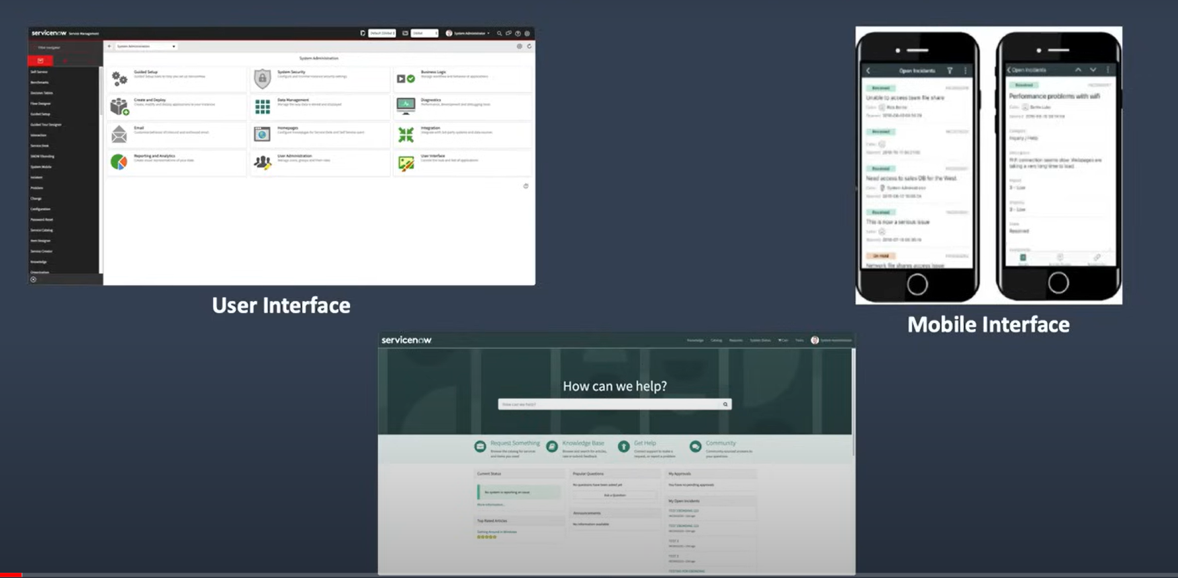

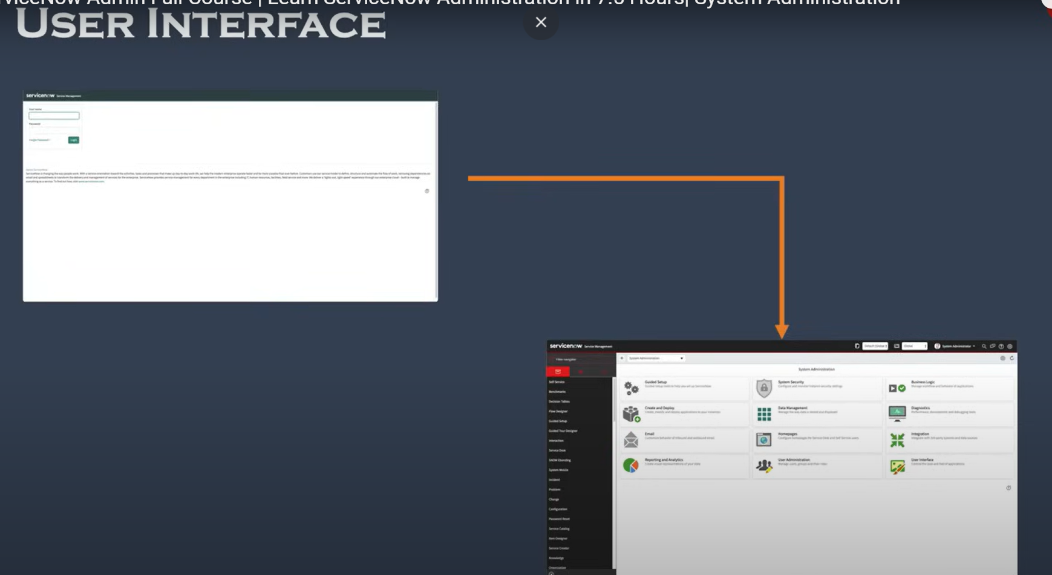

4Q) Configure notifications and implement knowledge management practices

**Ans**: Configuring notifications and implementing knowledge management practices in ServiceNow enhances communication and ensures that valuable information is easily accessible. Here's how you can do it:

**Configuring Notifications in ServiceNow**

1. **Create Notification Rules**:

- Navigate to System Notification > Email > Notifications.

- Define the conditions under which notifications should be sent (e.g., when a record is created, updated, or closed).

- Set the recipients, which could include specific users, groups, or roles.

**2. Customize Notification Content:**

- Edit the subject and message content to include dynamic fields from the records (e.g., ${number} for the incident number).

- Use HTML formatting to make emails more visually appealing and easier to read.

**3. Set Up Notification Channels:**

- ServiceNow supports multiple notification channels, including email, SMS, and push notifications.

- Configure the channels based on user preferences and ensure that they are enabled for different types of notifications.

**4. Subscription-Based Notifications:**

- Allow users to subscribe to specific notifications based on their interests or needs (e.g., updates on certain incidents or knowledge articles).

- Enable users to manage their subscriptions via the Self-Service Portal.

**5. Testing and Monitoring Notifications:**

- Test your notification configurations to ensure they are working as expected.

- Monitor the Outbound Email log to track notifications and troubleshoot any issues.

**Implementing Knowledge Management Practices**

**1. Create Knowledge Bases:**

- Set up different knowledge bases within ServiceNow to organize content by category (e.g., IT, HR, customer service).

- Define roles and permissions to control who can create, edit, and view knowledge articles.

**2. Authoring and Publishing Knowledge Articles:**

- Encourage subject matter experts to create knowledge articles using templates for consistency.

- Implement a review and approval process to ensure accuracy before publishing articles.

- Use metadata like tags and keywords to make articles easily searchable.

**3. Enable Feedback and Rating:**

- Allow users to rate articles and provide feedback, which helps in identifying the most helpful content and areas for improvement.

- Monitor feedback to continually improve the quality of your knowledge base.

**4. Automate Knowledge Article Suggestions:**

- Configure ServiceNow to automatically suggest relevant knowledge articles when users are creating incidents or requests.

- Use Virtual Agents and Chatbots to surface knowledge articles in real-time during user interactions.

**5. Track Knowledge Usage and Effectiveness**:

- Utilize dashboards and reports to monitor the usage of knowledge articles, such as how often they are accessed and by whom.

- Analyze metrics like article effectiveness in resolving issues to identify gaps and opportunities for new content.

**6. Promote Knowledge Sharing:**

- Encourage a culture of knowledge sharing by recognizing contributors and making it easy for employees to share their expertise.

- Regularly update the knowledge base to ensure content remains current and relevant.

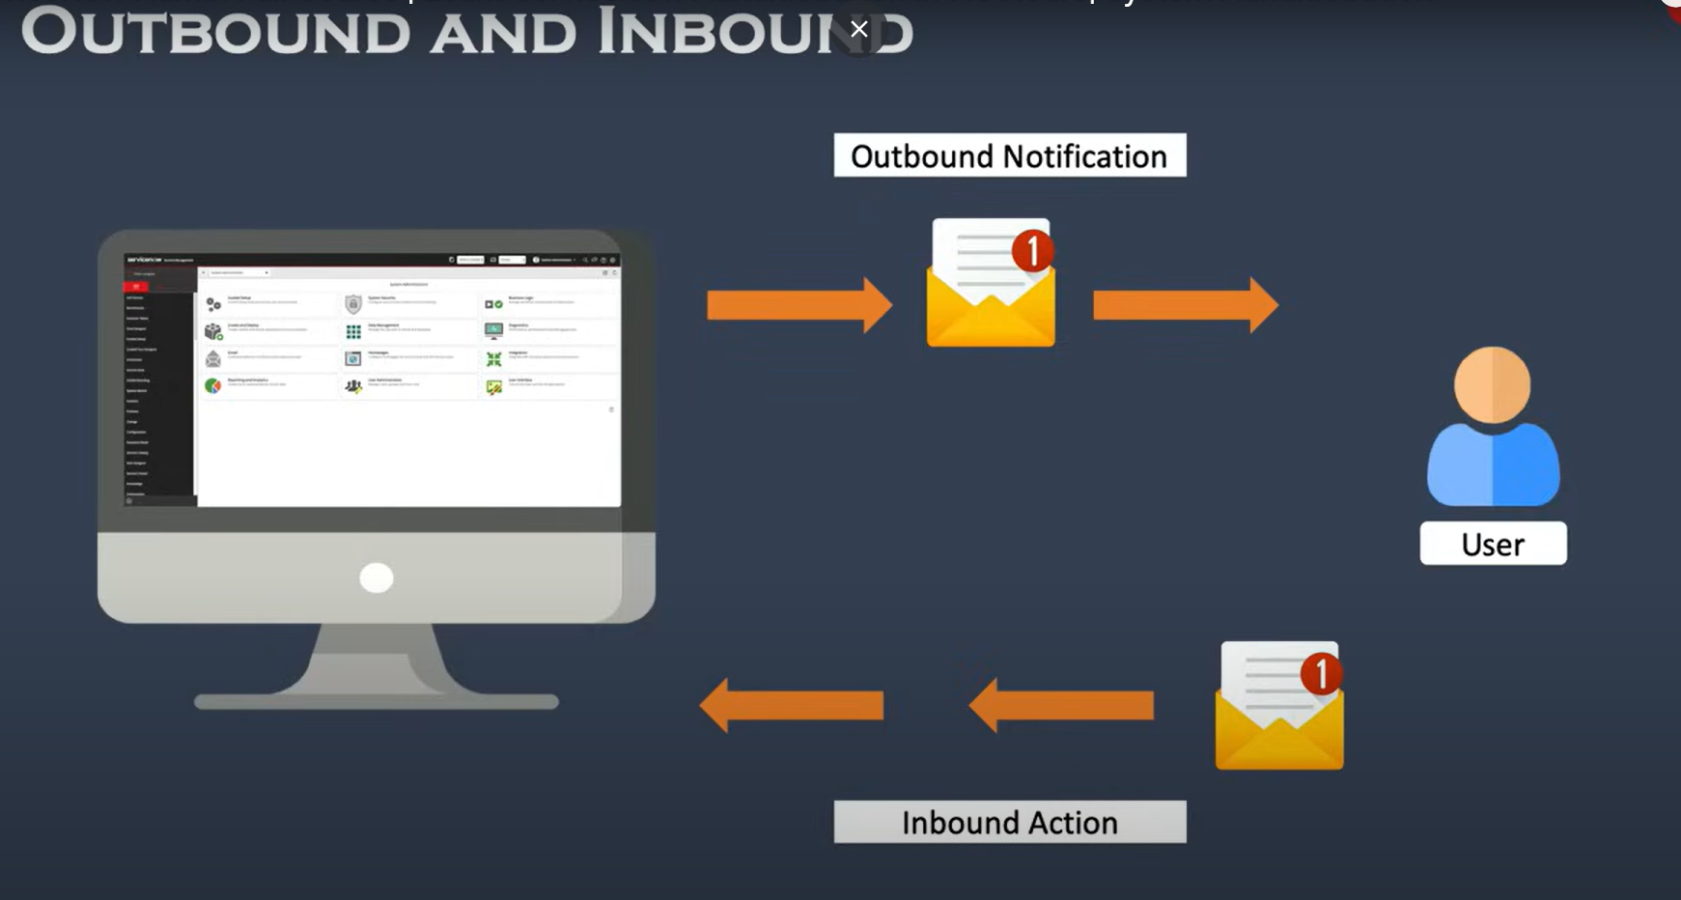

5Q) Create and manage service catalogs effectively.

**Ans**: Creating and managing service catalogs in ServiceNow allows organizations to provide a streamlined, user-friendly interface for requesting services and products. Here's how to do it effectively:

**Creating Service Catalogs in ServiceNow**

1. Define the Catalog Structure:

- Start by identifying the types of services or products your organization offers, such as IT services, HR services, or facilities requests.

- Organize these into categories and subcategories that make it easy for users to find what they need.

2. Create the Service Catalog:

- Navigate to Service Catalog > Catalog Definitions > Maintain Catalogs.

- Click New to create a new catalog and give it a name (e.g., "IT Services Catalog").

- Define the catalog's properties, such as description, active status, and availability.

3. Add Categories and Items:

- Within your catalog, create categories to group similar items (e.g., Hardware, Software, Access Requests).

- Add catalog items under these categories by navigating to Service Catalog > Catalog Definitions > Maintain Items.

- For each item, specify the details such as name, description, price, fulfillment instructions, and images.

4. Configure Variables and Variable Sets:

- Variables allow you to capture specific information from users when they request an item (e.g., device specifications, delivery location).

- Define variables for each catalog item and group them using variable sets for consistency across similar items.

5. Set Up Workflows for Fulfillment:

- Associate each catalog item with a workflow that automates the request fulfillment process.

- Workflows can include steps such as approvals, task assignments, and notifications to ensure that the request is handled efficiently.

6. Define User Access and Permissions:

- Control who can see and request specific items by setting user criteria and roles.

- This ensures that only eligible users can access certain catalog items based on their department, role, or location.

7. Configure Service-Level Agreements (SLAs):

- Attach SLAs to catalog items to define the expected delivery time and track performance against these targets.

- Use SLAs to prioritize requests and escalate issues if they are not resolved within the expected timeframe.

Managing Service Catalogs Effectively

1. Monitor and Update Catalog Content:

- Regularly review and update catalog items to ensure they are accurate and relevant.

- Remove obsolete items and add new services as they become available.

2. Use Reporting and Analytics:

- Leverage ServiceNow's reporting tools to monitor catalog usage, request fulfillment times, and user satisfaction.

- Analyze this data to identify trends, popular items, and areas for improvement.

3. Implement Feedback Mechanisms:

- Allow users to rate and provide feedback on catalog items to gather insights into their experiences.

- Use this feedback to make continuous improvements to the catalog.

4. Promote the Service Catalog:

- Increase awareness of the service catalog by promoting it through internal communications, training sessions, and the company intranet.

- Highlight new or popular services to encourage adoption.

5. Automate Routine Updates:

- Set up automation for routine tasks such as price updates, availability changes, and item retirements to keep the catalog up to date with minimal manual intervention.

6. Train Users and Support Staff:

- Provide training to both end-users and support staff on how to use and manage the service catalog.

- Ensure that users understand how to navigate the catalog, submit requests, and track the status of their requests.

6Q) Configure tables and fields, as well as access control lists

**Ans**: Configuring tables, fields, and access control lists (ACLs) in ServiceNow is essential for organizing data, controlling access, and ensuring security within the platform. Here's how to manage these configurations:

**Configuring Tables and Fields in ServiceNow**

1. Creating and Configuring Tables:

- Create a New Table:

- Navigate to System Definition > Tables.

- Click New to create a new table.

- Provide a Label and Name for the table. The Name field will automatically populate based on the label.

- Specify if you want to extend the table from an existing one (like Task, CMDB, etc.) or create a standalone table.

- Configure Table Properties:

- Set properties such as Auto-numbering for records, Application Scope, and Access Controls.

- Define the table's behavior, such as allowing or disallowing attachments, history tracking, and indexing for faster queries.

2. Creating and Configuring Fields:

- Add Fields to a Table:

- Within the table configuration, scroll to the Columns section.

- Click New to add a field. Select the field type (e.g., String, Integer, Date/Time, Reference) and give it a Label.

- Configure field properties, such as default values, mandatory status, read-only status, and reference behavior for reference fields.

- Use Field Types Effectively:

- Choose appropriate field types to ensure data integrity and ease of use. For example, use Choice fields for predefined options, Reference fields to link to records in other tables, and Glide Date/Time for capturing date and time information.

3. Customizing Forms and Lists:

- Form Layout:

- Customize the form layout by navigating to System UI > Forms and Layouts > Form Layout.

- Add or rearrange fields, create sections, and use related lists to display relevant information.

- List Layout:

- Modify list views by navigating to System UI > Lists > List Layout.

- Choose which fields are visible in list views, set sorting options, and create filters for quick access to important data.

**Configuring Access Control Lists (ACLs) in ServiceNow**

1. Understanding ACLs:

- ACLs in ServiceNow control who can access or modify data within tables and fields. They are evaluated in the following order: Table-level, Field-level, and Record-level.

- ACLs are defined for operations such as Read, Write, Create, and Delete.

2. Creating ACLs:

- Navigate to System Security > Access Control (ACL).

- Click New to create an ACL.

- Define the following:

- Type: Select whether the ACL applies to a Record, Field, or Scripted access.

- Operation: Choose the operation (Read, Write, Create, Delete) that the ACL will control.

- Name: Specify the table or field name to which the ACL applies.

- Condition: Add conditions that must be met for the ACL to apply. For example, restrict access to records where the "State" is "Closed."

- Script: (Optional) Use scripting to define complex logic for when the ACL should grant or deny access.

3. Testing ACLs:

- Use the Impersonate feature to test ACLs from the perspective of different users and roles.

- Navigate to the table or field and attempt the restricted operation to ensure the ACL behaves as expected.

4. Best Practices for ACLs:

- Least Privilege Principle: Grant the minimum level of access required for users to perform their job functions.

- Use Roles Effectively: Assign roles that group similar access needs and apply ACLs to these roles instead of individual users.

- Monitor and Audit ACLs: Regularly review and audit ACLs to ensure they align with your organization's security policies and remove any unnecessary access rights.

7Q) Import data into ServiceNow and manage the CMDB.

**Ans**: Importing data into ServiceNow and managing the Configuration Management Database (CMDB) are crucial for maintaining accurate records and ensuring that your ServiceNow environment reflects the actual state of your IT infrastructure. Here's how to manage these tasks effectively:

**Importing Data into ServiceNow**

1. Data Import Overview:

- ServiceNow allows you to import data from various sources like CSV files, Excel spreadsheets, XML files, or directly from external databases.

- The Import Set feature is commonly used to import data into ServiceNow tables.

2. Steps to Import Data:

- Create an Import Set Table:

- Navigate to System Import Sets > Create New.

- Create a new import set table or choose an existing one where the data will be temporarily stored

- Load Data:

- Go to System Import Sets > Load Data.

- Select your import set table and choose the file you want to import (CSV, Excel, etc.).

- Configure the file format settings, such as delimiter for CSV files.

- Load the data into the import set table.

- Map Fields:

- After loading the data, you need to map the source fields to the target table fields in ServiceNow.

- Go to System Import Sets > Transform Maps.

- Create a new transform map, selecting the import set table as the source and the target table (e.g., Incident, CMDB, etc.) as the destination.

- Use Auto Map Matching Fields for automatic mapping or manually map fields if needed.

- Add any Transform Scripts to handle special logic or data transformations during the import.

- Run the Transform:

- Once mapping is done, run the transform to move data from the import set table to the target table.

- Monitor the transform progress and review the import logs for any errors or issues.

3. Best Practices for Data Import:

- Data Validation: Validate your data before importing to ensure it meets ServiceNow's data quality standards.

- Test Import: Always test the import on a small dataset first to ensure the process works as expected.

- Backup Data: Backup the target table before performing bulk imports to avoid data loss.

**Managing the Configuration Management Database (CMDB)**

1. Understanding the CMDB:

- The CMDB is a centralized repository that stores information about Configuration Items (CIs), such as hardware, software, networks, and services.

- Accurate management of the CMDB is vital for IT operations, service management, and compliance.

2. Populating the CMDB:

- Manual Entry: You can manually add CIs to the CMDB by navigating to the respective CI class (e.g., Computer, Application) and creating a new record.

- Discovery Tool: Use ServiceNow's Discovery tool to automatically discover and populate CIs in the CMDB. Discovery scans your network, identifies devices, and updates the CMDB.

- Integration: Integrate with other IT management tools (e.g., SCCM, AWS) to synchronize CI data automatically.

3. Managing CI Relationships:

- Define Relationships: For accurate service mapping and impact analysis, define relationships between CIs (e.g., "Depends on," "Hosted on").

- Dependency Views: Use the Dependency Views feature to visualize relationships and dependencies between CIs in a graphical format.

- Service Mapping: Implement Service Mapping to create detailed maps of business services, showing how CIs are interconnected and their roles in delivering services.

4. Maintaining CMDB Accuracy:

- Regular Audits: Regularly audit the CMDB to ensure data accuracy. Use reconciliation and data certification to verify that CIs reflect the actual state of your environment.

- Data Governance: Establish data governance practices to maintain the quality and consistency of CMDB data. This includes defining roles, responsibilities, and processes for updating the CMDB.

- Change Management Integration: Integrate the CMDB with your change management process to automatically update CI records when changes occur, ensuring the CMDB remains up-to-date.

5. Using CMDB for Incident, Problem, and Change Management:

- Incident Management: Leverage the CMDB to quickly identify affected CIs during incident management, improving response times and accuracy.

- Problem Management: Use the CMDB to identify recurring issues with specific CIs, aiding in root cause analysis and problem resolution.

- Change Management: Ensure that changes to CIs are properly tracked and approved, minimizing the risk of unauthorized changes and service disruptions.

8Q) Integrate ServiceNow with other systems and applications.

**Ans**: Integrating ServiceNow with other systems and applications can extend its functionality and create a seamless IT ecosystem. Below is a guide on how to effectively manage integrations with ServiceNow:

**Integration Overview**

ServiceNow can be integrated with various external systems such as CRM platforms, ERP systems, IT management tools, cloud services, and custom applications. These integrations help automate workflows, synchronize data, and improve communication across systems.

**Common Integration Methods**

1. Web Services (REST/SOAP)

- REST API: ServiceNow provides RESTful APIs that allow you to interact with other systems using standard HTTP methods (GET, POST, PUT, DELETE).

- SOAP API: SOAP-based web services can also be used for integrations, though REST is more commonly used due to its simplicity.

- Use Cases: Pulling data from an external CRM system, updating incident records from a monitoring tool, etc.

2. MID Server

- What It Is: The MID (Management, Instrumentation, and Discovery) server is a lightweight Java application that facilitates communication between ServiceNow and external systems located within your network, such as on-premises databases or enterprise applications.

- Use Cases: Integrating with on-premises systems, executing discovery, orchestration activities, or integrating with ERP systems.

3. Inbound and Outbound Email Integration

- Inbound Integration: Configure ServiceNow to receive emails and automatically create or update records (e.g., creating incidents from customer emails).

- Outbound Integration: ServiceNow can send emails to notify external systems or users about events (e.g., status updates, approvals).

- Use Cases: Triggering incident creation via emails, sending notifications to external stakeholders.

4. Integration Hub

- What It Is: Integration Hub provides pre-built connectors and spokes for common integrations with third-party applications, reducing the need for custom development.

- Use Cases: Integrating with Slack for communication, Jira for issue tracking, or Microsoft Teams for collaboration.

5. Data Import and Export

- Import Sets and Transform Maps: These are used to import data into ServiceNow from external sources (like Excel files or databases).

- Exporting Data: Use REST APIs, export sets, or data export functionalities to send data from ServiceNow to external systems.

- Use Cases: Bulk importing of assets into CMDB, exporting incident data for reporting in external BI tools.

6. Database Integration

- JDBC: ServiceNow can connect to external databases using JDBC (Java Database Connectivity) to push or pull data.

- Use Cases: Synchronizing customer data from an external database, pulling financial records for incident reporting.

7. Custom Scripts

- Scripted REST APIs: Create custom REST APIs within ServiceNow to meet specific integration needs that are not covered by out-of-the-box APIs.

- Use Cases: Integrating with custom-built applications, handling complex business logic during data exchange.

**Steps for Successful Integration**

1. Requirements Gathering:

- Identify the business objectives and specific requirements for the integration.

- Determine the systems that need to be integrated, the type of data to be exchanged, and the frequency of data exchange.

2. Choose the Right Integration Method:

- Select the appropriate integration method (REST, SOAP, MID Server, etc.) based on the requirements, the systems involved, and the data types.

3. Configure Authentication:

- Set up authentication mechanisms such as OAuth 2.0, Basic Auth, or API tokens to secure communication between ServiceNow and the external system.

4. Develop and Test:

- Develop the integration by configuring APIs, setting up the MID Server, or using Integration Hub connectors.

- Thoroughly test the integration in a non-production environment to ensure data flows correctly and securely.

5. Monitor and Maintain:

- Once deployed, continuously monitor the integration for any errors or performance issues.

- Regularly update the integration to accommodate any changes in the external systems or business requirements.

**Best Practices for Integration**

- Use Standard APIs: Whenever possible, use standard ServiceNow APIs to ensure compatibility and reduce the need for custom code.

- Security Considerations: Ensure that all data exchanges are secure by using encryption and adhering to security best practices.

- Data Mapping and Transformation: Clearly define how data will be mapped and transformed between systems to avoid data inconsistencies.

- Error Handling: Implement robust error handling to manage any failures or exceptions during data exchange.

- Documentation: Maintain detailed documentation of the integration process, including configurations, scripts, and workflows.

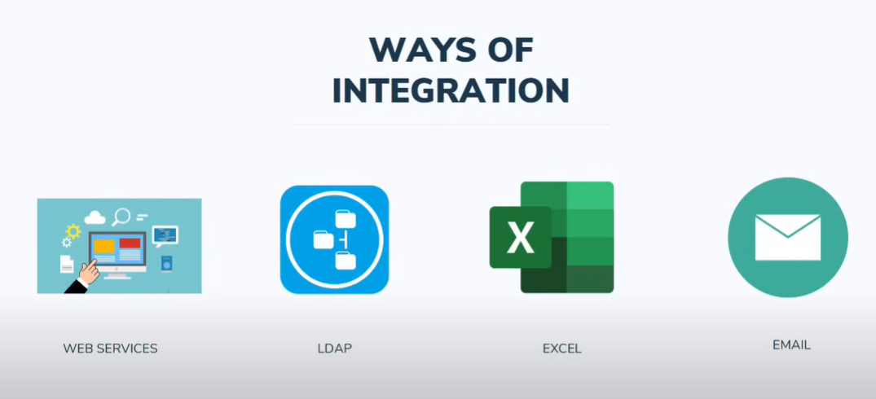

9Q) Utilize update sets, events, and platform statistics for effective administration.

**Ans**: Utilizing update sets, events, and platform statistics effectively is crucial for efficient ServiceNow administration. Here’s a detailed guide on how to leverage these features:

**Update Sets**

Purpose: Update sets are used to manage and transfer customizations from one instance to another (e.g., from development to test to production). They ensure that changes are consistently applied across environments.

**Creating and Managing Update Sets**

1. Create an Update Set:

- Navigation: Go to System Update Sets > Local Update Sets.

- Action: Click New to create a new update set.

- Details: Enter a descriptive name, set the status to "In Progress", and add any necessary notes.

2. Add Changes to an Update Set:

- Automatic: Changes made while the update set is active are automatically included.

- Manual: You can manually add records to the update set from the record's form view by selecting Add to Update Set.

3. Preview and Commit:

- Preview: Check for any conflicts or issues before committing the update set. Navigate to System Update Sets > Retrieved Update Sets, select the update set, and click Preview.

- Commit: After previewing and resolving any issues, commit the update set to apply the changes. This is done from the Retrieved Update Sets section.

4. Best Practices:

- Naming: Use descriptive names for update sets to easily identify their purpose.

- Scope: Keep update sets small and manageable to avoid conflicts and make debugging easier.

- Documentation: Document the changes included in the update set for future reference.

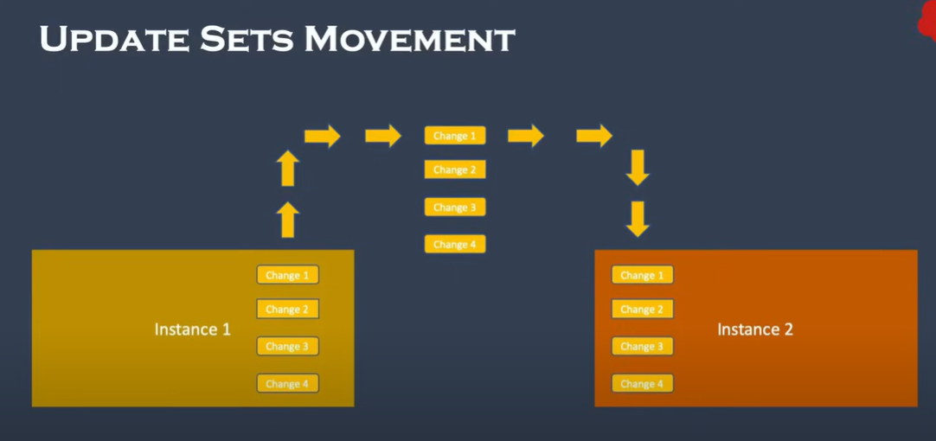

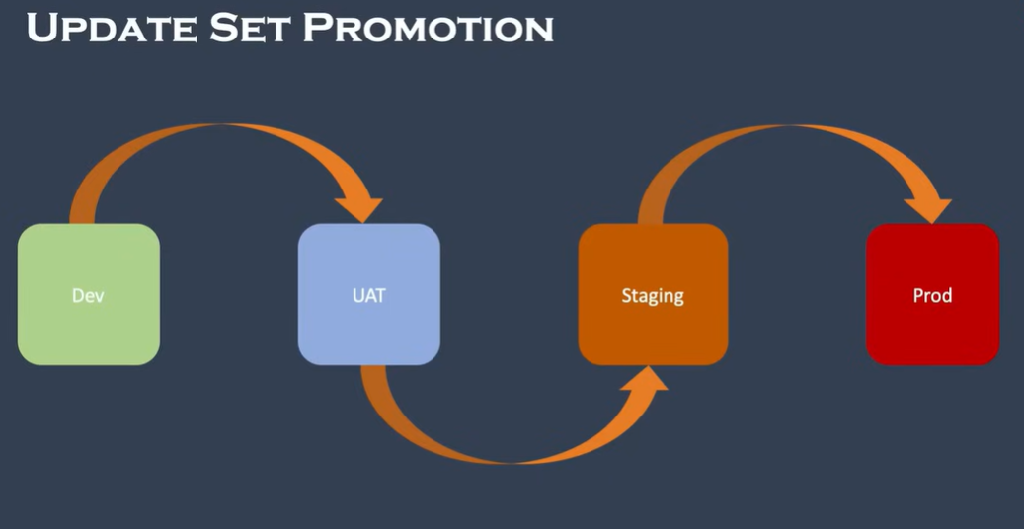

**Events**

Purpose: Events in ServiceNow are used to trigger actions or workflows based on specific conditions or occurrences. They are essential for automation and notifications.

Creating and Managing Events

1. Create a New Event:

- Navigation: Go to System Policy > Events.

- Action: Click New to create a new event.

- Details: Define the event name, set the event type (e.g., informational, warning), and specify the conditions under which the event is triggered.

2. Trigger Events:

- Scripted: Use Business Rules, Script Includes, or other scripts to trigger events programmatically.

- Example: A Business Rule can trigger an event when an incident is created or updated.

3. Event Handlers:

- Notification: Create notifications or alerts based on events.

- Workflow: Use workflows to automate processes in response to events.

- Navigation: Go to System Notification > Notifications or Workflow Editor to configure these.

4. Best Practices:

- Use Descriptive Names: Ensure event names clearly describe their purpose.

- Monitor Event Usage: Regularly review events to avoid unnecessary processing or performance issues.

- Test: Thoroughly test events in a development environment before deploying them to production.

**Platform Statistics**

Purpose: Platform statistics provide insights into the performance and usage of the ServiceNow instance. They help in monitoring and optimizing system performance.

**Accessing Platform Statistics**

1. System Diagnostics:

- Navigation: Go to System Diagnostics > Stats.

- Action: Review various statistics related to memory usage, CPU load, response times, etc.

2. Performance Metrics:

- Navigation: Go to System Performance > Metrics.

- Action: Monitor performance metrics like transaction response times, database query performance, and overall system health.

3. Log Files:

- Navigation: Go to System Logs > System Log.

- Action: Review log files to diagnose issues and track system events.

4. Best Practices:

- Regular Monitoring: Frequently check platform statistics to identify and address potential performance issues early.

- Analyze Trends: Look for trends over time to anticipate and mitigate performance degradation.

- Optimize: Use statistics to identify areas for optimization, such as slow-performing queries or scripts.