# Change the Color of Text

<h2 style="color: blue">CatPhotoApp</h2>

# Change the Font Size of an Element

h1 {  
  font-size: 30px;  
}

# Style Multiple Elements with a CSS Class

.blue-text {  
  color: blue;  
}

<h2 class="blue-text">CatPhotoApp</h2>

# Import a Google Font

<link href="https://fonts.googleapis.com/css?family=Lobster" rel="stylesheet" type="text/css">

h2{

font-family: Lobster;

}

# Specify How Fonts Should Degrade

For example, if you wanted an element to use the Helvetica font, but also degrade to the Sans-Serif font when Helvetica wasn't available, you could use this CSS style:

p {  
  font-family: Helvetica, Sans-Serif;  
}

# Add Images to your Website

<img src="https://www.your-image-source.com/your-image.jpg" alt="Author standing on a beach with two thumbs up. ">

The text inside an altattribute is used for screen readers to improve accessibility and is displayed if the image fails to load.

# Size your Images

<style>  
  .larger-image {  
    width: 500px;  
  }  
</style>

# Add Borders Around your Elements

<style>  
  .thin-red-border {  
    border-color: red;  
    border-width: 5px;  
    border-style: solid;  
  }  
</style>

# Apply multiple classes to an element

<img class="class1 class2">

# Add Rounded Corners with a Border Radius

.thick-green-border {

border-color: green;

border-width: 10px;

border-style: solid;

**border-radius:10px;**

}

# Make Circular Images with a Border Radius

**border-radius:50%;**

# Link to External Pages with Anchor Elements

Anchor : a piece of heavy metal that is lowered to the bottom of the sea, lake etc to prevent a ship or boat moving

# Nest an Anchor Element within a Paragraph

<p>

<a href=” ”>

</a>

</p>

# Make Dead Links using the Hash Symbol

Replace the value of your a element's href attribute with a #, also known as a hash symbol, to turn it into a dead link.

<p>Click here for <a href="#">cat photos</a>.</p>

# Turn an Image into a Link

<a href="#">

<img

src="https://bit.ly/fcc-running-cats"

alt="Three kittens running towards the camera. "

>

</a>

# Create a Bulleted Unordered List

<ul>  
  <li>milk</li>  
  <li>cheese</li>  
</ul>

# Create an Ordered List

<ol>  
  <li>Garfield</li>  
  <li>Sylvester</li>  
</ol>

# Create a Text Field

<input type="text">

# Add Placeholder Text to a Text Field

<input type="text" placeholder="this is placeholder text">

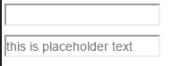

# Create a Form Element

<form action="/url-where-you-want-to-submit-form-data">

<input type=”text”>

</form>

# Add a Submit Button to a Form

<form action="#">

<button type="submit"></button>

</form>

# Use HTML5 to Require a Field

<input type="text" required>

# Create a Set of Radio Buttons

<label><input type="radio" name="indoor-outdoor"> Indoor</label>

# Create a Set of Checkboxes

<label><input type="checkbox" name="personality"> Loving</label>

<label><input type="checkbox" name="personality"> Lazy</label>

<label><input type="checkbox" name="personality"> Energetic</label>

# Check Radio Buttons and Checkboxes by Default

<input type="radio" name="test-name" checked>

# Nest Many Elements within a Single Div Element

<div>

</div>

# Give a Background Color to a Div Element

.green-background {  
  background-color: green;  
}

# Set the ID of an Element

<h2 id="cat-photo-app">

# Use an ID Attribute to Style an Element

#cat-photo-element {  
  background-color: green;  
}

# Adjusting the Padding of an Element

padding, margin, border.

Margin : khoảng cách giữa 2 thẻ HTML.

Padding : khoảng cách giữa thẻ HTML và nội dung.

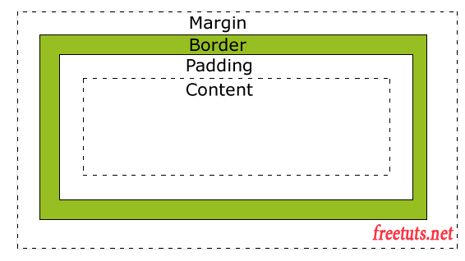

# Adjust the Margin of an Element

.green-box {

background-color: green;

padding: 20px;

margin: 20px;

}

# Add a Negative Margin to an Element’

.red-box {

background-color: red;

padding: 20px;

margin: -15px;

}

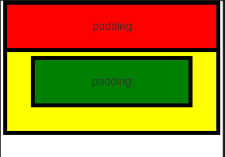

# Add Different Padding to Each Side of an Element

.red-box {

background-color: red;

padding-top: 40px;

padding-right: 20px;

padding-bottom: 20px;

padding-left: 40px;

}

.green-box {

background-color: green;

padding-top:40px;

padding-left:40px;

padding-bottom:20px;

padding-right:20px;

}

