CS 5200-02 – Database Management Systems
Project Proposal

Group Name:
LeeK

Kristen Lee

Proposal Description
Sabrina Carpenter is a singer and actress that has risen to fame through her music and her work on the Disney Channel series Girl Meets World. This project will be a database application designed to manage and store information about Sabrina Carpenter’s various concert tours over the years.
The users of this database are employees of Sabrina’s tour scheduling team. This application will allow these users to track, input/update, and query detailed information about each tour, including setlists, venues, and opening artist. Additionally, this system will track ticket sales, which will link customers to specific venues and locations.
Each tour will have a unique name. We will also track the start and end dates, as well as its status (ongoing, ended, upcoming). Each tour can have many shows associated with it. A show will have an id, a date, and time. Each show will be hosted at a venue which will have an id, name, and capacity. For each show we will track its status which can hold values of upcoming, cancelled, or completed. Every venue has a location which is composed of a country, city, and state/region which will create a unique instance of location. Each show can have zero to many opening acts and we will track the act’s name and assign them an identification number. At each show, Sabrina can perform many songs. Our database will keep track of the names of the songs performed as well as the order in which they are performed. Each song comes from one of Sabrina’s published albums. The users of this database may also be interested in customer ticket sales. A customer can buy many tickets for a show. When buying a ticket a customer gives their first and last name, a phone number, and their email. Ticket transactions have a total cost, date the tickets were purchased, and amount of tickets a customer purchases.

Software
I will be using SQL with the MySQL Workbench to create the tour database. I have two ideas of how to implement my user interface. The first idea is to use command line arguments for the user to interact with the database. For this, I would use Java. My second idea would be to use R for data analysis, data visualization, and reporting, and then use RShiny to create a simple interactive web application. A restriction of using RShiny is that it is not well suited for large-scale web applications.

Why does this interest me?
I am a fan of Sabrina Carpenter and her music, and I thought it would be fun to research some of her past tours, see where she has travelled to, and which songs she’s played at which shows.

UML Diagram

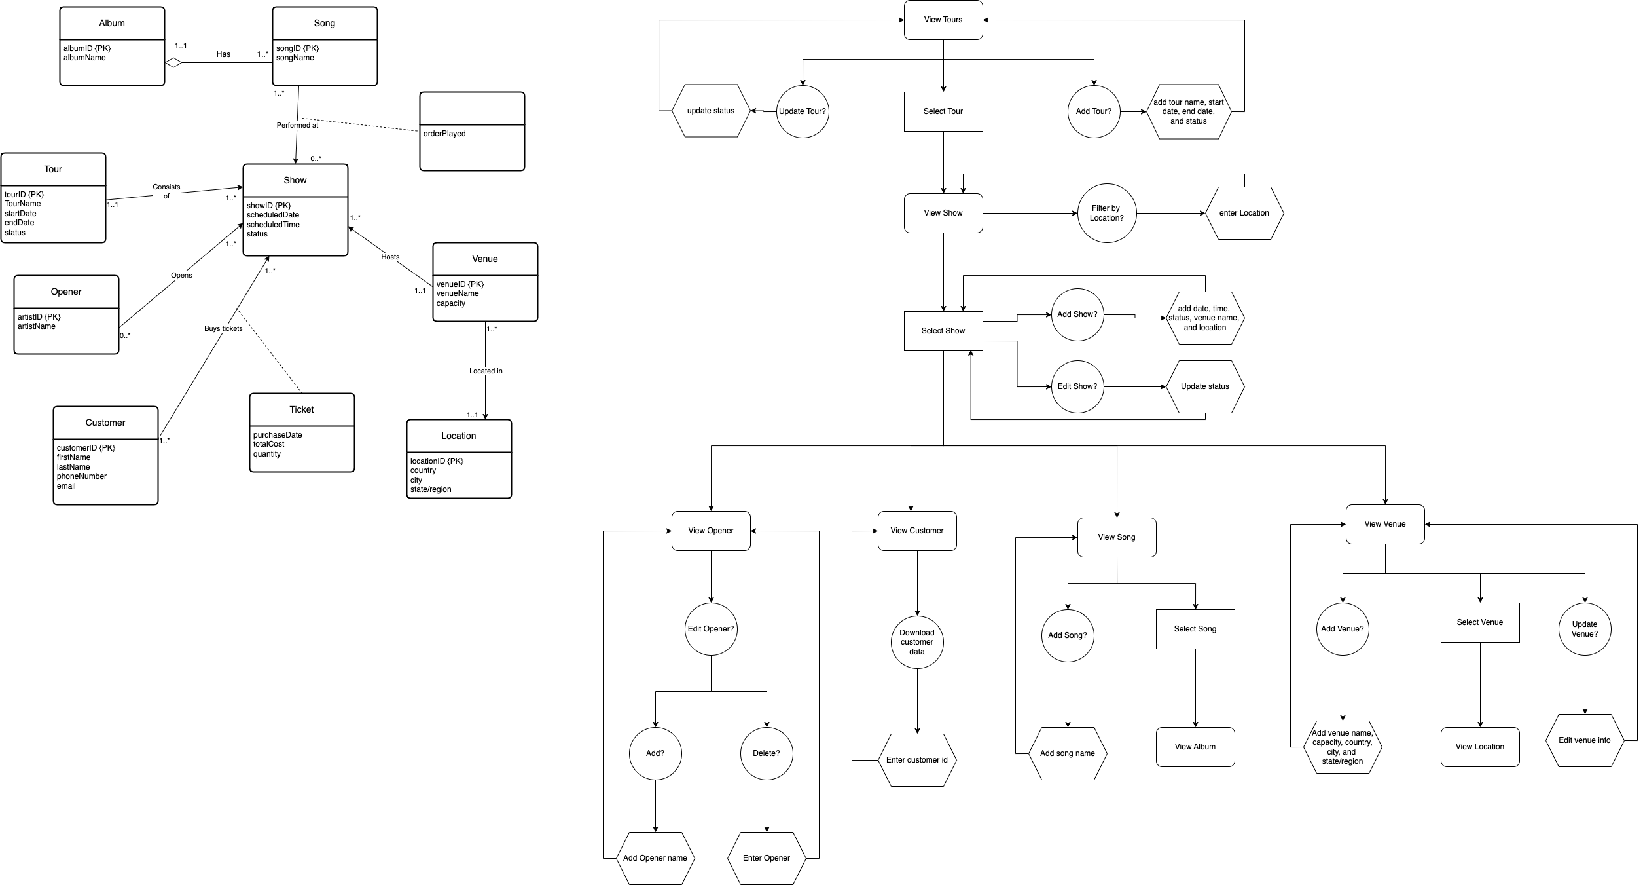

User Interaction Flow Diagram
