Assignment1
Flask example:
from flask import Flask, request, jsonify

app = Flask(__name__)

@app.route("/login", methods=["POST"])
def login():
data = request.json # payload
username = data.get("username")
password = data.get("password")

if username == "admin" and password == "123":
return jsonify({"message": "Login success"})
else:
return jsonify({"message": "Invalid credentials"}), 401

if __name__ == "__main__":
app.run(debug=True)

Assignment-2

SQL Queries on JOINs and Operations

Sample Tables Used
Table 1: Students
CREATE TABLE students (
student_id INT,
name VARCHAR(50),
department VARCHAR(50)
);
INSERT INTO students VALUES
(1, 'Ravi', 'CSE'),
(2, 'Anu', 'ECE'),
(3, 'Kiran', 'ME');

Table 2: Marks
CREATE TABLE marks (
student_id INT,
marks INT
);
INSERT INTO marks VALUES
(1, 85),
(2, 90),
(4, 70);

1) INNER JOIN
👉 Returns only matching records from both tables.
SELECT students.name, marks.marks
FROM students
INNER JOIN marks
ON students.student_id = marks.student_id;
✅ Output: Ravi, Anu
❌ Kiran excluded (no marks)

2) LEFT JOIN
Returns all records from left table + matched records from right.
SELECT students.name, marks.marks
FROM students
LEFT JOIN marks
ON students.student_id = marks.student_id;
✅ All students shown
❌ Kiran → marks = NULL

3) RIGHT JOIN
Returns all records from right table + matched from left.
SELECT students.name, marks.marks
FROM students
RIGHT JOIN marks
ON students.student_id = marks.student_id;
✅ Student with marks shown
❌ student_id = 4 → name = NULL

4) CROSS JOIN
Returns Cartesian product.
SELECT students.name, marks.marks
FROM students
CROSS JOIN marks;
Rows = students × marks

5) JOIN with WHERE Condition
SELECT students.name, marks.marks
FROM students
INNER JOIN marks
ON students.student_id = marks.student_id
WHERE marks.marks > 80;

6) GROUP BY with JOIN
SELECT students.department, AVG(marks.marks) AS avg_marks
FROM students
INNER JOIN marks
ON students.student_id = marks.student_id
GROUP BY students.department;

7) HAVING Clause
Filters grouped data
SELECT students.department, COUNT(*)
FROM students
INNER JOIN marks
ON students.student_id = marks.student_id
GROUP BY students.department
HAVING COUNT(*) > 1;

8) IN Operator
SELECT * FROM students
WHERE student_id IN (1, 3);

9) BETWEEN Operator
SELECT * FROM marks
WHERE marks BETWEEN 80 AND 90;

10) LIKE Operator
SELECT * FROM students
WHERE name LIKE 'A%';
✔ Names starting with A

11) IS NULL
SELECT students.name
FROM students
LEFT JOIN marks
ON students.student_id = marks.student_id
WHERE marks.marks IS NULL;
✔ Students without marks

12)UNION
Removes duplicates
SELECT name FROM students
UNION
SELECT student_id FROM marks;

13) UNION ALL
Keeps duplicates
SELECT student_id FROM students
UNION ALL
SELECT student_id FROM marks;

14) INTERSECT (PostgreSQL)
SELECT student_id FROM students
INTERSECT
SELECT student_id FROM marks;
✔ Common student IDs

15) EXCEPT (PostgreSQL)
SELECT student_id FROM students
EXCEPT
SELECT student_id FROM marks;
✔ Students without marks

Assignment-3
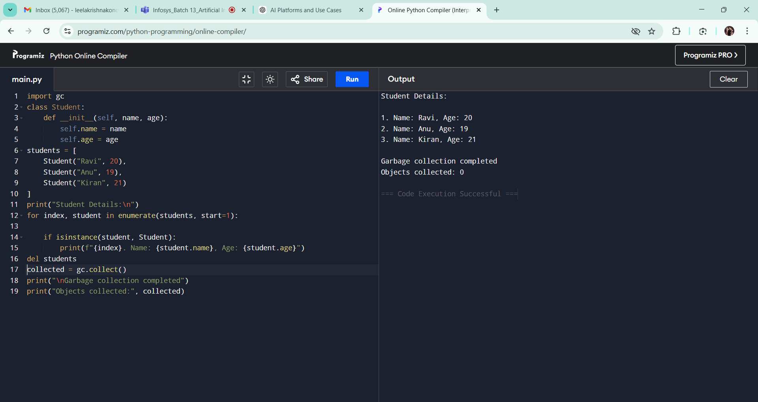
Assignment-4
