STUDENT ENROLLMENT & COURSE MANAGEMENT SYSTEM
(SECMS)
NM PROJECT — PROJECT DOCUMENTATION
Salesforce-Based Academic Enrollment Management System
Note: The 12 images in this document are MODEL / SAMPLE screenshots created for documentation layout. Replace them with actual Salesforce screenshots before final submission.

1. Project Overview
The Student Enrollment & Course Management System (SECMS) is a Salesforce-based application designed to centralize student, course, instructor, enrollment, approval, payment and reporting operations.

2. Problem Statement
Manual and fragmented enrollment processes can lead to scattered data, duplicate entries, approval bottlenecks and delayed reporting. SECMS addresses these issues through a centralized Salesforce solution.

3. Objectives
Manage student records; manage courses; process enrollments; support approval/rejection; assign instructors; automate notifications and tasks; generate reports and dashboards; configure security.

4. User Roles
Admin — full access. Enrollment Officer — create/update enrollments. Instructor — read-only access to assigned enrollments.

5. Main Modules
Student Management; Course Management; Instructor Management; Enrollment Management; Reporting and Dashboard.

6. Salesforce Objects
Student, Course, Instructor and Enrollment are the main project objects. Enrollment is related to Student, Course and Instructor.

7. Lightning Application
Student Enrollment & Course Management. Navigation can include Student, Course, Instructor, Enrollment, Reports, Dashboards, Home and Tasks.

8. Record Types & Page Layouts
Enrollment uses New Enrollment and Re-Enrollment record types. Separate page layouts can display fields relevant to each process.

9. Automation
SetEnrollmentDate sets Enrollment Date to the current date. Enrollment Approved Action handles approved enrollment notification and student status update. AutoAssign_Instructor assigns instructors by course category. Create_Followup_Task creates a follow-up task for requested enrollments.

10. Reports
Students by Status; Enrollments by Course; Pending Enrollment Approvals; Revenue Report – Fees Paid.

11. Dashboard
Student Management Dashboard can contain Students by Status donut chart, Enrollments by Course bar chart, Revenue gauge and Pending Approvals table.

12. Security
Profiles, permission sets and sharing settings are used to control access for Admin, Enrollment Officer and Instructor.

13. Functional & Performance Testing
Testing should cover student/course/instructor/enrollment creation, validation rules, record types, flow execution, approval behavior, reports and dashboards. Screenshots should be captured during testing.

14. Advantages
Centralized data; automated workflows; real-time reporting; structured enrollment processing.

15. Disadvantages
Salesforce dependency and initial configuration effort.

16. Future Scope
Payment gateway integration; student self-service portal; analytics-driven insights; mobile access support.

17. Conclusion
SECMS demonstrates how Salesforce can support the academic enrollment lifecycle through centralized data, automation, approvals, reporting, dashboards and security.

18. GitHub Submission Structure
README.md; Documentation/SECMS_Documentation.docx; Screenshots/actual testing screenshots; optional project notes.

19. Screenshot / Testing Evidence
The project instructions require screenshots during testing. The following 12 model screenshots are included as a documentation template. They are intentionally marked as MODEL / SAMPLE and must be replaced by actual Salesforce screenshots before submission.

Figure 1 — Student Record Creation
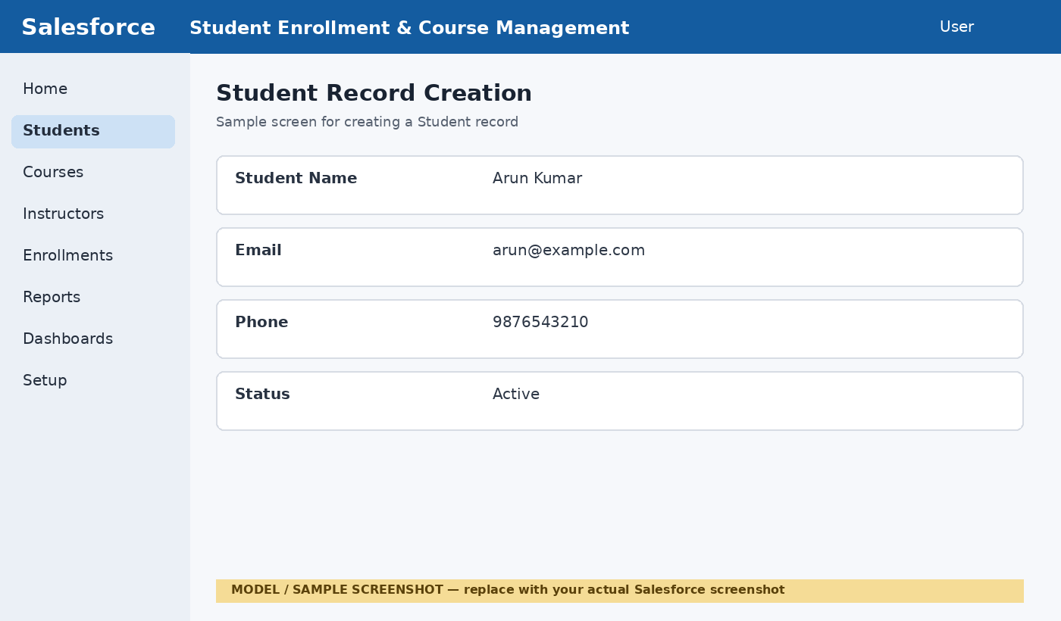
Testing evidence placeholder: replace this model image with the actual screenshot from the Salesforce org.

Figure 2 — Course Record Creation
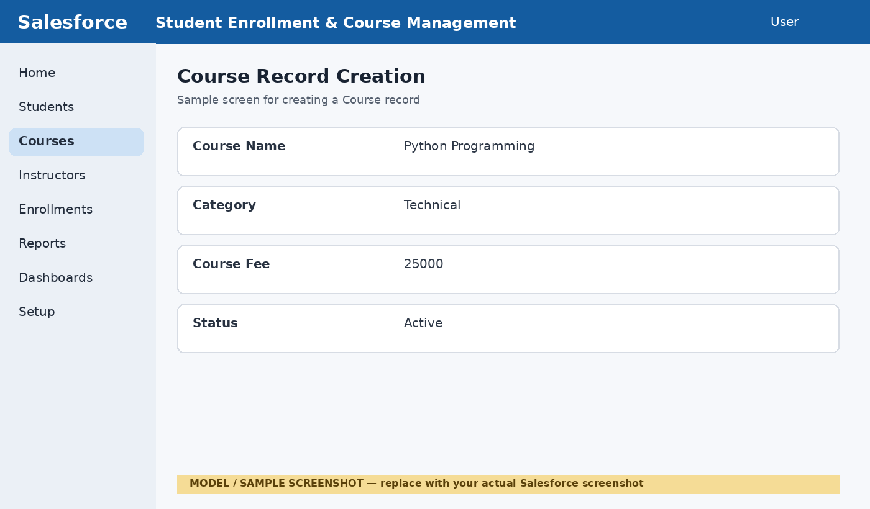
Testing evidence placeholder: replace this model image with the actual screenshot from the Salesforce org.

Figure 3 — Instructor Record Creation
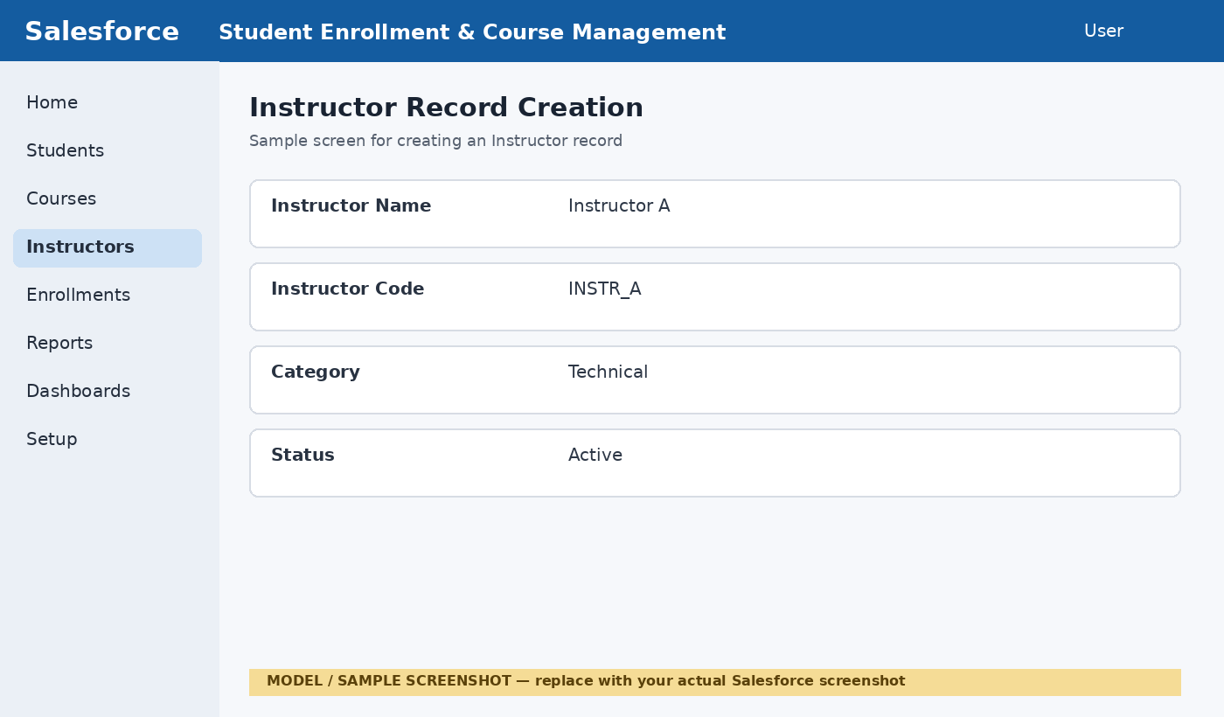
Testing evidence placeholder: replace this model image with the actual screenshot from the Salesforce org.

Figure 4 — Enrollment Record Creation
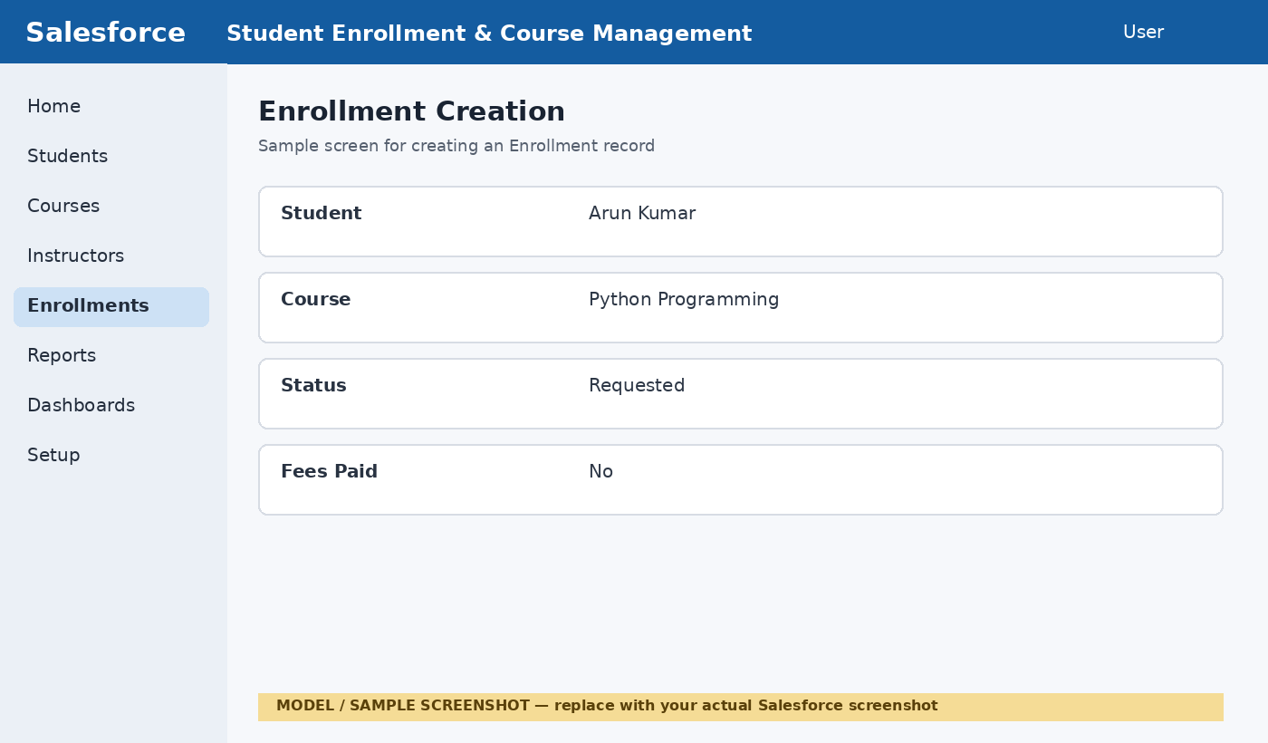
Testing evidence placeholder: replace this model image with the actual screenshot from the Salesforce org.

Figure 5 — Enrollment Record Types
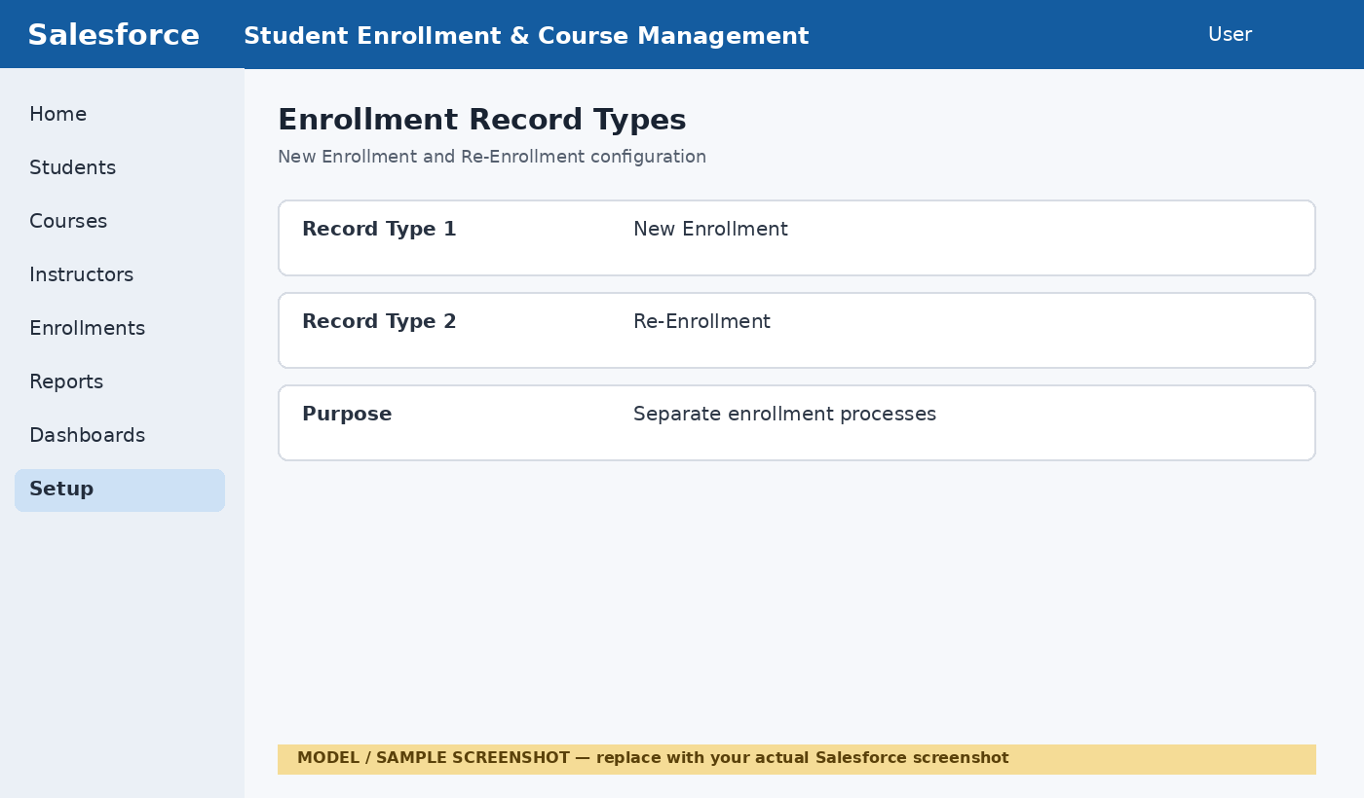
Testing evidence placeholder: replace this model image with the actual screenshot from the Salesforce org.

Figure 6 — SetEnrollmentDate Flow
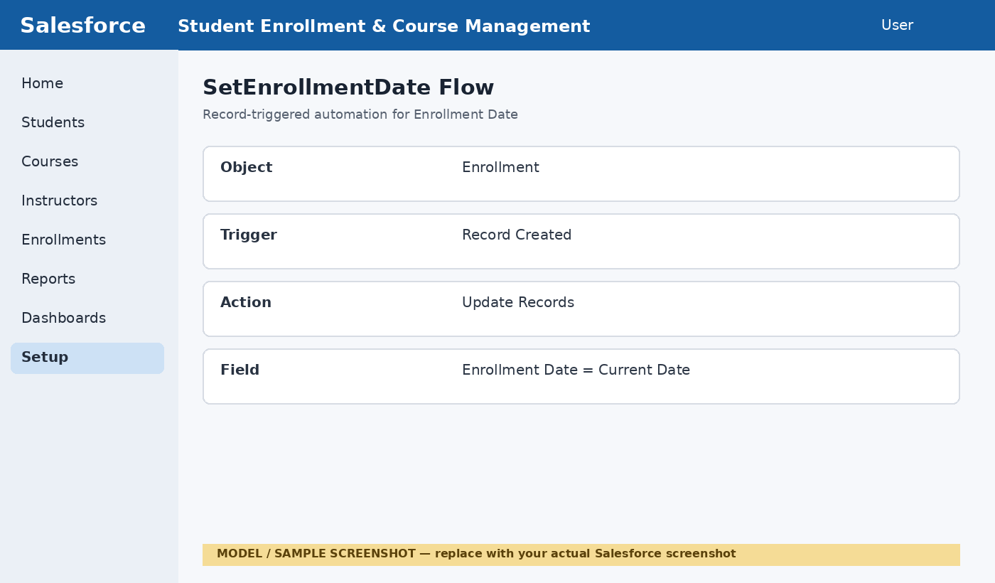
Testing evidence placeholder: replace this model image with the actual screenshot from the Salesforce org.

Figure 7 — Enrollment Approved Action Flow
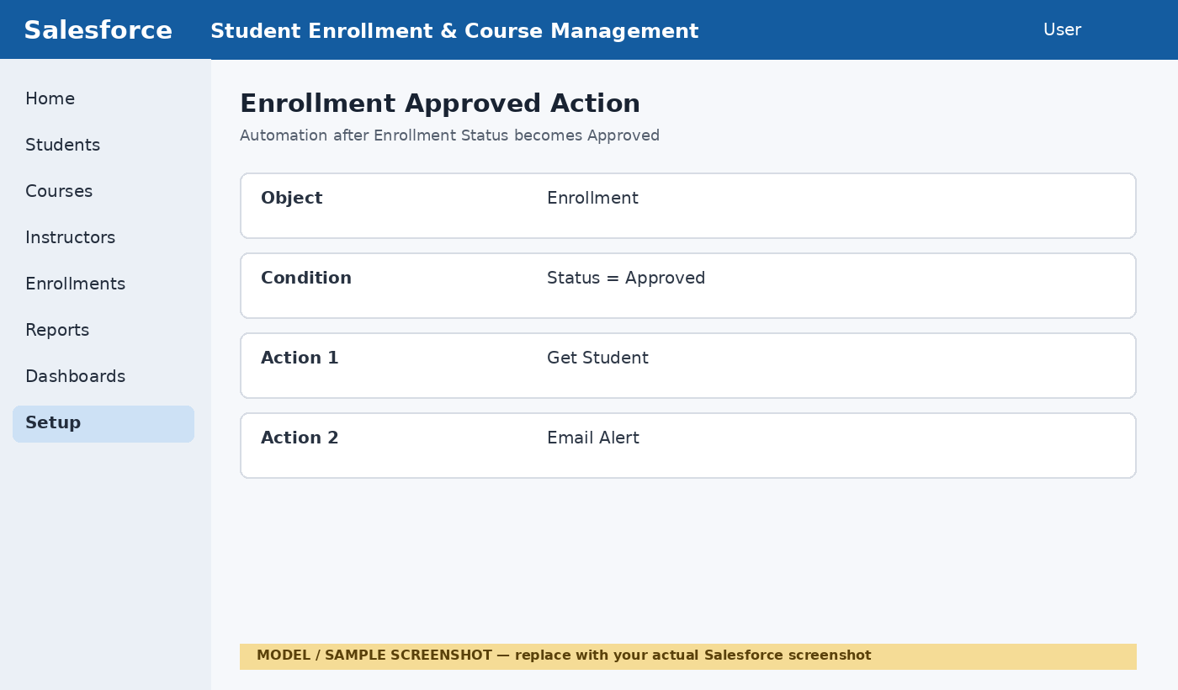
Testing evidence placeholder: replace this model image with the actual screenshot from the Salesforce org.

Figure 8 — AutoAssign_Instructor Flow
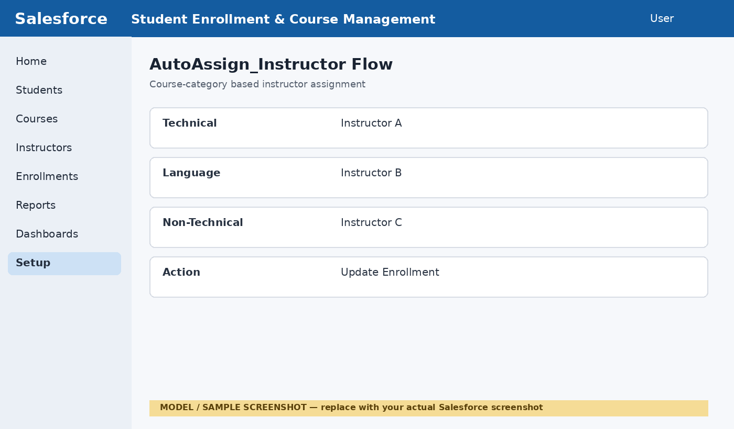
Testing evidence placeholder: replace this model image with the actual screenshot from the Salesforce org.

Figure 9 — Create_Followup_Task Flow
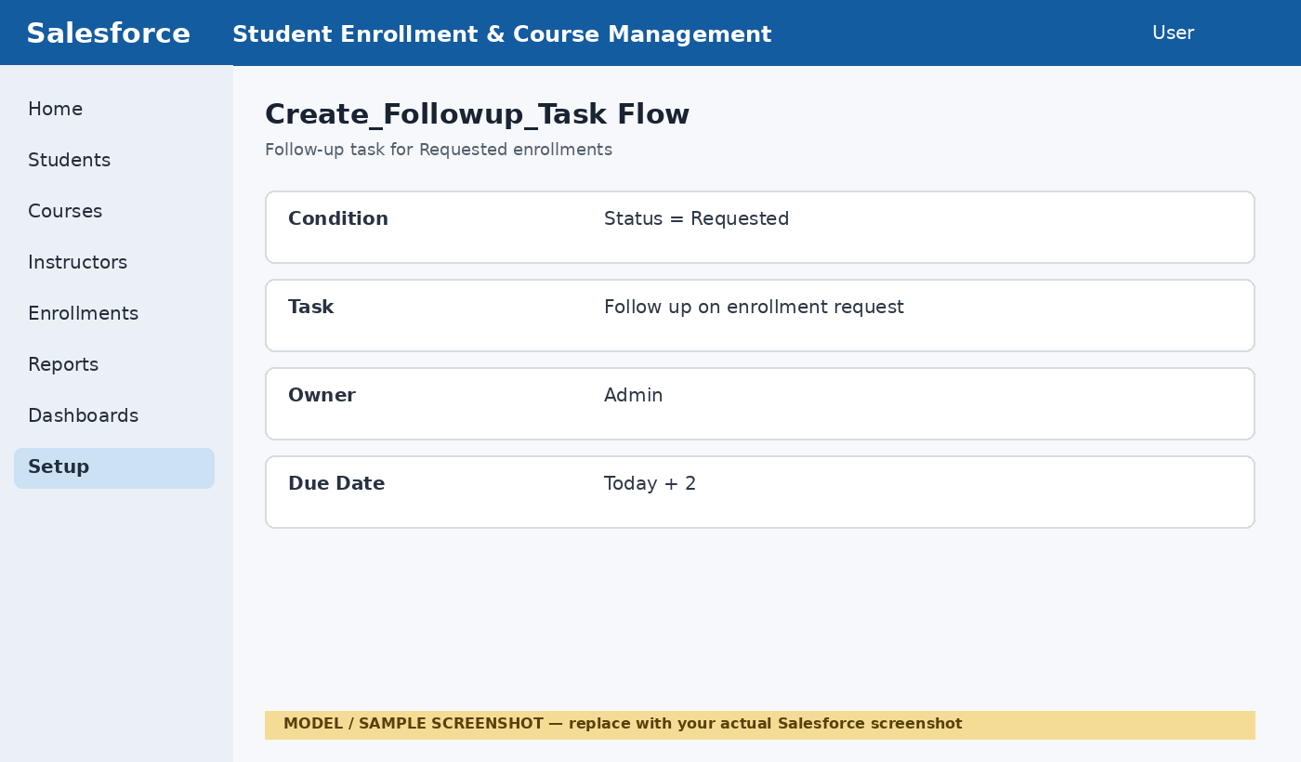
Testing evidence placeholder: replace this model image with the actual screenshot from the Salesforce org.

Figure 10 — Students by Status Report
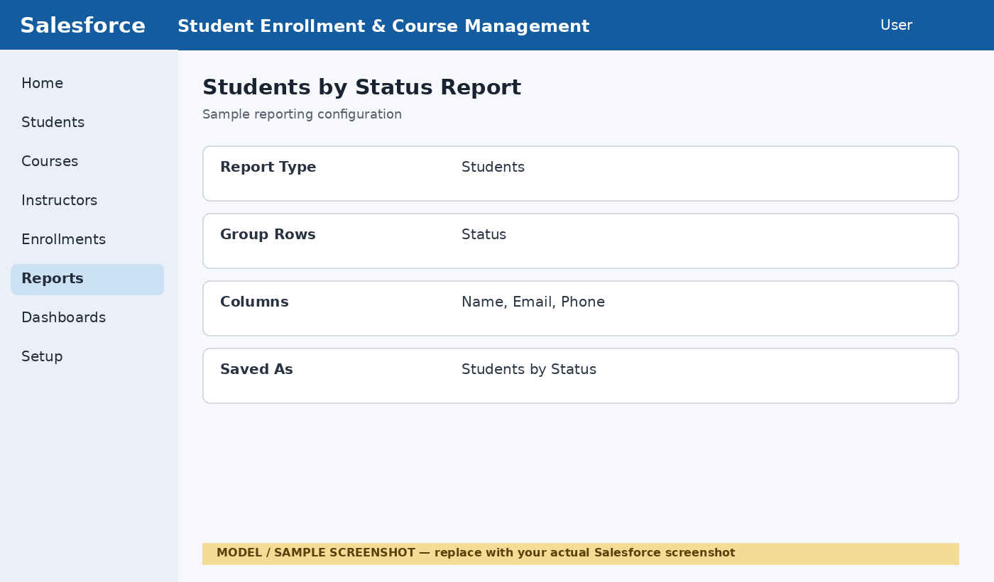
Testing evidence placeholder: replace this model image with the actual screenshot from the Salesforce org.

Figure 11 — Enrollments by Course Report
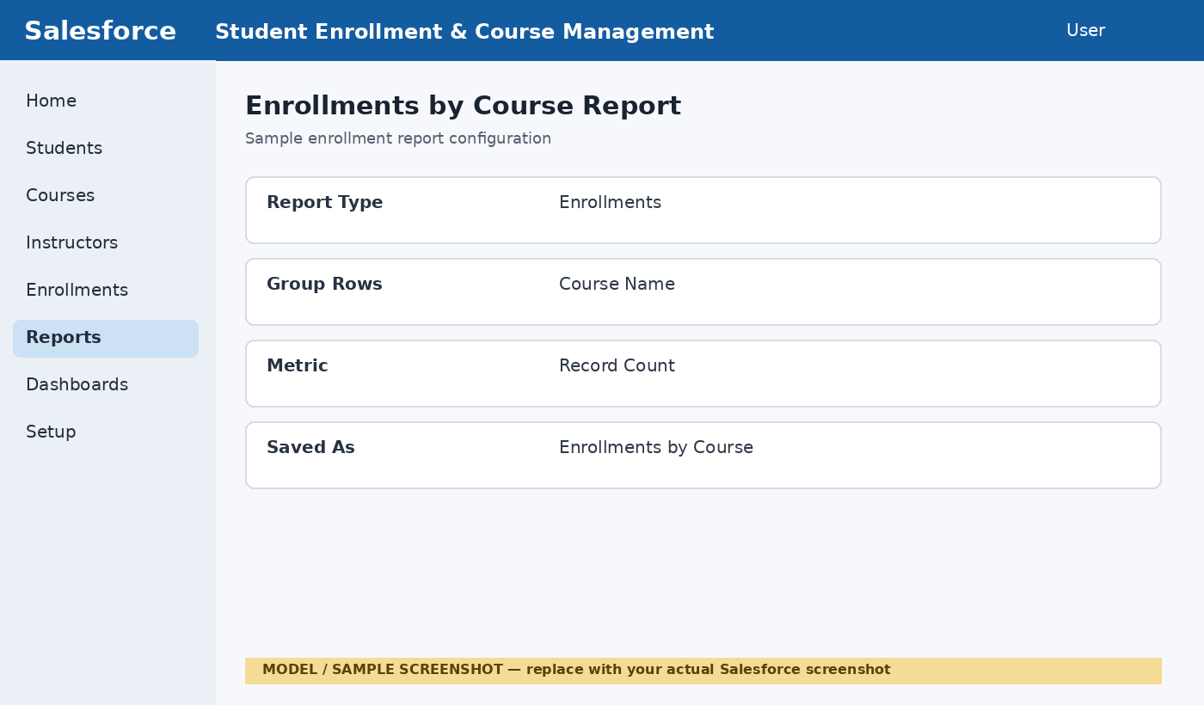
Testing evidence placeholder: replace this model image with the actual screenshot from the Salesforce org.

Figure 12 — Student Management Dashboard
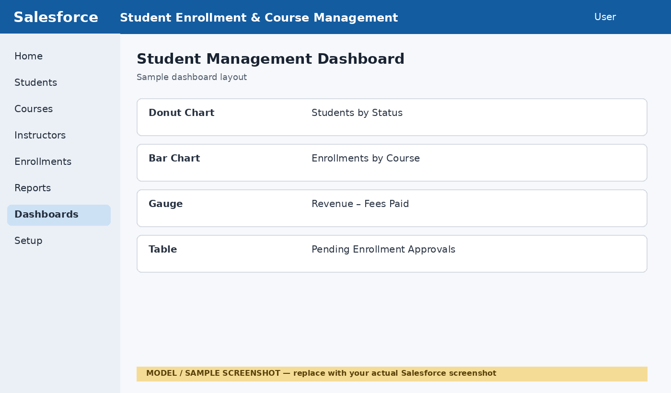
Testing evidence placeholder: replace this model image with the actual screenshot from the Salesforce org.

20. Appendix — GitHub Checklist
- Create GitHub repository for SECMS.
- Upload README.md / project description.
- Upload final documentation.
- Create Screenshots folder.
- Replace all model screenshots with actual Salesforce screenshots.
- Upload testing screenshots with clear filenames.
- Add final Salesforce Developer Org / demo reference if required.
- Verify that all required milestones are documented.
Project: Student Enrollment & Course Management System (SECMS)
Platform: Salesforce
Project Type: NM Project

