A Project Report on

IMPLEMENTATION OF VEHICLE MISHAP AVERTING SYSTEM

Submitted in partial fulfillment of the requirements for the award of the Degree of

Bachelor of Technology

in

Department of Electronics and Communication Engineering

By

K. TEJASWI

P.KALYANI

B.SURYA LEELA

K.KANAKA MAHA LAKSHMI

K.YAMINI DURGA

Under the Esteemed Supervision of

14MQ5A0417

13MQ1A0480

13MQ1A0457

14MQ5A0416

14MQ5A0415

Ms.G.SITA ANNAPURNA M.Tech.

Assistant Professor

DEPARTMENT OF ELECTRONICS AND COMMUNICATION ENGINEERING

SRI VASAVI INSTITUTE OF ENGINEERING AND TECHNOLOGY

(Affiliated to JNTUK, Kakinada and Approved by AICTE, New Delhi)

NANDAMURU.

2013 – 2017

S

DEPARTMENT OF ELECTRONICS AND COMMUNICATION ENGINEERING

SRI VASAVI INSTITUTE OF ENGINEERING AND TECHNOLOGY

(Affiliated to JNTUK, Kakinada and Approved by AICTE, New Delhi)

NANDAMURU

CERTIFICATE

This is to certify that the thesis entitled “**Implementation of vehicle mishap**

averting system” is being submitted by

K. TEJASWI

P.KALYANI

B.SURYA LEELA

K.KANAKA MAHA LAKSHMI

K.YAMINI DURGA

14MQ5A0417

13MQ1A0480

13MQ1A0457

14MQ5A0416

14MQ5A0415

in partial fulfillment of the requirements for the award of degree of B. Tech in Electronics and

Communication Engineering from Jawaharlal Nehru Technological University, Kakinada

is a record of bonafide work carried out by them at Sri Vasavi Institute of Engineering and

Technology.

The results embodied in this project report have not been submitted to any other

University or Institute for the award of any degree or diploma.

GUIDE:

Ms.G.SITA ANNAPURNA M.Tech.

HOD:

Dr. M.SRINIVASULU M.Tech, Ph D

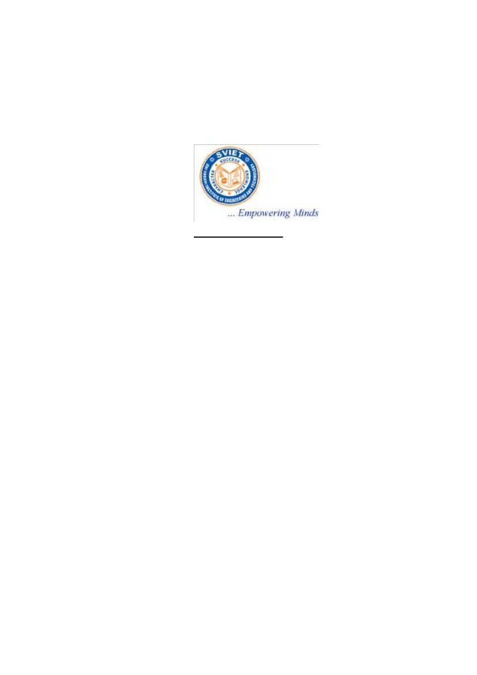

ACKNOWLEDGEMENT

We take great pleasure to express our deep sense of gratitude to our project guide

Ms. G. SITA ANNAPURNA Assistant Professor, for his valuable guidance during the

course of our project work.

We would like to thank Sri Dr. M. SRINIVASULU, Head of the Department

of Electrical and Electronics Engineering for his encouragement.

We would like to express our heart-felt thanks to Sir Dr. A. B. SRINIVASA RAO,

Principal, Sri Vasavi Institute of Engineering and Technology Nandamuru, Pedana for

providing all the facilities for our project.

Our utmost thanks to all the Faculty members and Non-Teaching Staff of the

Department of Electronics and Communication Engineering for their support through

Out our project work.

Our Family Members and Friends receive our deepest gratitude and love for

their support throughout our academic year.

K. TEJASWI

P.KALYANI

B.SURYA LEELA

K.KANAKA MAHA LAKSHMI

K.YAMINI DURGA

14MQ5A0417

13MQ1A0480

13MQ1A0457

14MQ5A0416

14MQ5A0415