**Kubernetes:**

Kubernetes is a **portable, extensible, open-source platform for managing containerized workloads and services**, that facilitates both declarative configuration and automation. It has a large, rapidly growing ecosystem. Kubernetes services, support, and tools are widely available.

**Step 1:** Go the module folder and add deployment and service yml files.

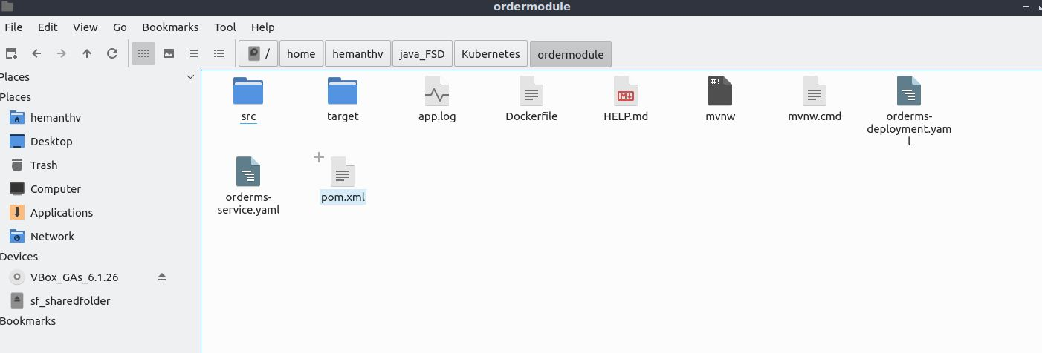

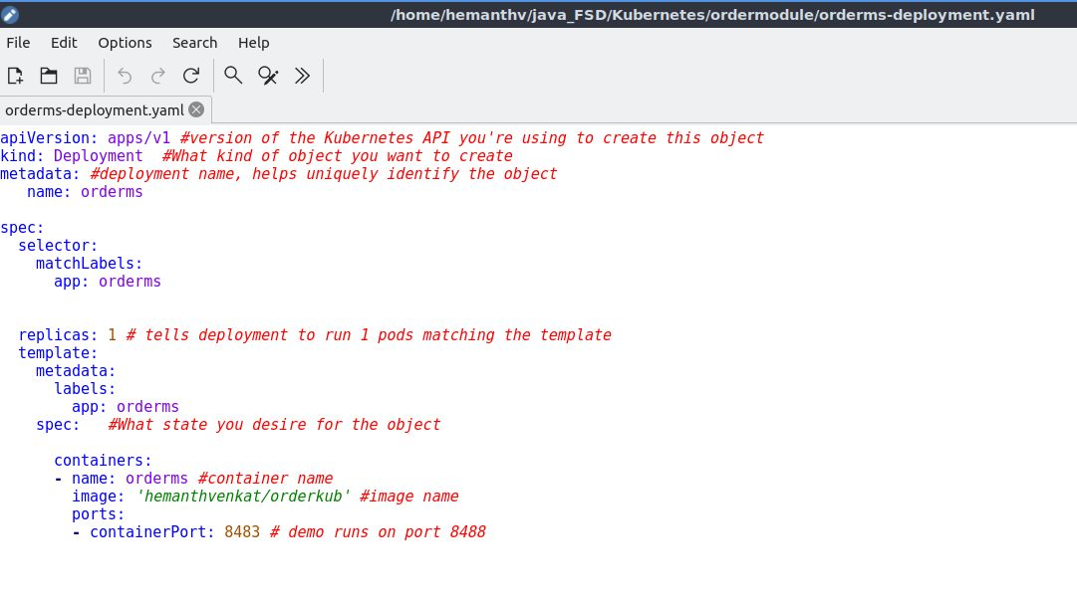

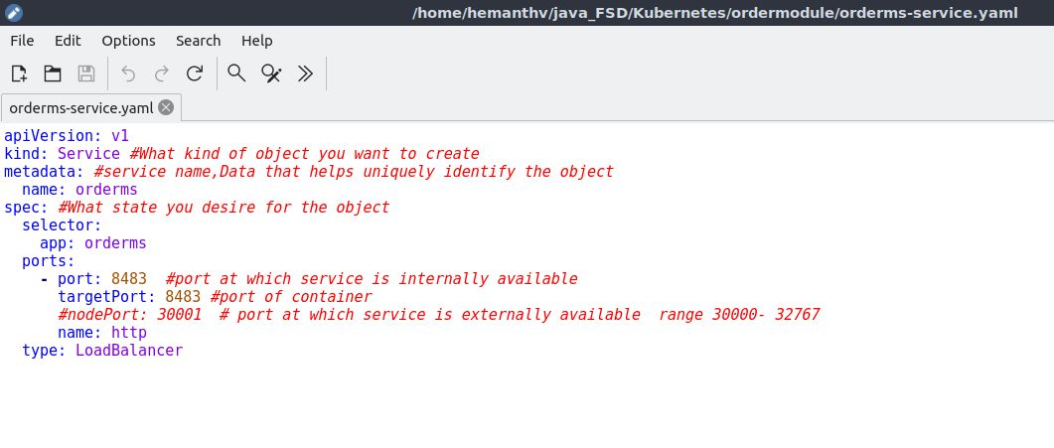

**Step 2:** Start the minikube by **minikube start** command.

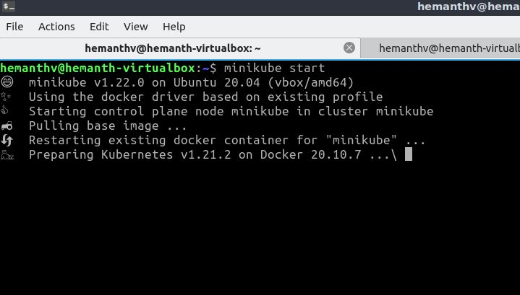

**Step 3:** Now create the deployment of order module by **kubectl apply -f orderms-deployment.**yml and also to see the deployments, we can use **kubectl get deployments** command.

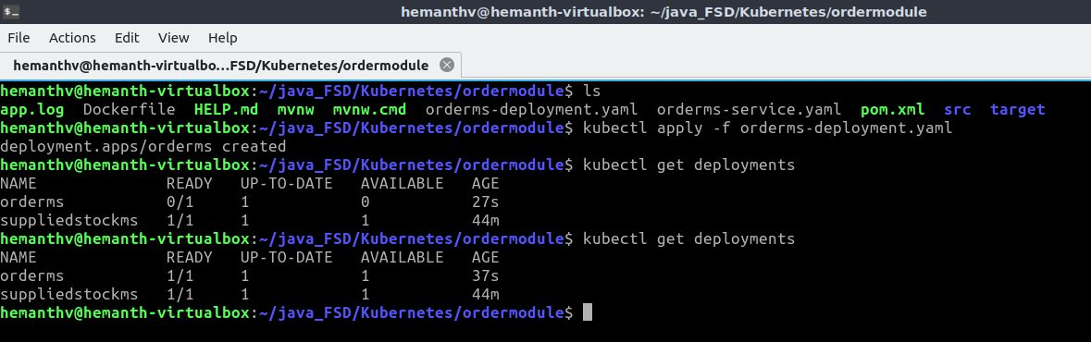

**Step 4:** Now Create the service for the deployment by **kubectl apply -f orderms-service.yml** and to see the service use **kubectl get services** command.

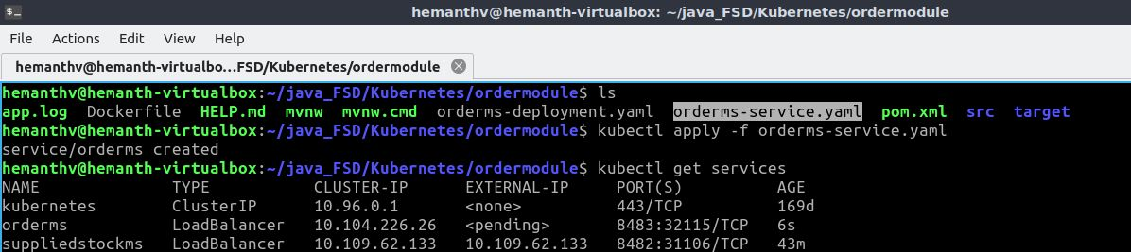

**Step 5:** By using the external-IP and port, open the application on browser.

