**DOCKER**

**Docker:**

**Docker** is a tool designed to make it easier to create, deploy, and run applications by using containers. Containers allow a developer to package up an application with all of the parts it needs, such as libraries and other dependencies, and deploy it as one package.

**Steps:**

1. Add **DockerFile** to the project folder, which contains all the commands related to docker containerization.
2. In the DockerFile, we have mentioned **mvn package** command to create executable jar file which can run at the time of running the container.

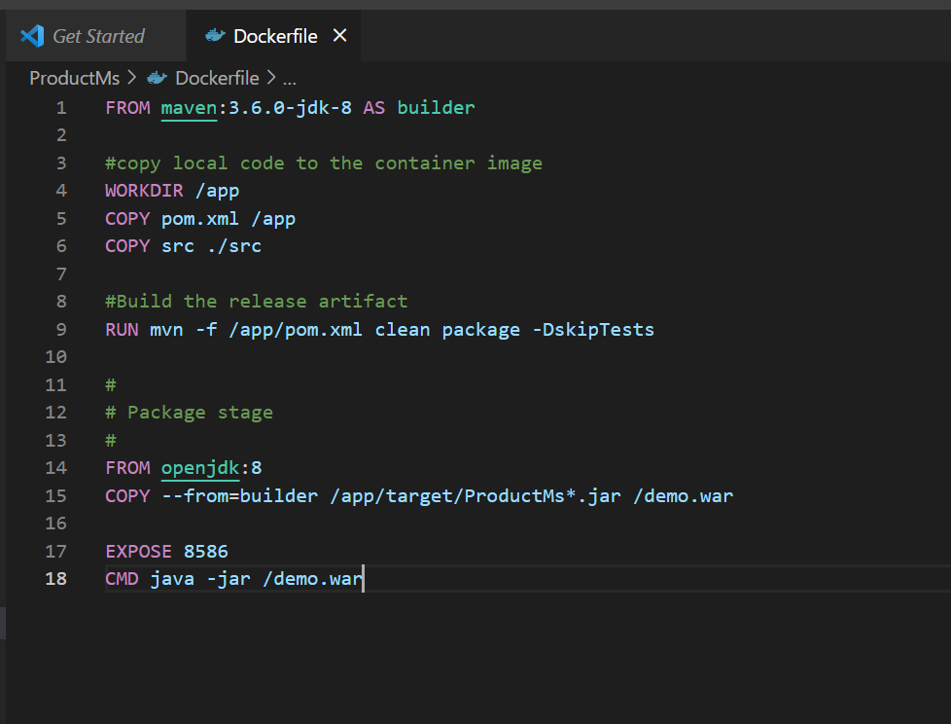

1. To create a docker image we use the command,

**docker build –t <image-name> .**

For example: **docker build –t productmodule .**

The Dot ( . ) represents the current directory where the DockerFile is located

1. To view all the images we use the command,

**docker images**

1. To run the image we use the command,

**docker run -p 8586:8586 productmodule**

1. To push the docker image that we created to the central repository like **Docker Hub**,

First we need to tag the image and login to the docker hub, we can do it through the command line,

1. We can use the **docker push <repository-name>** command to push our image to the central repository such as docker hub.

1. After pushing the image we will be able to see the image in the docker hub website,

