Pictobox

Lee Lab's Behavioral Stimulus and Data Acquisition Hardware

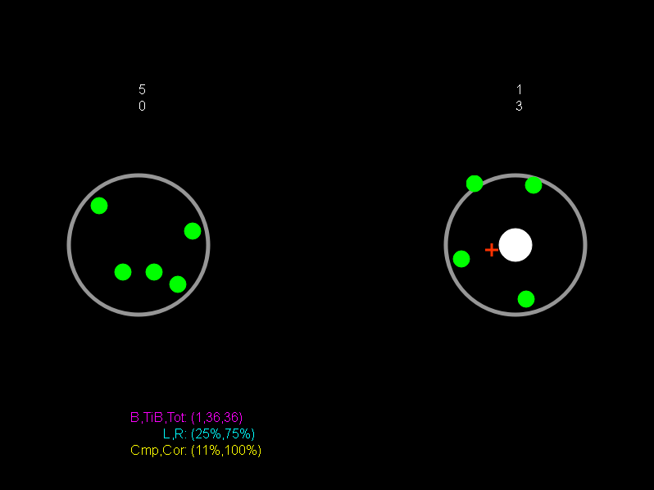

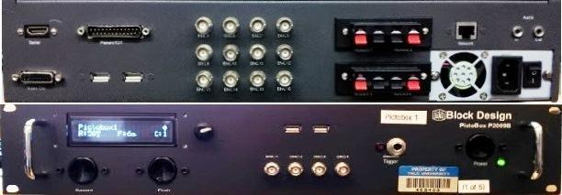

*Developed by: Matt Gay, Mark Hammond, Michael Petrowicz and Joey Schnurr*

*2009-2013*

Contents

Overview 3

Internal Components 4

Major Components 5

Motherboard 5

Data Acquisition (DAQ) Card 8

Data Acquisition (DAQ) Breakout Board 10

Relay Board 12

LCD Display 13

Power Supply and Hard Disk 14

Pictobox Case 15

Other Components 16

Front Panel 16

Back Panel 16

Side Panels 17

External Parts 17

Parts List 18

Connectivity 19

Installation 21

Future Directions 23

Reposition the motherboard 24

Add a Hard Disk Mount 24

Consider other NI DAQ Cards 24

Consider the NI Compact RIO System 25

# Overview

While any standard PC can be used to run Picto experiments, typical experiments require at least two channels of analog input for a position signal, a high current output for reward delivery and a parallel port connection for neural timing synchronization. It is also desirable to have a physical control panel for reward delivery, and in some cases a digital voltage output as well. In the past, we have handled this by adding specialized data acquisition cards to a regular PC and breaking out various types of inputs and outputs with multiple custom built breakout boxes. At a certain point, we realized that if we are already doing all of this custom work over and over again for multiple components in every lab, it might be more efficient to just create one streamlined package that includes everything: PC, signal I/O, reward controllers and control panel, and so the Pictobox was born.

The Pictobox is a rack mounted custom built computer. It includes 8 channels of analog input, 8 channels of digital output, a 25 pin parallel port, 4 high current 12V reward ports, an LCD display setup for viewing system information and changing settings, and buttons for manual reward delivery. The system can power two displays, one over its DVI port and another over HDMI. The complete system, shown from both the front and back appears below:

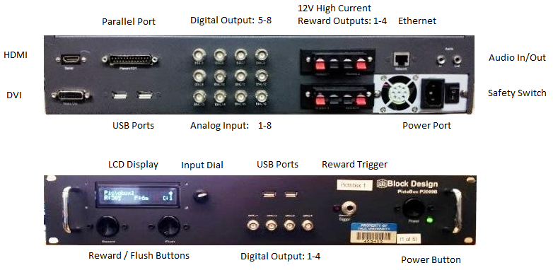

Figure - Pictobox I/O - Front panel (bottom) and back panel (top)

# Internal Components

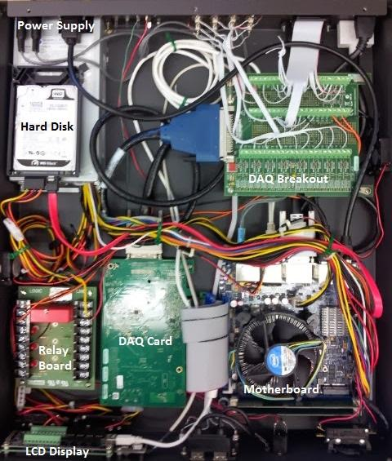

Figure - Pictobox Internal Components

## Major Components

The Pictobox is specially designed to accommodate each of its major internal components in a set location. We have squeezed a lot of functionality into a fairly small package, so it is very important to always consider wire and cable placement while putting the box together. In particular, it is very important to do as much soldering as possible before placing any of the major components into the case. Soldering at the strange angles necessary when assembling the case can be difficult enough without having to worry about accidentally destroying the motherboard. In this section, we will go through each of the Pictobox's major internal components, describe its function and provide guidelines for its installation.

### Motherboard

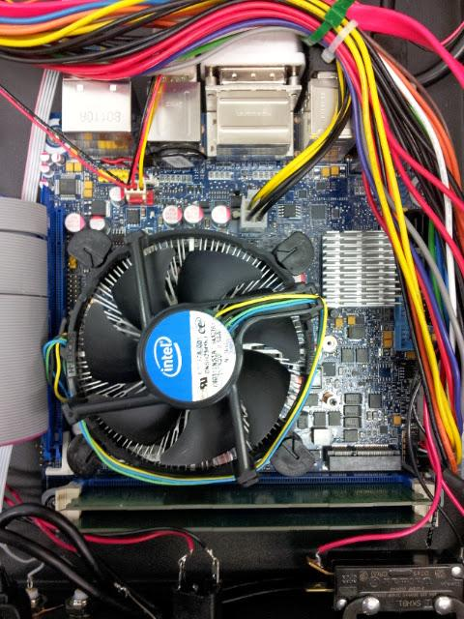

Figure - Pictobox Motherboard

The motherboard is the nervous system of any computer, and the platform for the computer's CPU brain. As we have designed the Pictobox, our approach in selecting particular components has evolved and the motherboard is a good example of this phenomenon. Originally, the Pictobox contained a VIA EPIA-M700-15 Mini-ITX Motherboard with a built in VIA processor and 1GB of RAM. That motherboard was selected with the consideration that the Pictobox only had one job - running Picto experiments - so a powerful machine was not necessary. In practice however, the motherboard was really only borderline capable of handling all that we had to throw at it. In particular, as Picto software development progressed, we took advantage of high modern processor speeds to complete some development tasks quickly if not in the most efficient way possible. As a result of this, we shifted our focus. Our approach now is to always err on the side of overkill. The current motherboard is an Intel DH77DF Mini-ITX motherboard with an Intel Core i5-2400 3.1 GHz processor and 4GB of RAM. Yes, this is overkill, but for an extra hundred dollars or so we save ourselves a lot of headaches.

It is likely that by the time the next Pictobox is built or a current one is upgraded there will be a new, better motherboard and/or this one will no longer be for sale. You are encouraged to upgrade the motherboard and there is a great tool online to help with this and selection of other PC components at: <http://pcpartpicker.com/>. Considerations to make when choosing a motherboard for Pictobox are as follows:

***Is it the right size?*** The Pictobox is designed to accommodate Mini-ITX form factor motherboards. Whatever motherboard you choose will need to be that size to fit correctly into the box. Alternatively, you could redesign the box.

***Does it support the processor we want?*** Motherboards are designed to work with different processors. Make sure that the one you select will work with the processor you want.

***Do we have enough power for it?*** This is probably not a major issue, but some motherboards may come with built in huge graphics cards. Our power supply has limited power and this needs to be taken into account when selecting each component.

***Does it have the ports we need?*** This is the most important factor in selecting a motherboard since we have certain ports that we simply need to provide on the Pictobox. In particular, the Pictobox motherboard must have:

1. A VGA or DVI-I port, but *not DVI-D* - We use CRT monitors with Picto due to their low latency. Flat panel monitors can have 10ms - 100ms lags from the time the PC thinks it is rendering an image to the time that the image actually appears. CRT monitor lags are in single ms. To drive a CRT monitor, we need a VGA connection. DVI-D does not provide the necessary analog signal. DVI-I provides both an analog and digital signal and this is what we are currently using. Note that the second monitor may be digital since it is an extra feature and we don't use it for the subject display (it is only used if running the legacy Orion system on a Pictobox).
2. Enough USB ports - The Pictobox exposes 4 USB ports externally, and two are used internally to interface with the control panel LCD and dial. Currently, we get 2 of the external USB ports from a USB header on the motherboard itself. The other two external ports and the LCD and Dial are plugged into the USB ports on the back of the motherboard.
3. A PCIe, PCI, or other interface to the DAQ card - Currently we are using a National Instruments PCIe-6321 card for handling digital/analog I/O. Before this we used a National Instrument PCI-6221 card. The newer card has a PCIe interface and the old one has a PCI interface. Otherwise, they are the same. It turns out that it has become very difficult to find Mini-ITX motherboards with PCI ports since PCIe has mostly taken over. This meant that in order to use a number of PCI-6221 cards that were purchased a few years ago, we had to buy a PCI-PCIe adapter. By the time you are making these kind of purchasing decisions, it may very well be that some other kind of interface is now used, so be sure to buy a motherboard / DAQ card with compatible interfaces.
4. .An Ethernet Port - The smaller the motherboard, the more likely it is just going to have a wireless network interface, but wireless is not going to work for us since we don't currently have a wireless local network and even if we did, the bandwidth would probably be too low.
5. A compatible fan header - The Pictobox has two fans. Make sure that the fans you buy will work with the type of fan header exposed on the motherboard. To be honest, I'm not sure if the fans are really necessary since the CPU comes with its own fan, but they certainly don't hurt.
6. Enough RAM slots - Currently we use 4GB of RAM in the Pictobox. Again, this is a result of our "err on the side of overkill" approach. Make sure that the motherboard you purchase can handle at least 4GB.

Once you have purchased a motherboard, you will need to be sure to install it correctly. Again, don't put it in the box until you have soldered everything that needs to be soldered. The front panel buttons in particular are pretty awkwardly placed as are the reward and power LEDs. If you try to solder those after the motherboard is in place you are going to regret it. Do all of that work first, be careful to cut all the wires to the right length, not too long, not too short. In particular be careful to use the correct length for the power button and power LEDs so that they will be able to reach the front panel header on the motherboard. Also be sure that you will be able to connect the motherboard to the DAQ card. Those cards are typically meant to be installed perpendicular to the motherboard but we are placing them side by side. We currently use a PCI or PCIe (depending on which system) flex cable to take care of this issue. Lastly, make sure to install the motherboard, or at least the cables going from it to the back of the Pictobox before you install the DAQ breakout board. Most of the cables will fit nicely underneath the DAQ breakout board, and things will get very messy if you put them on top of the board or route them around the board.

### Data Acquisition (DAQ) Card

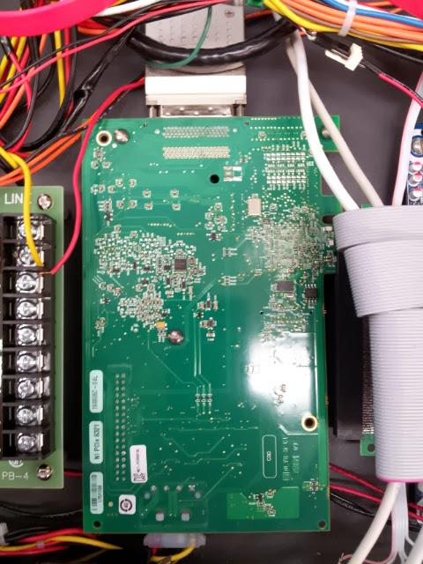

Figure - Pictobox DAQ Card - Current model is National Instruments PCIe-6321

Pretty much everything that the Pictobox can do that a regular computer cannot is due in part to the DAQ card. This card samples the input analog voltage signals representing eye gaze position and pupil diameter. It handles all digital output, whether over the BNC connections or the parallel port. It also triggers the relay that provides the high current signal for rewarding. We are currently using the National Instruments PCIe-6321 card for this purpose. This card connects to the motherboard through a PCIe port and requires its own power from the box's power supply. The card comes with the breakout board shown in figure 2 that allows us to connect to individual inputs using screw connections and these are connected with a short thick cable. The card includes 16 analog inputs, 8 of which we have attached to BNCs. It has 24 digital I/O lines. We are using 8 of these as BNC outputs and 8 more as outputs on the parallel port. 2 analog outputs are provided, both of which are currently being used with the Relay board.

It turns out that this board is sufficient to meet our current needs but does not actually completely fill the Picto specifications. The analog input and digital output are all fine and we even have 8 lines on each of these ports to spare. The problem is in handling rewards. The relay board used for rewarding requires one enable line and one line for each reward channel. The reward lines require precise timing, and I have not found a way to control this timing for the digital lines. Frankly, I don't remember the details of this issue, but there was some problem using a clock with digital lines, there are also only 4 timers available on the board, 2 of which need to be used for analog input channels. We were able to use the analog lines with the other clocks, which is why we used an analog line to control the reward relay. We also used an analog pin for the relay board enable line instead of a digital pin. The end result is that we currently only support a single reward channel. In order to support multiple reward channels we will need to either figure out a way to time 4 of the extra 8 digital output pins, or upgrade the DAQ card to something with more capabilities. Currently though, we only use one reward line so this is not an issue.

As far as installation goes, the NI DAQ board needs to be connected to the motherboard with a flex cable since it is meant to be positioned perpendicular to that board but we install them in parallel. In a number of the Pictoboxes, we are using PCI-6221 boards which were available before the PCIe-6321 board. These have a PCI interface and so they require both a PCI flex cable and a PCIe-PCI converter board which needs to be plugged into the power supply. In both cases, make sure that you've soldered everything to the front panel before installing the DAQ board. It is also a good idea to install the front panel LCD and dial before installing the DAQ board since there is some precise placement of input wires required there. Keep in mind that the PCIe-6321 requires power from the power supply. It is difficult to plug this in after the board has been screwed down, so do that first. Lastly, the board is connected to the DAQ breakout board with a special short thick cable. Attach that and loop it a few times because although it is short we really only need it to go a few centimeters and it is not quite that short.

### Data Acquisition (DAQ) Breakout Board

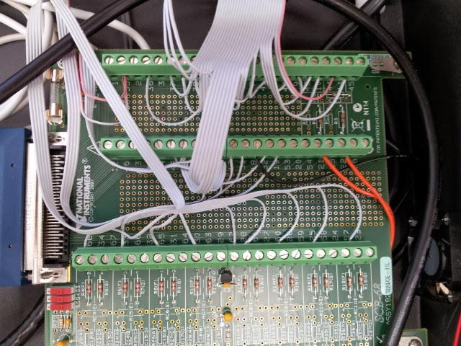

Figure - Pictobox DAQ Breakout board - Current model is National Instruments SCB-68A

The DAQ Breakout board allows us to connect the input and output lines from the DAQ card to the rest of the world using real life human sized hands. It consists of a large number of screw connectors each of which corresponds to one line from the DAQ card. We are currently using the National Instruments SCB-68A which is specifically designed to work with the PCIe-6321 DAQ card. The following table includes the mapping of DAQ signal names to pin numbers for the PCIe-6321. Pin numbers are printed next to each screw connector on the breakout board.

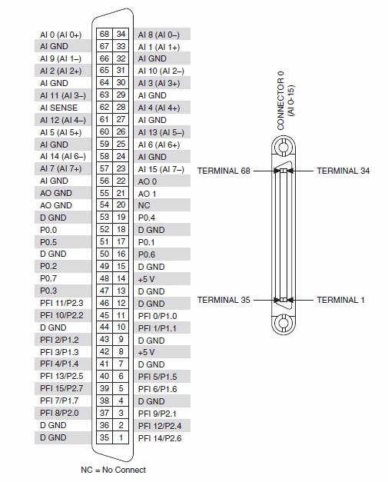

Figure - Pictobox DAQ Breakout board Signal to pin mapping

Make sure to install the DAQ Breakout board after laying down all cables that need to go from the motherboard to the back of the Pictobox since many of these will fit nicely underneath the board. Also, sometimes pins that you would expect to be near one another end up being on opposite sides of the breakout board, so be very careful when cutting the wires going to the board to be sure that they will be able to reach their destination pin.

### Relay Board

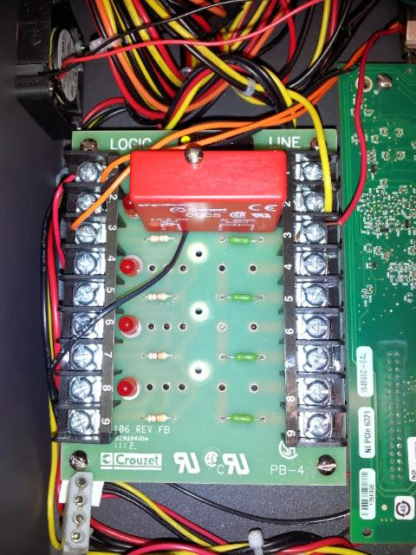

Figure - Relay Board - Current model is Crouzet PB-4

The relay board holds up to 4 relays that connect the power supply's 12 volt source to one of the four red pins on the back panel reward outputs. The four black outputs are connected to ground. We use relays because in the typical case rewards are delivered by a high current system, a solenoid in our case or a pump or motor in other cases. If we attempted to drive these high current devices directly from the DAQ card we would probably break something. The relays allow us to use a high current power source while insulating our DAQ card so that it is only working with low current logic. The relay board itself requires a connection to 5V and ground and each individual relay can be switched on by raising a single pin to 5V. To be sure that we don't accidentally open reward solenoids during startup, we use the 5V power source as an enable pin and it is only raised once the Director application starts.

When installing the relay board, be sure that you have already installed the LCD display, control dial, reward and flush buttons since they will be much harder to access once the relay board is in place. Also, be careful about static charge when touching the individual relay circuits. We have broken a few of these somehow during the installation process, so they seem to be quite sensitive. For a discussion of why we are only using one of the four relays (and therefore only one of the four reward channels), see the [Data Acquisition (DAQ) Card](#_Data_Acquisition_(DAQ)) section.

### LCD Display

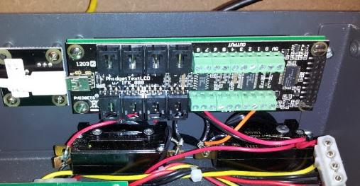

Figure - LCD display - Phidgets 1203_2

The LCD display is controlled by the Picto EmbeddedFrontPanel application and provides information about the Picto Director in a clear and concise way as well as the capability to make quick changes to various important settings. It displays the name of the current Pictobox, its connectivity / run status and its current default reward duration, flush duration and IP address. The dial (Phidgets 1052_0) can be used to move through menus and change settings in the display.

When installing the LCD display, make sure to install the reward and flush buttons first and solder all the necessary wires to their contacts. Install the phidgets dial before the LCD as well since the LCD's USB connector needs to fit behind the dial board. We frequently had to change the width of some of the spacers on the phidgets dial to find the sweet spot where the board has some clearance from the front panel but isn't so far back that the button cannot be pushed. We also need to make sure the LCD USB cable will fit behind it. Once the reward button, flush button and dial are installed, make sure to connect the appropriate wires to the LCD digital inputs and only then screw it into the front panel. It is extremely difficult to connect the wires after the LCD is screwed in. These wires are used to detect when the reward and flush buttons are pressed. Connectivity details can be found in the Connectivity section.

### Power Supply and Hard Disk

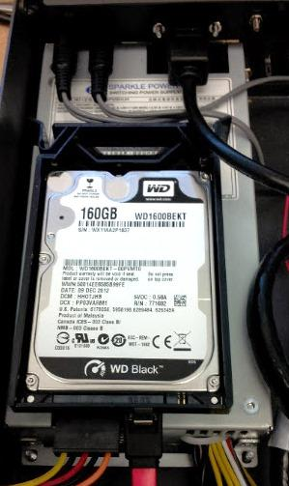

Figure - Power supply and hard disk - Sparkle Power SPI2501UH-B204 and Western Digital WD1600BEKT

The power supply and hard drive are two components that are very likely to change in future builds of the Pictobox. The power supply in particular has become difficult to find, and hard drive models change fairly frequently. When ordering the power supply, make sure that it can supply at least 250 watts, that it has the correct dimensions (100x40.5x190) and that it will be compatible with the motherboard. The hard drive does not have any tight requirements so long as it can connect to the motherboard and does not have a tiny capacity (we are currently using a 160GB hard drive which is significantly more than necessary).

The power supply should be one of the first things that you install in the Pictobox since it does not sit particularly close to anything that needs to be soldered and it needs to go in before the audio and ethernet ports that screw in above it. The hard drive is actually the only component of the Pictobox for which no predefined position was planned. The original Pictobox was going to use a VIA motherboard with integrated compact flash card that was going to be used as a hard drive, but that turned out to not be feasible. Our solution has been to purchase a plastic 2.5 inch hard drive caddy. We simply velcro the caddy to the top of the power supply and place the hard drive inside. Another thing that might not be clear is how we supply the 12 volts from the power supply to the reward relays. To do this, we simply take one of the power lines that we aren't using, cut and strip its 12 volt wire and screw it into the relay input. Simple and easy.

### Pictobox Case

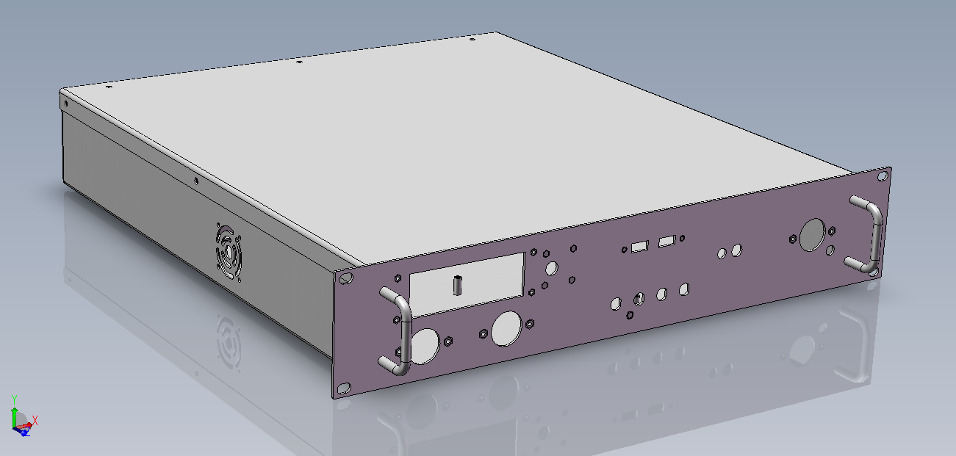

Figure - Pictobox Case Design - Revision 2

The Pictobox case is custom designed to accommodate the needs of modern neurobiological decision making experiments. The case was designed in Lee Lab and built by [Protocase](http://www.protocase.com/). The current design is called "Pictobox Revision 2". The .easm and .edrw solidworks designs can be found by digging through the Lee Lab network drives, but the easiest way to order a new case is to simply contact Protocase and ask for it because they have the design on file. The case was carefully designed to include all of the screw mounts necessary for all of the Pictobox components (except for the hard disk, see Power Supply and Hard Disk). Note however that if we replace any components in the Pictobox with different brands, we will either need to make sure that those new components are screw compatible with the old ones or move the screw mounts in the case.

## Other Components

### Front Panel

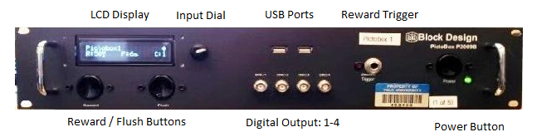

Figure - Front panel components

The front panel includes all of the controls that a user needs to interact with the Pictobox in normal day to day activity. Three buttons (C&K ASKHC2B14AC) are used for Reward, Flush and Power. A phidgets LCD display and rotary encoder dial are included for information display and simple Director configuration (see LCD Display). Two panel mounted USB ports are included which are driven by the motherboard's USB header (FrontX P1082-012 cable). Four BNC ports are supplied for digital outputs. A manual reward trigger plug (MultiComp SP101H-Z) is supplied for the purpose of attaching an external reward trigger. Two LEDs are supplied to indicate when the Pictobox is powered up and when a reward is being supplied (Lumex SSI-LXH387GD and SSI-LXH387ID).

### Back Panel

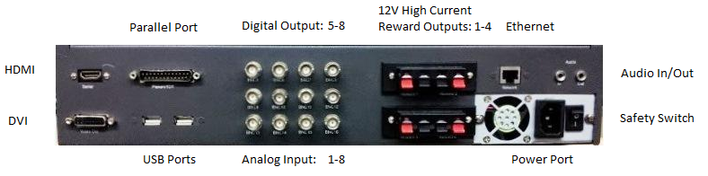

Figure - Back panel components

The back panel includes input and output ports that are connected when a Pictobox is first installed but rarely adjusted after that. DVI-I (DataPro 1143-01C) and HDMI (Adafruit 978) panel mount ports are supplied to drive external displays. A panel mounted parallel port (Amphenol g17k25101001eu) is supplied for sending alignment codes to a neural data acquisition system. Two additional panel mounted USB ports (FrontX P108-012) can be used for things like a keyboard and mouse if desired. Four BNC ports are provided for additional digital output lines and 8 BNC ports are provided for Analog inputs. Four Red-Black "speaker" connection jacks are supplied for connection to high current rewarder devices. These are difficult to find on standard electronics supplier sites but are typically available from small resellers on eBay. A panel mount ethernet port (FrontX P115-024) is provided for connecting to the network. Panel mount audio in and out ports (FrontX P092-024 and P0902-024) are provided. A 250 watt power supply (see Power Supply and Hard Disk) provides power to all internal Pictobox components.

### Side Panels

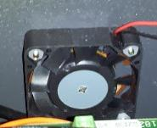

Figure - Side panel fan

The Pictobox side panels are empty apart from a fan on each side (NMB 1604KL-04W-B30-B00). It is important to be sure that the fans are oriented such that one blows air in and the other blows it out, otherwise they are essentially useless.

### External Parts

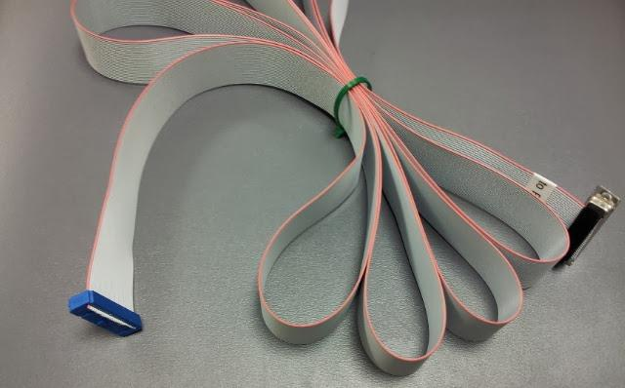

Figure - Alignment code parallel cable

* An alignment code parallel cable is used for connecting the Pictobox parallel port to a neural data acquisition system's event input port. This is built with standard 26 line parallel cable (with one wire removed), a DB-25 "Crimp-On" female connector (MultiComp MH10577), screw locks for that connector (FCI 863005ATLF), and a 26 pin connector socket (CW Industries CWR-227-26-0203).
* A manual reward trigger is used to trigger rewards when a workstation is not available and the user can't physically stand next to the Pictobox to use the reward button. This is built with a push button (Switchcraft ED903), a standard cable and a "phone audio" plug (MultiComp SP101H-Z).
* Currently, we use a solenoid in the lab to provide juice reward. The solenoid needs to take a 12V power supply and have reasonable aperture and flow. We have found that the [Sizto](http://www.stcvalve.com/Process_Valves.htm) 2P025-1/8-1-D-S is effective for this purpose.
* In order to support running the legacy Orion software on Pictoboxes and provide an alternative for re-running old experiments rather than redesigning them from scratch, we added the HDMI port to drive an operator display. We also had to deal with an incompatibility in the alignment system. In Picto we only use 7 pins of the parallel port for a maximum of 128 separate alignment codes. Orion uses 15 pins of the parallel port for alignment codes. In order to support this, we made a special cable that connects to both the parallel port and all 8 digital output ports and terminates in a regular Plexon connector (CW Industries CWR-227-26-0203). To make this work, we essentially just cut lines 10-17 of the cable going to the Pictobox parallel port and instead attach them to BNC cables going to digital outputs 1-8 respectively. By setting things up this way, we can just swap out the Orion-on-Pictobox cable for a regular one when we move back to running Picto.

# Parts List

We use a spreadsheet called PictoboxPartsList for ordering Pictobox parts and have stored it in this file's directory. The spreadsheet is current as of summer 2013 when we last used it to purchase Pictobox parts. Keep a few things in mind when using the spreadsheet.

* There are two sets of links in each row. The first link is to the part manufacturer's website where the part is described. The second link is to the part reseller’s page where the part is available for purchase. Obviously, either one or both of these may no longer be functional when you read this; however, the second reseller link should generally be more dependable than the first manufacturer link. This is due to the fact that we updated the reseller links during our latest purchase but did not touch the manufacturer links.
* Wherever possible, the quoted number of units needed is the exact number required per Pictobox. In some cases (i.e. screws) it is impossible to purchase the exact number so we have quoted the minimum number of items (i.e. bags of screws) that will cover a single Pictobox. In other cases, such as particular delicate, inexpensive parts, it is actually a good idea to buy at least one more than necessary since they are fairly easy to break during installation, particularly on your first attempt. The DB-25 Female connector in particular comes to mind. This part is very easy to install backwards or break during crimping and once crimped it cannot be reused. Buy extras of these types of items. We will use them at some point and you will save yourself a week waiting for a single tiny part to arrive.
* Obviously the unit cost quoted in the spreadsheet is extremely variable. This is useful to provide a rough cost estimate though.
* The current cost of a single Pictobox system, including all hardware, the case and screws is around $2,700. About $1000 of this is used entirely for the National Instruments cards with another $600 going toward the Pictobox case and $300 toward the motherboard and CPU. Everything else comes to about $800.
* Notes are included in the final column to provide some useful information about the part being purchased.

# Connectivity

The best way to build a Pictobox is unquestionably to borrow another Pictobox and just reproduce all of its connections. With this said, we also have another useful aid, a PictoboxConnections spreadsheet prepared by Michael Petrowicz that documents all of the connections that need to be made in the Pictobox. This spreadsheet includes a number of sections, one for each major Pictobox component. Each section includes all of that component's ports and pins in its "Connect FROM" columns. Each row of that column represents a single Port/Pin. The "Connect TO" columns include the Component, Port and Pin to which that "Connect FROM" pin is connected. There is also a Power Consumption (W) column that is useful in estimating power requirements for new types of Pictobox power supplies and a Notes column with additional information.

Of all the sections in the spreadsheet, the Connector Block section (referred to as the DAQ Breakout elsewhere in this document) is the most detailed. Many of the connector block's pins are wired to BNCs, Relay board pins, etc, in a standard way for all Pictoboxes. Pins that are wired to the parallel port, however, need to be wired differently as a function of how the Pictobox will be used. This is true because the parallel port is connected directly to the neural data acquisition system's event input. Different neural DAQ's have different event input interfaces and the Pictobox parallel port needs to be wired accordingly. At this point, we have built Pictoboxes to interface with Yale's Lee Lab Plexon systems and the Spike2 systems in Yale's Arnsten Lab. We have not yet wired a Pictobox for interfacing with the TDT neural DAQ system.

An example of the "Connect TO" and "Connect FROM " columns in the PictoboxConnections spreadsheet appears below. This entry is for the pin used by the Picto Director as the lowest alignment code bit:

|  |  |  |
| --- | --- | --- |
| Connect FROM | Connect TO |  |
| 11 (PFI 0/P1.0) | **PLEXON(3-Bit 0)/TDT()/SPIKE2(LB0)** | 2/?/21 |

The Connect FROM column indicates that pin 11 on the connector block is the NI DAQ card's PFI/P1.0 pin, which we configured in the Director to be the 0th (lowest) bit of the alignment code output. The first column of the Connect TO section shows us that when connecting to the Plexon system this pin needs to be connected to Plexons's Bit-0 which is pin 3 of the event port located on the physical Plexon box. When connecting to the Spike2 system this pin needs to be connected to Spike 2's LB0 (low byte zero) input. The last column of the Connect TO section shows us that when connecting to Plexon, the pin needs to be connected to pin 2 of the Pictobox's parallel port because that will end up connecting to the Plexon event port's pin 3-Bit 0. When connecting to Spike2, the pin needs to be connected to pin 21 of the Pictobox parallel port because that will end up connecting to Spike2's LB0 port when the parallel cable is attached.

Since we have not yet wired a TDT system, that middle parts of both columns in our example are left empty (ie. TDT() and /?/). The TDT documentation is not particularly clear with regards to the hardware event code interface; however, it appears that the TDT digital input port is configurable for things like event code inputs and we are most likely using some type of standard configuration. When it comes time to wire a Pictobox for use with a TDT system, we will want to contact TDT for help in figuring out the exact input pin configuration that our system is using. We will then need to wire the Pictobox accordingly so that our alignment code pins and trigger line match up with the correct event code inputs and trigger input. We will also need to be sure to use an appropriately shaped connector on the TDT side of our alignment code parallel cable since the standard connector that we include in the PictoboxPartsList is specific to Plexon. If you are the one going through this process and wiring up the first Pictobox for use with TDT, you are kindly requested to update the PictoboxConnections spreadsheet and this section accordingly.

# Installation

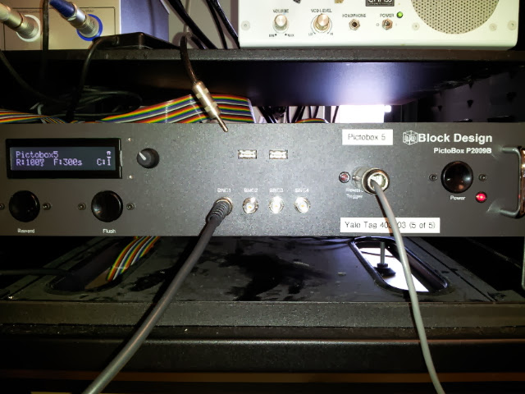

Figure 15 - A rack mounted Pictobox

Installation of a Pictobox is fairly straightforward; however, there are a few guidelines that can be helpful in the process. First of all, Windows 7 needs to be loaded onto the system using the standard Windows installation process. Most of the necessary drivers for the box should have come on a disk with the motherboard. National Instruments drivers will need to be installed separately with the NI-DAQmx Version 9.1 installer. The latest DirectX libraries will be needed and can be installed using [DxWebSetup](http://www.microsoft.com/en-us/download/details.aspx?id=35). Picto software should be installed in the normal way. Once the software is installed, a script should be set up to start the Picto Director application and placed in the Start menu’s Startup folder so that it will start the Director application automatically when the Pictobox turns on. Command line options for the script will vary depending on your experiment requirements; however, a typical script will look something like the following:

*start /d C:\picto\bin\PictoDirector.exe -name Pictobox1 -systemNumber 1 -pictobox -xChan 0 -yChan 1 -xDiamChan 2 -yDiamChan 3 -positionPeriod 2 -diamPeriod 4*

Also make sure that the system resolution is set to 800x600 and disable the windows password on startup requirement so that you won’t need to plug a keyboard in whenever you restart.

As in the case of any rack mounted system, if standing behind the rack is not trivial you will want to connect all ports on the back before screwing the Pictobox onto the rack. When facing the back of the box, make sure to connect the positive and negative terminals of the reward solenoid to the top left red and black speaker style connectors. This is reward channel 1, currently the only supported reward channel. If using x,y analog voltage signals for eye position, attach them to the leftmost connectors in the central row of BNC ports on the back of the case (BNC9, BNC10). If using horizontal and vertical diameter inputs, attach those to the next two BNC connectors (BNC 11, BNC 12) such that your central row consists of PosX, PosY, HorizDiam, VertDiam in that order. Next connect the parallel cable to the Pictobox parallel port and the event port of the neural data acquisition system. At this point you can proceed as you would in installing any normal PC. Attach the Ethernet cable, the audio out, the display (subject display should be a CRT connected to the DVI-I through a VGA adapter), any desired USB devices, and of course the power cord. Make sure that the power supply safety switch is set to on before attempting to power up the Pictobox.

On the front of the box, if desired, you may plug the reward cable into the reward trigger plug. If any digital output is needed, the 4 digital out BNC ports on the front of the box may be used.

# Future Directions

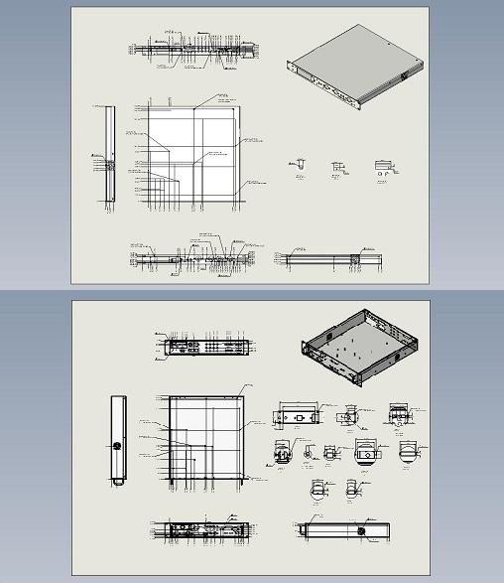

Figure - Pictobox Revisions 1 and 2

The Pictobox case and components have gone through a number of revisions since they were first conceived, and the current configuration should by no means be the final one. Some ideas for future changes and upgrades appear below.

## Reposition the motherboard

Standardization of motherboard form factors has come a long way. It is certainly nice that all Mini-ITX motherboards are screw compatible so that we can select one of many motherboard brands for the Pictobox. We are still limited in our selection, though, by all of the Pictobox case's preconfigured requirements for a certain number of USB ports, DVI, HDMI, etc. so that none of the holes on the case's front or back panel will be empty. The Pictobox internals are also fairly messy due to all of the various cables that are used to reproduce the ports on the back of the motherboard at the positions of the various custom cut holes. We are missing out here on one of the greatest parts of motherboard standardization which is the built in port / shield system that allows modern desktop developers to pop a motherboard into a case and let it deal with its own ports.

Every modern motherboard exposes all sorts of ports on one side: USB, HDMI, DVI, Ethernet, Audio, etc. Motherboards come with an aluminum shield that fits around their particular port setup and fits into a standard rectangular opening. If we simply cut a correctly sized opening at the back of the Pictobox, position the motherboard there and use the shield then we won't need to purchase all of the various FrontX and other cables that we use to move those ports to the back of the box. The case will be much cleaner without all of those cables running all over the place. We can still use cables from the motherboard USB header to expose USB ports on the front of the box and connect to the phidgets LCD and rotary dial, but the case internals would be significantly neater.

## Add a Hard Disk Mount

The Pictobox currently contains no built in hard disk mount since it was originally designed with the idea of using a compact flash card attached directly to the motherboard. Now that we are using a hard disk, we have been simply purchasing a plastic case and velcroing it to the top of the power supply. There is nothing inherently wrong with this, but if we do redesign the case for another reason, it would be a good idea to also add screw mounts to attach the hard disk in a set position.

## Consider other NI DAQ Cards

At one point around the middle of 2012 we met with some National Instruments representatives who informed us that in newer data acquisition cards there would be some type of functionality for defining specific output voltage pulse streams rather than simply using a periodic up/down/up/down signal. Currently the Director uses a sort of patch to handle rewarding with the current periodic system. It sets up a periodic reward signal task with period equal to twice the desired reward length. The signal starts high and the Director software waits for the reward signal to drop and then turns off the task before it has a chance to go high again. There is no inherent disadvantage to this other than the fact that we can't support reward signals shorter than half a frame, but that wouldn't really be necessary anyway. Considering our problem of finding enough timers on the DAQ board to control all four reward controllers (see the [Data Acquisition (DAQ) Card](#_Data_Acquisition_(DAQ)) section for details), it might make sense to consider one of these newer types of chips however. Possibly we could use this cleaner method of triggering rewards and take care of the limited timers issue at the same time.

## Consider the NI Compact RIO System

National Instruments recently developed a system called the [Compact RIO](http://www.ni.com/crio-9068/). This system includes an extensible chassis with built in computer and slots for installing multiple types of standardized configurable I/O components. Currently this box is far too expensive to be a reasonable alternative for the Pictobox, but at some point the price may drop to the point that it can be considered. When and if that happens, it would be worth spending some time considering whether we could reproduce Pictobox functionality by using one of these systems.