ACTIVITY -DAY1

<html>

<head>

<title>My page</title>

</head>

<body>

<h1>welcome to my page</h1>

<p>This is a paragraph</p>

</body>

</html>

OUTPUT:

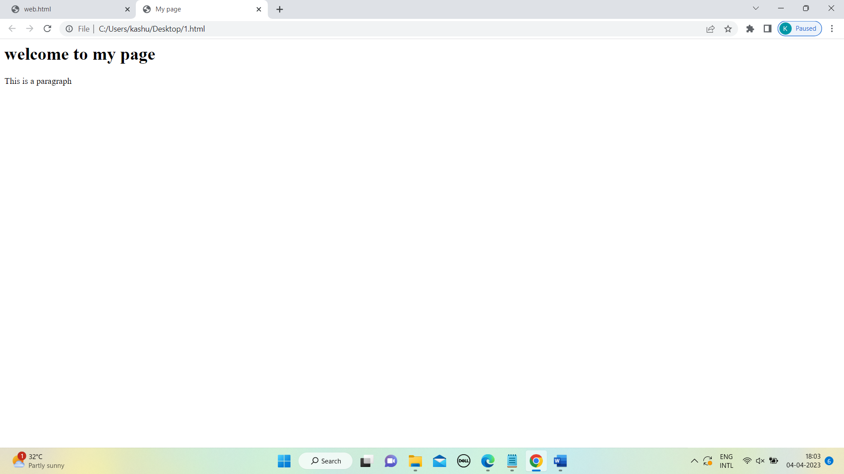

2.

html>

<head>

<style>

body {background-color:Gray;}

table {

font-family:arial;

border-collapse:collapse;

width:100%;

}

td,th{

border:1px solid #dddddd;

text_align:left;

padding:8px;

}

</style>

</head>

<body>

<h1 style="background-colour:#FF0000;">STUDENT DETAIL</h1>

<body>

<table>

<tr>

<th>Name</th>

<th>age</th>

<th>Department</th>

</tr>

<tr>

<td>Rose</td>

<td>19</td>

<td>IT</td>

</tr>

<tr>

<td>John</td>

<td>18</td>

<td>cse</td>

</tr>

<tr>

<td>david</td>

<td>18</td>

<td>IT</td>

</tr>

</table>

<img src ="C:\Users\kashu\Downloads\saveetha.jfif" width="1000" height="500">

<h2 style="background-colour:#FF0000;">To know more visit</h2>

<a href="https://www.w3schools.com">Visit W3Schools.com!</a>

<ul>

<li>Rose</li>

<li>John</li>

<li>Lily</li>

</ul>

</br>

<ol>

<li>Rose</li>

<li>John</li>

<li>Lily</li>

</ol>

</body>

</html>

OUTPUT:

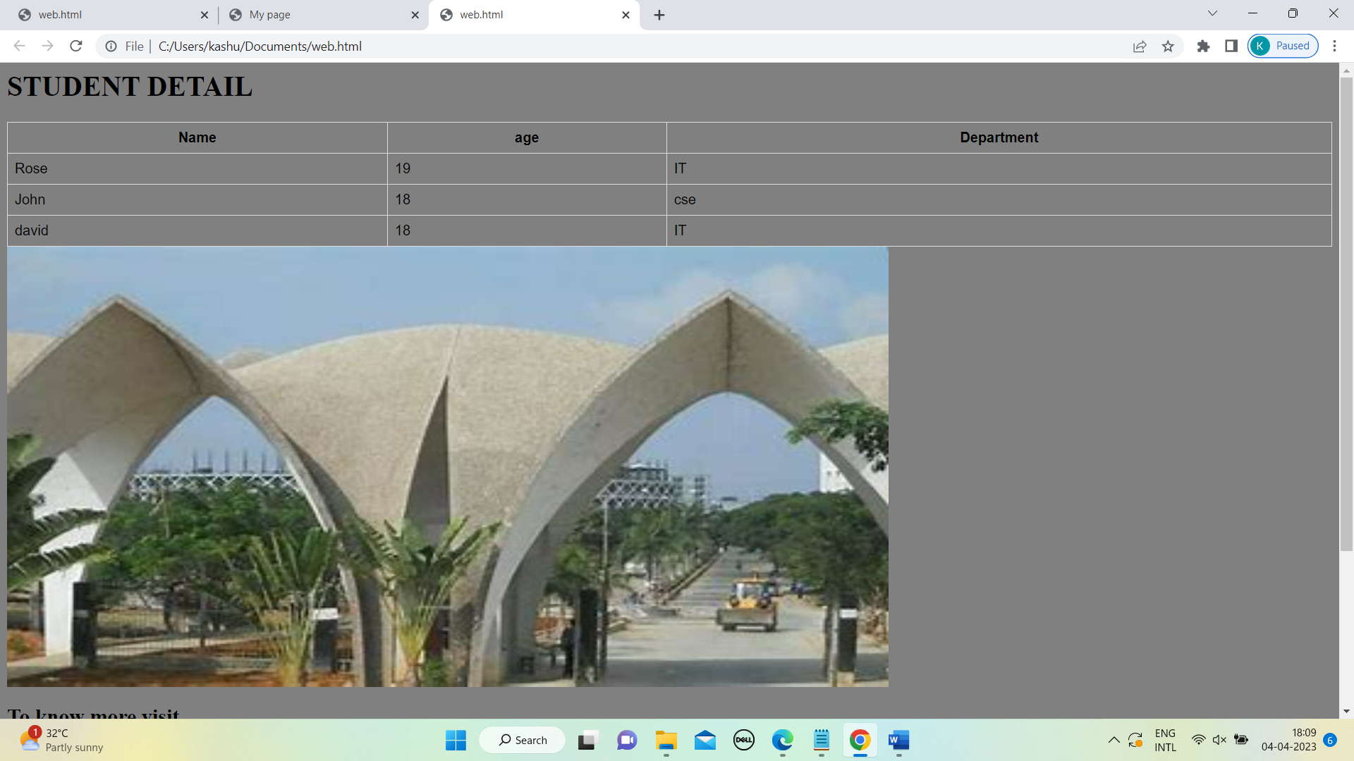

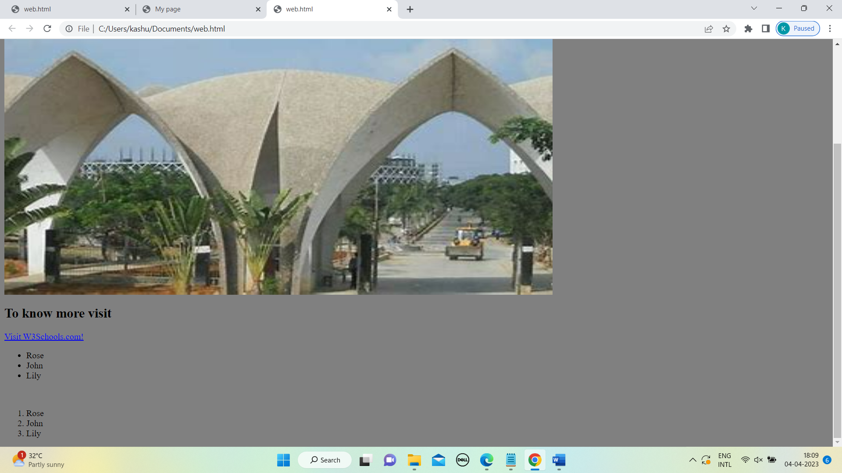

3.

<html>

<head>

<style>

body {background-color: PowderBlue;}

</style>

</head>

<body>

<input type="text" placeholder="enter the name" /> <br/> <br/>

<input type="email" placeholder="enter the email"/> <br/> <br/>

<input type="button" value="submit"/> <br/> <br/>

</body>

</html>

OUTPUT:

