1.

<!doctype html>

<html>

<head>

<script>

function jsFun()

{

var valuee, element;

valuee = parseInt(document.getElementById("num").value);

if(valuee)

{

if(valuee <100)

document.getElementById("paraTwo").innerHTML = "Less than 100";

else

document.getElementById("paraTwo").innerHTML = "Greater than 100";

}

}

</script>

</head>

<body>

<p id="paraOne">Enter a Number: <input id="num">

<button onclick="jsFun()">Enter</button></p>

<p id="paraTwo"></p>

</body>

OUTPUT:

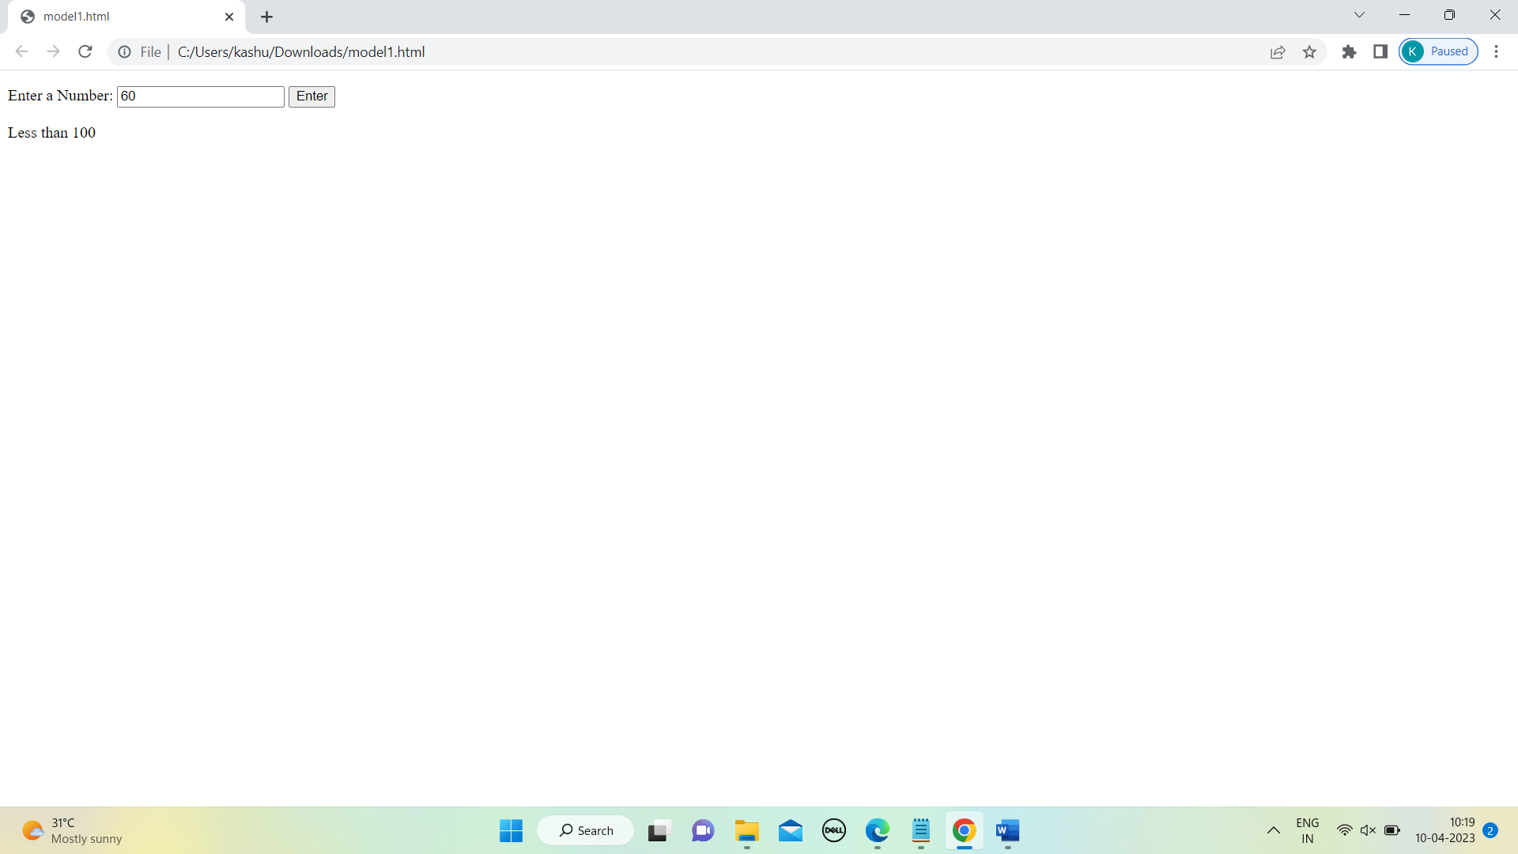

2.

<html>

<title>

web technology;

</title>

<head>

<style>

table, th, td {

border: 1px solid black;

}

</style>

</head>

<table>

<tr>

<th> C1 </th>

<th> C2 </th>

<th> C3 </th>

<th> C4 </th>

</tr>

<tr>

<td> R1 C1 </td>

<td> R1 C2 </td>

<td> R1 C3 </td>

<td> R1 C4 </td>

</tr>

<tr>

<td> R2 C2 </td>

<td> R2 C3 </td>

<td> R2 C4 </td>

<td> R2 C5 </td>

</tr>

<td> R3 C1 </td>

</tr>

</table>

OUTPUT:

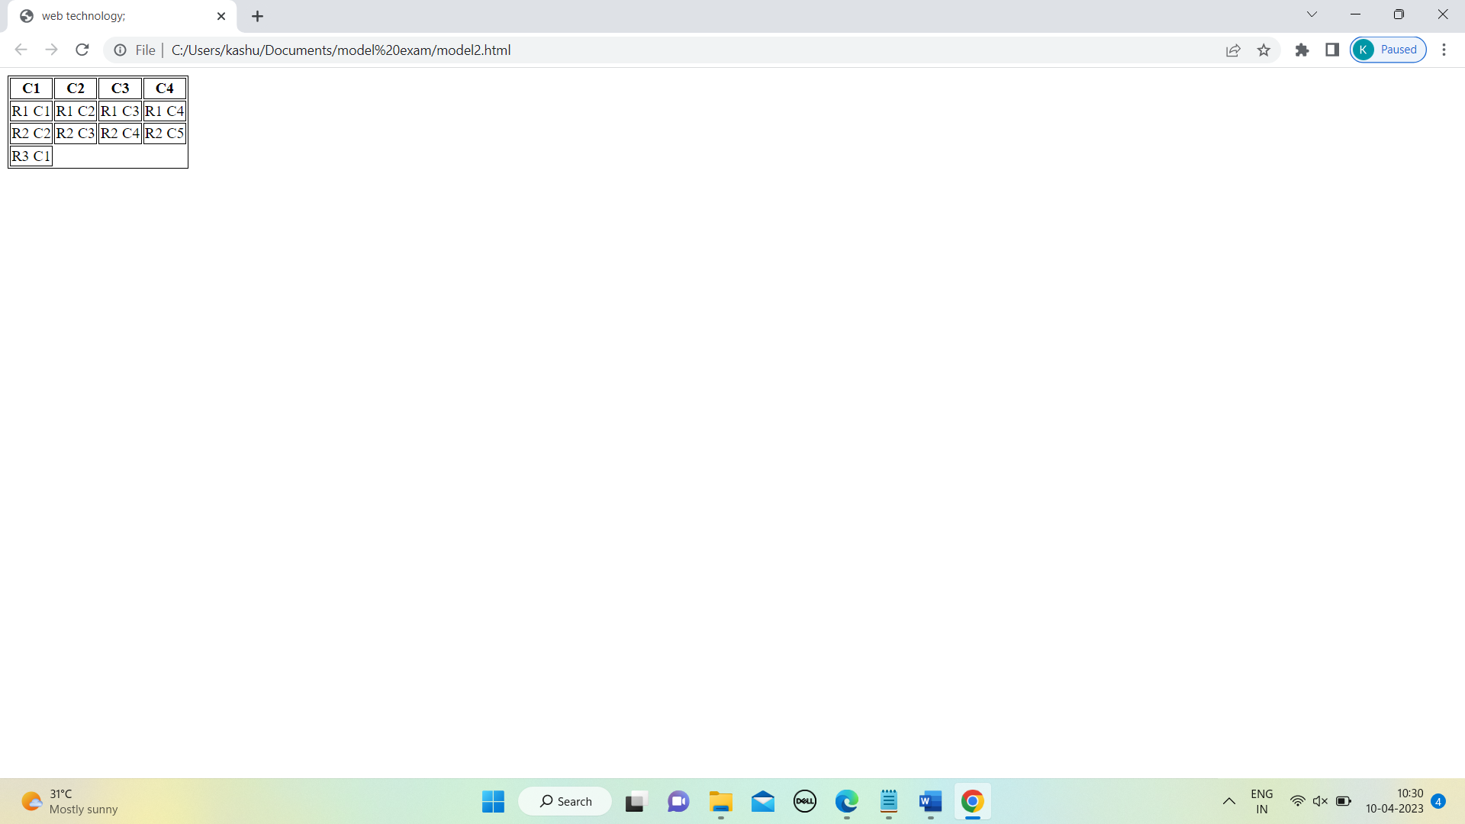

3.

!DOCTYPE html>

<html>

<head>

<meta charset="utf-8">

<title>JS DOM paragraph style</title>

</head>

<body>

<p id="text">JavaScript Exercises-resource</p>

<div>

<button id="style" onclick="changeStyle()">Style</button>

</div>

<script>

function changeStyle() {

var textElement = document.getElementById("text");

textElement.style.fontFamily = "bold";

textElement.style.fontSize = "25px";

textElement.style.color = "red";

}

</script>

</body>

</html>

OUTPUT:

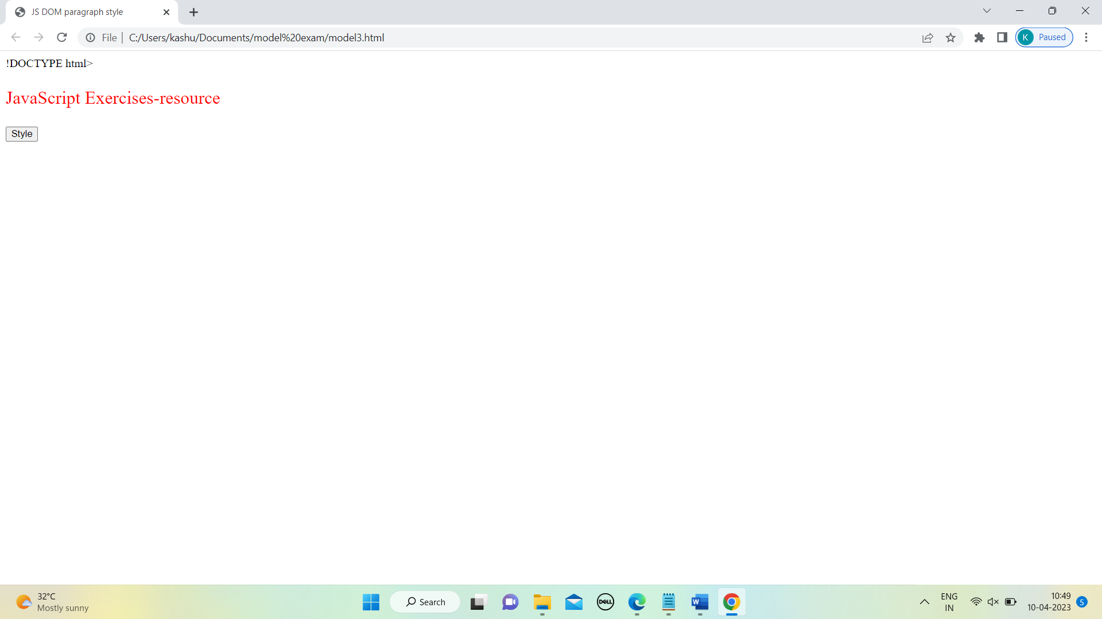

6.

<!DOCTYPE html>

<html>

<head>

<title>Select a Subject</title>

</head>

<body>

<h2>Select a Subject:</h2>

<form action="#" method="post">

<input type="radio" id="java" name="subject" value="Java">

<label for="java">Java</label><br>

<input type="radio" id="unix" name="subject" value="UNIX">

<label for="unix">UNIX</label><br>

<input type="radio" id="ddbsm" name="subject" value="DDBMS">

<label for="ddbsm">DDBMS</label><br>

<input type="radio" id="oose" name="subject" value="OOSE">

<label for="oose">OOSE</label><br><br>

<input type="submit" name="submit" value="Submit">

<input type="reset" name="reset" value="Reset">

</form>

<script>

// Check if a cookie already exists

if (document.cookie.indexOf("subject") !== -1) {

alert("You have already selected a subject!");

}

// Add a cookie on form submission

document.querySelector('form').addEventListener('submit', function(event) {

event.preventDefault(); // prevent default form submission

var selectedSubject = document.querySelector('input[name="subject"]:checked').value;

if (document.cookie.indexOf("subject") === -1) {

document.cookie = "subject=" + selectedSubject;

alert("Subject selected: " + selectedSubject);

else {

alert("You have already selected a subject!");

}

});

</script>

</body>

</html>

OUTPUT:

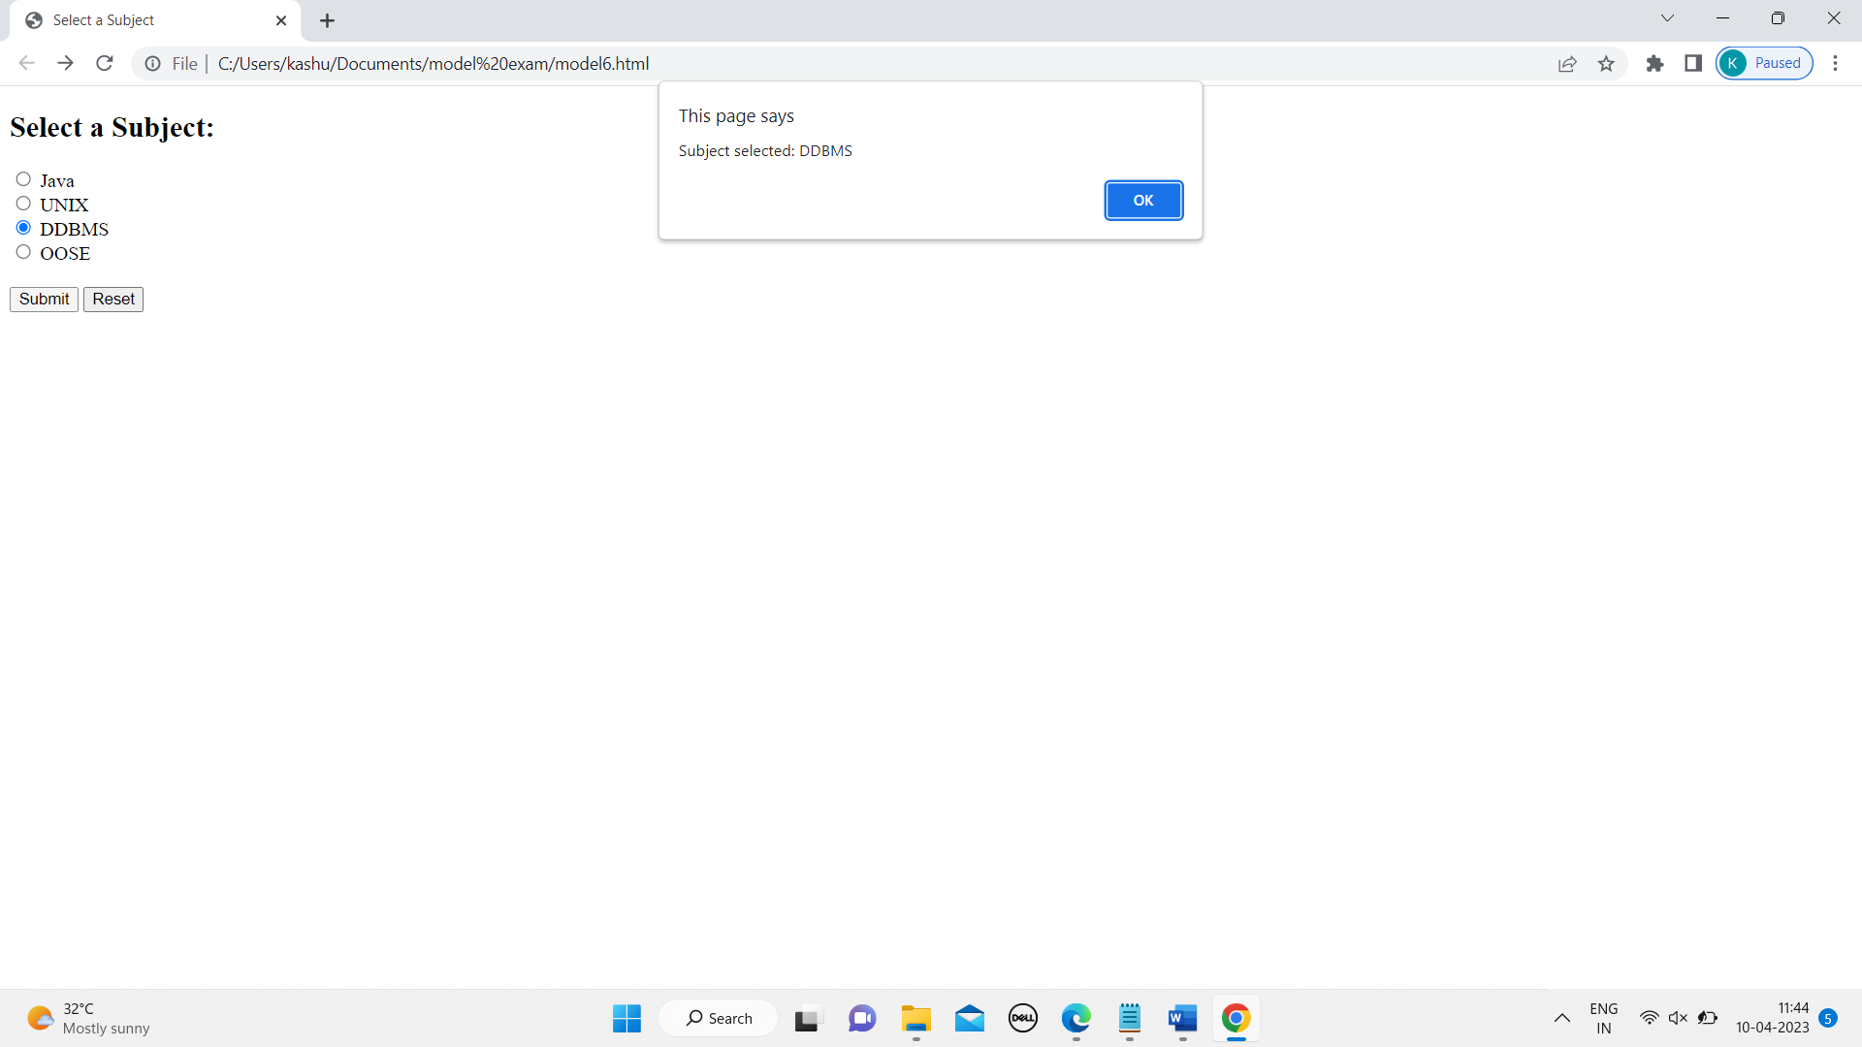

8.

<!DOCTYPE html>

<!-- JSExVar.html -->

<html lang="en">

<head>

<meta charset="utf-8">

<title>JavaScript Example: Variables and functions prompt() and confirm()</title>

<script>

var username = prompt("Enter your name: ", "");

if (confirm("Your name is " + username)) {

document.write("<h1>Hello, " + username + "!</h1>");

} else {

document.write("<h1>Hello, world!</h1>");

}

</script>

</head>

<body>

<p>Welcome to JavaScript!</p>

</body>

</html>

OUTPUT:

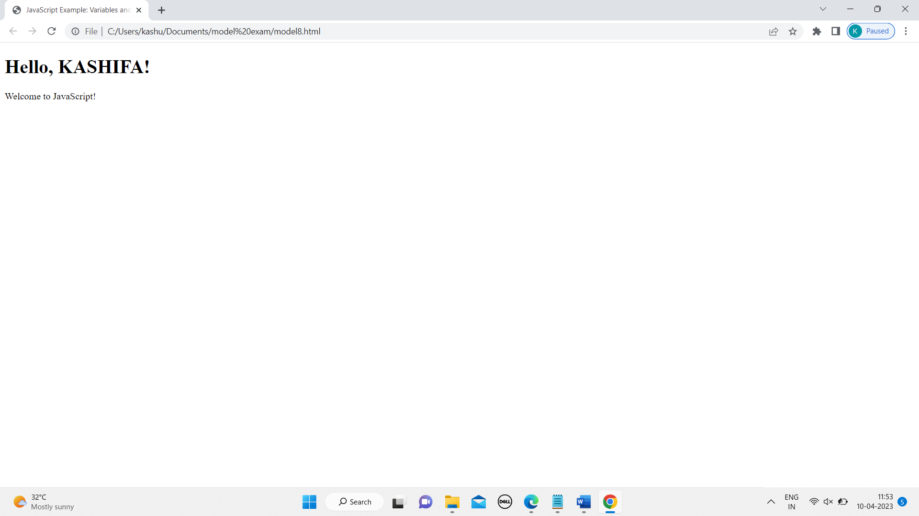

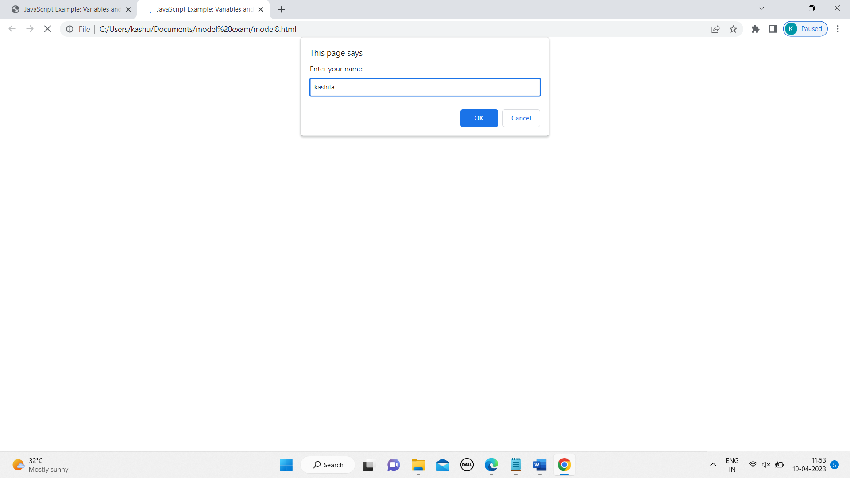

9.

<!DOCTYPE html>

<html>

<head>

<title>Current Date and Time</title>

<script>

function displayDateTime() {

var currentDate = new Date();

var datetime = "Current date and time: " + currentDate.toLocaleString();

document.getElementById("datetime").innerHTML = datetime;

}

</script>

</head>

<body onload="displayDateTime();">

<p id="datetime"></p>

</body>

</html>

OUTPUT:

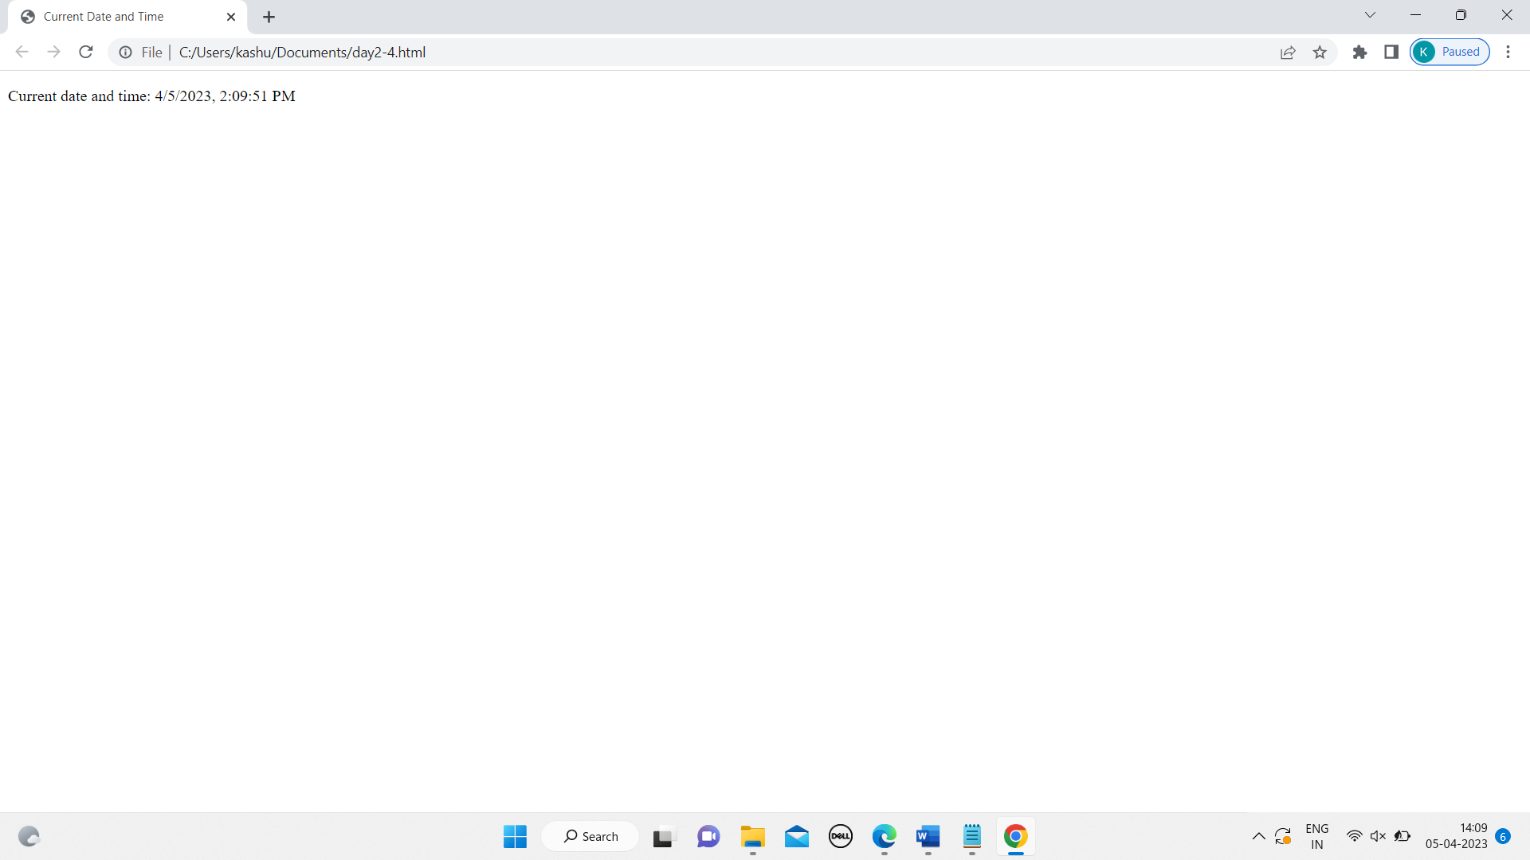

10.

<!DOCTYPE html>

<html>

<head>

<title>My Web Page</title>

<meta charset="UTF-8">

<meta name="viewport" content="width=device-width, initial-scale=1.0">

</head>

<body>

<button onclick="openGmail()">Open GMAIL</button>

<button onclick="getPageURI()">Get Page URI</button>

<script>

function openGmail() {

window.open("https://mail.google.com/", "_blank");

}

function getPageURI() {

alert(window.location.href);

}

</script>

</body>

</html>

OUTPUT:

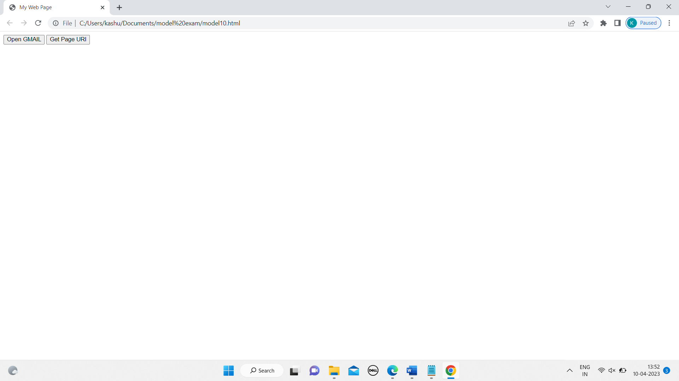

11.

<!DOCTYPE html>

<html>

<head>

<title>Email Validation</title>

<script>

function validateEmail() {

var email = document.getElementById("email").value;

var emailPattern = /^[a-zA-Z0-9._-]+@[a-zA-Z0-9.-]+\.[a-zA-Z]{2,}$/;

if (emailPattern.test(email)) {

alert("Valid email address!");

} else {

alert("Invalid email address!");

}

}

</script>

</head>

<body>

<h2>Email Validation</h2>

<input type="text" id="email" placeholder="Enter email address">

<button onclick="validateEmail()">Validate</button>

</body>

</html>

OUTPUT:

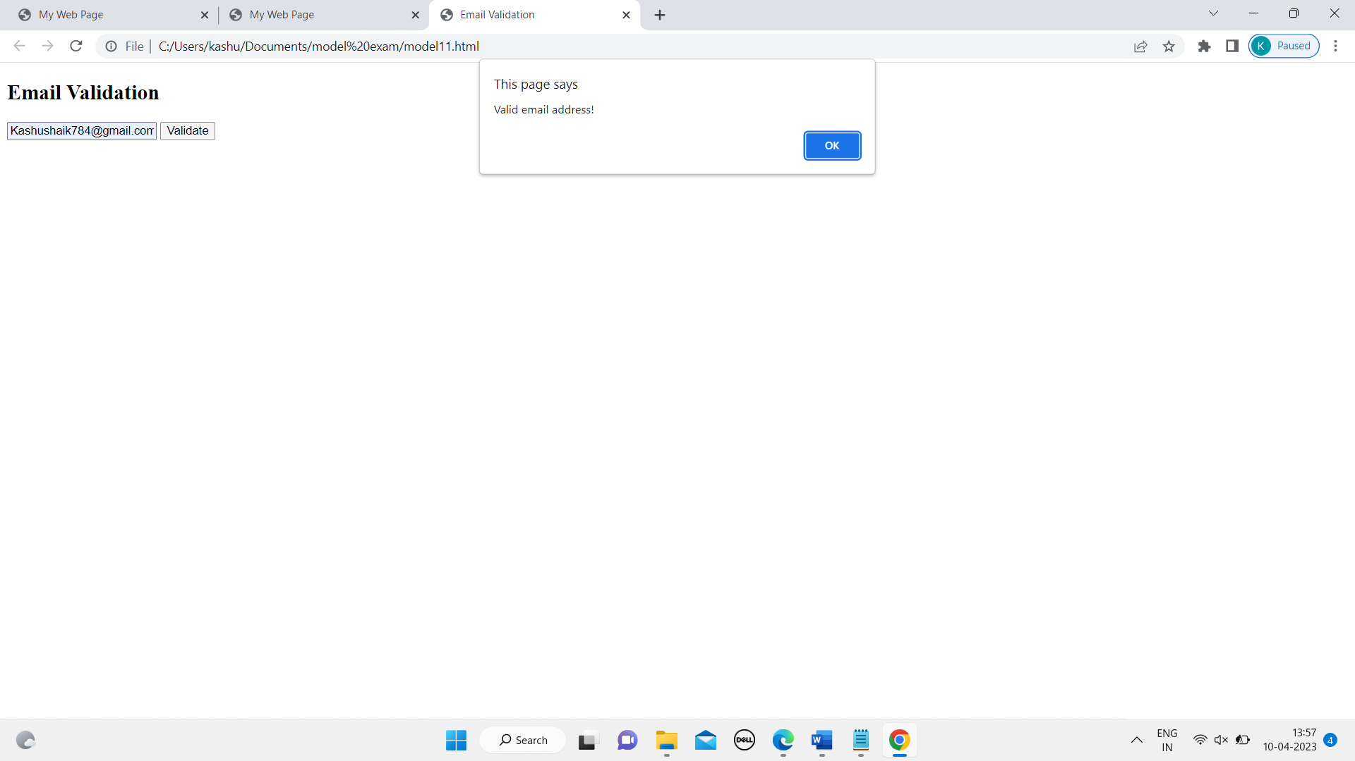

12.

<!DOCTYPE html>

<html>

<head>

<title>Switch statement example</title>

</head>

<body>

<label for="day">Select a number from 1 to n:</label>

<select id="day" onchange="displayMessage()">

<option value="1">1</option>

<option value="2">2</option>

<option value="3">3</option>

<option value="4">4</option>

<option value="5">5</option>

<option value="6">6</option>

<option value="7">7</option>

<option value="8">8</option>

</select>

<p id="message"></p>

<script>

function displayMessage() {

const dayNumber = document.getElementById("day").value;

let day;

switch(dayNumber) {

case "1":

day = "Monday";

break;

case "2":

day = "Tuesday";

break;

case "3":

day = "Wednesday";

break;

case "4":

day = "Thursday";

break;

case "5":

day = "Friday";

break;

case "6":

day = "Saturday";

break;

case "7":

day = "Sunday";

break;

default:

day = "Invalid day";

}

document.getElementById("message").innerHTML = "The day is " + day + ".";

}

</script>

</body>

</html>

OUTPUT:

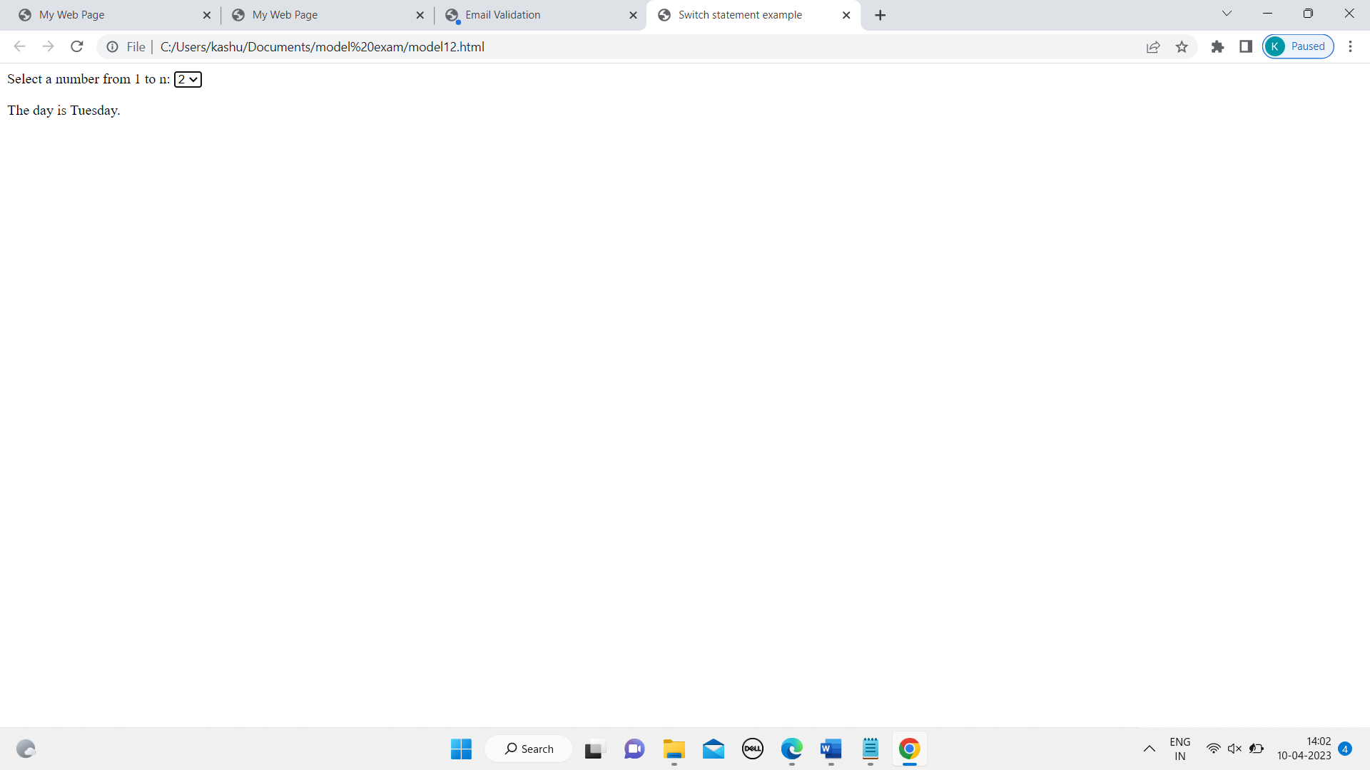

13.

<?xml version="1.0" encoding="UTF-8"?>

<!DOCTYPE html PUBLIC "-//W3C//DTD XHTML 1.0 Transitional//EN"

"http://www.w3.org/TR/xhtml1/DTD/xhtml1-transitional.dtd">

<html xmlns="http://www.w3.org/1999/xhtml">

<head>

<title>Table</title>

<style type="text/css">

table {

border-collapse: collapse;

width: 100%;

}

th{

padding: 15px;

text-align:left

font :Bahnschrift SemiBold SemiConden;

border-bottom: 2px solid #ddd;

}

td {

padding: 8px;

text-align:left;

font :Bahnschrift SemiBold SemiConden;

border-bottom: 1px solid #ddd;

}

td {

background-color: pink;

}

th {

background-color: maroon;

}

</style>

</head>

<body>

<table>

<tr>

<th>Team 1</th>

<th>Team 2</th>

</tr>

<tr>

<td>Marks 1</td>

<td>Marks 2</td>

</tr>

<tr>

<td>kash</td>

<td>rose</td>

</tr>

</table>

</body>

</html>

OUTPUT:

