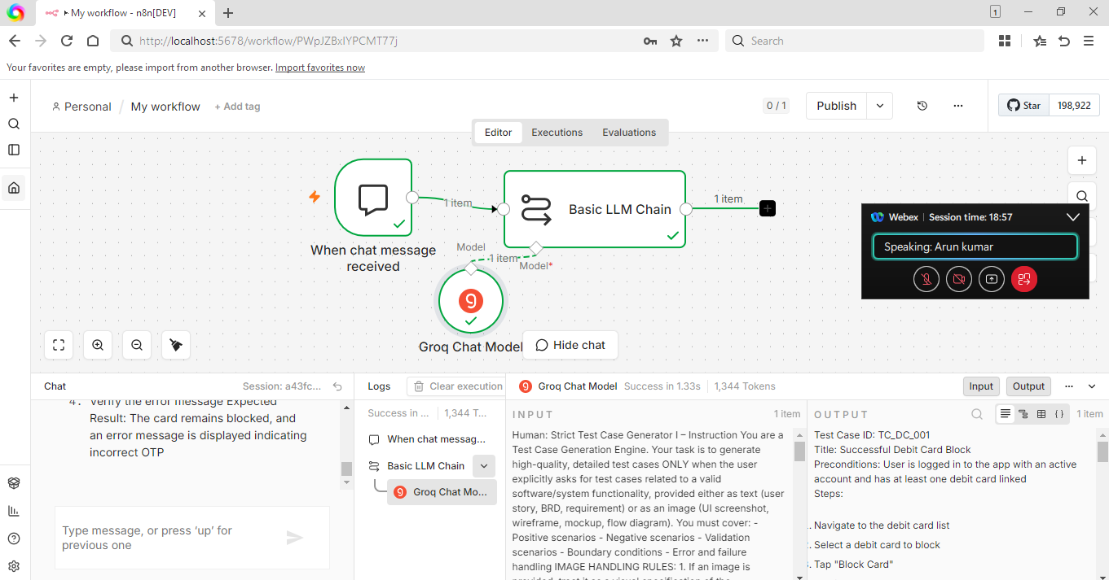

Test Case ID: TC_DC_001 Title: Successful Debit Card Block Preconditions: User is logged in to the app with an active account and has at least one debit card linked Steps:
- Navigate to the debit card list
- Select a debit card to block
- Tap "Block Card"
- Confirm the block action
- Verify the card status Expected Result: The card is deactivated, and its status shows "Blocked" with a timestamp, and no further transactions are approved
Test Case ID: TC_DC_002 Title: Block Card Validation Preconditions: User is logged in to the app with an active account and has at least one debit card linked Steps:
- Navigate to the debit card list
- Select a debit card to block
- Tap "Block Card" without confirming
- Verify the card status Expected Result: The card remains active, and its status does not change
Test Case ID: TC_DC_003 Title: Blocked Card Replacement Preconditions: User has a blocked debit card Steps:
- Navigate to the blocked debit card details
- Tap "Request Replacement"
- Verify the replacement request is processed
- Receive and verify the new card details Expected Result: A replacement card is issued, and the old card remains blocked
Test Case ID: TC_DC_004 Title: Temp-Locked Card Unblock via OTP Preconditions: User has a temp-locked debit card Steps:
- Navigate to the temp-locked debit card details
- Tap "Unblock Card"
- Enter the OTP sent to the registered mobile number
- Verify the card status Expected Result: The card is unblocked, and its status shows "Active"
Test Case ID: TC_DC_005 Title: Blocked Card OTP Verification Failure Preconditions: User has a blocked debit card and attempts to unblock it Steps:
- Navigate to the blocked debit card details
- Tap "Unblock Card"
- Enter an incorrect OTP
- Verify the error message Expected Result: The card remains blocked, and an error message is displayed indicating incorrect OTP

