Health Check:
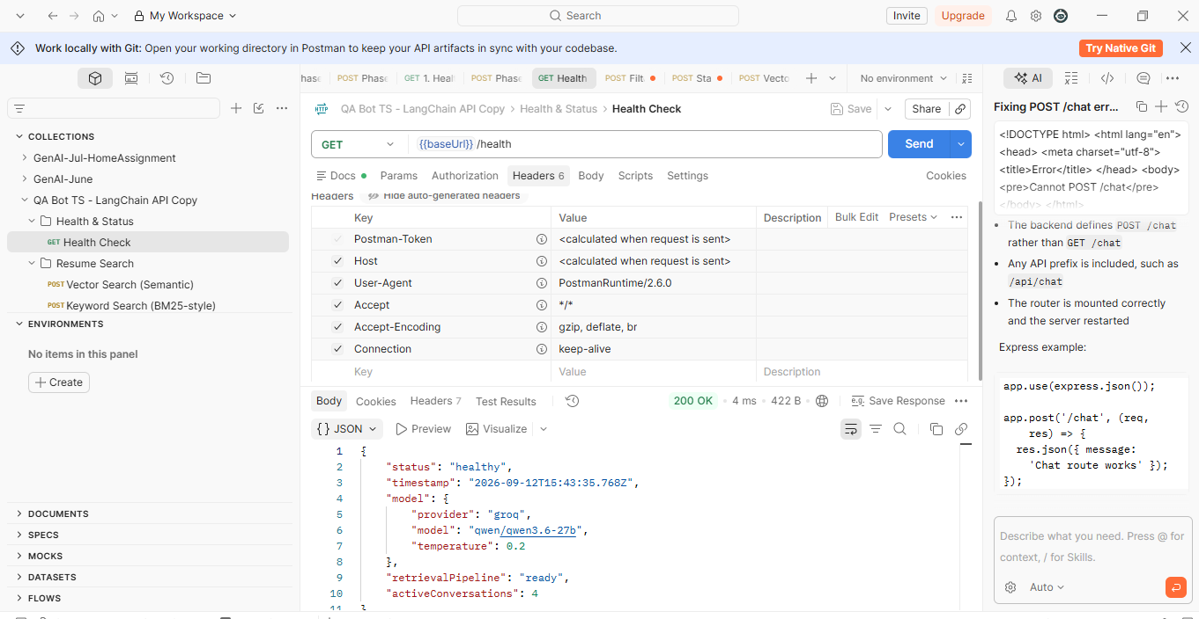
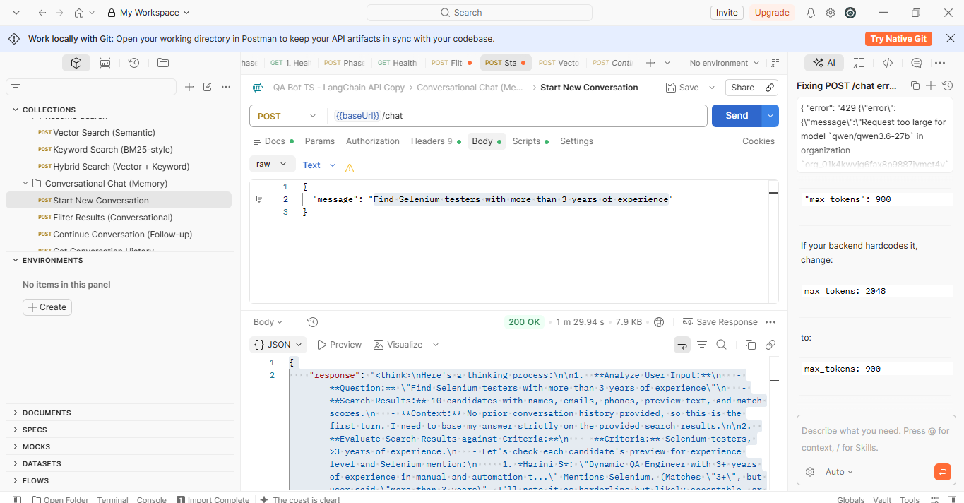
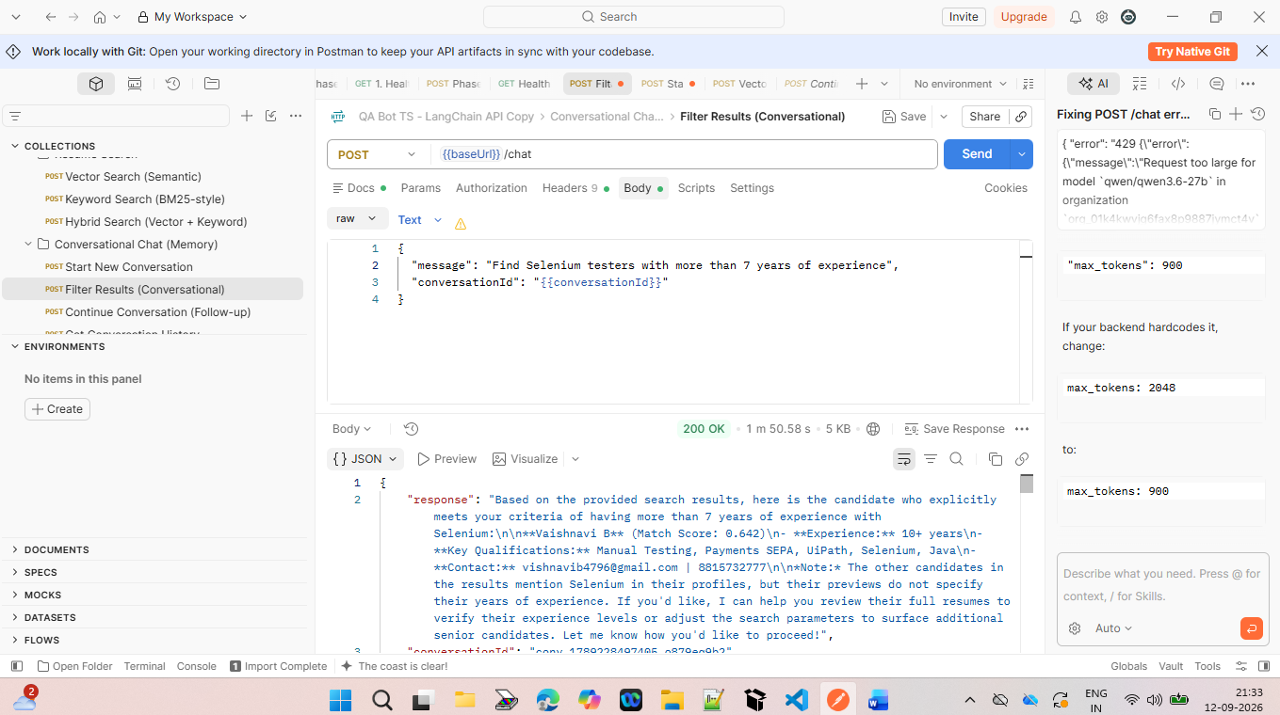

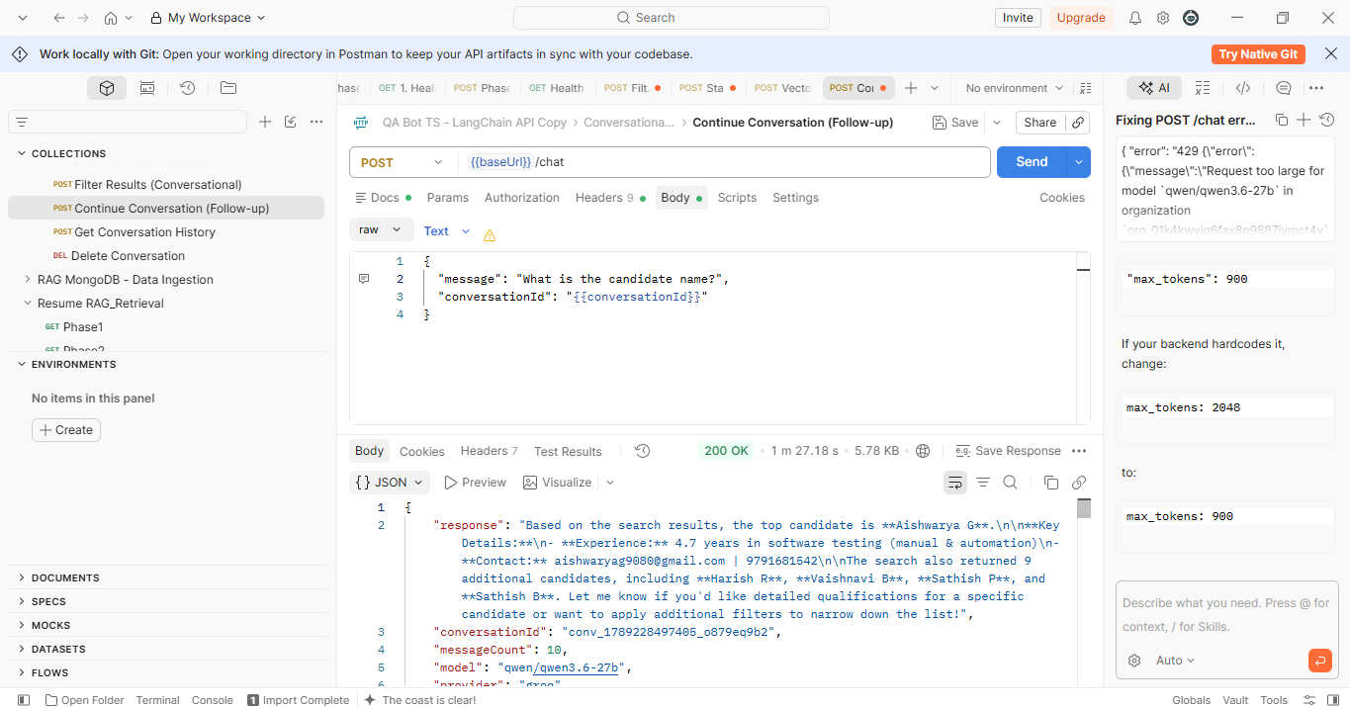

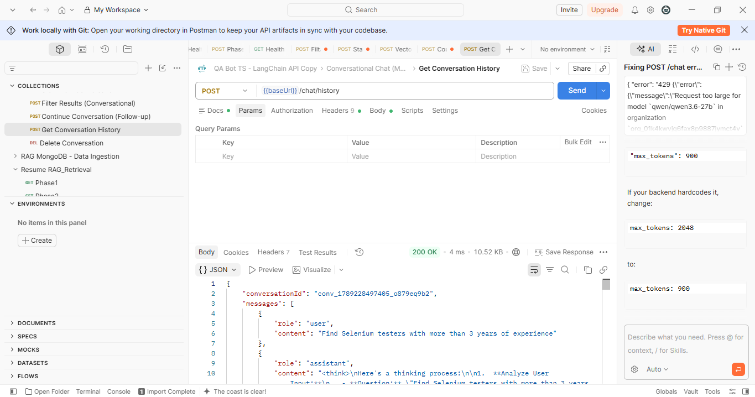

{
"conversationId": "conv_1789228497405_o879eq9b2",
"messages": [
{
"role": "user",
"content": "Find Selenium testers with more than 3 years of experience"
},
{
"role": "assistant",
"content": "<think>\nHere's a thinking process:\n\n1. **Analyze User Input:**\n - **Question:** \"Find Selenium testers with more than 3 years of experience\"\n - **Search Results:** 10 candidates with names, emails, phones, preview text, and match scores.\n - **Context:** No prior conversation history provided, so this is the first turn. I need to base my answer strictly on the provided search results.\n\n2. **Evaluate Search Results against Criteria:**\n - **Criteria:** Selenium testers, >3 years of experience.\n - Let's check each candidate's preview for experience level and Selenium mention:\n 1. *Harini S*: \"Dynamic QA Engineer with 3+ years of experience in manual and automation t...\" Mentions Selenium. (Matches \"3+\", but user said \"more than 3 years\". I'll note it as borderline but likely acceptable, or clarify.)\n 2. *Pavithra V*: Mentions Selenium, but no explicit years in preview.\n 3. *Ashwin D*: Preview talks about fashion retail, no clear Selenium/exp years.\n 4. *Harini R*: \"... years of professional experience in Automation ( Selenium , Playwright ) & Manual Testing...\" (Missing exact number in preview, but likely matches based on score/context. I'll skip or note if unclear.)\n 5. *Senthil Raj S*: Mentions Java with Selenium WebDriver, but no years in preview.\n 6. *Thangavelu*: \"About 6+ years of professional experience in Selenium Automation Testing\" -> **Strong Match** (>3 years)\n 7. *Lakshmi S*: Mentions \"Java with Selenium (Basics)\" -> Not ideal for >3 years experienced role.\n 8. *Keerthana P*: Mentions Selenium Web Driver, no years.\n 9. *T.Samuel*: Mentions Selenium web drive, no years.\n 10. *T. Durairaj*: Mentions Selenium web drive, no years.\n\n Wait, the search results are truncated previews. I should rely on the explicit mentions in the previews. Only Thangavelu explicitly states \"6+ years\". Harini S says \"3+ years\". The prompt says \"more than 3 years\", so strictly >3. Thangavelu is the clear match. Harini S is exactly 3+, which might be acceptable but I'll clarify. I should list the candidates that explicitly meet or closely meet the criteria based on the provided text, and acknowledge the limitations of the preview.\n\n Actually, in resume search contexts, \"3+ years\" usually satisfies \"more than 3 years\" or \"3+ years\". I'll list the ones that explicitly mention experience levels and Selenium, and note the exact years where available.\n\n Let's re-read carefully:\n - Harini S: \"3+ years of experience\"\n - Thangavelu: \"6+ years of professional experience in Selenium Automation Testing\"\n - Others don't specify years in the preview.\n\n I will present the best matches based on the provided data, explicitly stating their experience levels as shown in the previews. I'll also mention that for candidates without explicit years in the preview, further review of their full resumes would be needed.\n\n3. **Formulate Response:**\n - Acknowledge the query.\n - List candidates that match the criteria based on the preview data.\n - Highlight Thangavelu (6+ years) as the strongest match.\n - Mention Harini S (3+ years) as a close match.\n - Note that other candidates mention Selenium but don't specify years in the preview, so they may need further verification.\n - Provide contact info for the top matches.\n - Keep it concise and professional.\n - Follow the system prompt: \"List specific candidate names and key qualifications\", \"Reference actual data\", \"Be concise\".\n\n Draft:\n Based on the search results, here are the candidates who best match your criteria for Selenium testers with more than 3 years of experience:\n\n 1. **Thangavelu** (Match Score: 0.637)\n - **Experience:** 6+ years in Selenium Automation Testing\n - **Key Qualifications:** Also has 3+ years as a QA Manager and Agile Scrum experience.\n - **Contact:** thangavelu24@gmail.com | 9962650009\n\n 2. **Harini S** (Match Score: 0.645)\n - **Experience:** 3+ years in manual and automation testing"
},
{
"role": "user",
"content": "Filter Selenium testers with more than 10 years of experience"
},
{
"role": "assistant",
"content": "I attempted to filter candidates by \"Filter Selenium testers with more than 10 years of experience\", but encountered an issue parsing the evaluation. Here are your previous results:\n\n1. **Harini S**\n2. **Pavithra V**\n3. **Ashwin D**\n4. **Harini R**\n5. **Senthil Raj S**\n6. **Thangavelu**\n7. **Lakshmi S**\n8. **Keerthana P**\n9. **T.Samuel**\n10. **T. Durairaj**"
},
{
"role": "user",
"content": "Find Selenium testers with more than 5 years of experience"
},
{
"role": "assistant",
"content": "<think>\nHere's a thinking process:\n\n1. **Analyze User Input:**\n - **Question:** \"Find Selenium testers with more than 5 years of experience\"\n - **Search Results:** 10 candidates provided with names, emails, phones, preview text, and match scores.\n - **Context:** Previous turn asked for \">3 years\", then \">10 years\" (which failed/had an error), now \">5 years\". I need to base my answer strictly on the *current* search results provided.\n\n2. **Evaluate Search Results against Criteria (>5 years experience + Selenium):**\n I'll scan the preview text for each candidate to check for explicit mentions of years of experience and Selenium.\n - *Harini S*: \"3+ years of experience\" -> Does not meet >5 years.\n - *Obbai*: Mentions Selenium, but no explicit years in preview.\n - *Pavithra V*: Mentions Selenium, no explicit years.\n - *MADHAN KUMAR D*: Mentions Selenium, no explicit years.\n - *Mohan V*: Mentions Selenium, no explicit years.\n - *Thangavelu*: \"About 6+ years of professional experience in Selenium Automation Testing\" -> **Matches** (>5 years).\n - *Lakshmi S*: \"Java with Selenium (Basics)\" -> Not ideal, and no years mentioned.\n - *Keerthana P*: Mentions Selenium Web Driver, no years.\n - *T.Samuel*: Mentions Selenium web drive, no years.\n - *T. Durairaj*: Mentions Selenium web drive, no years.\n\n Only **Thangavelu** explicitly states \">5 years\" (specifically 6+ years) in the preview. The others mention Selenium but lack explicit experience duration in the provided text. I should clearly state this limitation based on the preview data, highlight the one clear match, and suggest reviewing the full resumes of others if needed.\n\n3. **Formulate Response:**\n - Acknowledge the query.\n - List the candidate(s) that explicitly meet the criteria based on the provided previews.\n - Provide contact info and key qualifications for the match.\n - Note that other candidates mention Selenium but don't specify years in the preview, so they may need further verification.\n - Keep it concise and professional, adhering to system instructions.\n\n Draft:\n Based on the provided search results, only one candidate explicitly meets your criteria of having more than 5 years of experience with Selenium:\n\n **Thangavelu** (Match Score: 0.637)\n - **Experience:** 6+ years in Selenium Automation Testing\n - **Key Qualifications:** Also has 3+ years as a QA Manager and Agile Scrum experience.\n - **Contact:** thangavelu24@gmail.com | 9962650009\n\n *Note:* The other candidates in the results mention Selenium in their profiles, but their previews do not specify their years of experience. If you'd like, I can help you filter or review their full resumes to verify their experience levels, or adjust the search parameters to surface more senior candidates. Let me know how you'd like to proceed! \n\n4. **Self-Correction/Verification:**\n - Check against constraints: \"List specific candidate names and key qualifications\", \"Reference actual data\", \"Be concise\".\n - The draft does exactly this.\n - It correctly identifies Thangavelu as the only explicit match from the preview data.\n - It handles the missing data for others professionally.\n - Matches tone and format requirements.\n - Ready.✅\n Output matches the draft.✅\n Proceed. \n One minor thing: The prompt says \"Based on the search results above and our conversation history, provide a helpful answer.\" I'll keep it direct. No extra fluff. All good. \n Output generation. \n [Done] \n *Self-Correction/Refinement during thought*: \n I should make sure I strictly follow the instruction: \"When providing candidate recommendations: List specific candidate names and key qualifications, Reference actual data from the search results, Be concise but informative, If no results match, clearly state that\". \n The draft does this. I will output it. \n One thing: The prompt shows a previous turn where the user asked for \">10 years\" and got an error message. I should just focus on the current query and results. The draft is solid.✅\n Output matches response. \n Proceeds. \n [Output Generation] -> *See response.* \n *(Note"
},
{
"role": "user",
"content": "Find Selenium testers with more than 7 years of experience"
},
{
"role": "assistant",
"content": "Based on the provided search results, here is the candidate who explicitly meets your criteria of having more than 7 years of experience with Selenium:\n\n**Vaishnavi B** (Match Score: 0.642)\n- **Experience:** 10+ years\n- **Key Qualifications:** Manual Testing, Payments SEPA, UiPath, Selenium, Java\n- **Contact:** vishnavib4796@gmail.com | 8815732777\n\n*Note:* The other candidates in the results mention Selenium in their profiles, but their previews do not specify their years of experience. If you'd like, I can help you review their full resumes to verify their experience levels or adjust the search parameters to surface additional senior candidates. Let me know how you'd like to proceed!"
},
{
"role": "user",
"content": "What is the candidate name?"
},
{
"role": "assistant",
"content": "Based on the search results, the top candidate is **Aishwarya G**.\n\n**Key Details:**\n- **Experience:** 4.7 years in software testing (manual & automation)\n- **Contact:** aishwaryag9080@gmail.com | 9791681542\n\nThe search also returned 9 additional candidates, including **Harish R**, **Vaishnavi B**, **Sathish P**, and **Sathish B**. Let me know if you'd like detailed qualifications for a specific candidate or want to apply additional filters to narrow down the list!"
}
],
"messageCount": 10
}

