Carbon Platform — Application Documentation
Oct 16, 2026 · @Vayublue

Executive summary
Carbon Platform is an end-to-end, auditable system for agricultural carbon projects: it takes a farmer from onboarding through to carbon credits sold on a marketplace and the farmer's share paid out. All 15 planned build phases (1 to 12B-III) are delivered; the remaining gaps are external contracts (registry, payment, antivirus, LIMS) and production infrastructure.
The lifecycle it covers
- Farmer onboarding and KYC, farm boundaries and land history
- Carbon project set-up and farm participation
- Standard, activity and methodology selection (VM0042, VM0044, VM0047, Gold Standard, CCTS and others)
- MRV: monitoring periods, stratification, sampling and field data collection
- Soil samples, chain of custody and laboratory results
- Carbon calculation from a frozen, hashed snapshot of the data
- Internal pre-verification, then independent VVB/ACVA verification
- Registry submission and credit issuance
- Credit ledger: ownership, reservation, transfer and retirement
- Marketplace: buyer KYC, listings, orders and payments
- Revenue recognition, farmer entitlements and payouts
Who uses it. 21 system roles across six kinds of organization: the platform operator, project developers, farmers and farmer groups, soil laboratories, verification bodies (VVB/ACVA) and credit buyers. Each sees only its own organization's data.
What it is not. The platform orchestrates laboratories, verifiers, registries and banks through adapters. It is not itself a laboratory, verifier, registry or certification body, and it never presents a simulated external confirmation as real.
Design principles. Every state change goes through an explicit state machine and is written to append-only audit tables. Critical steps need a second person (separation of duties). Calculated, verified and registry-issued quantities are kept separate and never converted into each other. DEMO and LIVE data cannot be mixed.

System architecture
One FastAPI application holds every business rule; the browser only displays and previews, and SQL Server is the single system of record.
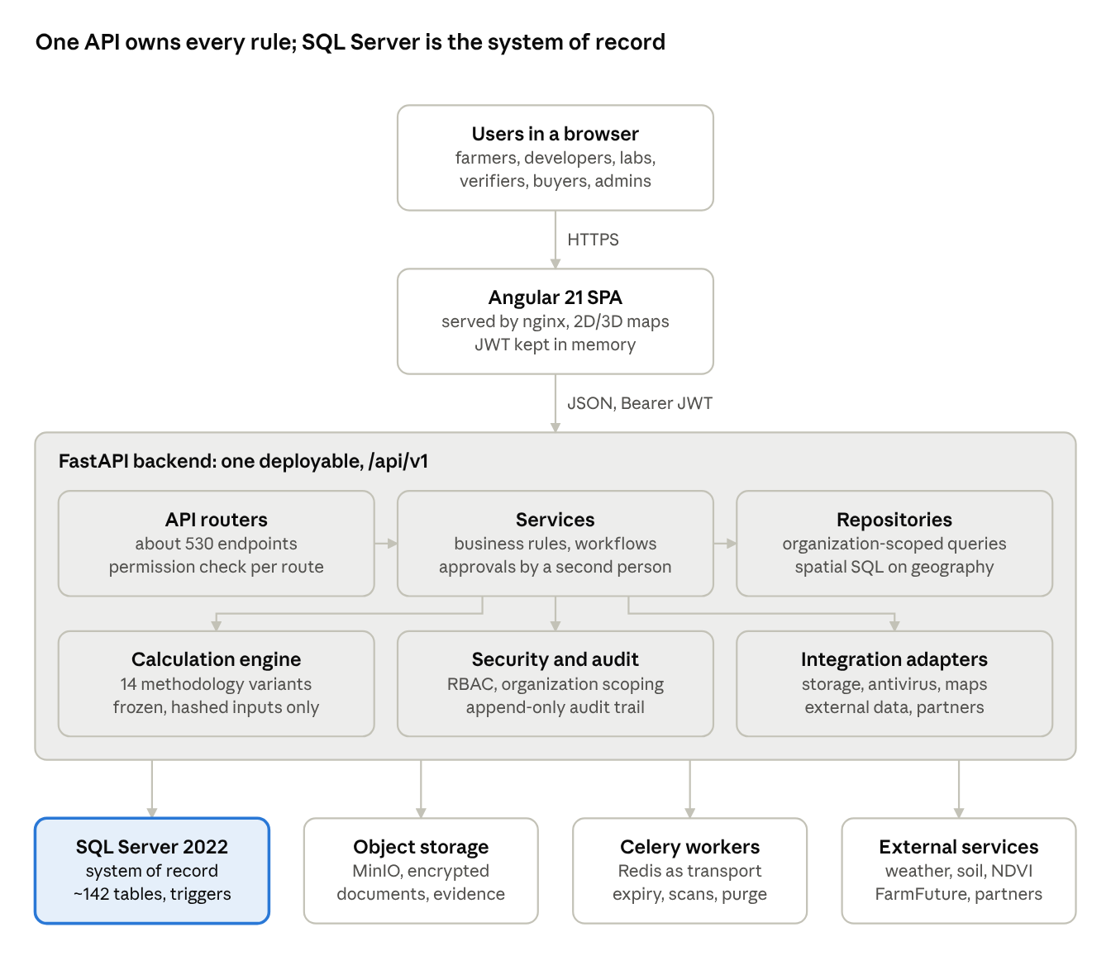
system architecture · browser, API, data stores, external services
Each domain module owns its router, service, repository and models, and no module reads another's tables except through its service. Celery workers run the same code for scheduled jobs, with Redis only as transport. Registry, payment, payout and laboratory partners are reached through adapters that are manual until contracts exist.

Technology stack
The platform is a Python/FastAPI backend on Microsoft SQL Server with an Angular single-page frontend, packaged as one deployable (a modular monolith).
Layer | Technology | Notes
Frontend | Angular 21, TypeScript 5.9 (strict), Angular Material | Standalone components, signals, zoneless, OnPush
Maps | Leaflet 1.9 (2D), MapLibre GL 6 (3D) | Browser only draws; SQL Server validates and measures
Backend API | FastAPI 0.115, Pydantic v2, Uvicorn | Versioned REST API under /api/v1, Swagger at /docs (off in production)
Data access | SQLAlchemy 2.0, Alembic 1.15, pyodbc | 23 Alembic migrations; schema changes only through Alembic
Database | Microsoft SQL Server 2022 | geography (SRID 4326) for GIS, READ_COMMITTED_SNAPSHOT on, append-only audit triggers
Background jobs | Celery 5.6 with Redis 7 as broker | Redis is transport only; SQL Server records every job and attempt
Object storage | MinIO / S3 (own SigV4 client) or local disk in development | Private, versioned bucket, SSE-S3 encryption, SHA-256 verified
Auth and security | JWT (PyJWT), bcrypt, Fernet encryption (cryptography) | Rotating refresh token in httpOnly cookie; bank details encrypted at rest
Testing | pytest, Vitest, Playwright-based E2E smoke | ruff and mypy for lint and type checks
Packaging | Docker Compose | SQL Server, Redis, MinIO, backend, worker, beat, frontend

Repository structure
The code lives in two Git repositories checked out side by side: carbon_platform_new (backend, database, Docker, docs, ops) and carbon_project_frontend (the Angular app, split out on 2026-10-09). In this workspace the frontend sits under carbon_frontend/carbon_project_frontend.
Folder | Contents
backend/app | FastAPI application (about 230 files): api, services, models, schemas, repositories, rules, calculation, integrations, security, audit, workers, reports, seed, core
backend/alembic | 23 database migrations, one or more per phase (0001 identity to 0023 stratum inputs)
backend/tests | 57 pytest suites plus TEST-only fixtures (calculation, payment, payout, registry, S3 stub, antivirus)
backend/manage.py | Admin CLI: create-db, migrate, seed-reference, bootstrap-admin, seed-demo, backup, restore-drill, rotate-data-key, storage-migrate
carbon_project_frontend/src/app | Angular feature folders: auth, dashboard, admin, farmer, farms, projects, methodologies, mrv, lab, calculation, verification, registry, ledger, marketplace, finance, plus core, shared, layout
methodology-docs | Source material per methodology (VM0042, VM0044, VM0047, VM0051, GS-SOC, GS-AR, CCTS, IPCC, Verra common) and extracted text
docs | 50+ design, workflow, runbook and test documents (architecture, API, schema, roles, security, deployment, phase decision logs)
docker, docker-compose.yml | Backend Dockerfile, MinIO init script, full local stack
ops | SQL Server Agent backup jobs, MinIO backup and replication script
database | Placeholders for seed, reference data and scripts (reference data is seeded from code)
storage | Local development document storage (git-ignored)

Functional modules
The application is split into 15 business modules, one per lifecycle stage, each with its own API router, service, data model and screens. Each module was delivered and tested as a build phase.
# | Module | What it does | Main roles
1 | Identity and administration | Login, JWT sessions, MFA-ready accounts, users, organizations, roles and permissions, audit log, security centre | Platform Admin, Security Admin, Support
2 | Farmers | Farmer registration, KYC with hashed ID and duplicate check, versioned consents and agreements, encrypted bank accounts, farmer self-service | Project Manager, Field Agent, Farmer
3 | Farms and GIS | Farm boundaries (draw, GeoJSON, KML, FarmFuture import), versioned land, crop and practice history, overlap detection, GIS review, evidence documents, external data (weather, soil, NDVI) | Field Agent, GIS Specialist, Platform GIS Specialist
4 | Projects | Project lifecycle (20 states), farm participation, carbon rights, crediting periods, derived project boundary (union of farm boundaries) | Project Manager
5 | Standards and methodologies | Catalogue of standards and activities; versioned, approval-controlled methodology rules; a deterministic applicability engine recommends a methodology, a specialist confirms and locks it | Methodology Specialist
6 | MRV and sampling | MRV plan, monitoring periods, stratification, sampling design with seeded random points, mobile field-work screens, field records with GPS and photos, datasets | MRV Manager, Field Supervisor, Field Agent, GIS Specialist
7 | Laboratory | Lab engagements, sample registration and sealing, chain of custody, shipments, receipt, analysis results, independent lab QA, retests | Lab Technician, Lab Manager
8 | Calculation | Freezes a hashed input snapshot, runs the methodology module, QA checks, approval; 14 methodology modules registered | Calculation Analyst, QA Officer
9 | Internal pre-verification | Findings on calculation runs, calculation report PDF, internal readiness for verification | QA Officer, MRV Manager
10 | VVB / ACVA verification | Assign a verification body with conflict-of-interest declaration, submit a package, findings and corrective actions, recorded verification decision | Project Manager, VVB Reviewer
11 | Registry and issuance | Registry accounts, project registration, frozen submission snapshots, registry-stated issuance (batches, vintages, serials) confirmed by a second person | Registry Manager
12 | Credit ledger | Double-entry ledger of issued credits: opening, reservation, internal and registry transfers, retirement with certificate; protected against double spending | Credit Manager, Buyer
13 | Marketplace | Buyer KYC, fixed-price listings approved by a second person, orders that reserve credits, manual payments with evidence, refunds | Buyer, Marketplace Compliance Officer, Finance Manager
14 | Revenue and payouts | Revenue recognised per delivered order, revenue-share versions, farm allocations, frozen settlement runs, farmer entitlements, payouts with bank evidence and reconciliation | Finance Manager, Farmer
15 | Background jobs and operations | Celery workers for expiry sweeps, document rescans, orphan-file clean-up, retention purge; health, metrics, backup and restore drills | Platform Admin
Methodologies with a calculation module. Seven code modules implement 14 registered methodology variants. All are marked NOT_PRODUCTION_READY until a methodology expert approves them against the official text.
Standard | Methodology | Scope
Verra | VM0042 v2.2 Improved Agricultural Land Management | SOC measure-and-remeasure with control sites, IPCC emission factors, uncertainty, buffer, VCUs
Verra | VM0044 v1.2 Biochar | Persistent carbon, production and application emissions, transport leakage
Verra | VM0047 v1.1 ARR (census) | Woody carbon by planting-unit census, burning and fertiliser emissions, buffer
Verra | VM0051 v1.1 Rice (QA3) | Rice methane by IPCC emission factors, N2O, uncertainty
Gold Standard | GS 402 v1.0 Soil Organic Carbon (5 variants) | Zero tillage, improved tillage, cover crops; measurement or IPCC factor approaches
Gold Standard | GS 403 v2.1 A/R | Removals per modelling unit, 20 % compliance buffer, Paris Agreement alignment
India CCTS | BM FR05.002, FR05.001, AG04.002 | Afforestation/reforestation, mangroves, rice methane

Calculation pipeline
A calculation runs only on approved, frozen data: the same inputs always give the same SHA-256 hash and the same result, and a different person must approve it. An approved run is a calculated tonnage, not a credit.
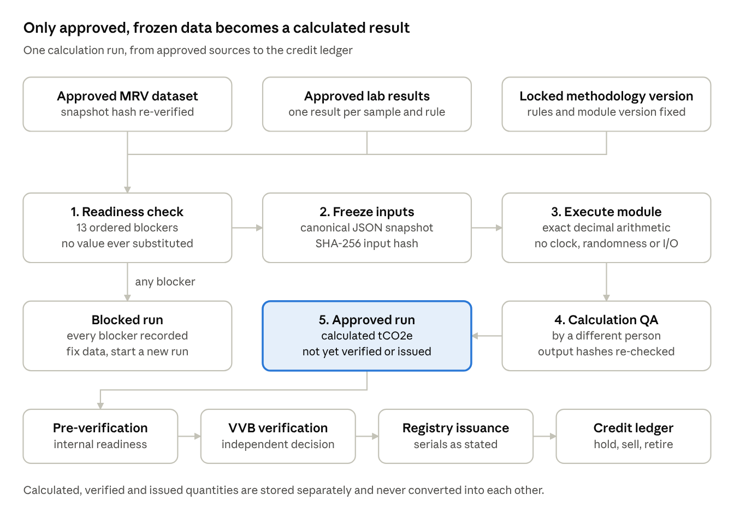
calculation pipeline · 3 sources, 5 steps, 4 downstream stages
Run states move DRAFT → INPUTS_FROZEN → CALCULATED → QA_REVIEW → APPROVED; a failed readiness check makes the run BLOCKED with every reason recorded. Nothing is ever estimated or filled in: a missing lab result, an unapproved dataset or a unit mismatch blocks the run. Before execution the sources are re-checked, and any change since the freeze stops the run as INPUTS_OUT_OF_DATE.
Example: VM0042 v2.2. Soil organic carbon is measured at project farms and linked control sites in a baseline and a monitoring round, compared on an equivalent soil mass basis, then reduced by sampling uncertainty. Emissions from fuel, liming, fertiliser and burning use IPCC 2019 default factors. The net result less the buffer gives the VCUs.

Data model
The SQL Server schema holds about 142 tables in 19 domain areas, created by 23 Alembic migrations. The backbone is one chain: organization → farmer → farm → project → monitoring period → dataset → calculation run → verification → issuance → ledger → order → revenue → payout.
Domain | Tables | Key entities
Identity and access | 9 | organizations, users, roles, permissions, user_roles, sessions, refresh_tokens
Audit | 5 | audit_logs, workflow_events, security_events, login_audit, api_access_logs (all append-only)
Documents | 3 | documents, document_versions, document_scans (shared by every module)
Farmers | 7 | farmers, consents, agreements, encrypted bank accounts
Farms | 10 | farms, farm_boundaries (versioned geography), ownership, land / crop / practice history, overlap checks, external observations
Projects | 11 | projects, project_farms, carbon rights, crediting periods, project_boundaries, status history
Catalogue | 3 | standards, activities, standard_activities
Methodologies | 13 | methodologies, versions, applicability / monitoring / calculation rules, evaluations, project_methodologies (the lock)
MRV and sampling | 17 | mrv_plans, monitoring_periods, project_strata, sampling_designs, sampling_points, field_collection_records, mrv_datasets
Laboratory | 9 | engagements, lab_samples, custody events, shipments, lab_tests, lab_results, QA reviews
Calculation | 4 | calculation_runs, calculation_inputs (frozen snapshot), calculation_outputs, QA reviews
Pre-verification | 4 | findings, calculation reports, readiness
Verification | 7 | verification_assignments, submissions, findings, corrective actions, verification_decisions
Registry | 7 | registry_accounts, registrations, submissions, credit_issuances, credit_batches, serial ranges
Credit ledger | 7 | ledger entries, credit_positions, reservations, transfers, retirements, reversals
Marketplace | 9 | buyer_profiles, KYC reviews, listings, orders, order_items, payments, refunds
Finance | 13 | revenue_records, revenue-share and farm-allocation versions, settlement_runs, farmer_entitlements, payouts, reconciliations
Background jobs | 3 | jobs, append-only attempts, worker heartbeats
Notifications | 1 | in-app notifications
Schema conventions
- UUID primary keys, UTC datetime2 timestamps, and an environment column (LIVE / DEMO) that keeps demo data apart.
- Every status column has a CHECK constraint; JSON columns are validated with ISJSON.
- History is never overwritten: boundaries, land history and methodology versions get a new version, with a filtered unique index guaranteeing one current row.
- Audit, custody, QA, approved results, scan history and job attempts are append-only, enforced by database triggers.
- GIS columns use the SQL Server geography type (SRID 4326); area, validity and overlaps are computed by SQL Server.
Full column-level detail is in docs/database-schema.md.

API reference
The backend exposes about 530 REST endpoints under /api/v1, grouped into 30 routers. All are JSON over HTTPS with a Bearer JWT; interactive documentation is at /docs (Swagger) outside production. Full detail is in docs/api.md.
Area | Base path | Endpoints | Purpose
Authentication | /auth | 6 | Login, refresh, logout, change password, current user
Administration | /admin, /admin/users, /admin/organizations | 29 | Users, organizations, roles, permissions, audit log, security events, sessions
Farmers | /farmers | 24 | Farmer records, KYC, consents, agreements, bank accounts, self-service /farmers/me
Farms | /farms | 37 | Boundaries, history, ownership, evidence, overlaps, external data, FarmFuture import
Projects and catalogue | /projects | 45 | Projects, farms, participants, periods, standards and activities
Methodologies | /methodologies, /projects | 27 | Methodology versions and rules, evaluation, recommendation, lock
MRV and sampling | /mrv | 58 | Plans, periods, strata, sampling designs and points, field records, datasets, QA
Laboratory | /lab (project side), /laboratory (lab side) | 49 | Engagements, samples, custody, shipments, tests, results, QA
Calculation | /calculations | 43 | Readiness, runs, outputs, QA, findings, reports, internal readiness
Verification | /verification (project side), /vvb (verifier side) | 35 | Assignments, submissions, findings, corrective actions, decisions
Registry and credits | /registry, /credits | 64 | Registry accounts, submissions, issuances, ledger openings, reservations, transfers, retirements
Marketplace | /marketplace, /orders, /payments, /refunds | 40 | Buyer KYC, listings, orders, payments, refunds
Finance | /revenue, /revenue-share, /allocations, /costs, /settlements, /payouts | 49 | Revenue, sharing, settlements, entitlements, payouts
Platform | /documents, /evidence/documents, /notifications, /jobs, /config, /health | 24 | Documents and quarantine, notifications, background jobs, client config, health checks
FarmFuture integration (added October 2026). Imports candidate farm boundaries from a farmer's FarmFuture account, looked up by mobile number.
Endpoint | What it does
POST /farms/{farm_id}/farmfuture/estates | Validates the mobile number with FarmFuture (defaults to the farmer's phone on file) and lists that user's estates and farms
POST /farms/{farm_id}/farmfuture/farms/{farmfuture_farm_id}/areas | Fetches the mapped zones of one FarmFuture farm as polygons, merged by SQL Server
Nothing is saved by these calls. The chosen area goes through the normal boundary flow: SQL Server validation, a new boundary version with source IMPORT, overlap checks and GIS review. Lookups are audited with the mobile number masked.
Conventions. Server-side pagination with whitelisted sorting, a standard error envelope with a request ID, UTC ISO-8601 timestamps, and 404 (not 403) for records outside the caller's organization so their existence does not leak. GET /metrics (token-protected) sits outside the API prefix.

Frontend
The Angular app has about 40 screens behind one shell whose side navigation shows only what the signed-in user's permissions allow. A farmer, for example, sees only their own profile, farms, projects and payouts.
Navigation group | Screens | Typical user
Home | Dashboard, profile, change password | Everyone
Farmers and farms | Farmers list / create / detail (profile, KYC, consents, agreements, bank, farms, documents); Farms list / create / detail (map, boundary editor, FarmFuture import, ownership, history, evidence, overlaps, external data) | Project Manager, Field Agent, GIS Specialist
Projects | Projects list / create / detail (farms, team, standard, activity, methodology tabs) | Project Manager
Methodologies | Methodology catalogue, version detail with rules and Calculation tab; Standards and activities | Methodology Specialist
MRV | MRV workspace per project: plan, periods, strata, sampling design, datasets, samples and laboratory, verification and registry tabs | MRV Manager
Field work | Mobile-sized screens for assigned collections: navigate to point, GPS, photos, field record | Field Agent
Laboratory | Laboratory workspace, test page, QA page, sample detail, result lineage | Lab Technician, Lab Manager
Calculations | Calculation readiness, runs, run detail with outputs, findings and reports | Calculation Analyst, QA Officer
VVB workspace | Assigned verifications, submission package, findings, decision | VVB Reviewer
Registry and credits | Registry, issued credits, credit ledger, My credits (buyer holdings) | Registry Manager, Credit Manager, Buyer
Marketplace | Marketplace, listings, orders, payments, buyer profile, KYC review | Buyer, Compliance Officer, Finance
Finance | Revenue and costs, revenue sharing, settlements, payouts, My payouts | Finance Manager, Farmer
Administration | Users, organizations, roles and permissions, consent types, audit log, background jobs, security centre, document quarantine | Platform Admin, Security Admin
How it is built. Each feature folder has its own API service and models; a central ApiService with interceptors handles silent token refresh and errors. Maps use Leaflet in 2D and MapLibre in 3D, with a fallback to 2D when WebGL is unavailable. Business rules stay on the server; the client mirrors only state machines and password rules for instant feedback. A DEMO banner marks demo data.

Configuration, setup and deployment
The platform runs today natively on Windows for development; the Docker Compose stack is written but has not yet been run, and production needs a secret store, Redis, MinIO and an antivirus vendor before go-live.
Local development (verified)
- Install Python 3.10+, Node 22+, SQL Server 2019+ and ODBC Driver 17 or 18.
- Copy .env.example to backend/.env and set the secrets, including DATA_ENCRYPTION_KEY.
- In backend: create a virtual environment and pip install -r requirements/dev.txt.
- python manage.py setup creates the database, runs migrations and loads reference data (roles, permissions).
- python manage.py bootstrap-admin creates the first Platform Admin; seed-demo optionally adds DEMO data.
- Start the API: uvicorn app.main:app --port 8000 (API at /api/v1, Swagger at /docs).
- In the frontend repository: npm ci then npx ng serve (http://localhost:4200, proxies /api to port 8000).
Docker Compose stack. Eight services: sqlserver (SQL Server 2022), redis (Redis 7), minio and minio-init (object storage with encryption and buckets), backend (API), worker and beat (Celery), and frontend (nginx serving the Angular build). Infrastructure ports bind to 127.0.0.1 only and secrets reach containers only at run time.
Key configuration groups (all in .env.example)
Group | Settings
Database | DATABASE_URL or SQL_SERVER_* parts, TLS and trusted-connection options
Secrets | SECRET_KEY, JWT_SECRET with key rotation (JWT_KEY_ID), DATA_ENCRYPTION_KEY
Storage and antivirus | STORAGE_BACKEND (local / s3), OBJECT_STORAGE_*, MALWARE_SCANNER
Maps | MAP_TILE_*, MAP_TERRAIN_URL, MAP_SATELLITE_URL (public sources are development only)
Rate limiting and proxies | RATE_LIMIT_BACKEND (memory / redis), TRUSTED_PROXIES
Background jobs | REDIS_URL, JOB_*
External data | WEATHER_PROVIDER, SOIL_PROVIDER, SATELLITE_PROVIDER (planetary-computer / copernicus), FARMFUTURE_*
Providers | PAYMENT_PROVIDER and others are manual; production refuses mock or test provider names
Observability | JSON logs, GET /metrics bearer token, notification (SMTP deferred)
Production checklist (from docs/deployment.md)
- APP_ENV=production, HTTPS only, secure refresh cookie, secrets mounted from a secret store (no .env).
- Least-privilege SQL login at runtime; migrations run as a separate deploy step before the new code rolls out.
- Redis with password and TLS for rate limiting and Celery; exactly one celery beat.
- STORAGE_BACKEND=s3 (MinIO) and a real antivirus scanner; start-up refuses production without them.
- Licensed map tiles; encrypted, off-host SQL Server backups with restore drills (manage.py restore-drill, verify-restore).
- Health endpoints /health/live and /health/ready for the load balancer.

Testing and quality
The code base carries about 530 backend tests and 165 frontend tests, plus an end-to-end smoke test; every phase had to pass all of them before it was closed. The last recorded full run in docs/implementation-status.md is from the Phase 10 exit gate (326 pytest, 118 Vitest passing); the suites have grown since and were not re-run for this document.
Layer | Tool | Scope
Backend | pytest, 57 suites, about 530 test functions | Run against a real SQL Server test database: API, services, security, multi-tenancy, privilege escalation, append-only triggers, concurrency (ledger, marketplace, finance, jobs, storage), each methodology module against reference values, performance harness
Frontend | Vitest, 24 spec files, 165 tests | Components, API services, guards, state mirrors
End to end | e2e/smoke.cjs (headless Chrome via Playwright) | Signs in as each role on DEMO data and walks every module's main page
Static checks | ruff, mypy, alembic check | Lint, types, and no drift between models and migrations
How to run
cd backend
.venv/Scripts/python -m pytest
.venv/Scripts/ruff check .
.venv/Scripts/mypy app manage.py
.venv/Scripts/alembic check
cd ../../carbon_project_frontend
npx ng test --watch=false
npx ng build
npm run e2e:smoke
Manual end-to-end guides. docs/e2e-test-guide.md takes one project from an empty catalogue to a farmer payout through the UI, step by step for every role (GS402 path, about 170 test credits). docs/e2e-test-walkthrough-vm0042.md and the new docs/e2e-test-palthope-vm0042.md cover the VM0042 path with soil sampling and the laboratory.
TEST-only doubles. Payment, payout, registry, antivirus and S3 are tested with injected fixtures that are never registered in the running application, so a mock can never be mistaken for a real confirmation.

Security, known gaps and next steps
Security controls are built and tested in the application; what blocks go-live is infrastructure that has not been provisioned and external contracts that have not been signed.
Security controls in place
Area | Control
Passwords and sign-in | bcrypt (cost 12), minimum 12 characters, lockout after 5 failures for 15 minutes, login rate limits per IP and per email
Sessions | 15-minute JWT access token held in memory; refresh token stored only as a SHA-256 hash, rotated on every use, reuse revokes the session
Authorization | Permission check on every route, organization scoping in every query, escalation guards, last-admin protection; out-of-scope records return 404
Separation of duties | A second, different person approves KYC, bank accounts, farm boundaries, methodology versions, MRV approvals, lab QA, calculations, issuance, ledger moves, payments and payouts
Personal data | KYC IDs stored only as a keyed fingerprint plus last 4 digits; bank numbers Fernet-encrypted; restricted documents; key rotation supported
Integrity | Append-only audit, custody, QA and ledger tables enforced by database triggers; calculation inputs, outputs, reports and snapshots hashed with SHA-256 and re-verified
Money and credits | Row-locked ledger transactions prevent double spending; conservation checks; no amount is ever accepted from the client
Files | Type detected from content, size limits, antivirus hook with quarantine, KML/XML entity attacks rejected
External parties | Laboratories and VVBs get separate allow-list APIs that hide farmer identity, KYC, bank and location data
Platform | Secure headers and CSP, explicit CORS, body-size limit, Swagger off in production, structured logs with secret redaction
Known gaps
Gap | Impact | Status
No methodology module approved for production | All 14 modules are NOT_PRODUCTION_READY, so no real calculation can run in production | Needs a methodology expert's review and second-person approval
Production infrastructure not provisioned | India-based hosting, SQL Server with backups, MinIO, Redis, secret store, monitoring, reverse proxy, licensed map tiles | Pending (production-readiness checklist section B)
No antivirus vendor selected | Production refuses to start without one | Decision pending
No registry, payment, payout or LIMS contract | Issuance, payments, payouts and lab results are recorded manually with evidence | Adapters ready; awaiting contracts
Docker Compose never run | Container stack unverified | Docker not installed on the development machine
No offline field capture | Field agents need a connection | Not built
Notifications are in-app only | No email, SMS or WhatsApp | SMTP chosen, delivery deferred
MFA not enabled | Columns ready, no enrolment flow | Planned
Some status docs out of date | README.md and docs/implementation-status.md still say no calculation module exists | Needs a documentation refresh
Recommended next steps
- Have a methodology expert review VM0042 v2.2 (the lead methodology) against the official text and record the production-readiness approval.
- Provision the production environment and complete the six go-live gates in docs/production-readiness.md (ready health on every node, a timed restore drill within the 1-hour RTO, a week of log backups under 15 minutes, every alert tested, antivirus detecting the EICAR file).
- Select the antivirus vendor and secret store, then run the Docker Compose stack end to end.
- Complete the Palthope Estate VM0042 end-to-end test (docs/e2e-test-palthope-vm0042.md) on the new database with real soil reports.
- Refresh README.md and docs/implementation-status.md to reflect the calculation modules, FarmFuture import and external data features added in October 2026.

