Carbon Platform — Product Documentation
Oct 16, 2026 · @Vayublue

What Carbon Platform is
Carbon Platform helps farmers earn income from the carbon their land stores. It manages the whole process in one place: signing up farmers and mapping their farms, measuring soil and crops, calculating the carbon removed, getting it independently verified and issued as carbon credits, selling those credits to buyers, and paying farmers their share.
Every step is recorded, so anyone reviewing a credit can trace it back to the farm, the soil samples and the people who approved each stage.
What makes it different
- One connected system. Farm data, field work, lab results, calculations, verification, credit sales and farmer payments live together instead of in separate spreadsheets.
- Built for smallholder agriculture. Many small farms are grouped into one project, each with its own boundary, history and share of the revenue.
- Trustworthy by design. Important decisions need a second person to approve them, and records cannot be quietly changed afterwards.
- Fair to farmers. Revenue from every credit sold is traced to the farms that produced it and paid out according to an agreed sharing plan.
- Works with many carbon standards. It supports leading Verra, Gold Standard and Indian (CCTS) methodologies for soil carbon, rice, biochar and tree planting.
Carbon Platform coordinates the outside parties a carbon project needs (soil laboratories, independent verifiers, carbon registries and banks). It does not replace them: it gives each of them a clear, controlled way to take part.

Who it is for
Seven groups work together on the platform, and each person sees only what their role needs. A farmer sees their own farms and payments; a laboratory sees only the samples sent to it; a buyer sees only the credits on offer and their own purchases.
Who | What they do on the platform
Farmers and farmer groups | Keep their profile and farm details up to date, see the projects they are part of, and follow their payouts
Project developers | Run carbon projects: enrol farmers and farms, choose the carbon standard, plan and carry out field monitoring, manage verification, credits and revenue sharing
Field teams | Visit farms, collect soil samples and field data on a phone, and record GPS points and photos
Soil laboratories | Receive samples, record analysis results and pass them through their own quality check
Independent verifiers | Review the project's evidence and calculations, raise findings and record their verification decision
Credit buyers | Complete a buyer check, browse and buy credits, hold them and retire them against their climate goals
Platform team | Set up methodologies, manage users and organizations, review buyers, and keep the platform secure
Inside a project developer, work is split across clear roles such as project manager, field supervisor, GIS specialist, monitoring manager, carbon analyst, quality officer, registry manager, credit manager and finance manager. In total the platform has 21 roles.

The journey
A carbon project moves through twelve steps in three phases: set up the farmers and farms, measure the carbon, then turn verified carbon into income for the farmers.
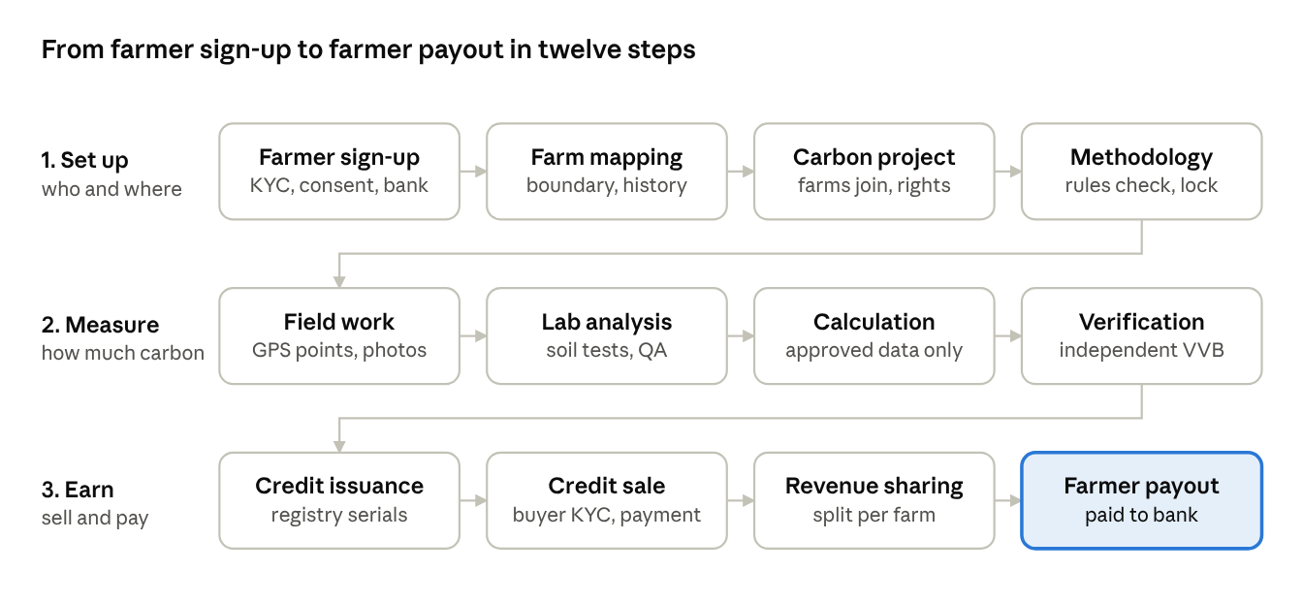
the carbon project journey · 3 phases, 12 steps
Each step must be completed and approved before the next one opens, so nothing reaches a buyer without its full trail of evidence. Monitoring repeats every period, so a project earns credits again each time new carbon gains are measured and verified.

Features
The product covers the full life of a carbon project in eleven areas, from the first farmer sign-up to the last payout.

1. Farmer onboarding
- Register farmers with contact details, identity check (KYC) and duplicate detection.
- Record consents and farmer agreements, with every version kept.
- Store bank details securely for payouts; a second person verifies them.
- Farmers get their own view of their profile, farms, projects and payments.

2. Farms and land
- Map each farm boundary by drawing on a map, uploading a file, or importing it from the farmer's FarmFuture account.
- See farms on 2D and 3D maps with satellite imagery.
- Area is measured automatically, and overlapping farms are flagged for review.
- Keep the farm's history of land use, crops and practices, plus ownership and evidence documents.
- Pull in reference data for a farm: weather history, soil properties and satellite crop health (NDVI).

3. Carbon projects
- Create a project and add verified farms to it, with carbon rights recorded for each farm.
- The project boundary is built automatically from its farms.
- Track the project through its stages with checklists at each step.

4. Choosing the methodology
- Pick the carbon standard and activity (for example, improved soil management or rice cultivation).
- The platform checks the project against each methodology's rules and recommends the ones that fit.
- A methodology specialist confirms the choice, and it is locked for the project.

5. Monitoring and field work
- Plan monitoring: periods, land groups (strata) and how many sampling points each needs.
- Sampling points are placed on the map automatically and assigned to field staff.
- Field staff use phone-friendly screens to find each point, record data, take photos and capture GPS.
- Supervisors review submissions before the data is approved.

6. Soil sampling and laboratory
- Engage a soil laboratory for the project.
- Track every sample from field to lab: sealing, shipping, receipt and analysis (chain of custody).
- The lab records results and a second lab reviewer approves them; retests are supported.

7. Carbon calculation
- Calculate the carbon removed or avoided using the project's methodology.
- The calculation uses only approved field data and approved lab results, and a quality officer approves it.
- A calculation report is produced for the verifier.

8. Independent verification
- Assign an independent verifier (VVB or ACVA) to a monitoring period, with a conflict-of-interest declaration.
- The verifier sees a secure package of the evidence, raises findings, and the project responds with corrective actions.
- The verifier's final decision is recorded.

9. Registry and carbon credits
- Record the project's registration with the carbon registry and submit verified results for issuance.
- Record issued credits exactly as the registry states them: batches, vintages and serial numbers.
- A credit ledger tracks who holds every credit, with reservations, transfers and retirements, and it is protected against double counting and double selling.

10. Marketplace
- Buyers complete a buyer check (KYC) reviewed by the platform's compliance officer.
- Sellers list credits at a fixed price per credit; a second person approves each listing.
- Buyers place orders, pay with proof of payment, and receive their credits once payment is confirmed.
- Buyers can retire credits and receive the registry's retirement certificate.

11. Revenue sharing and farmer payouts
- Revenue from every delivered order is recorded automatically.
- An agreed sharing plan sets how revenue is split, and each farm's share is calculated per monitoring period.
- Payouts go through approval, bank payment with proof, and reconciliation, each done by different people.
- Farmers see their payouts in their own view.
Also included: in-app notifications, document management with virus scanning, a full audit log, user and role administration, and automatic housekeeping such as expiring unpaid orders.

Carbon methodologies supported
A methodology is the official rulebook a carbon standard publishes for measuring and crediting one kind of activity. The platform can calculate credits under the methodologies below, covering soil carbon, rice farming, biochar and tree planting.
Activity | Methodology | Standard | What is credited
Improved farming practices (soil carbon) | VM0042 v2.2 Improved Agricultural Land Management | Verra | Extra carbon stored in the soil, measured against nearby comparison sites, plus lower emissions from fuel, fertiliser, lime and burning
Soil carbon: zero tillage, improved tillage, cover crops | GS 402 Soil Organic Carbon Framework (5 options) | Gold Standard | Soil carbon gains, by soil sampling or by standard factors
Tree planting | GS 403 Afforestation / Reforestation | Gold Standard | Carbon stored in growing trees
Tree planting on farmland | VM0047 v1.1 Afforestation, Reforestation and Revegetation | Verra | Carbon in planted trees, counted tree by tree
Tree planting and mangroves | CCTS BM FR05.002 and FR05.001 | India Carbon Credit Trading Scheme | Carbon in trees and shrubs; soil carbon for mangroves
Rice farming | VM0051 v1.1 Improved Rice Management | Verra | Lower methane from changed water and straw management
Rice farming | CCTS BM AG04.002 | India Carbon Credit Trading Scheme | Lower methane from rice paddies
Biochar | VM0044 v1.2 Biochar Utilization | Verra | Carbon locked into soil or materials as biochar
Each methodology is built from the official published document. Before it is used for real credits, a methodology expert reviews it and a second person approves it for production. New methodologies can be added as projects need them.

How credits are calculated and verified
A farm earns credits for the extra carbon it stores, minus the emissions its farming causes, minus two safety deductions. Four separate approvals come before any credit is issued.
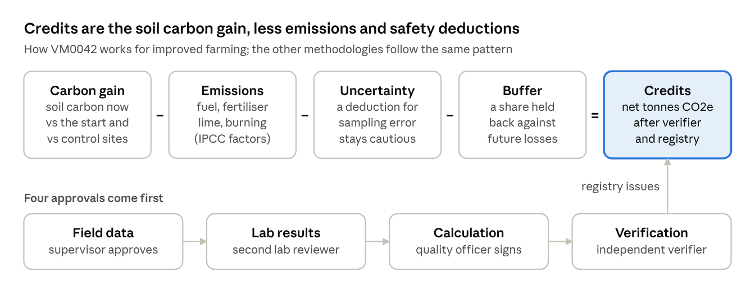
how credits are calculated · 5 parts, 4 approvals
For soil carbon, field teams sample the soil at the start of the project and again at each monitoring round, on project farms and on nearby comparison (control) sites. The gain beyond what the comparison sites show counts as the project's effect. The uncertainty deduction makes sure credits are never over-claimed, and the buffer is set aside in case stored carbon is later lost. The registry issues the final credits only after the independent verifier's positive decision.

Data sources and partners
The platform brings in outside data to support each farm's record and works with the partners a carbon project depends on. Outside data is kept as supporting evidence; credits are always calculated from measured, approved project data.
Source or partner | What it provides | How it is used
FarmFuture | Farm boundaries a farmer has already mapped in FarmFuture, found by their mobile number | Imported as a starting boundary, then checked and approved like any other boundary
Open-Meteo | Daily rainfall, temperatures and evapotranspiration history | Weather evidence on the farm's record
ISRIC SoilGrids | Soil carbon, pH, texture and density estimates for the farm's location | Soil reference evidence
Satellite imagery (Sentinel-2, Landsat via Microsoft Planetary Computer or Copernicus) | Crop health (NDVI), moisture, cloud cover and surface temperature over the farm | Satellite evidence of land use and practices
Soil laboratories | Analysis of soil samples | Approved results feed the carbon calculation
Independent verifiers (VVB / ACVA) | Review and verification decision | Required before credits can be issued
Carbon registries (Verra, Gold Standard, CCTS) | Project registration, credit issuance and retirement certificates | Recorded in the platform with the registry's references and documents
Banks | Buyer payments and farmer payouts | Recorded with payment proof and reconciled
Today, laboratories, registries and banks take part through recorded steps with supporting documents. Direct system connections can be added once agreements with those partners are in place.

Trust and transparency
Carbon credits are only worth something if people trust them, so the platform makes every number traceable and every important decision checked by a second person.
- Full traceability. Any credit can be traced back through registry issuance, verification, the calculation, lab results and field samples to the individual farm.
- Four-eyes approval. Identity checks, bank details, farm boundaries, methodology set-up, monitoring data, lab results, calculations, credit movements, payments and payouts each need a second, different person to approve.
- Records that cannot be rewritten. Approved data is never edited in place; a change creates a new version, and the history and audit log are kept permanently.
- No guessing. If a required measurement is missing, the calculation stops and says why. It never fills in an estimate.
- No double counting. A farm cannot be credited in two active projects, and each credit can only be sold or retired once.
- Clear separation of quantities. Calculated, verified and issued amounts are kept apart and never silently turned into one another.
- Privacy for farmers. Identity numbers and bank details are protected and masked; laboratories and verifiers see only what their task needs, without farmers' personal details.
- Secure access. Strong passwords, account lockout after failed sign-ins, and every user limited to their own organization's data.
- Demo kept apart. Demonstration data is clearly marked and can never mix with real project data.

Product status
All eleven feature areas are built and working, from farmer onboarding to farmer payouts. What remains before going live with real projects is approval of the methodologies, connections with outside partners, and the production hosting set-up.
Area | Status
Farmer onboarding, farms and maps | Ready
Projects and methodology selection | Ready
Monitoring, field work and laboratory tracking | Ready
Carbon calculation for 8 methodologies | Built; each awaits expert review before use on real credits
Verification, registry, credit ledger and marketplace | Ready, with partner steps recorded manually
Revenue sharing and farmer payouts | Ready, with bank payments recorded manually
FarmFuture boundary import and farm reference data | Ready
Coming next
- Expert review and approval of VM0042, the lead soil-carbon methodology, so it can be used for real credits.
- A full live trial on the Palthope Estate coffee project, using real soil reports from baseline and monitoring rounds.
- Production hosting in India, with backups, monitoring and virus scanning in place.
- Direct connections with registries, payment providers and laboratories as partner agreements are signed.
- Offline field data capture for areas with poor mobile coverage, and notifications by email and SMS.

