AI-POWERED AUTOMATED ANSWER SCRIPT EVALUATION USING OCR AND RUBRIC-BASED SEMANTIC ANALYSIS
Author Name¹, Co-author Name²
¹Department of [Department], [College/University], [City, Country]
²Department of [Department], [College/University], [City, Country]
Email: [author email] • [co-author email]
Abstract—Manual evaluation of descriptive answer scripts is time-consuming and may introduce variation in scoring across evaluators. This paper presents the design of an AI-powered automated answer script evaluation system that combines document preprocessing, optical character recognition (OCR), question-wise answer extraction, semantic comparison with a model answer, and rubric-based mark allocation. The proposed workflow accepts a question paper, model answers, marking rubric, and scanned student answer scripts. Extracted responses are mapped to questions and assessed against key concepts and rubric criteria, while low-confidence or ambiguous cases are routed to a professor for review. The system is intended to support—not replace—instructor judgement, with traceable feedback and role-based access for professors and students. A reproducible evaluation protocol is defined using OCR character error rate, question extraction rate, score agreement, processing time, and manual correction rate. Since measured experimental data were not supplied with the source materials, numerical performance claims are intentionally left for completion after testing.
Keywords— Automated assessment, optical character recognition, handwritten text recognition, semantic similarity, rubric-based grading, educational technology.

I. INTRODUCTION
Assessment of descriptive answers requires an evaluator to interpret meaning, identify relevant concepts, apply a marking scheme, and provide feedback. When large numbers of handwritten scripts must be assessed, the process can require substantial time. Differences in handwriting, scan quality, answer structure, and terminology further complicate automation. A useful evaluation system therefore needs more than text recognition: it must preserve question context and connect extracted answers to explicit scoring criteria.
This paper describes a modular system for AI-powered automated answer script evaluation. The professor uploads the question paper, model answer, rubric, and student scripts. The system validates and preprocesses documents, extracts text using OCR, groups responses by question, compares them with reference concepts, and proposes marks according to rubric criteria. A professor can inspect evidence, correct OCR errors, and approve final marks.
The contributions are: (1) an end-to-end workflow linking OCR and rubric-guided evaluation; (2) a confidence-aware review stage for uncertain handwriting or question mapping; (3) a testing protocol that separates OCR quality, extraction quality, grading agreement, and runtime; and (4) a reporting design for professor and student dashboards.

II. RELATED WORK
Automated assessment has traditionally used keyword matching, rule-based scoring, and feature-based text similarity. These approaches are transparent but may fail when students express the same concept using different wording. Modern language-processing methods can compare semantic content, although model-generated scores still require calibration against a rubric and expert judgement.
OCR systems convert scanned pages into machine-readable text. Printed-text OCR is generally easier than handwriting recognition because handwriting varies in slant, spacing, character shape, and line alignment. Document skew, low contrast, shadows, compression, and page curvature can reduce recognition quality. Consequently, preprocessing and confidence-based review are important parts of the pipeline.
The proposed system combines these components rather than treating OCR output as automatically correct. Its design keeps the original page available for verification and uses a rubric to make the basis of each proposed score explicit. A literature review should be expanded with verified publications relevant to the exact OCR engine and semantic model selected for implementation.

III. SYSTEM METHODOLOGY

A. System Architecture
The architecture contains an input layer, document-processing layer, OCR pipeline, answer-mapping component, AI evaluation engine, verification layer, and reporting dashboards. The input layer receives the question paper, model answer, rubric, and student scripts. Processing standardizes file formats and prepares page images. OCR produces text and, where available, confidence values and positional information. Answer mapping associates extracted responses with question numbers before the scoring engine evaluates them.
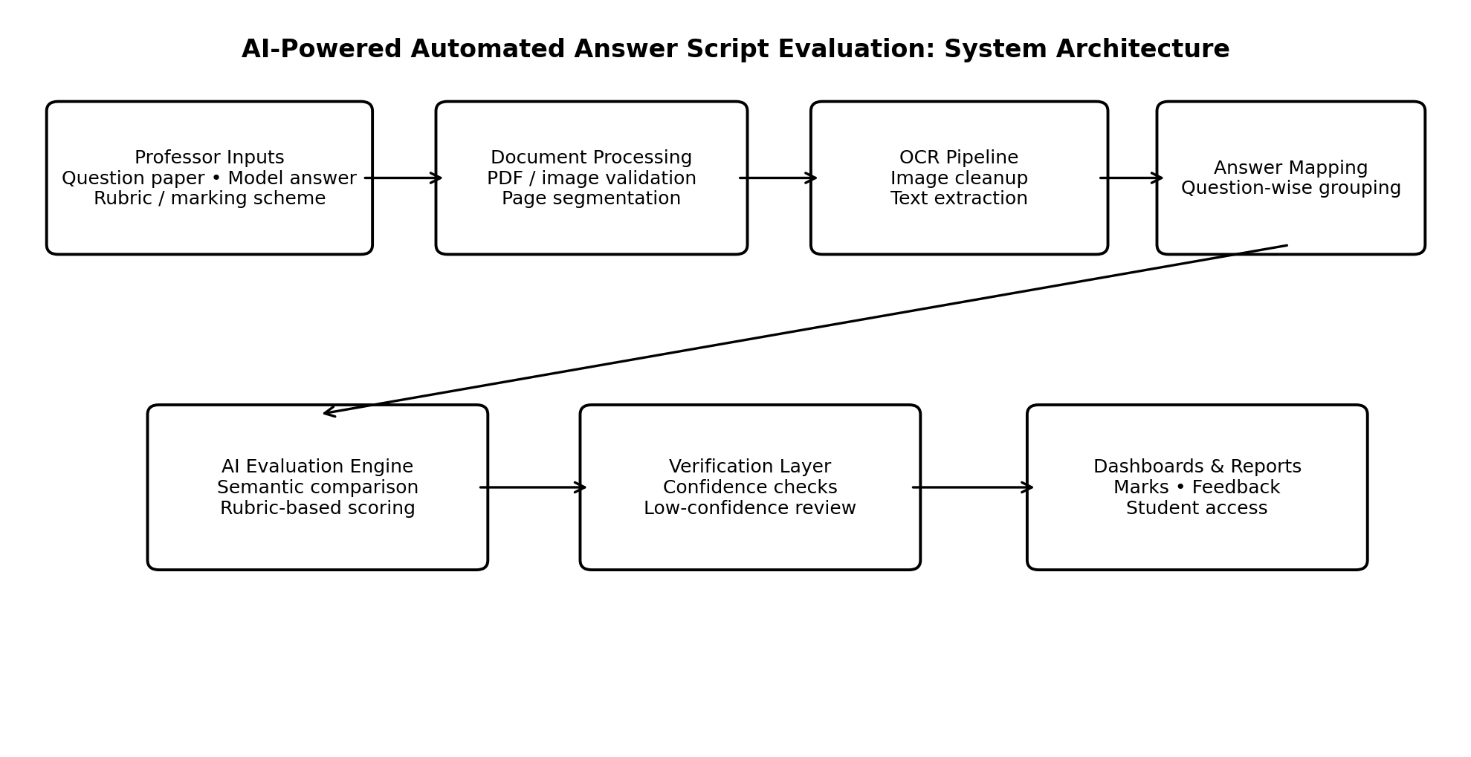
Fig. 1. Proposed architecture for automated answer script evaluation.

B. Document Preprocessing and OCR
Each uploaded file should be validated for type, size, page count, readability, and corruption. PDF pages are rendered at a consistent resolution. Image preprocessing may include grayscale conversion, denoising, contrast enhancement, deskewing, binarization, and page-boundary detection. These operations should be applied selectively because aggressive thresholding can erase faint pen strokes.
OCR output should retain page number, bounding box or line position where available, recognized text, and confidence. The system should not treat a blank OCR result as proof that the student left the answer blank. If text extraction is empty or confidence is low, the interface should ask for image review, preprocessing retry, or manual transcription.

C. Question-Wise Answer Extraction
Question boundaries can be inferred from explicit numbering, section headings, page layout, and sequence rules. The extraction module should support answers continuing across pages and should avoid assigning a sub-question to the wrong parent question. Each extracted response is stored with its question identifier and source-page reference. When the mapping confidence is below a configurable threshold, the response is flagged for review.

D. Rubric-Based Semantic Scoring
For each question, the rubric is represented as criteria with descriptions, maximum marks, and optional criterion weights. The model answer supplies reference concepts, but exact string overlap should not be the only scoring signal. The evaluator checks conceptual coverage, correctness, relevance, explanation quality, and any question-specific requirements. The system generates a proposed score and criterion-level rationale; it should not award marks solely because a response is long or uses similar wording.
A generic weighted score can be expressed as:
S = Σᵢ wᵢ sᵢ, subject to 0 ≤ sᵢ ≤ mᵢ
where sᵢ is the awarded score for criterion i, mᵢ is its maximum mark, and wᵢ is an optional normalized weight. If the rubric already specifies marks per criterion, the criterion scores can simply be summed, ensuring that the total does not exceed the question maximum. The final score is subject to professor review.

E. Confidence and Human Review
The system should separate OCR confidence from grading confidence. OCR confidence concerns whether the recognized text matches the page image; grading confidence concerns whether the extracted response clearly satisfies rubric criteria. Low-confidence cases, missing answers, conflicting question mappings, and scores near a decision boundary should be queued for human verification. The professor’s correction should be recorded for audit and later evaluation of system quality.
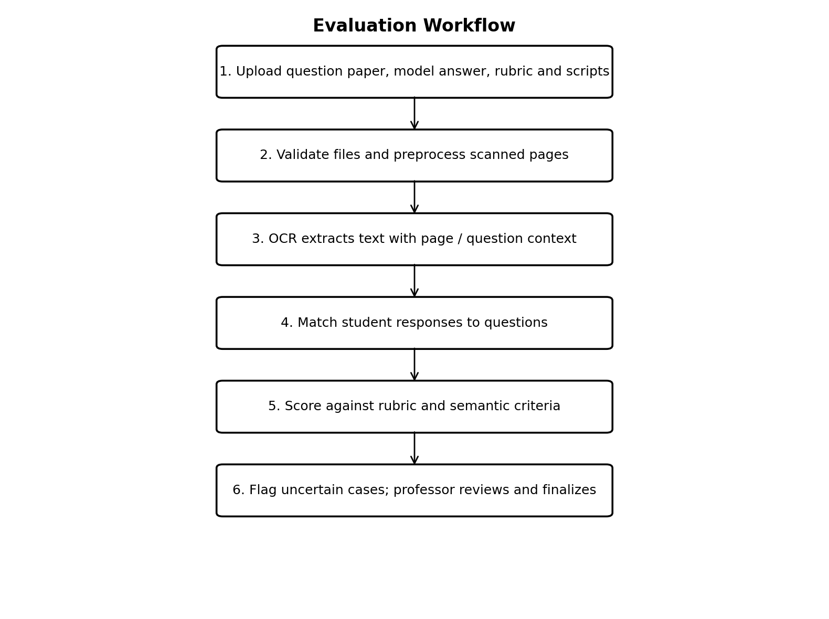
Fig. 2. End-to-end processing and review workflow.

IV. IMPLEMENTATION AND TESTING

A. Test Environment
The application can be implemented as a web-based system with a frontend dashboard, backend API, relational database, file storage, OCR service, and semantic scoring component. The final paper must state the actual operating system, processor, RAM, programming language and versions, OCR engine and model, AI model, database, and deployment configuration used in experiments. These values are left unspecified here because they were not present in the supplied template or sample paper.

B. Test Dataset and Procedure
Prepare a test set containing printed scripts, clear handwriting, difficult handwriting, skewed scans, low-contrast pages, multi-page answers, crossed-out text, and responses with alternative valid wording. Use an instructor-verified transcription as the OCR ground truth and independently marked scores as the grading reference. Split development and test scripts so that thresholds are not tuned on the same examples used for final reporting.
Run each script through the same pipeline and record processing time, extracted text, question mapping, proposed criterion scores, confidence flags, and human corrections. Repeat timing tests where possible and report mean and standard deviation. Do not report illustrative or estimated numbers as measured experimental results.

C. Evaluation Metrics
OCR quality can be measured using character error rate (CER), defined as (substitutions + deletions + insertions) divided by the number of characters in the reference transcription. Question extraction rate is the proportion of answers correctly assigned to their question identifiers. Grading agreement can be reported as mean absolute error (MAE) between system and instructor marks, exact-score agreement, and agreement within a predefined tolerance. Efficiency should include end-to-end time per script and the proportion requiring manual correction.

D. Testing Cases
Test case | Expected behavior | Status
Valid PDF upload | Accept file and register pages | To be measured
Blurred / low-contrast scan | Attempt preprocessing; flag uncertain text | To be measured
Handwritten answer | Extract text or route to review if confidence is low | To be measured
Answer spans pages | Preserve question grouping across pages | To be measured
Missing answer | Mark as absent only after visual/structure checks | To be measured
Rubric maximum marks | Prevent scores exceeding the question maximum | To be measured
Role-based access | Students see only authorized results and documents | To be measured
Large batch upload | Process safely with progress and error reporting | To be measured

V. RESULTS AND DISCUSSION
The supplied materials do not include a measured dataset or experimental logs for this answer-evaluation system. Therefore, no numerical accuracy, speedup, or grading-agreement claim is asserted in this draft. The following result table is a reporting structure to complete after the implementation is tested.
Metric | How to report | Measured value
OCR character error rate | Mean CER (%) on verified transcriptions | Enter result
Question extraction rate | Correctly mapped answers / total answers (%) | Enter result
Score agreement | MAE against instructor marks | Enter result
Exact-score agreement | Exact matches / total evaluated answers (%) | Enter result
Average processing time | Seconds per script; report mean ± SD | Enter result
Manual correction rate | Scripts requiring correction / total scripts (%) | Enter result
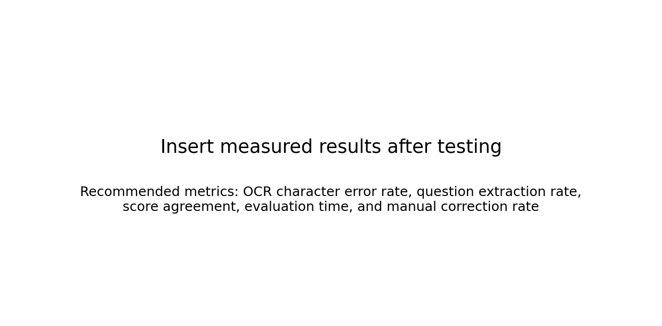
Fig. 3. Results placeholder: replace with charts generated from measured test data.
The evaluation should compare the complete system with a baseline such as OCR-only keyword matching and, where feasible, manual grading. Report the same scripts and scoring rubric across methods. Investigate errors by category—OCR failure, question-boundary failure, semantic misinterpretation, rubric ambiguity, and interface or storage failure—because each category requires a different remedy. A claim that the system is faster or more accurate should be made only if the observed results support it.

VI. LIMITATIONS AND ETHICAL CONSIDERATIONS
Handwriting recognition can fail on highly cursive writing, regional writing styles, faint ink, diagrams, mathematical notation, and mixed-language responses. Semantic models can overlook valid alternative reasoning or produce unsupported explanations. Rubrics may themselves be incomplete or ambiguous. The system should therefore provide traceable criterion-level feedback, preserve the original script, allow instructors to override marks, and log changes.
Student scripts and scores are sensitive educational records. Access control, secure transport, limited retention, audit logs, and institution-approved data handling should be implemented. Automated scores should be presented as recommendations until validated for the relevant subject and student population. Any deployment should assess bias and score consistency across handwriting styles, language proficiency, and accessibility needs.

VII. CONCLUSION AND FUTURE WORK
This paper presented a modular framework for AI-powered automated answer script evaluation using OCR, question-wise extraction, rubric-based semantic scoring, and human review. Its central design principle is that text extraction and scoring are separate stages, each requiring its own validation. A confidence-aware workflow can help prevent unreadable handwriting or uncertain question mapping from silently becoming incorrect marks. Future work includes evaluating handwriting-specific OCR models, optimizing batch processing, supporting mathematical and diagram-based answers, calibrating rubric scores against instructor judgements, and conducting a reproducible study with measured accuracy and runtime.

REFERENCES
[1] A. K. Jain, R. P. W. Duin, and J. Mao, “Statistical pattern recognition: A review,” IEEE Transactions on Pattern Analysis and Machine Intelligence, vol. 22, no. 1, pp. 4–37, 2000.
[2] R. Smith, “An overview of the Tesseract OCR engine,” in Proceedings of the Ninth International Conference on Document Analysis and Recognition (ICDAR), 2007, pp. 629–633.
[3] D. Jurafsky and J. H. Martin, Speech and Language Processing, 3rd ed. draft, 2024.
[4] A. K. Singh and A. K. Chaturvedi, “Automated essay scoring: A review of methods and applications,” use a verified bibliographic record before submission.
[5] Add the verified citation for the selected handwriting recognition model and version.
[6] Add the verified citation for the semantic language model and evaluation methodology used in the implementation.

