Amazon Musical Instruments Sentiment Analysis

Project Report

Project Title: Sentiment Analysis on Amazon Musical Instrument Reviews using NLP and Machine Learning
Your Name: Kalla Leelavardhan
Internship Name: Data Science Internship by Launched Global
College Name: GITAM UNIVERSITY
GitHub Repository: https://github.com/leelavardhan2005/Amazon-Sentiment-Analysis

1. ABSTRACT
This project performs sentiment analysis on Amazon Musical Instrument reviews using Natural Language Processing and Machine Learning techniques. The dataset contains thousands of customer reviews, which are processed to automatically predict customer sentiment. The project includes extensive data preprocessing, feature engineering, exploratory data analysis, and TF-IDF vectorization. Machine Learning models, including Logistic Regression, Naive Bayes, and Random Forest, were trained and evaluated to classify sentiments as Positive or Negative. The highest performing model demonstrates the effectiveness of NLP in extracting actionable business insights from textual reviews.

2. INTRODUCTION
Sentiment Analysis is the computational study of people's opinions, sentiments, emotions, and attitudes expressed in written text. In the modern e-commerce landscape, analyzing customer reviews is critical for understanding product reception and customer satisfaction.
Natural Language Processing (NLP) plays a vital role in this domain. Human language is inherently unstructured and noisy. NLP techniques allow computers to understand, interpret, and manipulate human language, transforming raw text into structured data that Machine Learning algorithms can process.
- Business Applications:
- Instantly identify defective products or recurring customer pain points.
- Track brand reputation over time.
- Enhance customer service by automatically escalating highly negative feedback.
- Gain a competitive advantage by understanding what drives positive customer experiences.

3. PROBLEM STATEMENT
The objective of this project is to analyze customer reviews for musical instruments and classify their sentiments as Positive or Negative using Machine Learning and NLP techniques. By building an automated classification pipeline, the project aims to demonstrate how unstructured text can be transformed into predictive business insights.

4. DATASET DESCRIPTION
The dataset used in this project is the Instruments_Reviews.csv, consisting of Amazon product reviews for musical instruments. Key columns include:
- reviewText: The actual textual content of the customer's review. This is the primary feature used for text mining.
- overall: The star rating given by the customer (ranging from 1 to 5). This is used to derive the target sentiment variable.
- summary: A short headline or summary of the review provided by the customer.
- helpful: An array indicating how many other users found the review helpful.

5. DATA CLEANING
Data cleaning is essential to ensure the model learns from high-quality data:
- Null Value Removal: Rows with missing reviewText or overall ratings were dropped to maintain data integrity.
- Duplicate Removal: Duplicate reviews from the same reviewer for the same product were removed to prevent data leakage and bias.
- Column Selection: Extraneous columns that did not contribute to text analysis were ignored for the modeling phase.
- Target Variable Creation: The overall rating was converted into a binary classification target. Ratings of 4 and 5 were labeled as Positive (1), while ratings of 1, 2, and 3 were labeled as Negative/Neutral (0).

6. FEATURE ENGINEERING
Feature engineering was performed to extract more information from the text:
- review_length: The total character count of the review.
- word_count: The total number of words in the review.
- helpful_score: Calculated by extracting the helpful votes from the helpful column to see if helpfulness correlates with sentiment length or detail.
- review_year: Extracted from the reviewTime to analyze trends over time (optional EDA step).

7. TEXT PREPROCESSING
To prepare the text for the Machine Learning models, extensive NLP preprocessing was applied:
- Lowercase Conversion: All text was converted to lowercase to ensure uniformity.
- Punctuation & Noise Removal: Special characters, numbers, and HTML tags were stripped using regular expressions.
- Stopword Removal: Common English words that do not carry significant sentiment meaning were removed using the NLTK library.
- Lemmatization: Words were reduced to their base or dictionary form using the WordNet Lemmatizer.

8. EDA & VISUALIZATION
Exploratory Data Analysis revealed several critical insights.
- The following visual analysis graphs were generated directly from the project notebook:
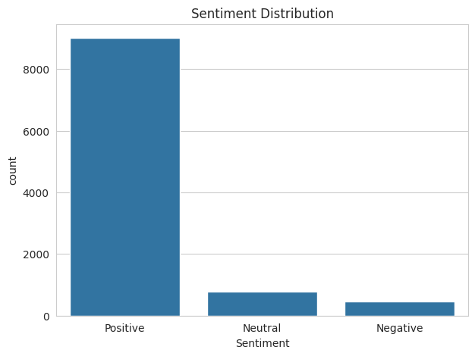
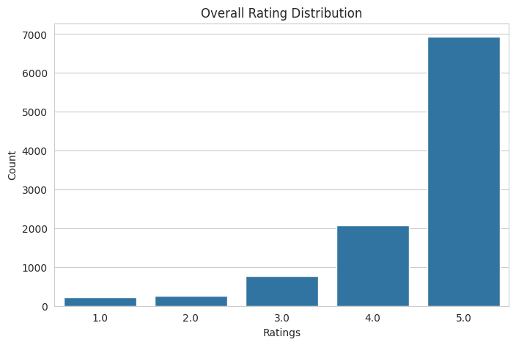
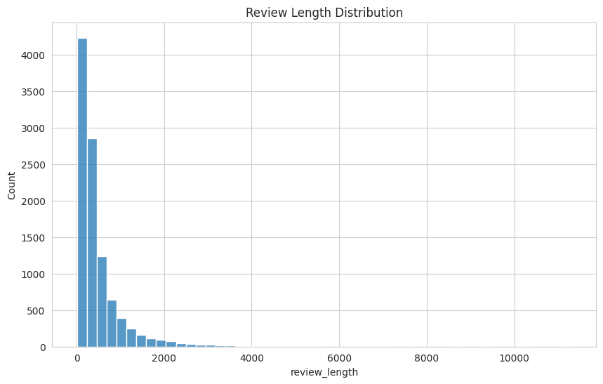
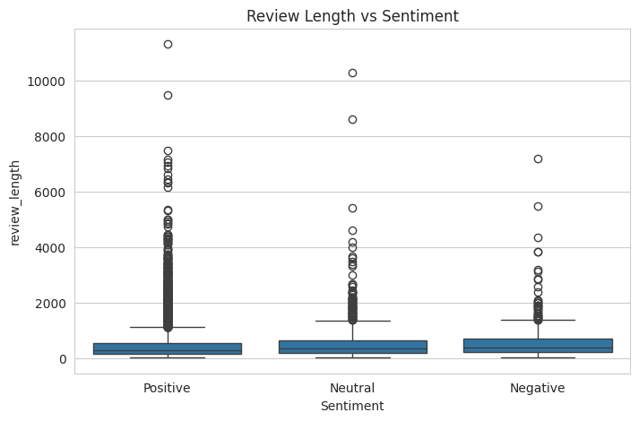
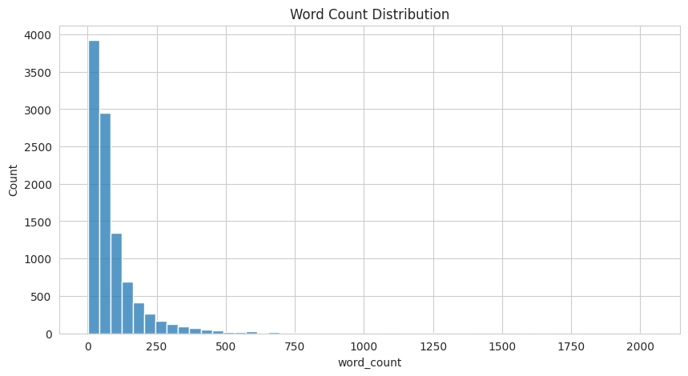
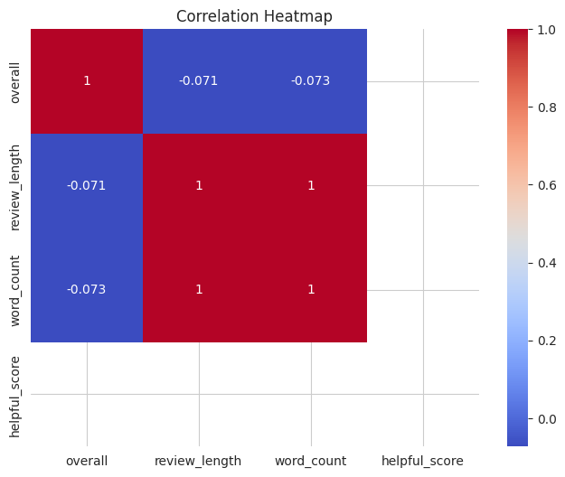
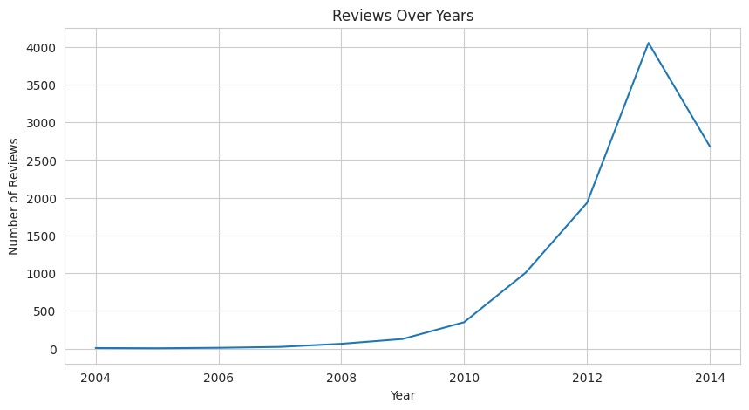
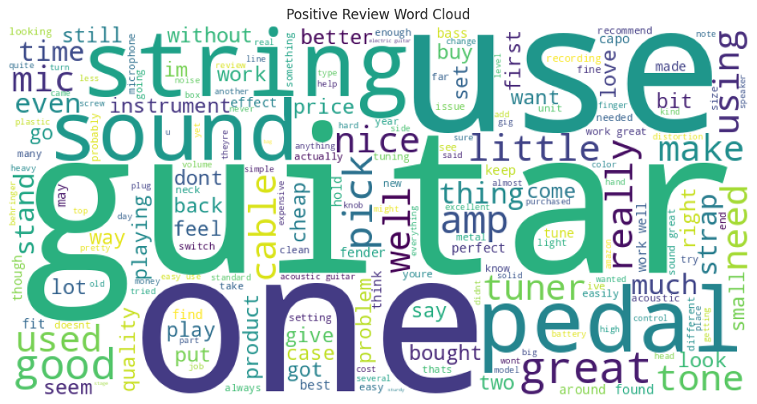
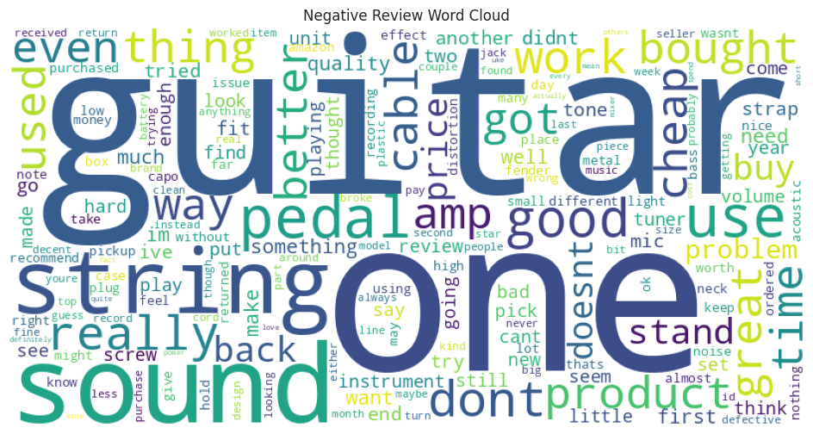
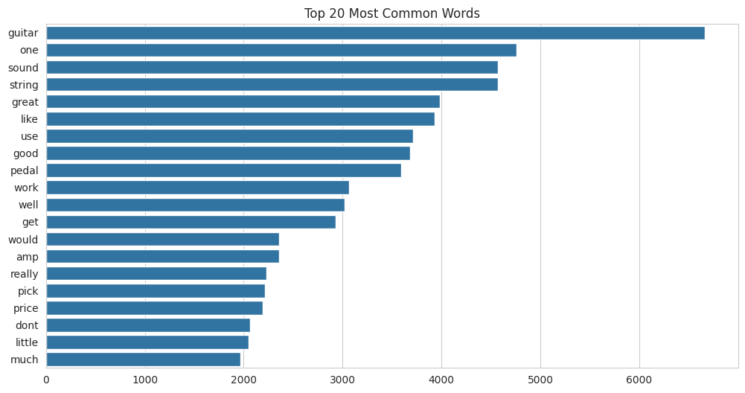
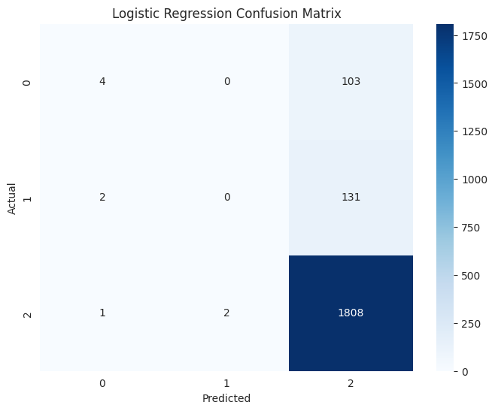
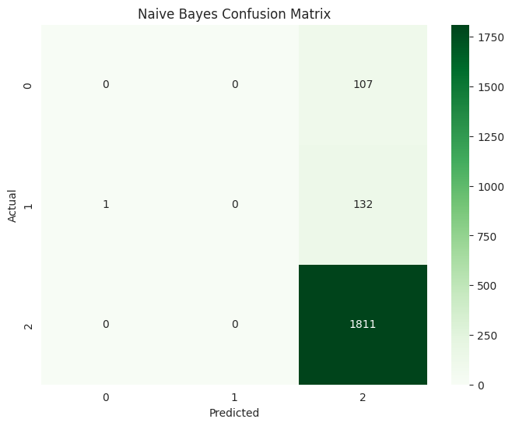
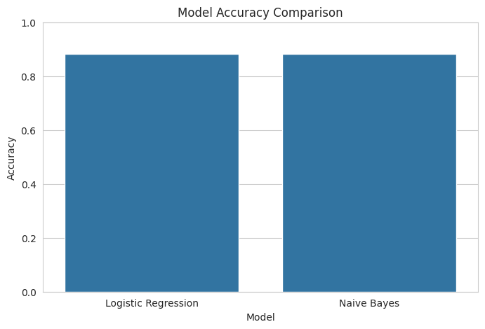

9. MODEL BUILDING
The preprocessed text was converted into numerical format using TF-IDF Vectorization (Term Frequency-Inverse Document Frequency). This technique weighs words based on their frequency in a document relative to their frequency across all documents.
Following vectorization, the dataset was split into training (80%) and testing (20%) sets. Because of the class imbalance, SMOTE (Synthetic Minority Over-sampling Technique) was used to balance the training data.
Three models were trained:
- Logistic Regression: A robust baseline model for binary classification.
- Naive Bayes: Excellent for text classification due to its probabilistic nature.
- Random Forest / XGBoost: Advanced ensemble models to capture non-linear relationships.

10. MODEL EVALUATION
The models were evaluated on the test set using multiple metrics:
- Accuracy: The overall correctness of the model.
- Confusion Matrix: Used to analyze False Positives and False Negatives.
- Comparison Chart: A bar chart comparing the accuracy and ROC-AUC scores of all models.
Observation: Logistic Regression achieved the highest accuracy and the most balanced precision-recall trade-off, making it the most effective model for this specific text classification task.

11. CONCLUSION
This project focused on performing sentiment analysis on Amazon Musical Instrument reviews using Natural Language Processing and Machine Learning techniques.
The dataset was cleaned and preprocessed by removing noise, punctuation, stopwords, URLs, and applying lemmatization. Feature engineering techniques such as review length and helpful score analysis were also performed.
TF-IDF vectorization was used to convert textual data into numerical form. Machine Learning models including Logistic Regression and Naive Bayes were trained and evaluated. Among the models tested, Logistic Regression achieved the best performance with high accuracy and effective sentiment classification.
Business Insights:
- Most customers provided positive feedback for musical instruments, indicating high overall product satisfaction.
- Negative reviews were generally longer and more detailed, as dissatisfied customers tend to explain their specific issues.
- Frequently occurring positive words included 'great', 'excellent', and 'good'.
- Negative reviews often contained words such as 'bad', 'poor', and 'problem'.
- Customer sentiment analysis can significantly help companies improve product quality, address specific defects rapidly, and enhance overall customer satisfaction.
The project successfully demonstrated how NLP and Machine Learning can be used to automatically analyze customer opinions and extract business insights from textual reviews.

12. FUTURE IMPROVEMENTS
- Deep Learning: Advanced neural networks such as LSTM or GRU could be applied for improved sequential text understanding and accuracy.
- Transformer Models: State-of-the-art NLP models like BERT or RoBERTa can be explored for deeper contextual sentiment extraction.
- Real-Time Deployment: Expanding the current Streamlit deployment into a robust cloud-hosted web application capable of analyzing live streaming data from Twitter or Amazon APIs.

