Z drive login

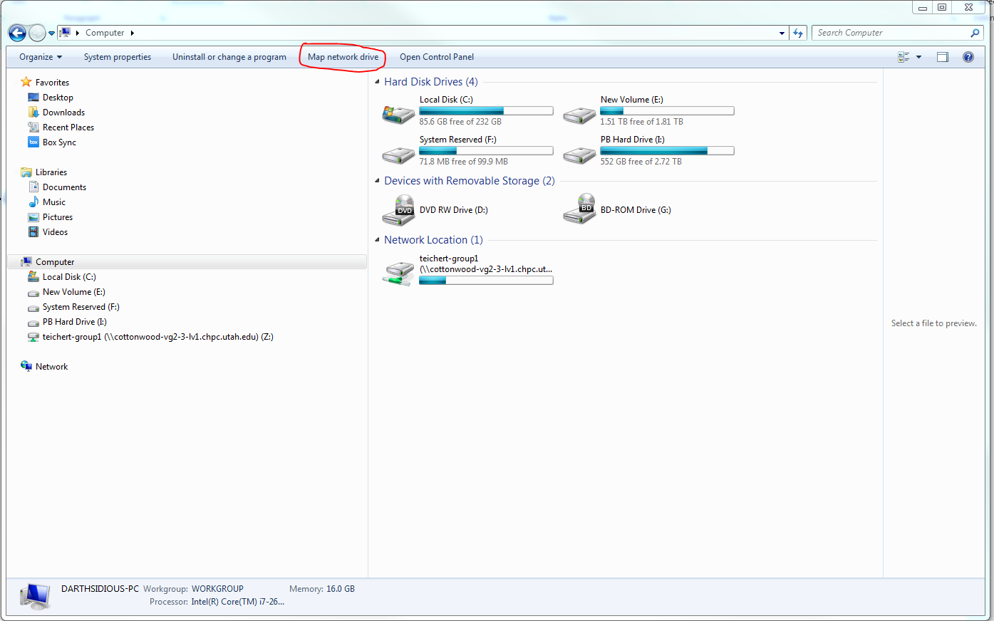

Drive Location

\\[cottonwood-vg2-3-lv1.chpc.utah.edu](http://cottonwood-vg2-3-lv1.chpc.utah.edu/)\teichert-group1

\\cottonwood-vg6-2-lv1.chpc.utah.edu\teichert-group2

Username

ad\calciumimaging

Password

PICTURES5BIO1bones2AND3cal4

FOR MAC

Go to Finder



In finder press Command+ K

Add Z Driver location ([cottonwood-vg2-3-lv1.chpc.utah.edu](http://cottonwood-vg2-3-lv1.chpc.utah.edu/)).

Add Y Driver location (smb://cottonwood-vg6-2-lv1.chpc.utah.edu)

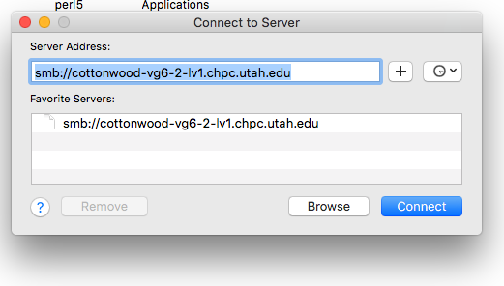

Use user name and Password

SAME AS WINDOWS (look up)

Select Teichert-group

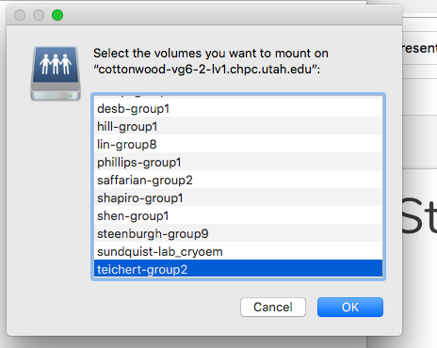

To access already mounted drive on Linux

1. Add this mounted drive to the fstab
2. First gain root access with sudo su
3. The do cd /mnt/etc
4. Now edit the fstab with nano fstab
5. Add to that line Y: /mnt/y defaults 0 0

sudo mkdir /mnt/d

sudo mount -t drvfs D: /mnt/d