GPS 2.0
User’s manual
Version 2.0.9 – for use in Mozambique

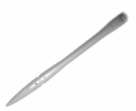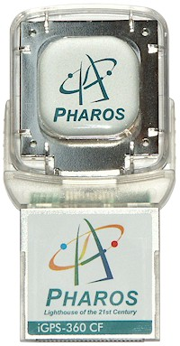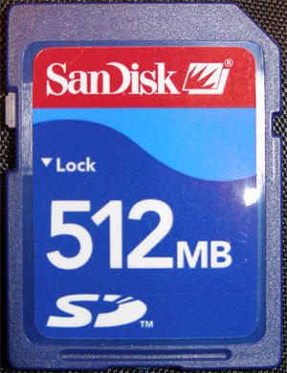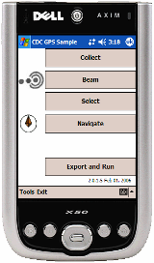

Introduction

The objective of this document is to summarize the operations of use of the GPS 2.0 software that is preinstalled on the Dell AXIM X50 (commonly referred to as PDA) that is attached to Pharos iGPS-360 CF unit (commonly know as GPS receiver). From hereon, both the PDA and the GPS receiver together are referred to as just PDA device.
The PDA device is used to map the precise locations of houses that will be surveyed in Mozambique. The PDA device will allow you to map and collect the co-ordinates (latitudes and longitudes) of the houses. Each house will be identified by a "point." Using GPS device, you will be able to navigate to your desired house from any location.
This document will only provide a brief description of the assembling and operational instructions for using PDA device to measure and record the location of houses.

Assembling the Units

This section describes how to attach the PDA device. Please be extremely careful while assembling the units as they are breakable. Make sure you assemble these units on a flat surface rather than in your hands.

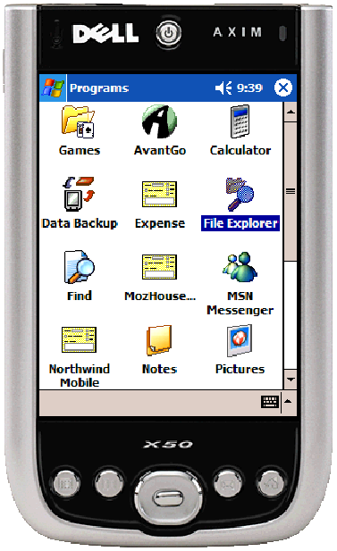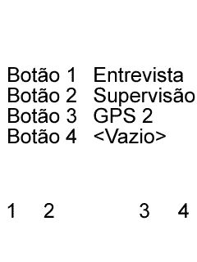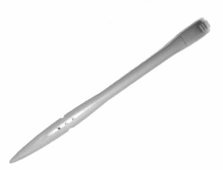
PDA: Dell AXIM X50 and Stylus

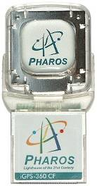
GPS: Assembled PHAROS iGPS360 CF receiver
Storage Disk: SanDisk 521MB digital memory card

Assembling the SanDisk memory card into the Dell AXIM X50
- Ensure the Dell AXIM X50 is in your hand with the screen facing towards you.
- Hold the SanDisk 512MB digital memory card (the letters facing toward you).
- Ensure that the card is oriented correctly, and slide it into the slot until you feel a click.

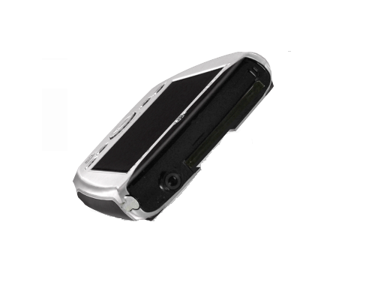
Insert SanDisk 512mb digital memory card into Secure Digital memory card slot (the small slot, not the big slot).

USE CAUTION!!

Inserting the GPS (PHAROS iGPS360 CF) receiver in PDA (Dell AXIM X50)
Insert the PHAROS iGPS-360 CF receiver into the Compact Flash card slot (the big slot)

USE CAUTION!!

Once assembled, your PDA device will look like the following figure. Please do not force or push the GPS receiver from the top as it may break.

Due to the fragile nature of the PDA device, it must be placed in the plastic container. Please make sure that the case is properly latched and do not remove the device from the plastic container or expose to water.

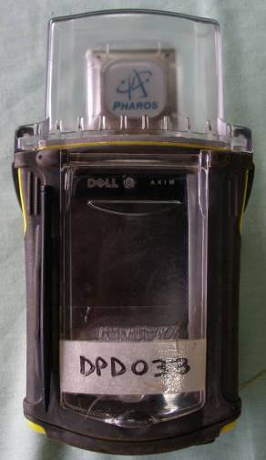

Getting started with GPS 2.0

This section describes the steps necessary to map the exact location of houses (“points”) of your interest with the GPS device.
Characteristics of the GPS 2.0 software application.
- The device is able to register the exact location of each house with a short description. GPS 2.0 eliminates duplicate registration entries automatically.
- GPS 2.0 will allow you to save your house locations and export them to the survey.

Instructions on how to capture the exact location of a house:

- To start GPS 2.0, flip open the front door of the plastic container. Turn on the power by pressing the power button located on the very top center (see picture below).
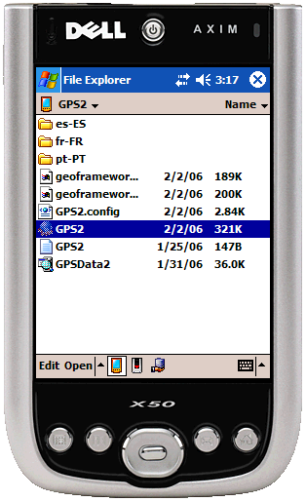
Press
Button

- After a few seconds, you must activate the GPS by pressing the third button which resembles an envelope (see picture below). The GPS 2.0 program may take 20 seconds to appear.

.
Press
Button

The following pages will describe the next steps to collect the location of the houses…
How to collect the location of houses…

Once you press the third button described previously, you must see the screen (figure below). Click on the top button that reads “Colectar” (as shown in the figure below).

DO NOT PRESS ANY OTHER BUTTONS AT THIS POINT. In case if you accidentally press any other button, click on “Sair” (located at the bottom left corner) to exit.

“Ferramentas” options is only for the field supervisor.
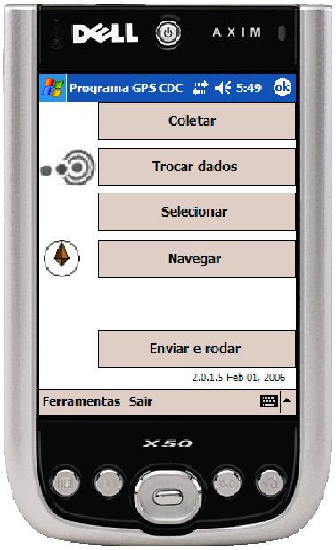

Your PDA device will look for satellites. This process can take up to 5 minutes to receive signal strength before your device will start to work. So, please be patient and wait for at least 5 minutes.

In the following figures, look for the color of the small circle (indicated by an arrow). If the color of the circle is green, then your GPS hardware has obtained the signal. If the green circle becomes a green square, then the GPS signal strength is strong (this is a good thing!). If the color is black, it means that the GPS devise is disconnected from PDA. Make sure the connection is proper. At times, the color may blink, which is normal.

Signal can be blocked by various ways, including the person holding the device. If you are inside a house that contains tin roof or in concrete buildings, you can block the GPS signal. If the PDA device is unable to connect or presents other problems, the small circle will turn to red color indicating the problem (as in left hand figure). Wait for a few minutes to check if the color changes to green. If you continue to have problems with the connection, please refer to the section on "Action to be taken if..." at the end of this User’s Manual.”

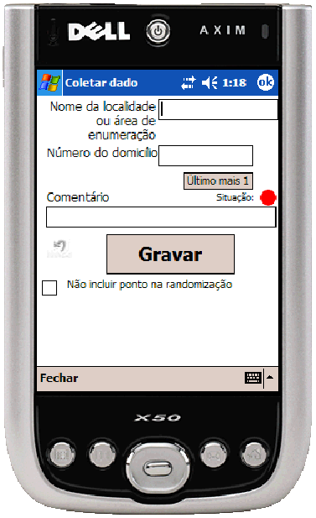

Once the PDA device is ready (you have either a green circle or square) you are able start mapping the location of the houses. In order to properly collect and save the location of each house, you must enter some basic information about the house.

Basic information to begin mapping:
The following figure indicates the boxes you need to complete to obtain the location of the house. Please note that the instructions for entering the data in the boxes are provided in subsequent pages.

1

2

3

4

5
(1) Fill in the village name (2) Fill in the house number (3) Fill in any additional comment that will allow you identify the house (4) Click on “Gravar” to save. If you make error after saving, click on the “reverse access” button to remove last record (5) Check on this box only if you want to identify the house or other location but do not want to include in the survey. If you check this box, the mapped location will NOT be selected as one of the survey samples.
Note: The reverse arrow will only delete the last record. If you wish to delete multiple mapped houses, please contact the supervisor. If you use reverse arrow, the “Numero do domicillo” will not advance.
To type either the text or the numerical number information, you must use the stylus and the keyboard. Follow these steps:
- Click the icon that resembles the keyboard (see the left figure above). You will see a keypad appear on the bottom of the screen (see the right figure above).
- Then using the stylus, click on the desired box where you wish the letters or numbers to appear. The blinking cursor will appear.
- Once you have selected the box and the cursor is blinking, simply click on the keypad to enter the desired letters or numbers. Watch for accuracy. If you want to delete, click on the <- button to delete the characters. Reread your entries to ensure that they are accurate.
- Repeat this procedure to enter all relevant information in all boxes. Click on the keyboard buttons to exit the keyboard. DO NOT click on “Fechar” to exit—if you do, you will exit the GPS 2.0 program!!
- MAKE SURE THAT THE CIRCLE/SQUARE IS GREEN IN COLOR WHEN YOU ARE SAVING. Click on “Gravar” to save your mapping data.
For example: if you wish to enter "1" for the number of the first house and "Maria Tobias" for the comment, the location for this house will be identified in the database like "1. Maria Tobias."
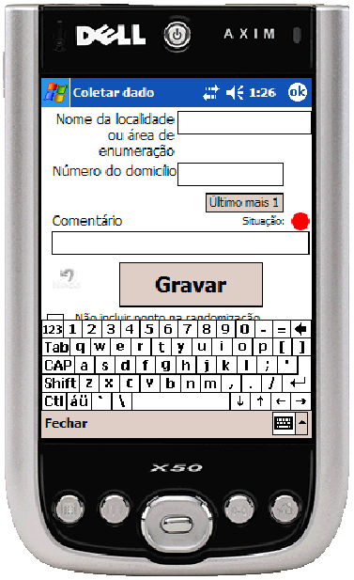

To write text:
- Click on the box where the text will be entered (e.g. Nome de localidade).
- Open the keyboard by clicking on the keyboard image in the lower right hand corner (see above figure)
- Using the stylus and the keyboard, click the letters to enter the information required. Click them in the box where you want to enter text.
- Click it in the symbol of a keyboard as shown on the bottom left figure.
- Write it your text in text box. If you want to enter the text in all uppercase letters, click on the CAP button (middle row far left side).
- DO NOT CLOSE THE KEYBOARD UNITL YOU ARE DONE WITH MAPPING OF ALL HOUSES!! To close the keyboard, click on the keyboard symbol in the lower right hand corner (same as for opening the keyboard).
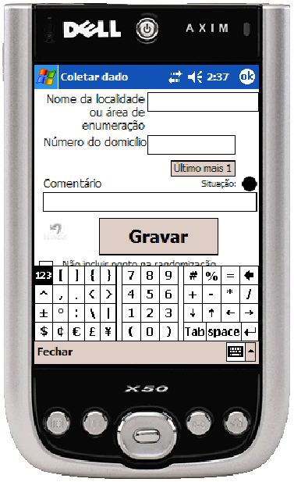
To write numbers:
- Click in the box of the numbers “123” (upper left hand corner of keyboard) on the keyboard as shown in the upper left figure).
- A keyboard of numbers appears (as shown in the upper right figure).
- Enter the desired number(s). For the purpose of the survey, please use the number from the “Distrito “menu from the survey application (refer to the picture below). This pull down list contains several lines. Each line will have numbers and letters and will only be displayed in one short line within the pull down box. Make sure that your description of the house should not be too long as you will not be able to see all the information.
- The way to understand each line appearing in the pull down box is as follows:
    - (*) is sample selected and (X) is alternate sample. The remaining information starts and ends with “.”
    - The first number is the house number begins and ends with “.”
    - The second is the name of the house/person
    - Third is the village name/number.

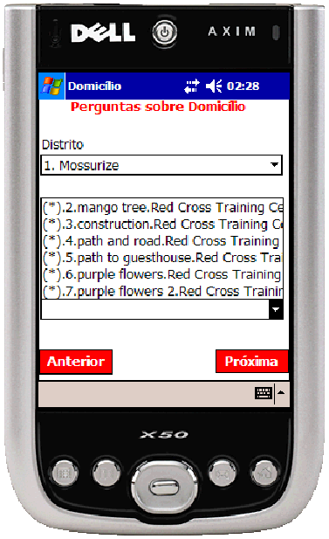

House Number, House Name, Village

- Make sure you will not enter the same house name as the other interviewer enters. For example, there will be four members of the time. Each maps with 100 houses. It is important for the first person to start with number 100 and the second person starts with 200, and so on. This process will make the listing of all the houses in the pull down box less confusing. If each interviewer starts with house number 100 then you will have four house numbers beginning with 100. Although this not a problem for the GPS 2.0 program to assign unique identification, for the interview it may cause confusion.
- To change the keyboard back to letters, click on “123” again.

To map a house or a location accurately, you must stand on the same spot to enter all the information and save. Walking around while entering the data may give you inaccurate mapping information.

Once you have finished entering the house mapping information …
The following figure indicates how the screen will look after you have filled-in all the relevant information and successfully saved the location of your first house.
You must fill in village/town name, the number of house, and a good but brief description of the house. If this information is not clear, it might pose problems. For example, if you found a location but the location is in the middle of 6 houses then it would become difficult to locate which particular house that you intend to visit. In this case, a clearly described house (either house door number or description…
Going back and forth—beween interview program and GPS

When you have completed entering the information and click on “Gravar,” you will notice that the “Gravado com sucesso” window appears. Now you completed measuring and documenting the location of the first house and ready to record the location of next house (see next figure). If you get an error message, please check all the boxes and make sure the information is valid and check to make sure the circle has the green light. If problem persists, please refer to the section on "Action to be taken if..." at the end of this User’s Manual.”

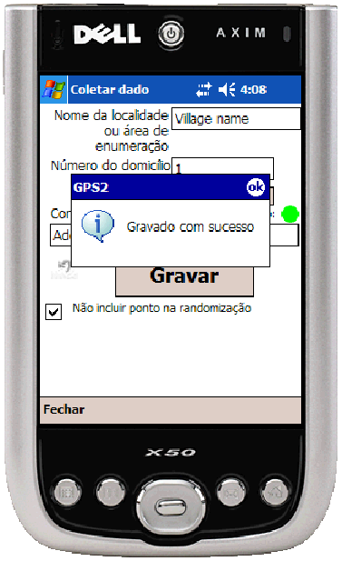
Must enter the village name (instructions above)

House number (you can only enter number/s) (instructions above)

Must enter additional comment that will allow you identify the house **EXTREMELY IMPORTANT-(instructions above)

Save

Check on this box only if you want to identify the house (more info) but do not want to include in the survey.

In the following figure, you will notice that the “Numero do domicillo” is advanced to “2” indicating that you are ready to record the second house.
After you have entered the information for the second house, click on the “Gravar” button in order to save. Repeat this step until you have mapped all the houses using this process.
When you have completed mapping all the houses, click on “Fechar” (located on the bottom left side of the figure below) to exit.

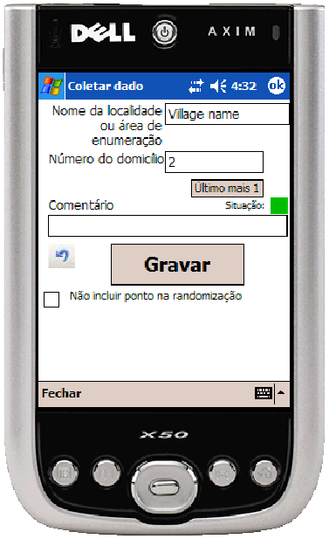
Notice the house number is automatically advanced to “2”
Click here to exit when you are done mapping all the houses

Beaming the mapped house locations (points)…
Once you have completed mapping all the houses (points) in the village, you are ready to combine your points by transferring (beaming) and join your points with the points from other members of your group. The process works similar to a remote control for a television when changing channels or turning the TV on or off. The resulting process will be a single file containing all the houses mapped by various surveyors.

PLEASE FOLLOW THE IMPORTANT INSTRUCTIONS BEFORE YOU TRANSFER FILES USING BEAM COMMAND!!!

Step1. You are “Person A.” Select the person you want to “beam” the file to. Make sure you and the person who wants to receive the beam (Person B) are facing each other. Both of you must hold your PDAs the way it is shown below.

Person A
(who sends the “beam”)
Person B
(who receives the “beam”)
Step 2. When your GPS devices are aligned, you will notice the color change. The beam icon located to the left side of “Trocar dados” will change from “gray” to “red/blue,” indicating the alignment is correct. Now, you (the person who sends the beam) are ready to click the “Trocar dados” button.
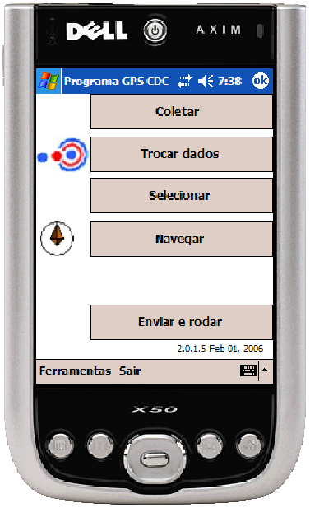
Person A
(who sends the “beam”)
Person B
(who receives the “beam”)
If your two PDAs are aligned, you will notice the color change from gray to red/blue. You can now click the “Trocar dados” button
Step 3: Now Person A is ready to beam file to Person B.

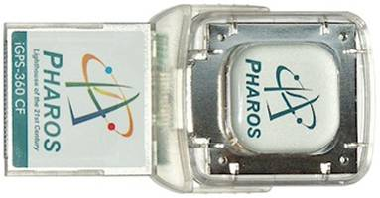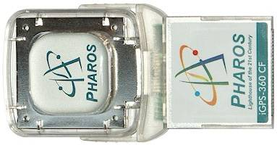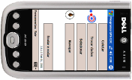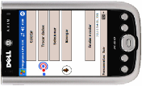
Person A
(who sends the “beam”)
Person B
(who receives the “beam”)
When both devices are sensing infrared signal,
both people must click on “Trocar dados”

Step 4: Upon pressing the “Trocar dados,” you will notice two buttons,”Receber dados” and “Enviar dados” appear on the screen.

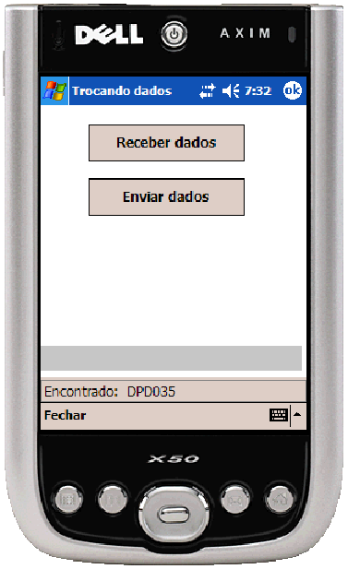
Person A
(who sends the “beam”)
Person B
(who receives the “beam”)
If your device is out of alignment and does not sense infrared sensor does not sense the receiver’s device, then you will notice in the following figure that the black bold letter on the two buttons will turn gray.

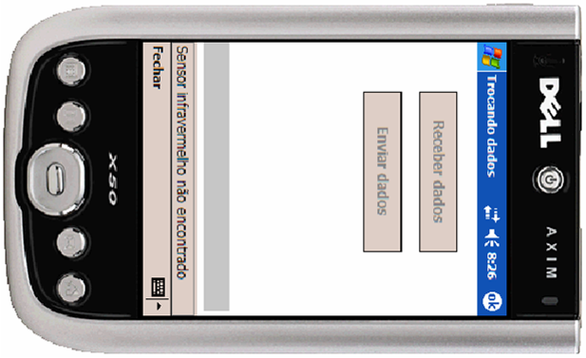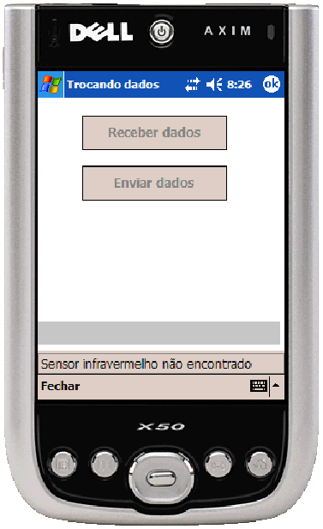
Person A
(who sends the “beam”)
Person B
(who receives the “beam”)
Aligned…………..…..Not aligned

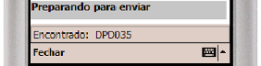
Aligned……………………….…………..Not aligned

Recheck to make sure the two devices are aligned like the following figure. Now you are ready to send and receive files.

Person A
(who sends the “beam”)
Person B
(who receives the “beam”)
Click on “Enviar dados”
Click on “Receber dados”
Step 4: Sending and receiving files for the first time.

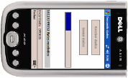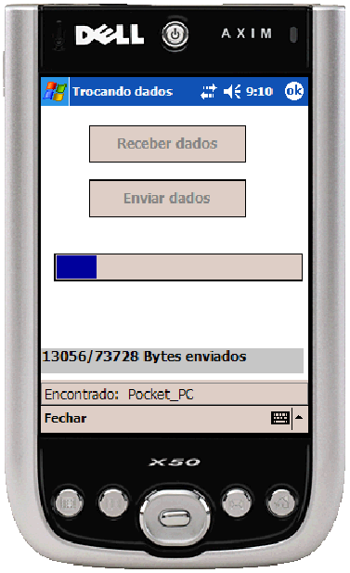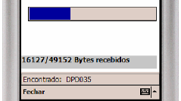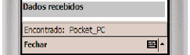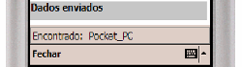
Person A
(who sends the “beam”)
Person B
(who receives the “beam”)
Sending……………………………………… …………..Receiving
Send Complete……………………………………………..Receive Complete

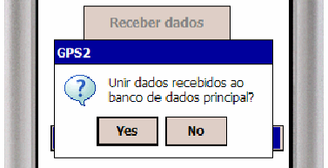

Note: If you have mapped large number of houses, the data will be large. As a consequence, both the sending time and the receiving time will be longer. So, please be patient and do not disturb the data transmission process.
Step 5: If you repeat step 4, and you are the receiver (Person B), your screen will resemble the following figures.

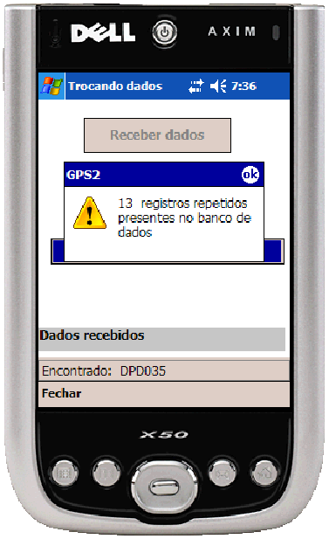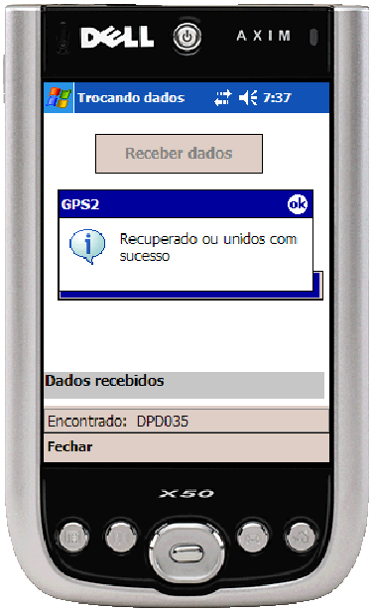

If you see either one of the two messages (as shown above), you have successfully completed the beaming of the files.

Note: The sender only see the “Dados enviados” at the bottom of the screen and no other message will appear. So, it is important for the sender to make certain that “Dados enviados” will appear at the bottom of the screen.
How to export the file containing to house mapping data to the survey program…

Once you have successfully mapped all the houses and saved the file, you are now able to export the mapping information to the survey.

Please click on “Enviar e rodar” (as shown in the right figure below) to export the mapping information to the survey applications.
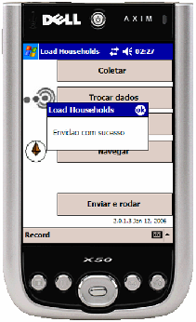

How to randomly select the houses from the list of mapped houses…
In order to conduct interview, you need to be able select (through simple random sample method) a few houses from the list of all the mapped houses. GPS 2.0 software application will automatically select the houses. Following steps will show you how to randomly select the houses from all the mapped houses.
- Click on “Select” button (as shown in the right figure below)
- In the middle figure, you will notice that GPS 2.0 has automatically selected points for you and provides you with two additional buttons at the bottom of the screen.
- Click on “Select” (as shown below in the middle figure)
- Your selection of simple random sample of houses from your original list of all mapped houses in the area is now successful (as shown below in the right figure)
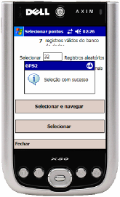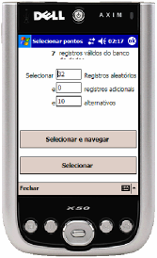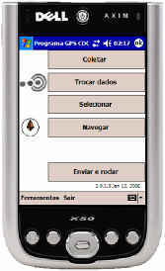
This list is a selection of xx number of houses from the master list of all the location of mapped houses. The supervisors must select a small list of houses from the navigation list and allocate so that each interviewer will get approximately the same amount of houses.

How to navigate to the location of house before you begin interviewing
The following figures and the accompanying text will provide you with the easy steps to locating the house you wish to conduct interview.
Before you begin, make sure if your GPS signal strength is good (green circle or green square). Once you have the GPS signal strength, you are ready to use the navigation option. If you click on any house, the house distance information will appear on the top right corner of the screen along with a blue circle outside the GPS navigation meter. If you are not seeing any distance information or the blue dot, it is probably due to lack of GPS signal. Please wait for the signal to come and retry again.
There are two reasons why a distance might change from the actual: (a) lack of signal strength, and (b) you might be moving. Also, it is important to note that the distances are approximate, not exact. In other words, the actual distance of the house from your location might be +/- 5 meters. It is due to this fact, each mapping information also contains a brief description of the house so that you can easily locate when you get close to a house you wish to interview.
Following steps will provide additional information about navigation.
Step 1: The next step is to just use compass to navigate back to the house you wish to go. You can navigate either using the “map” option or the “compass.” For your convenience, you can sort the location of houses either by distance from where you stand or from house number. If you wish to visit all houses near a location, then you can sort the list of mapped houses by distance. This will allow you to visit many houses that close to each other.
Step 2: Watch and follow the general direction of the red arrow mark (make sure you will watch your steps so that you won’t accidentally fall in a whole or bump into a tree).
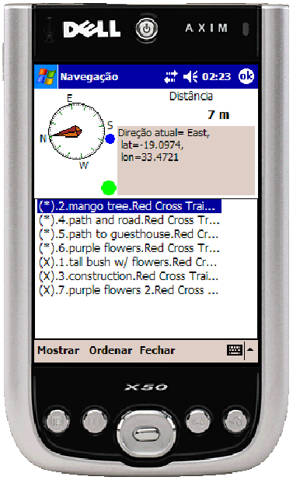
1

2

3
Step 3:
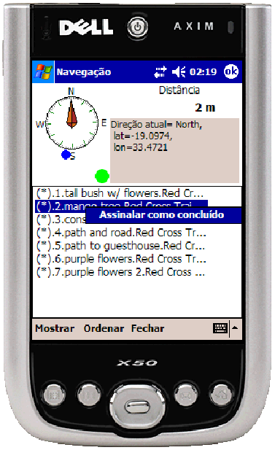
When you complete your interview, you are then able to mark the house as process and remove from list
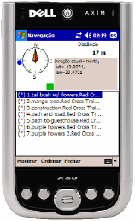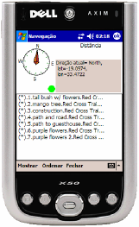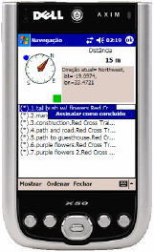

In case of an error in GPS signal the information…
In this figure, you will notice that the “Numero do domicillo” is advanced to “2” indicating that you are ready to record the second house.
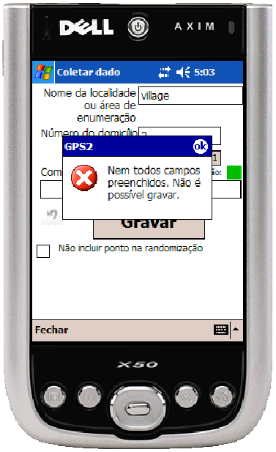
GPS signal error message

In case of GPS signal loss:
- At times, GPS Signal error can occur even if the signal strength indicator is either a green circle or a green square.
- A message will appear to indicate to you that the data of the GPS are not valid.
- Click OK and then Click the area of to have a new reading of the GPS. When the new GPS signal appears, click “Gravar” to save the data.
- If the GPS signal continues to give you this error message, then click on “Fechar” to close and restart the program by clicking on “Coletar.”

***{DO NOT TRANSCRIBE BEYOND THIS POINT} Adam will be working on it..

Step by Step instructions for beaming and merging

Steps numbered below:

- After entering Comments for all houses, Click ‘More’
- One person Click ‘Beam Out’
- When you see ‘Backed up successfully’ Click ‘ok’
- Aim the PDA at the other PDA. The PDA will say ‘Searching’, then ‘Pending’, then ‘Sending 1/1’, then ‘Done’.
- This sender should Click ‘ok’ in the upper right corner.
- The receiver should a box that asks, ‘Do you want to accept Filename?
- The receiver should Click ‘Yes’
- Repeat for other PDA

Joining tables and exporting:

- Click ‘Join/Restore’
- Click ‘Open File’
- Look for the file name sent by your friend. It should have today’s date, and the ‘Folder’ name on the grey bar should be blank. Click that file.
- You will see the filename on the page. If it is not the correct file, do NOT Click join. Click open and look for the correct file.
  - TIP: About halfway down the screen, you will see a gray bar with 2 or 3 columns on it. Click ‘Date’ to arrange files by date.
  - Each EA will have only one file that has a blank ‘Folder’ column. That will be the file to Click.
- If it is the correct file, Click ‘Join’. There is only 1 correct file.
- If it says ‘These tables have already been joined. Continue?’ Click ‘No’. If you Click ‘Yes’, you will have duplicate records in your database and in your sample.
- After you see ‘Joined successfully’, Click ‘ok’
- Click the ‘X’ in the upper right corner.
- Click ‘Export to Navio’
- Change ’29 Additional records’ to ‘0’
- Click ‘Export to Navio’
- You will see ‘Import Successful’. Click ‘ok’.
- You will see ‘ …Map was created’ Click ‘ok’
- Click ‘Exit’
Instructions and responsibilities for supervisors for the management of the PDAs and GPS equipment.

For the GPS team’s PDAs:

To back up the GPS database:

- Open GPS1.2
- Select "More"
- Select the double arrow to the right on the lower right-hand side of the PDA. >>
- Choose "Backup"
- Change the name of the file to match the name of the enumeration area, for example, “EA0101 complete". The folder should remain GPS1.2 Type should remain Pocket Access Database, and location should remain "Main memory".
- Click OK
- You should see a message that says "Backed up successfully"
- Click OK

To clean the GPS database:
- Select "Clean database"
- A question will appear that asks, "Backup data before erasing?"
- If you have already saved the data, then you can Click "No", or else Click "Yes" and see steps for backing up the data.
- It will warn you that "All unsaved data will be erased. Continue?” Click "Yes".
- The PDA should then give the message, "Cleaned successfully". Click OK.
- The GPS program should now be ready to be used the next day. Click the "X" in the upper right-hand corner to exit the current screen. Do this a second time until it says "OK" in the upper right corner, and Click "Exit".

For both team’s PDAs:

Full system backup
- From the Home Screen select (Click) Start
- From the Start Menu select (Click) Programs
- From the icons/list select (Click) Data Backup
- Select (Click) Backup all data
- Select (Click) Backup to: SD card (It will show “Built-in Storage” by default
- Name the file with the date (e.g., “09SEP05”)
- Select (Click) Start button (lower right quarter of the PDA screen)
- After starting, the process should take a couple of minutes, at the end of which it should report Backup is complete.
- Close the program so that the Home Screen is showing for the team in the morning.

Troubleshooting tips
Problem: The SD card is not available as an option for Backup
Solution 1: Remove the SD card and re-insert it. To remove the card, push it into the PDA slot and it will release outward.
Solution 2: If the SD Card is not available, Backup to Built-in Storage.

Problem: PDA freezing/hanging (Marcel, what is the best way to explain this?)
Solution: On the back of the PDA is a small hole for resetting the PDA. Press the tip of the stylus into the hole to reboot the PDA.

