Texas Hunger Initiative Project

May 7, 2023

Group 09

Sambhav Jain

Nhu Pham

Lee Zhang

***System Overview:***

**(1) Goal of Implementation Phase:**

In the implementation phase of the project, we strived to create a DDL script, a queries script, and a data analysis dashboard with a pivot table, a 3-D pie chart, and a stacked bar chart. Our project is to help business users to access and retrieve proper information regarding the database of Texas Hunger Initiative (THI) and provide insights into the database by visualization using Excel.

**(2) Deliverable Description & Purpose:**

**DDL Script:**

This script is created based on THI database. We essentially created a view which is a table of information from other tables in the database. The view is created by joining, or combining, the following tables: Sites, Sponsors, MealTypes, MealCounts, ServiceTypes, and ReimbursementRate. Then, we created a new data field within this current table named Expected Reimbursement Amount, which is the product of data field ReimbursementRate and MealCount. This view also lists Site Name, Sponsor Name, Meal Type, Service Type, Reimbursement Rate, Week Beginning Date, Meal Count. The purpose of this view is to allocate all the needed information in one place and analyze and visualize the data easier.

**Queries Script:**

This script has all the results that Summer Food Service Program (SFSP) sponsors have requested us to analyze and report. Each analysis result answers a certain business question. Also, our results will provide the business users with a basic understanding of the information and data manipulation for THI database, which stores all their information and data. The outputs are formatted in a user-friendly and straightforward way to aid the user’s reading of the results.

**Data Analysis Dashboard:**

In this dashboard, Excel is utilized to create important data visualization. The first visualization is a pivot table which shows the top ten sites according to the total expected reimbursements attributed to their meal counts. The first column is for the Total Expected Reimbursements, while the second column is for the Total Meal Counts. The top ten site names span each row. The second visualization is a 3-D pie chart which shows the total amount each sponsor can expect to be reimbursed. Each slice on the pie chart is the total reimbursement amount for each sponsor. The third visualization that we chose is a stacked bar chart to represent total expected reimbursements by meal type for sponsors. Each bar is a sponsor that is divided into meal types with its corresponding percentage.

**(3) General Instructions on How to Run SQL Scripts:**

**DDL Script:**

1. In the zipped folder, we have two SQL scripts: DDL.sql and Queries.sql. You will run the DLL.sql first then Queries.sql after that.
2. Open the SQL Server Management Studio (SSMS) or any other database management tool that allows you to run SQL scripts.
3. Connect to the database where you want to create or modify the database object.
4. Open the script in a query window in SSMS, in your database management tool, or from within the tool.
5. File Tab – Open – File – Select DDL.sql

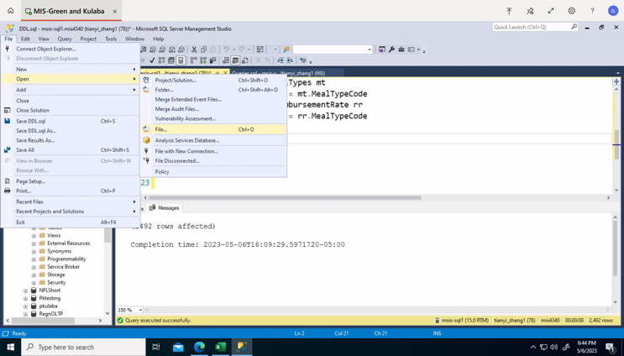

1. After loading DDL.sql, you will see this query on your window.

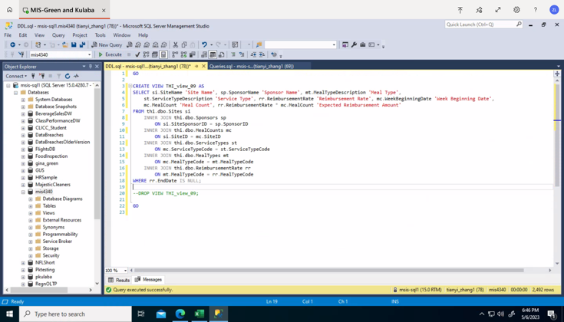

1. Execute the script by clicking the “Execute” button or pressing F5.
2. Verify that the object was created or modified as expected. You will see how many rows are affected.

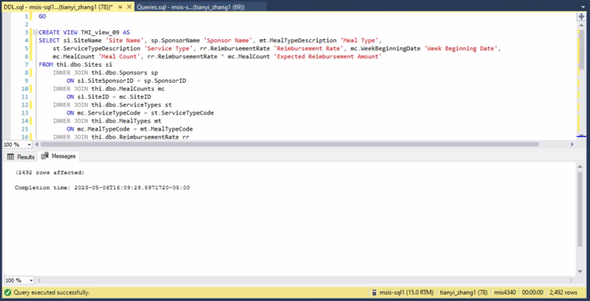

**Queries Script:**

1. After creating the view by DDL.sql, you will continue to load the Queries.sql.
2. File Tab – Open – File – Select Queries.sql
3. After loading Queries.sql, you will see this query on your window.

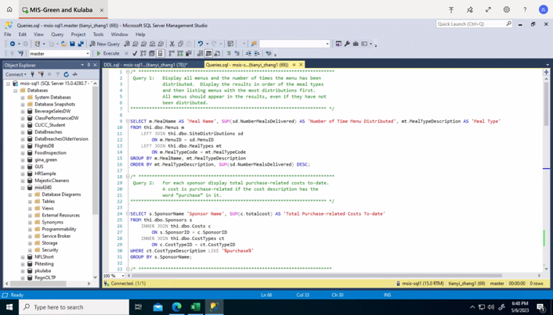

1. Execute the script by clicking the “Execute” button or pressing F5.
2. Verify that the object was created or modified as expected. You will get the result as the picture below.

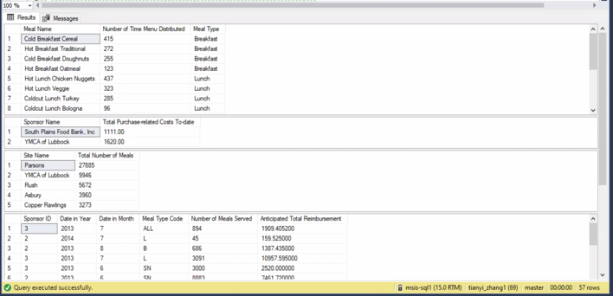

1. Note: You can run specific queries to see the specific table by highlighting the query that you want to see the result then clicking the “Execute” button or pressing F5.

**Excel:**

1. Open the Team09Part2.xlsx file. You can see five tabs – Dashboard, Pivot Table, 3-D Pie Chart, Stacked Bar Chart, and THI Data View on the bottom.
2. Select Dashboard to see the Pivot Table, 3-D Pie Chart and Stacked Bar Chart together.
3. Select Pivot Table, which shows top ten sites for the total expected reimbursement and total meal counts with a filter for week beginning date.
4. Select 3-D Pie Chart, which shows the top three sponsors for the total expected reimbursement with the explosion being the sponsor for the lowest reimbursement. You can filter the Pie Chart to add other sponsors.
5. Select Stacked Bar Chart which shows total expected reimbursement by meal type for sponsors. You can filter by sponsor name and meal type. Each bar shows a proportion by meal type for the sponsor.

***DDL Script:***

**Code:**

GO

CREATE VIEW THI_view_09 AS

SELECT si.SiteName 'Site Name', sp.SponsorName 'Sponsor Name', mt.MealTypeDescription 'Meal Type',

st.ServiceTypeDescription 'Service Type',

rr.ReimbursementRate 'Reimbursement Rate',

mc.WeekBeginningDate 'Week Beginning Date',

mc.MealCount 'Meal Count',

rr.ReimbursementRate * mc.MealCount 'Expected Reimbursement Amount'

FROM thi.dbo.Sites si

INNER JOIN thi.dbo.Sponsors sp

ON si.SiteSponsorID = sp.SponsorID

INNER JOIN thi.dbo.MealCounts mc

ON si.SiteID = mc.SiteID

INNER JOIN thi.dbo.ServiceTypes st

ON mc.ServiceTypeCode = st.ServiceTypeCode

INNER JOIN thi.dbo.MealTypes mt

ON mc.MealTypeCode = mt.MealTypeCode

INNER JOIN thi.dbo.ReimbursementRate rr

ON mt.MealTypeCode = rr.MealTypeCode

WHERE rr.EndDate IS NULL;

--DROP VIEW THI_view_09;

GO

**Output:**

Commands completed successfully.

Completion time: 2023-05-06T19:39:13.2075788-05:00

***Queries Script:***

**Code:**

/* *************************************************************************

Query 1: Display all menus and the number of times the menu has been distributed. Display the results in order of the meal types and then listing menus with the most distributions first. All menus should appear in the results, even if they have not been distributed.

************************************************************************* */

SELECT m.MealName AS 'Meal Name',

SUM(sd.NumberMealsDelivered) AS 'Number of Time Menu Distributed', mt.MealTypeDescription AS 'Meal Type'

FROM thi.dbo.Menus m

LEFT JOIN thi.dbo.SiteDistributions sd

ON m.MenuID = sd.MenuID

LEFT JOIN thi.dbo.MealTypes mt

ON m.MealTypeCode = mt.MealTypeCode

GROUP BY m.MealName, mt.MealTypeDescription

ORDER BY mt.MealTypeDescription, SUM(sd.NumberMealsDelivered) DESC;

/* *************************************************************************

Query 2: For each sponsor display total purchase-related costs to-date. A cost is purchase-related if the cost description has the

word ‘purchase’ in it.

************************************************************************* */

SELECT s.SponsorName 'Sponsor Name',

SUM(c.totalcost) AS 'Total Purchase-related Costs To-date'

FROM thi.dbo.Sponsors s

INNER JOIN thi.dbo.Costs c

ON s.SponsorID = c.SponsorID

INNER JOIN thi.dbo.CostTypes ct

ON c.CostTypeID = ct.CostTypeID

WHERE ct.CostTypeDescription LIKE '%purchase%'

GROUP BY s.SponsorName;

/* ************************************************************************

Query 3: Display the 5 sites serving the most meals within the past 12 years. Also display the total number of meals served by those sites.

************************************************************************* */

SELECT TOP 5 s.SiteName AS 'Site Name',

SUM(mc.MealCount) AS 'Total Number of Meals'

FROM thi.dbo.Sites s

INNER JOIN thi.dbo.MealCounts mc

ON s.siteID = mc.SiteID

INNER JOIN thi.dbo.SiteDistributions sd

ON s.siteID = sd.SiteID

WHERE YEAR(GETDATE()) - YEAR(mc.MealCountDate) <= 12

GROUP BY s.SiteName

ORDER BY SUM(mc.MealCount) DESC;

/* *************************************************************************

Query 4: Display total number of meals served and anticipated total reimbursement by sponsor, year, month, and meal type, in this order.

The reimbursement rate for each meal type is in the ReimbursementRate

table. The current reimbursement rate has an EndDate of NULL.

************************************************************************* */

SELECT ss.sponsorID AS 'Sponsor ID',

YEAR(mc.MealCountDate) AS 'Year',

MONTH(mc.MealCountDate) AS 'Month',

mt.MealTypeCode AS 'Meal Type Code',

SUM(mc.MealCount) AS 'Number of Meals Served',

SUM(mc.MealCount) * AVG(rr.ReimbursementRate) AS 'Anticipated Total Reimbursement'

FROM thi.dbo.MealCounts mc

INNER JOIN thi.dbo.MealTypes mt

ON mc.MealTypeCode = mt.MealTypeCode

INNER JOIN thi.dbo.ReimbursementRate rr

ON mt.MealTypeCode = rr.MealTypeCode

INNER JOIN thi.dbo.sites st

ON mc.SiteID = st.SiteID

INNER JOIN thi.dbo.Sponsors ss

ON st.SiteSponsorID = ss.SponsorID

WHERE rr.EndDate IS NULL

GROUP BY ss.sponsorID, YEAR(mc.MealCountDate), MONTH(mc.MealCountDate), mt.MealTypeCode;

/* ************************************************************************

Query 5: For each sponsor by month, display their total Operational costs to-date, total Meals Served to-date, and total Operational costs per meal to-date. Calculate the latter number based on the first two numbers.

************************************************************************* */

SELECT sp.SponsorName AS 'Sponsor Name',

MONTH(cs.DateofCost) AS 'Month',

SUM(cs.TotalCost) AS 'Total Cost',

SUM(mc.MealCount) AS 'Total Meal Count',

SUM(cs.totalCost) / SUM(mc.MealCount) AS 'Cost per Meal'

FROM thi.dbo.Sponsors sp

INNER JOIN thi.dbo.Costs cs

ON sp.SponsorID = cs.SponsorID

INNER JOIN thi.dbo.CostTypes ct

ON ct.CostTypeID = cs.CostTypeID

INNER JOIN thi.dbo.Sites st

ON st.SiteSponsorID = sp.SponsorID

INNER JOIN thi.dbo.MealCounts mc

ON st.SiteID = mc.SiteID

WHERE ct.CostTypeCategory = 'Operational'

GROUP BY sp.SponsorName, MONTH(cs.DateOfCost);

/* *************************************************************************

STORED PROCEDURE: Display sites that did not report meal counts for a user-specified week-beginning date. Do NOT hardcode information. USE a cursor and use a print statement.

************************************************************************* */

SELECT  st.SiteID AS 'Site ID', st.SiteName AS 'Site Name',

mc.MealCount AS 'Meal Count', mc.WeekBeginningDate AS 'Week Beginning Date'

FROM thi.dbo.sites st

INNER JOIN thi.dbo.MealCounts mc

ON st.SiteID = mc.SiteID

WHERE mc.MealCount IS NULL

AND mc.WeekBeginningDate = '2013-08-05';

**Output:**

**Query 1:**

Meal Name             Number of Time Menu Distributed Meal Type

-------------------------------------------------------------------------------------------------------------------------------------------------------------------------------------------------------------------------------------------------------------------------------------------------------------------

Cold Breakfast Cereal                        415                            Breakfast

Hot Breakfast Traditional                    272                            Breakfast

Cold Breakfast Doughnuts                      255                            Breakfast

Hot Breakfast Oatmeal                        123                            Breakfast

Hot Lunch Chicken Nuggets                        437                             Lunch

Hot Lunch Veggie                         323                             Lunch

Coldcut Lunch Turkey                         285                             Lunch

Coldcut Lunch Bologna                        96                              Lunch

Snack Sack 1                              96                              Snack

Snack Sack 2                              79                              Snack

Snack Sack 3                              NULL                            Snack

Snack Sack 4                              NULL                            Snack

Supper- Chicken Noodle Soup                           NULL                            Supper

Supper- Pasta                  NULL                            Supper

Supper- Sandwich              NULL                            Supper

Supper- Traditional              NULL                            Supper

Warning: Null value is eliminated by an aggregate or other SET operation.

(16 rows affected)

**Query 2:**

Sponsor Name           Total Purchase-related Costs To-date

----------------------------------------------------------------------------------------------------------------------------------------------------------

South Plains Food Bank, Inc                                                            1111.00

YMCA of Lubbock                                                        1620.00

(2 rows affected)

**Query 3:**

Site Name                                        Total Number of Meals

---------------------------------------------------------------------------------------------------------------------------------------------------------

Parsons                                                27885

YMCA of Lubbock                                        9946

Rush                                                   5672

Asbury                                                 3960

Copper Rawlings                                        3273

(5 rows affected)

**Query 4:**

Sponsor ID  Year Month Meal Type Code Number of Meals Served

Anticipated Total Reimbursement

----------------------------------------------------------------------------

3           2013         7             ALL            894        1909.405200

2           2014         7             L              45          159.525000

2           2013         8             B              686        1387.435000

3           2013         7             L              3091      10957.595000

3           2013         6             SN             3000       2520.000000

2           2013         6             SN             8883       7461.720000

1           2013         7             ALL            8603      18374.287400

3           2013         6             B              4189       8472.252500

2           2013         8             SN             5398       4534.320000

2           2012         6             SN             24           20.160000

2           2013         6             B              2255       4560.737500

2           2024         7             L              72          255.240000

2           2013         8             L              7145      25329.025000

1           2013         6             ALL            11641     24862.847800

2           2013         6             L              16548     58662.660000

2           2013         8             ALL            60          128.148000

3           2013         8             ALL            15           32.037000

3           2013         6             L              2955      10475.475000

3           2013         7             SN             2241       1882.440000

2           2013         7             B              2129       4305.902500

2           2013         7             SN             10040      8433.600000

1           2013         8             ALL            1740       3716.292000

1           2014         6             ALL            19           40.580200

2           2013         7             L              15986     56670.370000

2           2014         7             B              30           60.675000

3           2013         7             B              3555       7189.987500

Warning: Null value is eliminated by an aggregate or other SET operation.

(26 rows affected)

**Query 5:**

Sponsor Name    Month Total Cost Total Meal Count Cost per Meal

---------------------------------------------------------------------------------------------------------------------------------------------------------- ----------------------------------------------------------------------------

YMCA of Lubbock         5             108750.00    19940            5.453861

South Plains

Food Bank, Inc             6             2410214.00      346505           6.955784

YMCA of Lubbock         6             246645.00       39880            6.184679

South Plains

Food Bank, Inc             7             1652540.00      346505           4.769166

YMCA of Lubbock         7             863475.00       99700            8.660732

South Plains

Food Bank, Inc             8             869922.00       138602           6.276402

YMCA of Lubbock         8             234900.00       59820            3.926780

(7 rows affected)

**Query 6:**

Site ID Site Name Meal Count Week Beginning Date

----------------------------------------------------------------------------

65 Wheelock NULL 2013-08-05

(1 row affected)

Completion time: 2023-05-06T19:44:39.8702497-05:00

***Data Analysis Dashboard:***

**Dashboard:**

**i. Pivot table** showing the top 10 sites according to the total expected reimbursements attributed to their meal counts. Filter the table by week beginning date. Add data bars to show how each site contributes to the total:

**ii. 3-D Pie chart** showing the total amount each sponsor can expect to be reimbursed. Show the total reimbursement amounts on each pie slice. Pull out (i.e., "explode") the slice that shows the sponsor with the lowest total expected reimbursement amount.

**iii. Stacked Bar Chart** represents total expected reimbursements by meal type for sponsors. Each bar is a sponsor which is divided into meal types with its corresponding percentage.

* Meal Type Filter in Columns by Sponsor