Cointegration/process at test first step. Index = 601

If index is none, then choose a random index.

We then get a window before and after the index called history and forward.

Calibrate get a cointegration p value. If p>CL, no trade else use OLS to get hedge.

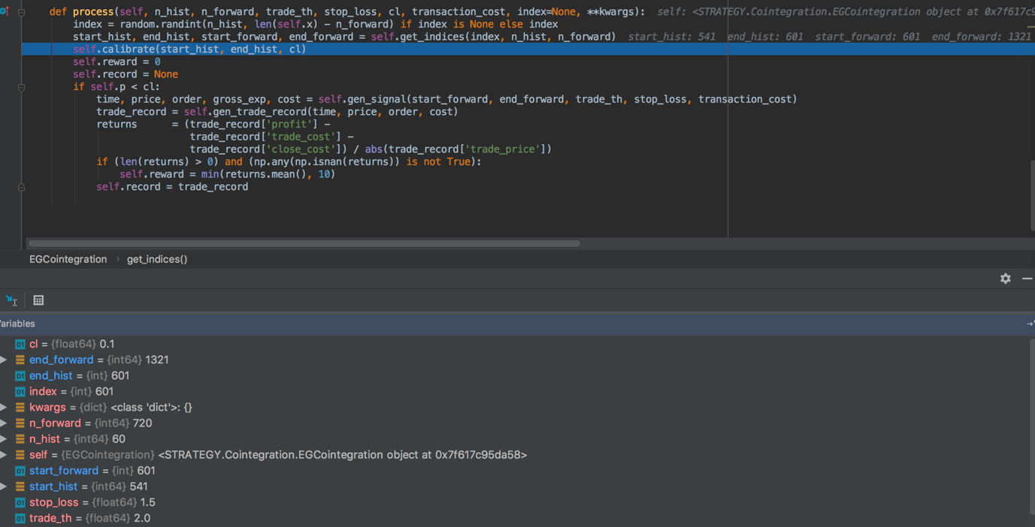v

Gen signal

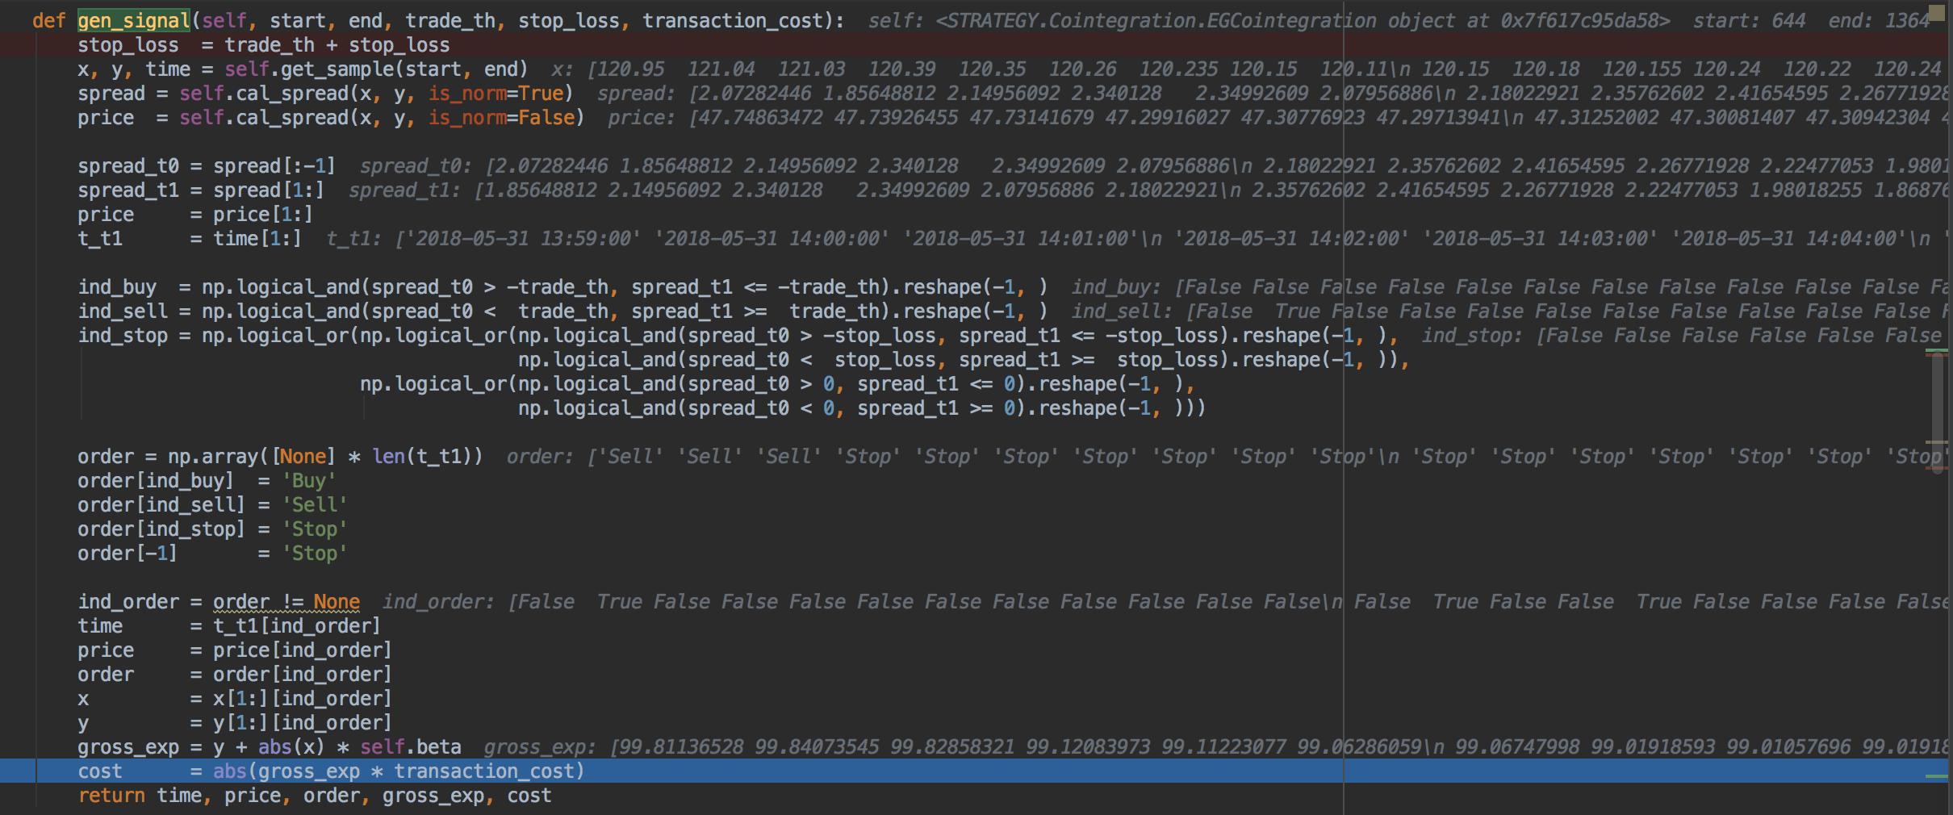

Optimal actions:



* **Going Long the Ratio** This is when the ratio ⍺is smaller than usual and we expect it to increase. In the above example, we place a bet on this by buying Y and selling X.
* **Going Short the Ratio** This is when the ratio ⍺is large and we expect it to become smaller. In the above example, we place a bet on this by selling Y and buying X.