# Documentation **baseline_table() function**

## Arguments:

dat ; name of dataframe

treatment ; vector that contains the treatment information, where 0=not treated, 1=treated

cont ; vector of the continuous variables you wish to use: e.g. c("age", "bmi", etc...)

cat ; vector of the dichotomous variables you wish to use: e.g. c("sex","CHF", etc...)

weight ; vector containing the weights

out_type ; 1=just overall, 2=just treated and not treated (DEFAULT), 3=overall and treated/not treated, will default to treated / not_treated

width ; scale of the output png, (recommended "70%")

## Example:

source(file=”Simdata.r”)

baseline_table(test_df, A, contnames, catnames, null.weight, 3, "70%")

Table 1. Baseline table from simulated data prior to weighting (unequal characteristics across groups)

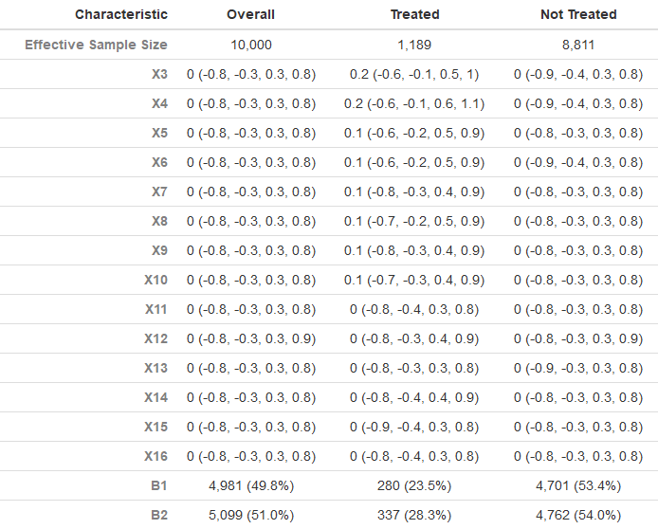

baseline_table(test_df, A, contnames, catnames, OW, 3, "70%")

Table 2. Baseline table from simulated data after weighting (equal characteristics across groups)

