Predicting Gene Expression using Regression Models on TCGA Data
Michael Lee Jonathan Wolf
Department of Computer Science Department of Computer Science
University of Washington University of Washington
Seattle, WA 98105 Seattle, WA 98105
leem42@uw.edu wolfj4@cs.uw.edu
Abstract
Gene expression refers to the process by which a functional gene is produced by the information from a gene. This process is ubiquitous in all organisms and understanding it better is all the more pertinent in a cancer data set. In this paper we predict gene expression for cancer afflicted patients using regression models.

1 Introduction
The Cancer Genome Atlas (TCGA) is a comprehensive study profiling thirty-three types of cancer. The goal of the study is to better understand the molecular basis for cancer. This study has generated over two petabytes of data publically available for researchers to analyze. This wealth of data has prompted many computational methods and made headway in finding features of cancer.

1.1 Purpose
The goal of this project is to predict gene expression for cancer afflicted patients. Making accurate predictions would provide potential for clinical application.

2 Methods
Our predicted values are continuous so we choose to use regression models for our machine learning techniques. In particular, ridge and lasso regression. Using various values for the weight coefficient and validation techniques we will choose optimal parameters.

3 Preliminary Results

Thus far we have run unregularized ridge regression on our data. Plotted below is various values of lamda for our model and the absolute error.
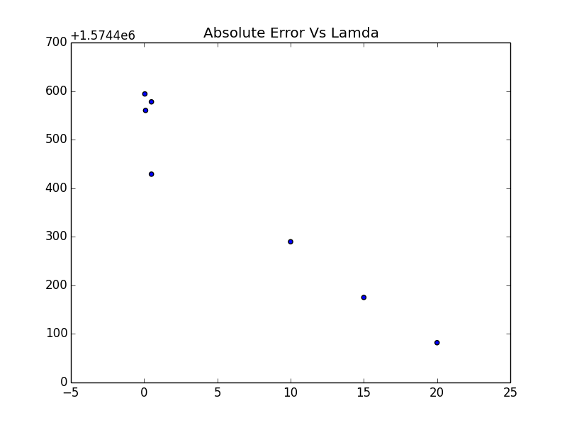

Seeing the preliminary results, we plan to incorporate further features to attain better predictive power. Specifically, mutations for each patient and their proximity to the gene being predicted.

5 Conclusion

Acknowledgments
References

