**Executive Summary**

This report focuses on exploring the Australian Open tennis tournament dataset. The Australian Open is a prestigious tennis event with a 122-year history from 1906 to 2024, showcasing champions from various countries. This dataset covers numerous metrics and trends, offering comprehensive insights into the tournament's history and champions.

After analysing the dataset with Excel and Tableau, several key findings were identified:

1. Top Players: 7 have won 5 or more titles, including four women (Margaret Smith, Serena Williams, Monica Seles, and Nancye Wynne Bolton) and three men (Novak Djokovic, Roger Federer, and Roy Emerson).
2. Champion Nationalities: The dataset reveals an increase in the diversity of champion nationalities over time. Before 1980, champions were predominantly from Australia, the USA, and Europe, but in recent years, a broader range of nationalities has emerged, reflecting the global growth of tennis.
3. Novak Djokovic: Djokovic is the top player, with ten championships from 2008 to 2023 and an average win rate of 0.6.
4. Australian Champions: Australia leads with 94 champions and 98 runners-up, reflecting its dominant tennis ecosystem over the years.
5. Highest Win Rate: The highest win rate for the Australian Open is 0.8889, achieved by Amélie Mauresmo in 2006.
6. Andy Murray: Murray has been a runner-up five times from 2010 to 2016, 4 of which were losses to Djokovic.
7. Gerald Patterson: Patterson has the most set wins, with an 18-16 match against John Hawkes in 1927.
8. Win Rates and Sets: The parallel coordinates graph shows that men's champions' win ratios tend to flatten as they play more matches, indicating consistency is crucial for success. Additionally, champions with varying win ratios across sets show the adaptability needed to succeed in competitive tennis.
9. Runner-Up Diversity: Andy Murray leads the top runner-up list, followed by Rafael Nadal, reflecting a range of nationalities among runner-ups.
10. Top 5 Champions Over Time: In the women's tournament, Daphne Akhurst dominated from 1925 to 1930, followed by Nancye Wynne Bolton from 1937 to 1951. For the men's tournament, Roy Emerson was key from 1961 to 1967, and recently, Roger Federer and Novak Djokovic have been dominant from 2007 to 2019.

**Data Exploration:**

|  |  |  |
| --- | --- | --- |
| Attribute Name | Type | Description |
| Year | Numeric (4-digit) | The year the tournament took place. |
| Gender | Categorical (Binary) | The gender of the champion, indicating if it was a men's or women's tournament. |
| Champion | Categorical (String) | The name of the tournament winner. |
| Champion Nationality | Categorical (3-letter) | The 3-letter ISO code indicating the champion's nationality. |
| Champion Country | Categorical (String) | The country of origin of the champion. |
| Champion Seed | Numeric (Integer) | The preliminary ranking of the champion for the purposes of the draw. |
| Score | Categorical (String) | The score for each set, represented as pairs of integers separated by commas. |
| Runner-up | Categorical (String) | The name of the runner-up in the tournament. |
| Runner-up Nationality | Categorical (3-letter) | The 3-letter ISO code indicating the runner-up's nationality. |
| Runner-up Country | Categorical (String) | The country of origin of the runner-up. |
| Runner-up Seed | Numeric (Integer) | The preliminary ranking of the runner-up for the purposes of the draw. |
| 1st Set Win Rate | Numeric (Ratio) | The percentage of wins in the first set. |
| 2nd Set Win Rate | Numeric (Ratio) | The percentage of wins in the second set. |
| 3rd Set Win Rate | Numeric (Ratio) | The percentage of wins in the third set. |
| 4th Set Win Rate | Numeric (Ratio) | The percentage of wins in the fourth set. |
| 5th Set Win Rate | Numeric (Ratio) | The percentage of wins in the fifth set. |
| Win | Numeric (Integer) | The total number of wins by the champion. |
| Loss | Numeric (Integer) | The total number of losses by the champion. |
| Win Ratio | Numeric (Ratio) | The ratio of wins to losses for the champion. |

**New Columns Created for Analysis:**

* Set Win Rates: Offer insights into a player's performance across different sets, showing consistency across the game.
* Win and Loss: Track the champion's total number of wins and losses, giving a clearer view of their success rate.
* Win Ratio: Provides a direct measure of a player's success, indicating the ratio of their wins to losses.
* Set Played: Shows the number of sets each champion plays, reflecting the endurance and consistency needed to succeed in the tournament.

**Geographic Distribution**

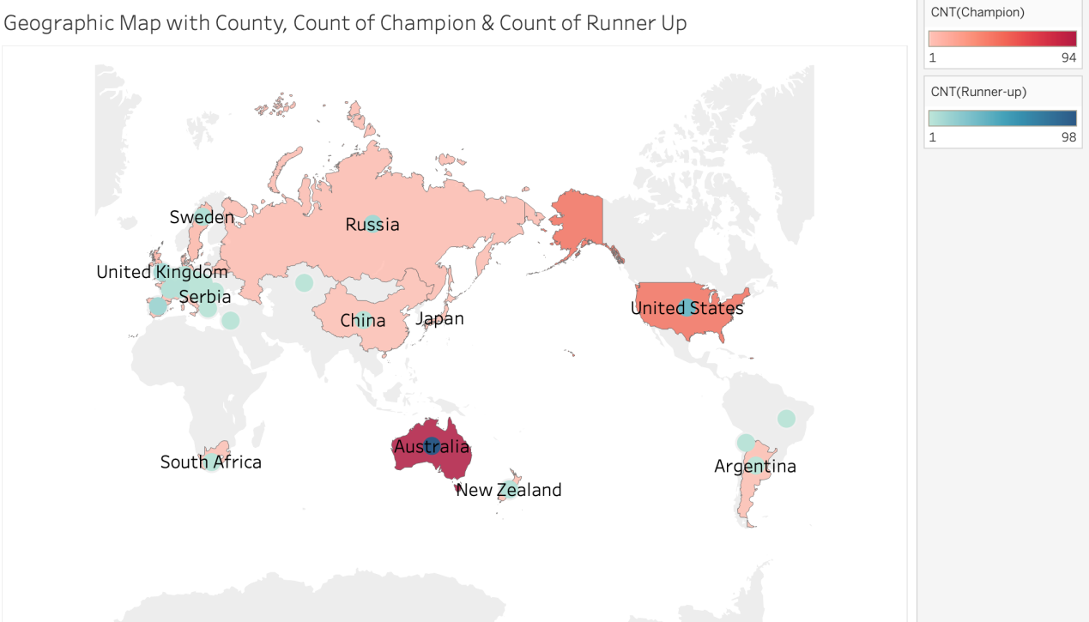

*Figure 1 Dual Axis Geographic Distribution of Champions and Runner-Ups*

Figure 1 presents a global perspective on the Australian Open's champions and runner-ups, highlighting each country's contribution. The visualisation uses colour intensity to indicate the concentration of champions and runner-ups from various nations, offering a comparative view. Australia has 94 champions and 98 runner-ups, reflecting its dominant tennis ecosystem over 120 years. The United States follows, with 43 champions and 43 runner-ups, indicating its significant contribution. Other countries, including Russia and the United Kingdom, show notable concentrations, underscoring their consistent involvement. This map emphasises the tournament's global reach, with diverse participation from countries such as Japan, China, and Argentina, and highlights established and emerging tennis nations.

Geographic visualisations offer several advantages, including providing a clear and intuitive representation of spatial data and enabling viewers to grasp geographical patterns and distributions quickly. For instance, in Figure 1, the geographic distribution visualisation of champions and runner-ups in the Australian Open showcases each country's contribution through colour intensity, allowing for easy comparison between nations and emphasising the tournament's global inclusivity and impact. However, these visualisations may also have limitations, such as potential distortion in map projections and oversimplification of complex spatial relationships. The reliance solely on colour intensity for interpretation could lead to misinterpretation if not carefully calibrated or explained. Despite these drawbacks, geographic visualisations remain valuable tools for exploring and communicating spatial data.

**Tree Map**

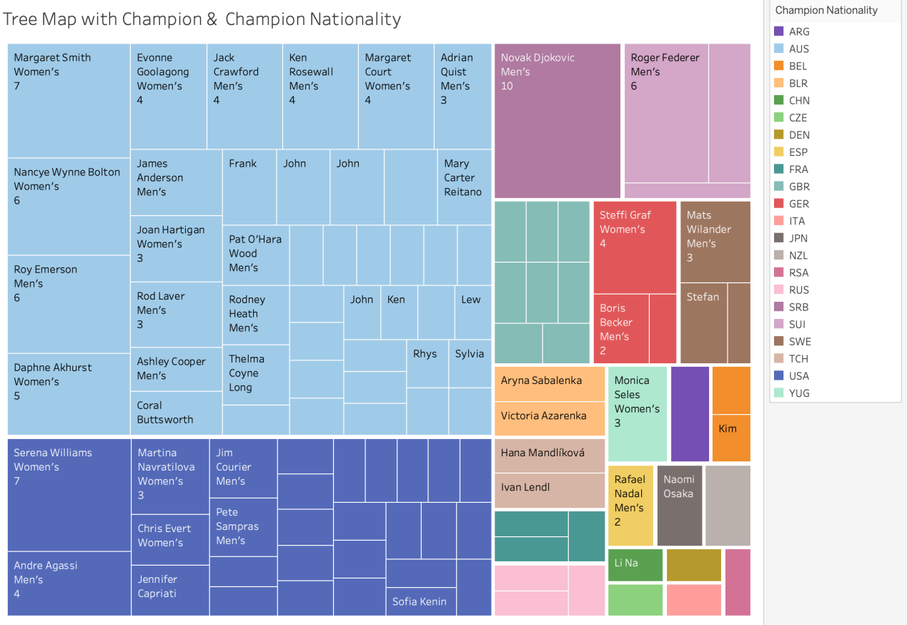

*Figure 2 TreeMap with Count of Champions & Champion Nationality*

The treemap provides an effective visual representation of champion nationality and their performance at the Australian Open. It shows that Australian champions dominated the competition historically, with nearly double the share compared to the USA. This dominance is reflected in players like Margaret Smith and Roy Emerson, who contributed significantly to Australia's success. The map also emphasises top players by block size, showcasing Novak Djokovic's ten wins, making him the most successful player in the tournament's history. This highlights contributions from players of various nationalities, including Serbia, Switzerland, and the USA. Additionally, the treemap shows a balanced distribution between male and female champions, with prominent players such as Serena Williams, Martina Navratilova, and Margaret Smith illustrating the depth of female participation in the Australian Open. Furthermore, the treemap demonstrates the international nature of the tournament, with champions from diverse nationalities, such as Britain, Russia, and Switzerland, showcasing the Australian Open's global reach.

The treemap visualisation technique offers several advantages. Firstly, it provides clarity through its colour-coding and block sizes, making it easy to discern trends in nationality distribution and the number of championships won by each player. Secondly, its comparative view allows users to see the relative contributions of different countries and individual champions. Lastly, the tree map is well-suited to represent categorical data, such as champion nationality, in a visually engaging manner. However, the tree map also has its limitations. One significant drawback is its limited detail. While it offers a high-level view of the data, it may lack finer details, such as individual match statistics or the specifics of each set. Additionally, there's a potential for colour overlap, mainly when similar colours are used for different categories. This can lead to confusion, especially with smaller blocks representing less prominent categories.

**Scatter Plot**

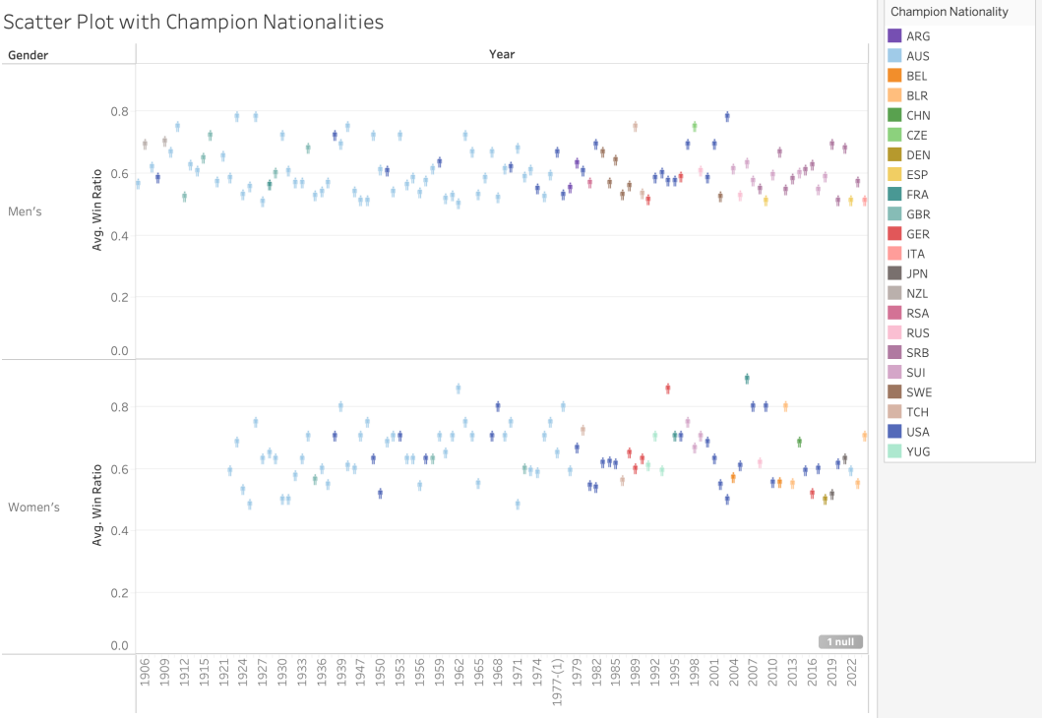

*Figure 3 Scatter Plot on Champion Nationalities*

Figure 3 presents a scatter plot displaying champion nationalities, colour-coded by country over time. The plot shows a growing diversity of champion nationalities over the years. Before 1980, winners predominantly came from Australia, the USA, and European countries, but in recent years, champions from various other nations have emerged, reflecting the global growth of tennis. The plot highlights a shift in regional dominance over time, with Australian champions dominating the early decades while more recent decades have seen champions from countries such as Switzerland, Serbia, and Spain. Additionally, the plot illustrates the introduction of gender representation in 1922, marking a fundamental shift towards inclusivity.

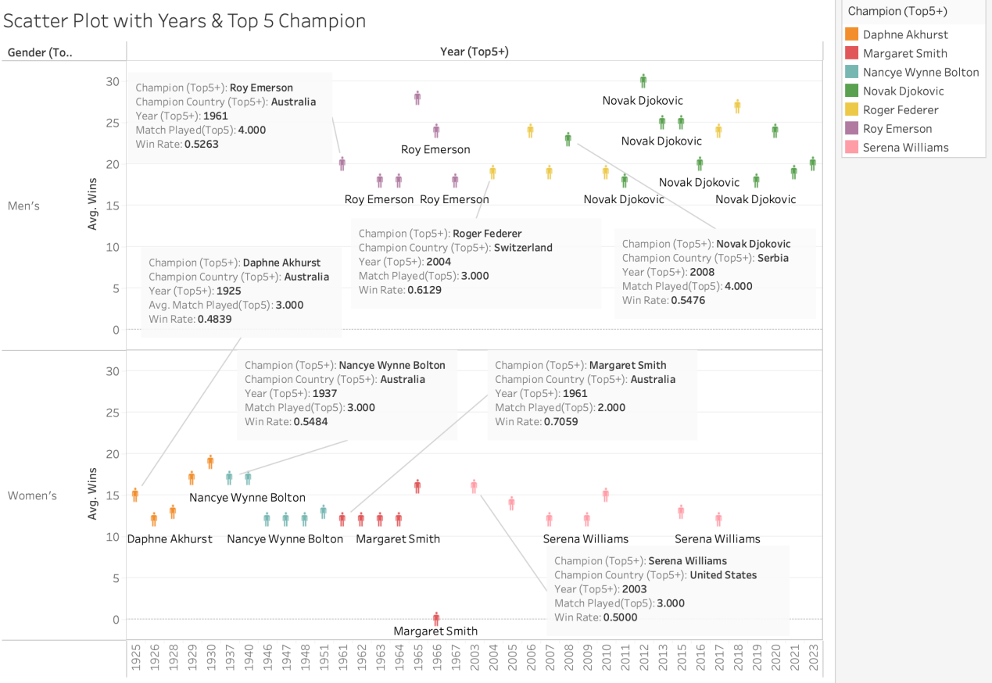

*Figure 4 Scatter Plot on Top 5 Champions Over The Years*

Figure 4 demonstrates the players that have dominated the Australian Open over various years. In the women's tournament, Daphne Akhurst dominated from 1925 to 1930, followed by Nancye Wynne Bolton from 1937 to 1951. Later, Margaret Smith and Serena Williams made substantial contributions, winning multiple championships. Roy Emerson was a key figure from 1961 to 1967 in the men's tournament. More recently, the primary dominants have been Roger Federer from Switzerland and Novak Djokovic from Serbia, particularly from 2007 to 2019.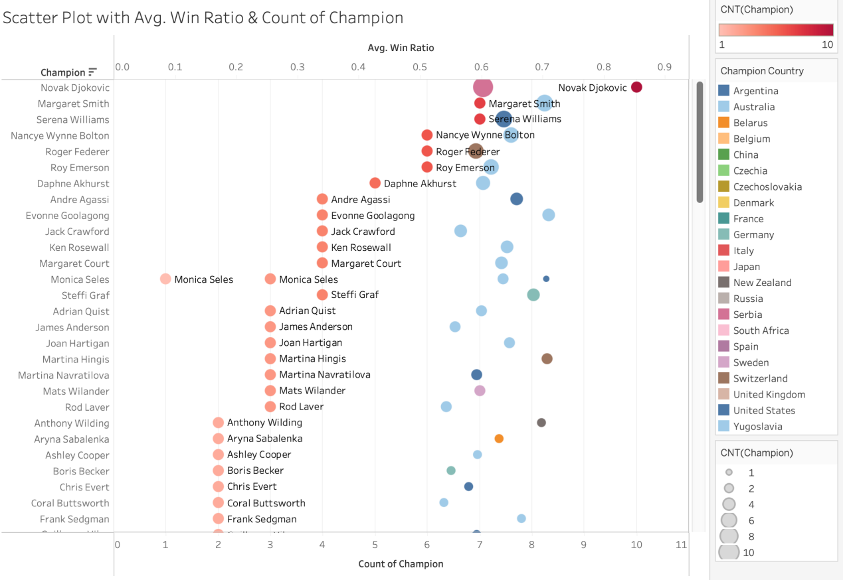*Figure 5 Dual Axis Scatter Plot on Champions and Average Win Ratio*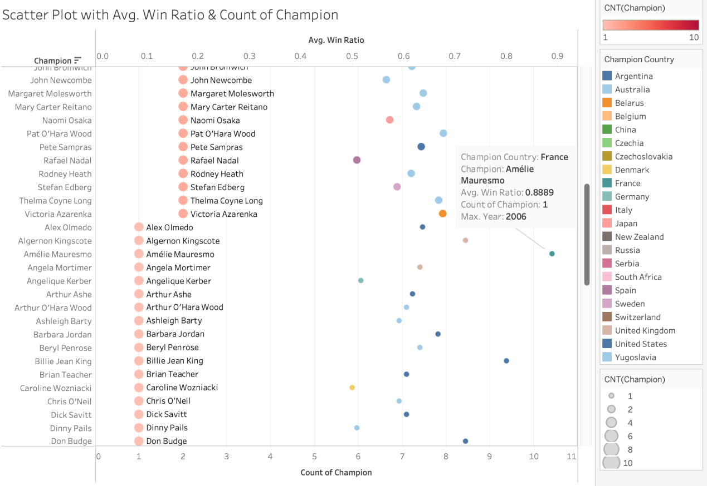

*Figure 6 Dual Axis Highest Win Ratio*

Figures 5 and 6 offer a scatter plot showcasing champions, their win ratios, and the number of championships won. The plot highlights Novak Djokovic as the top champion with ten wins and a consistent win ratio of 0.6, illustrating his sustained dominance. It also shows the balance between male and female champions, with top players like Margaret Smith and Serena Williams achieving multiple wins with solid win ratios. Monica Seles has won four championships, three representing Yugoslavia and one representing the USA in 2003, demonstrating her global influence. The scatter plot reveals varying career spans, with champions like Amélie Mauresmo achieving a single win in 2006 with a high win ratio of 0.8889, while others, including Djokovic and Williams, maintained longer, successful careers. The scatter plot also demonstrates the relationship between win ratios and the number of championships, with higher ratios indicating more efficient match performance.

Scatter plots offer advantages such as visualising relationships between two variables, like champion nationality over time or win ratios versus championships won, and depicting trends like the emergence of champions from diverse nationalities or dominance in specific periods. However, they may need help with large datasets or dense data clusters, leading to overcrowding and interpretation challenges. Additionally, scatter plots may only partially capture complex relationships between multiple variables, potentially limiting comprehensive insights into the data.

**Stacked Bar**

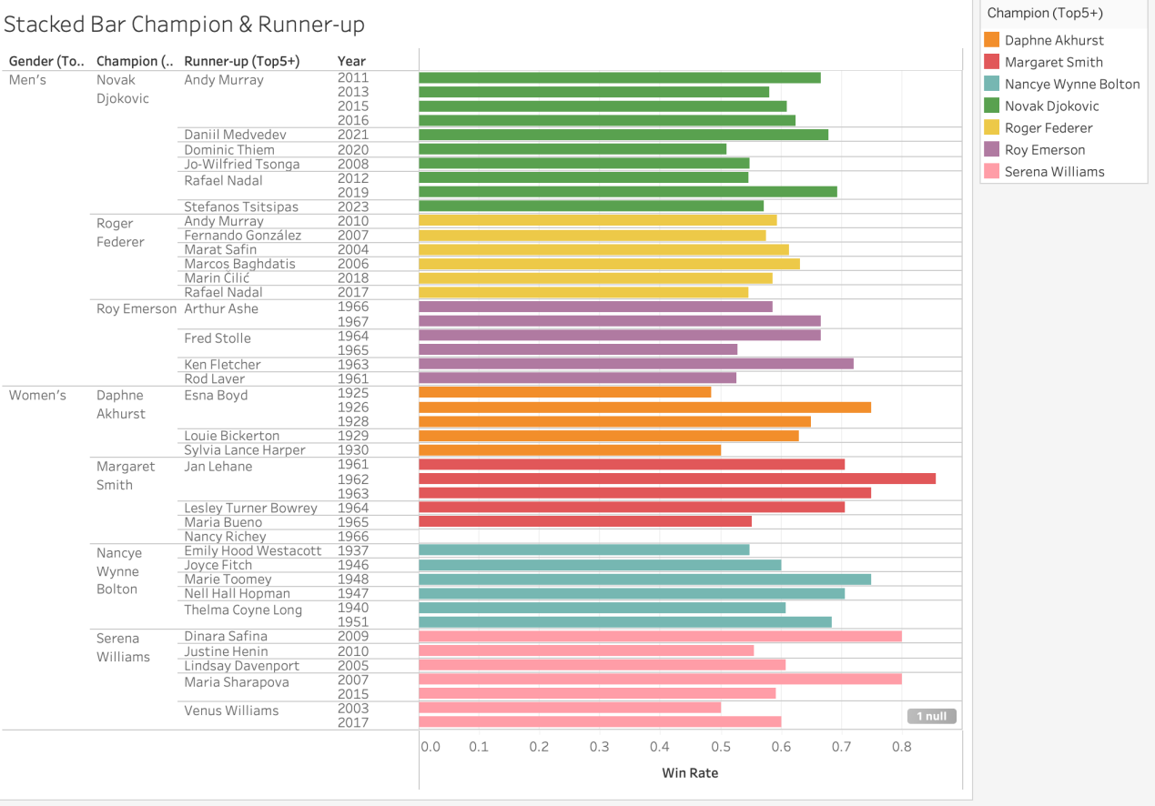

*Figure 7 Stacked Bar on Top 5 Champion with Runner-Up*

Figure 7 provides insights into the champions and their runner-up counterparts, showing several key trends. The stacked bar chart highlights Andy Murray, Rafael Nadal, Roger Federer, and Novak Djokovic as dominant figures in recent years. Djokovic and Federer have consistently won multiple championships, although they haven't faced each other in a final. The chart also demonstrates the competitive nature of these matches, with some runner-ups having substantial win rates despite not securing a championship. This highlights the consistency of top champions like Djokovic, Federer, Roy Emerson, and Serena Williams, reflecting their sustained success. The chart also illustrates a balanced distribution between male and female winners and runners-up, demonstrating increased opportunities for both genders in tennis.

**Word Cloud**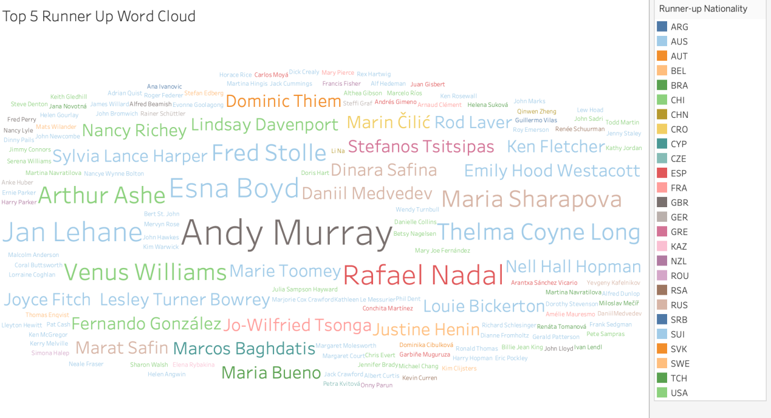

*Figure 8 Top 5 Runner-Up World Cloud*

Figure 8 visualises the names of the top 5 runners-up, emphasising their prominence in the tournament. The most prominent name, Andy Murray, from the UK, has five runner-up finishes from 2010 to 2016, reflecting his competitive presence despite not securing a championship win. Rafael Nadal is also highlighted with three runner-up finishes and two championships in 2009 and 2022, demonstrating his ability to compete at a high level over a long period. The word cloud also includes names like Dominic Thiem, Venus Williams, and Roger Federer, highlighting the competitive nature of the tournament and the range of players reaching the finals. Furthermore, it reflects the global nature of tennis, showcasing runners-up from various nationalities.

Word clouds offer a visually appealing way to highlight key terms or names based on their frequency or significance, enabling quick comprehension of essential information. However, they may need more detailed context, potentially leading to oversimplification or misinterpreting data relationships. Moreover, subjective factors like font size and colour choice can influence viewer perception.

## **Parallel Coordinates**

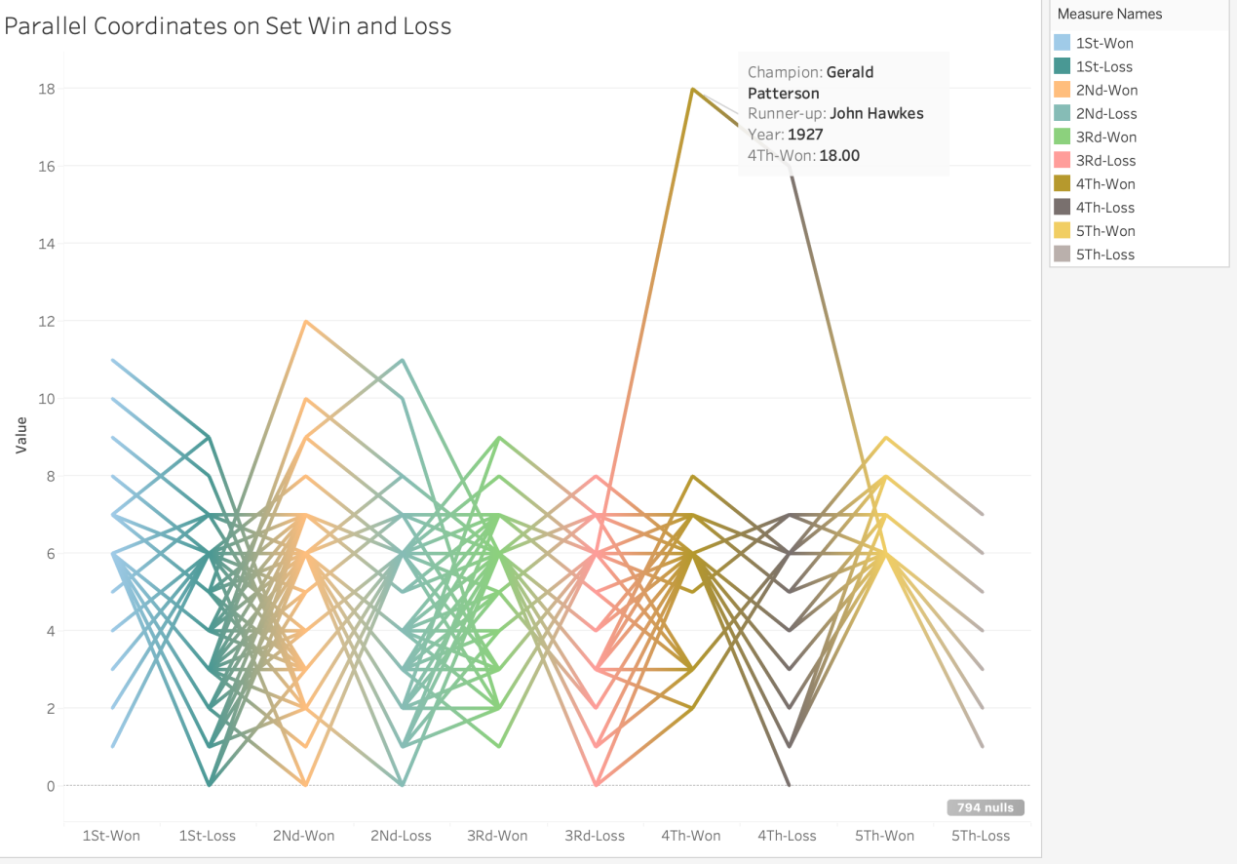

*Figure 9 Parallel Coordinates on Set Win and Loss*

Figure 9 presents a parallel coordinates graph showing the sets won and lost by champions and their runners-up. The graph highlights a significant outlier: Gerald Patterson playing the longest set in Australian Open history in 1927, with an 18-16 win over John Hawkes. This illustrates the tournament's competitive nature and the endurance players require.

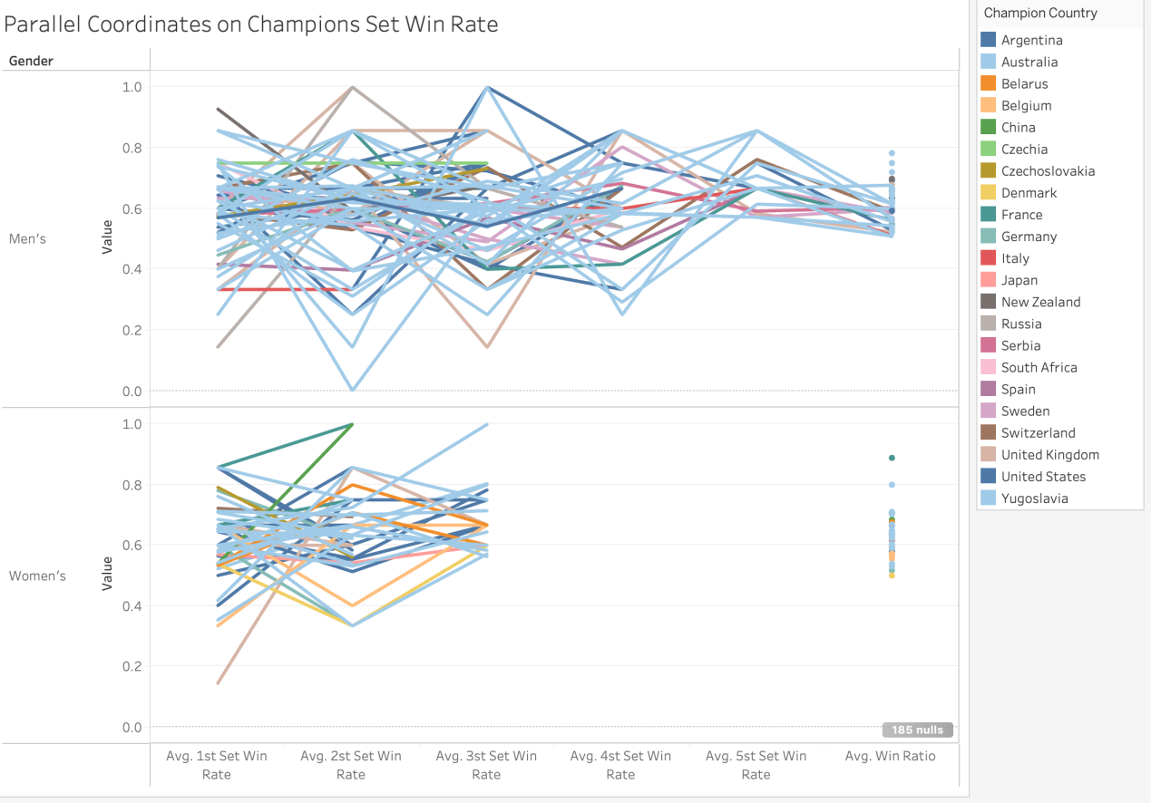

*Figure 10 Parallel Coordinates on Champions Set Win Rate*

Figure 10 presents a parallel coordinates graph showing the win rates of champions across different sets. The graph highlights how male champions' win ratios tend to flatten the more matches they play, indicating that consistency is critical to success. Additionally, the graph reveals some champions with varying win ratios across sets, illustrating the adaptability and resilience required to succeed in competitive tennis.

In the report, parallel coordinates graphs serve as powerful visual aids, enabling the simultaneous examination of multiple variables such as sets won and lost by champions and their runners-up or champions' win rates across different sets. These graphs clearly represent intricate relationships and trends within the dataset, aiding in identifying significant patterns or outliers. However, they also present challenges, particularly in overcrowding with many variables or data points, which may complicate interpretation. Additionally, ensuring the accurate conveyance of variable values is crucial to prevent potential inaccuracies or misinterpretations. Despite these limitations, parallel coordinate graphs remain indispensable tools for analysing complex data in the report's context, demanding careful consideration to address potential interpretation challenges while harnessing their analytical benefits.

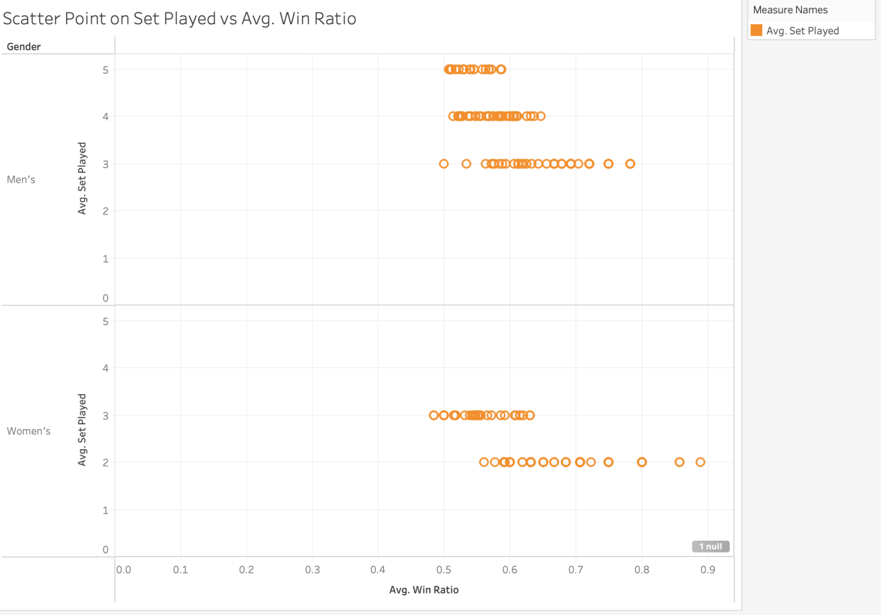

*Figure 11 Scatter Plot on Set Played Vs Avg Win Ratio*

Figure 11 shows a scatter plot comparing the number of matches played to the average win ratio for champions. The plot shows that, in general, the more matches a champion has played, the lower their average win ratio tends to be. This suggests that as champions compete in more matches, they face tougher competition, resulting in a drop or stabilisation in their win ratio.

**Conclusion**

In conclusion, the comprehensive analysis of the Australian Open tennis dataset has provided valuable insights into the tournament's rich history and the performance of top players over the years. The report identifies several key findings, including the dominance of top players like Novak Djokovic, Margaret Smith, and Serena Williams, the diversity of champion nationalities over time, and the contributions of various countries. Geographic visualisations, tree maps, scatter plots, and parallel coordinates graphs offer diverse perspectives, examining trends, patterns, and comparisons across different dimensions, including nationality distribution, set win rates, and win ratios.

Tableau has facilitated the clear presentation of complex data, allowing us to explore the relationships between champion nationalities, performance consistency, and individual accomplishments. This comprehensive analysis reinforces the Australian Open's global reach and competitive nature, highlighting tennis trends, achievements, and inclusivity. Overall, this report underscores the importance of data visualisation in uncovering meaningful insights and informing people interested in tennis about the trends or changes in the past 120 years.