Good Practices in Eclipse and Subversion

**Following good Eclipse practices**

1. How to create a Java Project

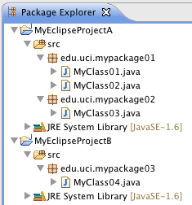

**Example**

* Go to File-> New -> Project… -> Choose: “Java Project”
  + **Do NOT use blank space when typing a *project name***
  + Eclipse will AUTOMATICALLY create a *Java Source Folder* **SRC**.
  + **Do create all your packages INSIDE this folder**
  + **Do create all your classes INSIDE the packages you just created**
  + **Do NOT create a class inside a default package**

1. Managing multiples workspaces

* **Do create a NEW Workspace every time that you want/need to develop a different application.**

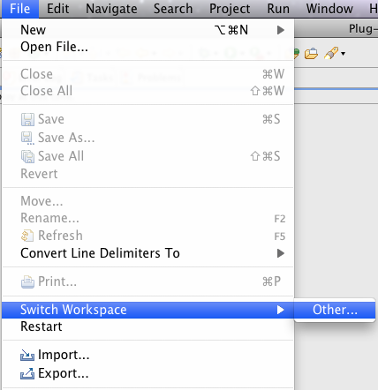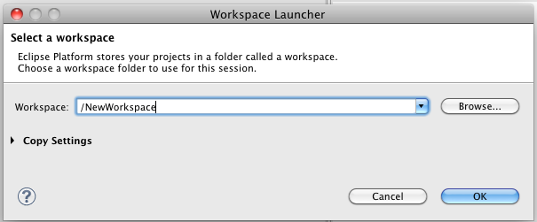**Following good Subversion practices**

1. Adding Eclipse projects in SubVersion

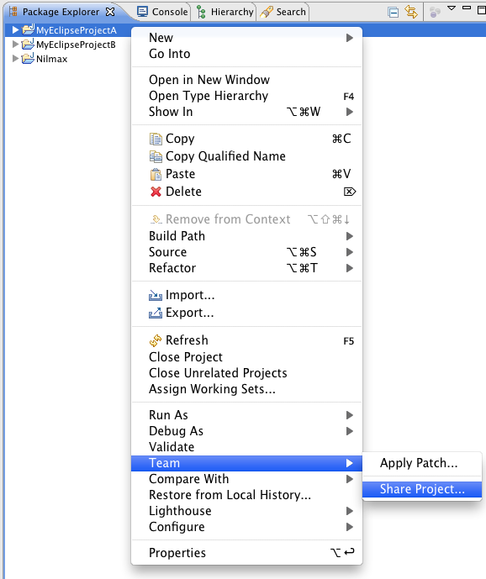

* **Do add each Eclipse Project under TRUNK directory**

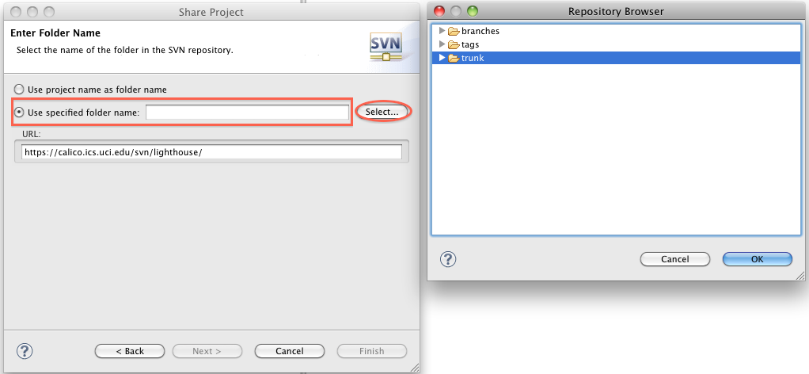

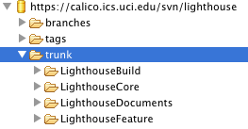

**Example**

**Some others recommendations**

1. Perform update before commit to avoid compile errors in the Trunk
2. Do not use the option REVERT in Subversion, that is a Lighthouse limitation