How to Update Lighthouse Plug-in

1. Go to Menu, Help -> Check for Updates

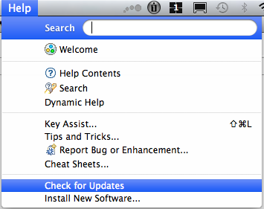

* 1. Check the Lighthouse Plug-in and click *next*
  2. *Accept the terms of the license agreements*
  3. Press *finish* button
  4. Re-start Eclipse

1. Go to *preference window*
   1. Click in the *synchronize model with database* button

